Suggested GP Trainee Quality Improvement Project (QIP)

RCGP Curriculum Requirements
WPBA: Quality Improvement Project (QIP)
The GMC recommends that all doctors demonstrate an involvement in Quality Improvement at least once a year. During your GP training you are expected to complete a Quality Improvement Project (QIP) when you are in your primary care placement in either ST1 or ST2 and a Quality Improvement Activity (QIA) in the other two training years.

Mandatory requirements
By the time you reach the end of training, you need a minimum of 1 QIP and 2 QIAs. The QIP should be evidenced in your portfolio (the section for the QIP is different from the QIA learning log) and your supervisor will assess, grade, and discuss this with you.
GPs in training are required to demonstrate their ability to engage with quality improvement in primary care, and to ensure that the subject of the QIP is relevant to primary care. As such, QIPs should be done in a primary care setting. If this is not possible, then the QIP can be done in a non-primary care setting, providing you discuss this in advance with your supervisor.
(The Royal College of General Practitioners, 2024)

The Importance of Equality, Diversity and Inclusion (EDI) in Primary Care
Equality, Diversity, and Inclusion (EDI) is essential in all areas of healthcare. EDI directly impacts both patient care and the development of well-rounded, empathetic healthcare providers. EDI in this context isn’t just a matter of ethics but is essential for high-quality healthcare that is accessible, respectful, and responsive to the needs of diverse populations.
EDI in primary care services is essential for creating a healthcare environment that treats every patient fairly, addresses the unique needs of a diverse population, and promotes an inclusive atmosphere for both patients and healthcare providers. This not only supports better health outcomes but also strengthens trust and equity within healthcare systems and the communities they serve.
A simple and effective way to create a more inclusive Primary Care Service is for GP trainees to undertake a relevant QIP during their practice-based placement.
We have outlined a suggested QIP below. It is important to note that a trainee may choose to do only one or two elements suggested as part of the QiP. Other elements could be picked up by another trainee in the same practice, at the same time or, in succession, with separate but related QiPs with the end goal of being becoming an accredited practice.

Suggested QIP: Towards Inclusive Healthcare; Achieving 'Pride in Practice' Accreditation for LGBTQ+ Inclusive Services

What is ‘Pride in Practice’?
Pride In Practice is an award for GP practices that works to improve the experiences of LGBTQ+ people accessing Primary Care Services.
(LGBT Foundation, 2023)

Project Aim
To achieve ‘Pride in Practice’ accreditation by creating a welcoming, respectful, and informed healthcare environment for LGBTQ+ patients within the GP practice learning organisation.

Background
LGBTQ+ patients often face barriers to healthcare, including fears of discrimination and a lack of understanding among healthcare providers regarding specific health needs. The ‘Pride in Practice’ accreditation, developed by the LGBTQ+ Foundation, recognises GP practices that commit to inclusive healthcare and continuous improvement in LGBTQ+ patient support. This project seeks to align with those standards, improve the quality of services provided, and support LGBTQ+ health and wellbeing in a general practice setting.

Objectives
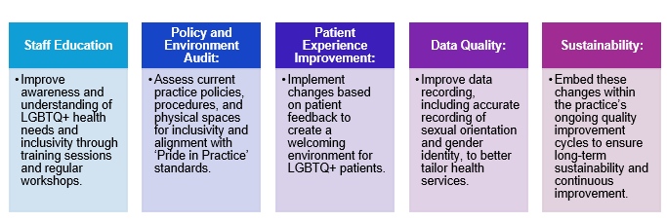

Steps for Implementation
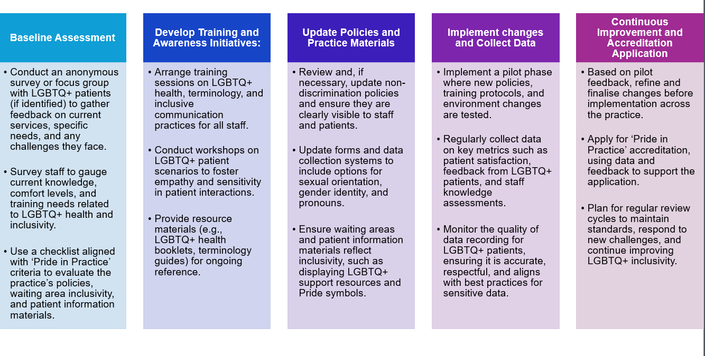

Project Measurement and Evaluation

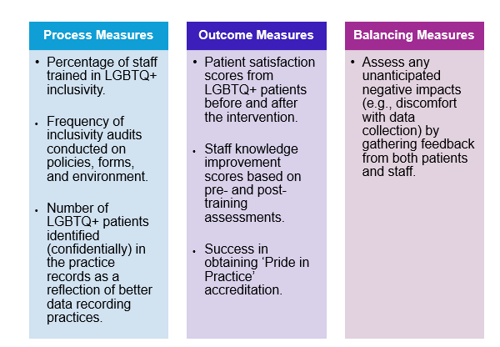

Potential Challenges and Mitigation Strategies
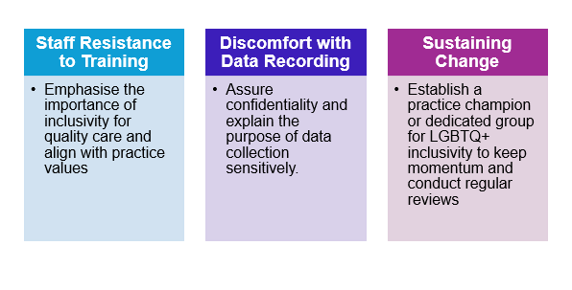

Project Timeline

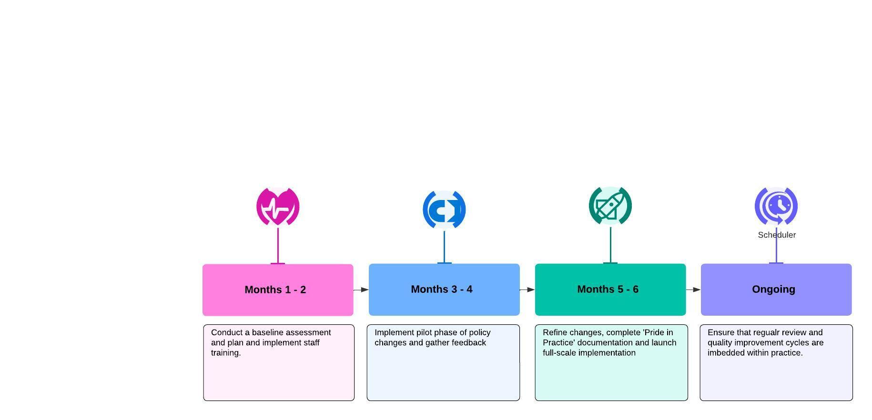

Expected Impact
This project aims to improve LGBTQ+ patient experience, foster an inclusive practice culture, and achieve ‘Pride in Practice’ accreditation. This can significantly enhance the reputation of the practice, increase patient trust, and set a precedent for other GP practices working towards similar goals.

Completed QIP
Once you have undertaken the QIP, you should then complete the QIP template:
- QIP template for the trainee to complete (blank copy) (DOCX file, 265 KB)
You should then upload the completed template as well as the Quality Improvement Project itself to the Trainee Portfolio. Your supervisor then assesses the QIP on the Portfolio and feedback is given to you by them, which should encourage further discussion. This example QIP shows a completed form and the GP supervisor comments:
- Home visit example with ES responses (DOCX file, 90 KB)

Feedback
Your supervisor will mark you against the following feedback levels: below expectation, meeting expectation or above expectations for each domain, compared to the expected level of a GP in training working in the clinical post. The supervisor also rates you on your overall competence.
This document sets out examples of what each feedback level might look like against each area of the QIP:
- QIP feedback levels and word pictures (DOCX file, 271 KB)

(The Royal College of General Practitioners, 2024)

Further details on QIPs can be found here: https://www.rcgp.org.uk/mrcgp-exams/wpba/qip

