Weekly Educational Bulletin: Number 6
COVID-19 Update
We are all reviewing the evidence and guidance that is emerging around Covid-19. We are watching the government updates, wondering how lock down will be relaxed and have questions like “when will there be a vaccine?” or “will there be an effective treatment this year?”
We are in the swing of remote consultations and well versed in the challenges as well as opportunities this method of consulting presents. We have seen and probably diagnosed cases of Covid-19, so have experience of the different ways this virus presents and how it should be managed.
With new medical conditions, the science and guidelines move quickly. While researching the emerging evidence this week, I came across a large, but well-presented summary of where we are so far with Covid-19. Although it is a large document, you can select online from the contents page the areas of interest to yourself.
I hope you find this a useful resource.
https://bestpractice.bmj.com/topics/en-gb/3000168/pdf/3000168/Coronavirus%20disease%202019%20%28COVID-19%29.pdf

Weekly Clinical Topic – Acne vulgaris

Acne Vulgaris
Definition: Acne vulgaris is a chronic inflammatory skin condition affecting mainly the face, back and chest - it is characterised by blockage and inflammation of the pilosebaceous unit (the hair follicle, hair shaft and sebaceous gland). It presents with lesions which can be non-inflammatory (comedones), inflammatory (papules, pustules and nodules) or a mixture of both
This is a common condition that affects most people at some point in their life.
- nearly 90% of teenagers suffer from acne, and half of them will continue to experience symptoms as adults
  - peak incidence is 13-16 years, although it may continue into the 20's, 30's and later
  - females with polycystic ovary syndrome or those with excess cortisol (e.g. steroid use) are prone
- by age 40 years, 1% of men and 5% of women still have lesions

Acne has clear detrimental effects:
- on a psychosocial level
- can lead to permanent scarring
Acne can be categorised into:
Mild
Predominantly non-inflamed lesions (open and closed comedones) with few inflammatory lesions.
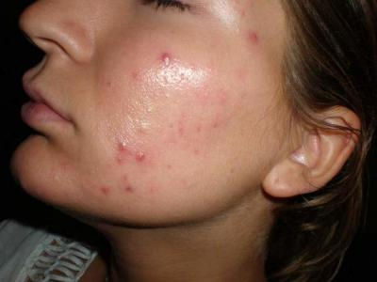
Moderate
More widespread with an increased number of inflammatory papules and pustules.
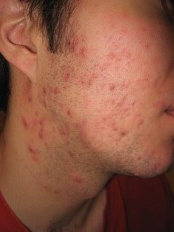
Severe
Widespread inflammatory papules, pustules and nodules or cysts. Scarring may be present.
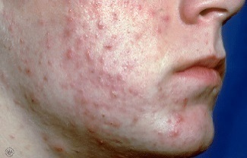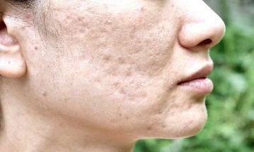
For further images: www.dermnet.org.nz.

TASKS:
Using the link below please complete the following:
https://cks.nice.org.uk/acne-vulgaris#!scenarioRecommendation
- What is the conservative treatment that should be advised when managing a patient with acne?

- What treatments are available in Primary Care for managing mild to moderate acne. What are the common side effects of these treatments?

- What other treatments are available for moderate acne if topical treatments are not effective?

- When would you refer a patient to a specialist with acne vulgaris?

Further Reading
Please read further or discuss the diagnosis and management of acne rosacea?

