Weekly Educational Bulletin: Number 5
Weekly Clinical Topic – Thyroid Problems

THYROID DISORDERS

Hypothyroidism

When should I suspect hypothyroidism?

Symptoms and signs of hypothyroidism may be subtle and non-specific — some people (especially the elderly) may be asymptomatic.
Primary hypothyroidism- Please list some symptoms of this condition:

Physical Signs of hypothyroidism may include:
- Coarse and dry hair
- dry skin
- hair loss
- Oedema, including swelling of the eyelids.
- Vocal changes such as hoarseness or deepening of the voice
- Goitre
- Bradycardia
- Diastolic hypertension
- Delayed relaxation of deep tendon reflexes
- Paraesthesia — due to carpal tunnel syndrome.
Secondary hypothyroidism
Symptoms and signs include those of primary hypothyroidism with or without those associated with:
- an intracranial mass such as headache, diplopia, or reduced peripheral vision.
- Abnormal pituitary hormone production such as skin depigmentation, atrophic breasts, galactorrhoea, amenorrhoea, erectile dysfunction, loss of body hair, Cushing’s syndrome, or acromegaly.

Postpartum thyroiditis (PP
The hypothyroid phase of PPT usually occurs between 3–8 months (most often at 6 months) postpartum and lasts typically 4–6 months.

HYPERTHYROIDISM
What are the clinical symptoms of hyperthyroidism?

Clinical signs of hyperthyroidism:
- Agitation
- fine tremor
- warm moist skin
- palmar erythema
- Sinus tachycardia, atrial fibrillation, heart failure
- dependent oedema
- eye signs (lid lag or retraction)
- Goitre (may be diffuse, multinodular, or single nodule). Examine the thyroid gland to assess its size, tenderness, symmetry, and nodularity.
In Graves' disease, the thyroid gland is usually diffusely enlarged and the pyramidal lobe is often palpable, and there may be a bruit. Typically, the gland is soft and symmetrical, but may be firm with an irregular surface (bosselation). In some people, the thyroid gland may not be palpable.
Non-tender thyroid nodules suggest toxic multinodular goitre.
A unilateral non-tender thyroid mass suggests a toxic adenoma.
A tender, enlarged, firm, irregular thyroid gland which is usually diffuse but may be asymmetrical, may suggest subacute (de Quervain's) thyroiditis.In amiodarone-induced thyroiditis, a small goitre is usually present.

How to Diagnose Hypo/Hyperthyroidism

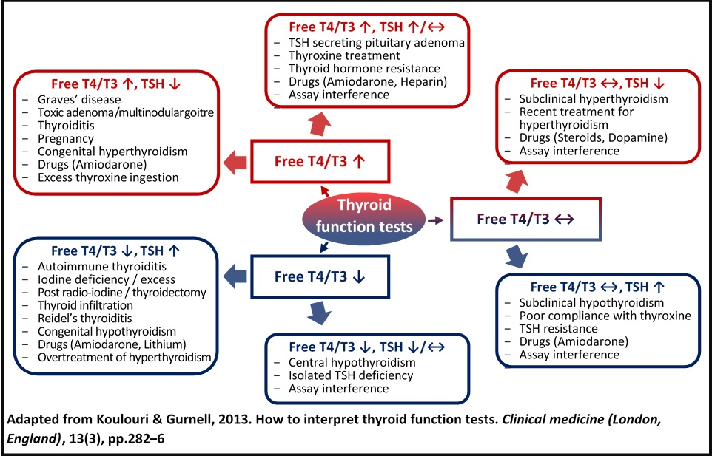

Management
- Arrange emergency admission if myxoedema crisis or a thyroid storm is suspected
- Refer or discuss with an endocrinologist (the urgency depending on clinical judgement) people who:
  - Are suspected to have subacute thyroiditis
  - Have a goitre, nodule, or structural change in the thyroid gland – if malignancy is suspected, refer using a suspected cancer pathway
  - Are suspected of having associated endocrine disease.- Do not start thyroid hormone replacement before specialist glucocorticoid replacement in suspected adrenal failure — this can precipitate an adrenal crisis.
  - Have adverse effects from levothyroxine (LT4) treatment.
  - Consider undiagnosed Addison’s disease if the person feels worse after starting treatment
  - Are female and planning a pregnancy,
  - Have pre-existing cardiac disease,
  - Have atypical misleading TFT results
  - Are suspected of having an uncommon cause of hypothyroidism, due to medications (for example amiodarone)
  - Have a persistently raised thyroid-stimulating hormone (TSH) despite adequate treatment.
- For people who do not need admission or referral:
  - treat overt primary hypothyroidism with levothyroxine (LT4) — do not prescribe combination therapy (LT4 and LT3) in primary care.
  - Review the person every 3–4 weeks after initiation of LT4 and adjust the dose according to clinical and biochemical parameters, aiming to:
    - Resolve the symptoms and signs of hypothyroidism.
    - Normalise serum TSH and improve thyroid hormone concentrations to the euthyroid state.
    - Avoid overtreatment, especially in the elderly.
    - Once a stable TSH is achieved, TSH can be checked 4–6 monthly and then annually.
    - Some drugs can have an effect on the absorption of LT4
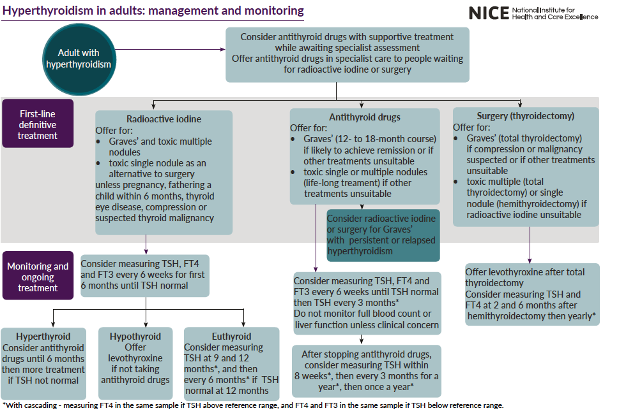

TASK
- A patient had normal TFT results but raised thyroid autoantibodies – what do you think should be the next step in management?
- How would the treatment of a child with hypothyroidism differ from that of adults?

Urgent and Unscheduled Care

MEDICAL EMERGENCY: Myxoedema coma
- This is a rare life-threatening clinical condition in patients with long standing and untreated hypothyroidism
- It can be difficult to diagnose and treat
- It has a mortality of 50%
Myxoedema Coma usually effects the mental state of a patient and they may present with:
- Apathy
- Low mood
- Cognitive decline
- Confusion and even coma
These symptoms can be subtle and misdiagnosed as dementia or depression
TASK
- How would you diagnose and investigate myxoedema coma

- How would this condition be treated in the hospital setting?

MEDICAL EMERGENCY: Throid Storm

This is an extreme manifestation of thyrotoxicosis due to the overproduction of thyroid hormones. Rarely it can be the first presentation of thyrotoxicosis in a patient. This condition needs to be treated aggressively and promptly to prevent death. If treated early the mortality rate is 10-30% and if left this rises to 50-90%.

TASK

- What are the presenting symptoms?

- How is this condition investigated?

- How is it treated?

- Explain what the Burch-Wartofsky point scale is

