Virtual Reality Simulation for Foundation Training
East of England

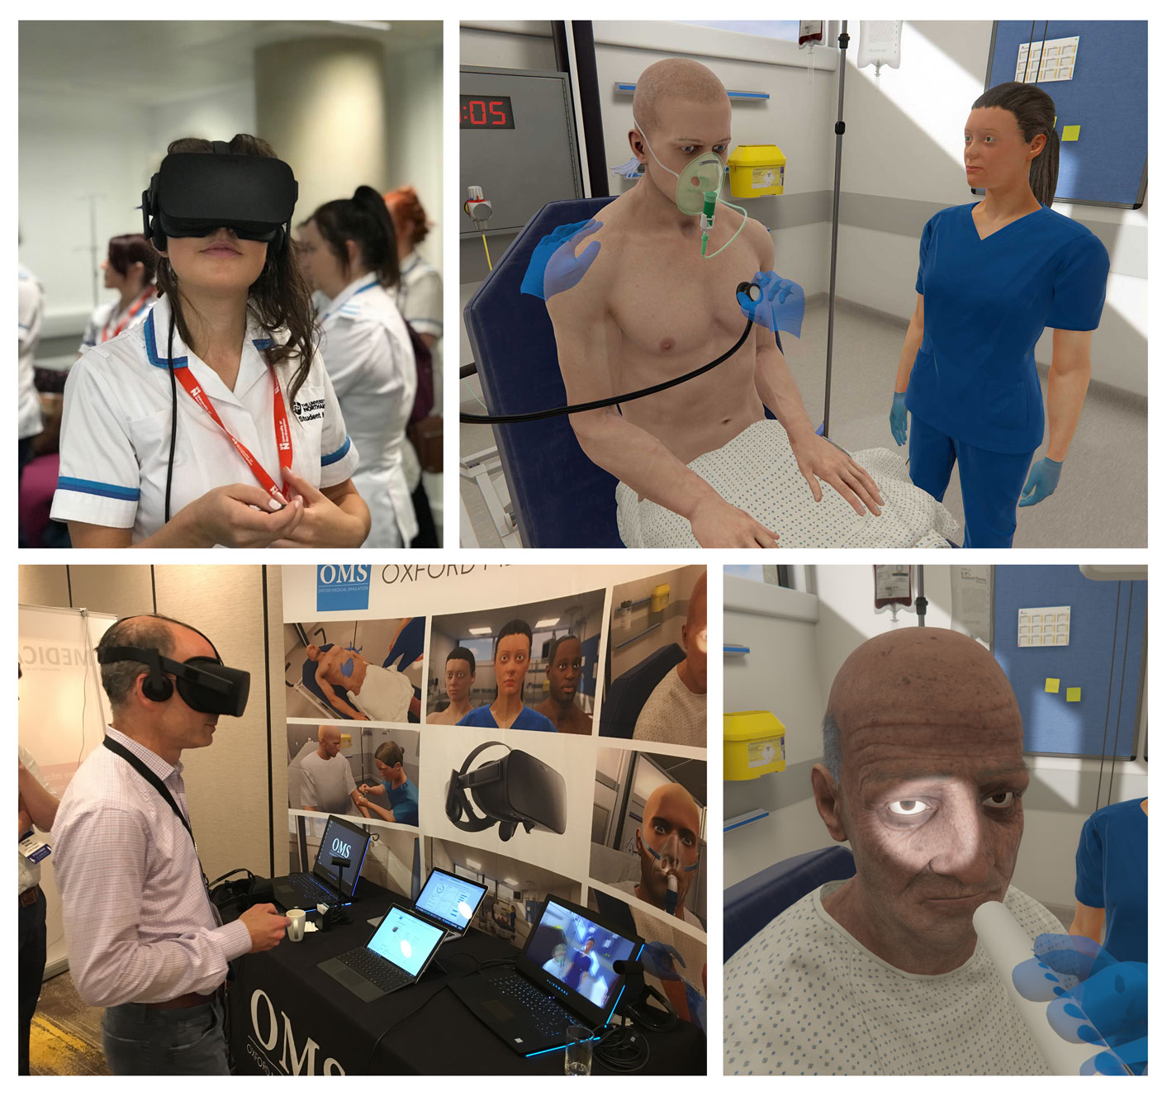

Virtual reality simulation for Foundation Training across East of England

Simulation-based education is an effective teaching method used to develop both clinical and non-clinical skills such as communication, prioritisation and team working. It provides trainees with a safe and supported environment to practice common clinical emergencies and may be the only opportunity trainees get to experience rarer emergencies such as anaphylaxis. This method of education is recognised in the Foundation Programme Curriculum.

Over the past few years, HEE East of England local office has invested in the provision of simulation-based education across the region. From August 2018, each foundation trainee attends one full day equivalent of mandatory high-fidelity simulation. During these sessions, the trainees are immersed into a simulated clinical scenario in real-time (e.g. a deteriorating patient), followed by a debriefing session involving the trainee(s) and their peers observing the scenario. Feedback from these sessions has shown that this educational experience is well liked by the trainees and improves their confidence in managing deteriorating patients. In fact, trainees have repeatedly requested more training using simulation.

Virtual reality simulation has been widely adopted in surgical training where it has been shown to be an effective way of training and improves patient outcomes. The same is true in medicine where virtual reality simulations can bridge the gap between theory and practice by immersing the learner in a realistic, dynamic, complex setting.⁽¹⁾

From August 2019, HEE East of England Foundation School have successfully introduced an innovative educational tool - Virtual Reality Simulation for both FY1 and FY2. This is designed to augment the existing physical simulation sessions using new technology – allowing trusts to scale the delivery of simulation-based education for trainees without the need to significantly expand faculty.

Virtual Reality simulation has been a great addition towards our educational programme. When face-to-face education opportunities were unfortunately cancelled due to recent extraordinary circumstances, trainees continue to have the flexibility to participate in virtual reality simulation, running scenarios on screen from a location and time that suits them.

We would like to thank all Trusts’ time and effort to make this introduction a success, as reflected by the trainees’ very positive feedback. We are delighted to announce that we are continuing our partnership with Oxford Medical Simulation, to deliver this flexible educational tool, with introduction of new exciting features such as mental health scenarios, step-up scenarios in paediatrics, as well as multi-player scenarios.

What is virtual reality?

Virtual reality involves a headset with screen inside so that when the user puts on the headset they are completely immersed in a new environment. Using software from Oxford Medical Simulation, users are immersed into a computer-generated, high-fidelity virtual clinical environment. Scenarios can be run within the virtual environment and user can ‘interact’ with virtual patient and staff by making selections on a wide range of pre-set options to take a history, examine, investigate, diagnose and treat in real time.

The virtual patient’s condition, appearance, physiology, blood results, blood gas results and ECGs are dynamic throughout the scenario, so the user can obtain a ‘feedback’ on the effects from their interventions as in physical simulation. The scenarios can be paused at any point by removing the headset if required. At the end of each scenario, personalised, objective feedback on user’s performance based on latest clinical evidences is produced, combined with opportunity for self-reflection.

Equipment and access

Each set of virtual reality simulation equipment consists of a dedicated portable laptop with the Oxford Medical Simulation software, and the VR headset (Oculus Rift). These can be kept securely, e.g. within the Postgraduate Department, with a sign-in/out access system.

In view of infection control concern for the VR headset, every Trust is encouraged to purchase silicone covers for the oculus rifts, which can be easily wiped clean between use with antibacterial wipe. HEE can fund up to 5 covers for each Trust. Please ensure the silicone cover is cleaned and completely dried between each user.

Each Foundation trainee will be given a unique login which allows access to a bank of 10 pre-selected scenarios. Additional scenarios are also available from August 2020 (please see below ‘scenarios’ section). Relevant additional resources (e.g. local Trust protocols, National guidelines, etc.) can be made available to facilitate the sessions. The VR equipment can be used anywhere in the Trust where there is a small obstruction-free area (for the learner to fully immerse into the session and move around once the headset is placed).

Availability of the on-screen option allows more flexibility should users prefer to run the scenarios without a headset, and access from their personal device. The OMS software is compatible with both Windows and Mac system. (Please refer to document “getting starting with OMS Distance for COVID-19”)

After completing a VR scenario, a summary page on the trainee’s performance and their reflection can be printed as evidence of learning and linked to the Foundation Curriculum (e.g. uploaded onto e-Portfolio). The trainees can access a record of their scenarios, scores and feedback anywhere using their login allowing them to reflect on their learning progress and identify key learning needs. The scenarios can be re-visited unlimited times.

All trainees’ access to the VR system, time in VR and performance data is available both to the trainee and the trust using the in-built analytics platform. This allows Educational Supervisors to review and discuss learning progress with the trainees during educational meetings.

Administrator access will be granted to individuals in each Trust to manage trainee access and make use of analytics and performance data. Trainee performance data is also made available for research within trusts and Deanery if required. In addition to administrator access, super-user access can be granted to specific personnel within each Trust, to help super-users familiarise their colleagues with the VR system.

Training on how to use the equipment will be provided by Oxford Medical Simulation for each Trust.

Implementation of VR for Foundation Trainees in HEE East of England

Nationally, all Foundation year doctors must receive 3 days of simulation per year (1 day equal to 6 hours). 2019/2020 academic year has changed such that 60 hours of education must be evidenced by each trainee in HORUS. Each Foundation school has been asked to set 30 hours of mandatory training in their region and made suggestions for appropriate activities for the additional 30 hours. Please refer to this guidance on the following web page.

https://heeoe.hee.nhs.uk/foundation/teachingopportunities

HEE East of England has mandated that at least 3 hours of VR simulation must be facilitated. This will be evidenced on HORUS and review of mandated attendance will be part of the ARCP process.

We also recommend an additional 3 hours facilitated VR to be provided by the Trust to count towards their non-mandated 30-hour education requirement. These sessions can be arranged separately, or can be carried out during their regular scheduled generic training sessions.

Virtual reality simulation, in conjunction with the one full-day equivalent of high-fidelity simulation, and other mode of simulation e.g. practical skills training, will be part of the 3 full-day simulation delivery by Trusts, and should be evidenced in the trainee chosen 30 hour on HORUS.

The provision of money to the trusts to purchase the machines and equipment was with the understanding that the trusts would mandate this minimum requirement, and optimally exceed this. We recommend that additional individual learner time and peer to peer facilitated sessions also be encouraged.

Learning opportunities

There are various ways that virtual reality can be adapted as an effective educational tool. The suggested opportunities are listed below:

1. Individual learning
As the OMS VR system does not require faculty, scenarios can be practiced individually at any time that suits the trainee. This allows deliberate practice according to trainee preference. Note that after any VR session feedback can either be viewed on the VR equipment or on the users own device (e.g. laptop or phone). This frees up the VR equipment for other users if required.

2. Small group learning (learner led or facilitated)

The virtual world can be projected real-time from its base laptop onto a projector or TV monitor, so that peers can observe the scenario whilst the scenario is being driven by a trainee. This can be done amongst trainees themselves (e.g. group of 4), or with the presence of a facilitator. Scenarios can be stopped at any point to allow discussion/ practice of human factors (e.g. communicating to a senior through SBAR). Trainees can also be encouraged to verbalise during the scenario, for example, when communicating to the virtual nurse.

The benefit of such learning environment is that this allows peer learning, as their peers would benefit from purposeful observation, allowing stimulating educational discussion during the debrief at the end of each case. A discussion at the end of each scenarios can take place, with focus on clinical learning objectives, signposting towards local/ national guidelines, trust polices, etc. These sessions are to be counted as addition to the one-day equivalent high-fidelity simulation that the trainees are currently attending.

As there are a total of 10 scenarios for each group, 5 scenarios can be selected by the Trust for the mandatory facilitated session, with 5 trainees participating in the session, each practise on one scenario using their OMS login. The other learners will achieve learning on the other scenarios by observation and active participation during facilitated discussion. The rest of 5 scenarios can be covered by the other 3-hour additional VR session provided by the Trust, or during their individual learning. Each trainee will have taken learning from all 10 scenarios. A certificate of attendance can be provided to trainees to evidence of facilitated sessions on their e-portfolio. It is suggested that faculty are provided with certificates for their participation in educational activity.
3. Individual top-up training

All VR sessions can fit in around the trainees’ schedule. As such, VR simulation can be used if the trainee cannot attend some of their usual educational sessions or if there is a requirement for additional training or remediation. It can also be used for trainees returning to practice.

4. Multi-player scenarios

From August 2020, we are very excited to have access to multi-player scenario, which will allow interactions between trainees and more human factor training e.g. leadership and teamwork. We have invited 6 different sites to participate and collaborate in this new initiative during the first few months, with a plan to roll-out across the whole region. At the end of the pilot period, feedback will be obtained from each Trusts regarding effective approach of running the scenarios.

Note that all of the above learning patterns can either be done flexibly (ad-hoc, without a structured timetable) or integrated alongside traditional simulation training. This could include running physical simulation with one group, and virtual simulation with another group to increase simulation throughput using virtual reality.

The followings are the focus of learning during each scenario:
- Critical thinking and clinical decision-making
- Interacting with the patient and colleagues
- Prioritising actions and efficiently managing the scenario
Each scenario lasts around 15 minutes, there is a timer on screen once a scenario is launched. It is important for trainers and trainees to note that whilst the users will be given a score at the end of each scenario, this educational tool is not used as an assessment; it is used as a tool to develop users’ clinical skill and knowledge through feedback and reflection. These can be used effectively by the learners for self-reflection, consolidate feedback and note their progress of learning as the same scenario is practiced repeatedly.

Faculty for facilitated sessions, scenarios and learning objectives

As scenarios are run on the VR system, the facilitators for the facilitated sessions are there to oversee the sessions and discuss learning objectives of the scenarios. Discussion is mainly around clinical elements, Trusts protocols and available guidelines, they and do not require to undergo debriefing training as the facilitators for the high-fidelity simulation sessions. From our recent feedback, this is the preferred method by the trainees as they find the facilitated discussions highly valuable.

Oxford Medical Simulation will provide each Trust with learning objectives for the selected scenarios, which can be made available for facilitators as guidance for the session. The learning objectives is also shown on the page once the scenario is completed by the trainee.

Scenarios

Please see below scenarios selected for each group of learners from August 2020. In addition to the 10 ‘standard’ scenarios on medical and surgical emergencies, each group have the opportunity to participate in a number of new additional scenarios which will be beneficial for their stage of training.

 | FY1 | FY2
10 Standard | Delirium with urosepsis | Neutropenic sepsis
 | Infective exacerbation of COPD | Acute severe asthma
 | AKI | Pneumothorax
 | DKA | PE and DVT
 | NSTEMI | GI Bleed
 | Pancreatitis | IVDU - cellulitis & abscess
 | Perforated diverticular disease & peritonitis | Pneumonia and renal transplant
 | CCF & pulmonary oedema | Bacterial meningitis
 | Post-op opioid overdose | Seizure and hyoglycaemia
 | Anaphylaxis | Alcohol withdrawal & suicidal ideation
Additional | Asthma (as an initial assessor e.g. nurse) | Paediatrics D&V
 | DKA (as an initial assessor e.g. nurse) | Paediatrics NAI
New Diabetic scenarios | Diabetic Ketoacidosis (new presentation) | Diabetic Ketoacidosis (new presentation)
 | Diabetic Ketoacidosis (in-patient) | Diabetic Ketoacidosis (in-patient)
 | Hypoglycaemia, IVDU | Hypoglycaemia, IVDU
 | Hypoglycaemia, over treatment | Hypoglycaemia, over treatment
Mental health | Dementia with difficult behaviour | Chronic pain and drug seeking behaviour
Interprofessional | ALS | ALS

It is up to each Trust to select the scenarios they would like to run for the mandatory facilitated sessions. Some Trusts have opted for scenarios that are not already covered during their high-fidelity simulation sessions, it is entirely flexible as long as trainees have the opportunities to practice on the other scenarios individually or in peer groups during their optional learning time.

Adaptation and suggested session plan from Basildon Hospital for implementation of VR:

Dr. Georgia Winnett has shared with us their approach at Basildon Hospital:

Twenty full day sessions have been allocated by the simulation suite to facilitate Foundation simulation (10 for 45 xFY1 and 10 for 45 xFY2). Their simulation team will be setting up the VR during each session.
Facilitators will be either the simulation team or educational supervisors - facilitators for VR do not need to be ‘sim’ trained but need to have facilitation skills for case-based discussions. They will be providing facilitators with a copy of the learning outcomes summary from the OMS system.

Each facilitated session will be for 5 trainees; each trainee will log onto the OMS system and undertake 1 scenario. The other 4 trainees will watch the VR scenario and then all participate in a group discussion of the experience (talk about what happened, analyse/clarify any uncertainty and then set action points to take back into the clinical setting).

In total, the group of 5 trainees will have discussed 5 scenarios (but only 1 scenario will appear on the OMS system). A certificate of participation will be issued electronically to each trainee for HORUS. It is then expected that the trainees will use the VR to count towards the non-mandated 30 education hours as they will be providing ample opportunity. They can also log onto the scenarios at home/library without VR if they wish.

9am-12pm Scenarios 1 to 5 |  | 12-2pm | 2-5pm Scenarios 6 to 10
Room 1 | Room2 | Sim suite | Room 1 | Room 2
Facilitated VR  5 FY names have been allocated as mandatory study days (rota co-ordinators contacted to ensure not on call/nights etc) | Self-directed VR (first come first served basis) | Clinical skills session (1 hour)  Examples include:  LP  Ultrasound for cannulae  Pleural aspiration  NG insertion and placement checking  Fracture NOF assessment  Trauma cases  ECG and ECHO discussions  Paediatric emergencies (manikin)  Laparoscopy trainers (FY2) | Facilitated VR – up to 5 FYs to book onto dates | Self-directed VR (first come first served basis)
Quality assurance

The VR licensing is a significant ongoing cost for the foundation school. To meet the requirements of showing value, they will ask you to:
- provide usage data for all your trainees, split into facilitated sessions, peer to peer sessions, and individualised learning. You will be able to draw this from HORUS, or ask the trainees to download a log from their VR equipment.
- support qualitative feedback from trainees
Further purchasing of licenses will be dependent on receiving this information, and we would anticipate that it will be available at ARCP.

Funding for simulation

This innovative learning option has been funded centrally by the HEE East of England local office for trusts to provide a minimum of 3 hours of facilitated VR training.
  - Each Trust has been given funding to obtain 2 suitable computer systems and paired Oculus Rift,
  - Funding for a license for each FY1 and FY2 trainee to access 10 scenarios (plus extras) per year
HEE East of England provides additional funding for high fidelity simulation (1 day per year) at £150 per trainee.

LDA funds are expected to be used to provide procedural skills simulation equivalent to 6 hours per year per trainee.

References

Simulation-based medical teaching and learning, Abdulmohsen H. Al-Elq. J Family Community Med. 2010 Jan-Apr; 17(1): 35–40.

