Lister Hospital ST3 EM Endocrinology Education Day 10/05/2019
Travel, Parking and Refreshment Information

ADDRESS
Education Centre
Lister Hospital,
Coreys Mill Lane,
Stevenage,
SG1 4AB

SITE MAP – Education centre circled in orange
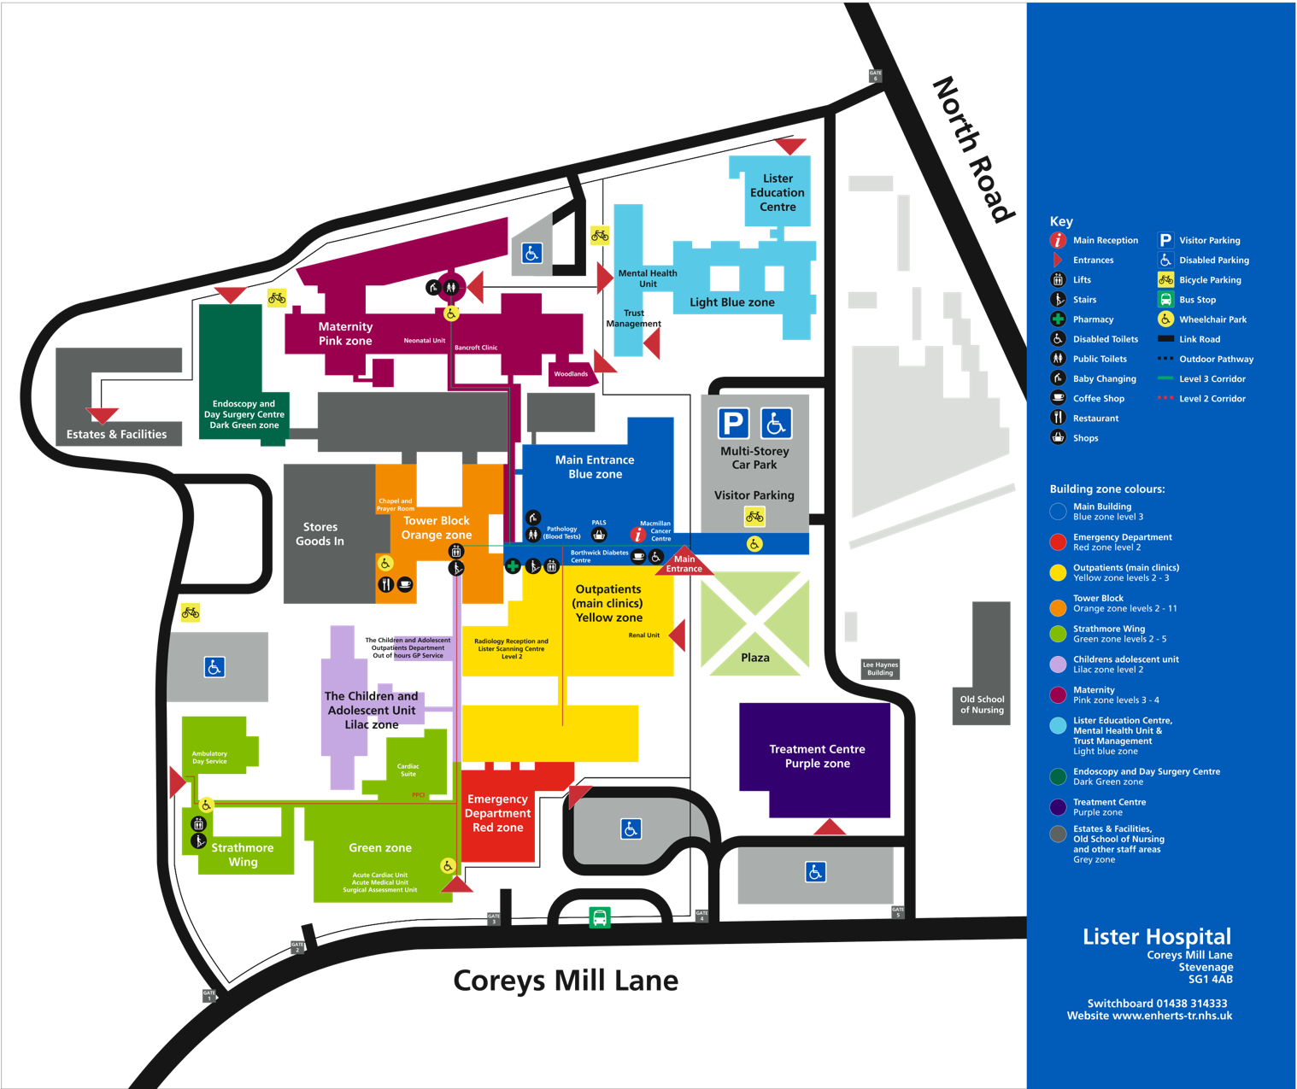

PARKING

There is a multistorey visitor car park on site (see map) the charges for which are as follows:

1 to 2 hours £4.50
2 to 3 hours £6.30
3 to 4 hours £6.80
4 to 5 hours £7.40
5 to 6 hours £8.20
6 to 24 hours £9.10

There is a less costly alternative. Sainsburys at Coreys Mill have a car park management company looking after their car park (Horizon). The cost of a full day's parking is £4, but this must be booked and paid for in advance on-line, there is no facility to pay on the day. It is listed on their site as SG1, Sainsburys, Stevenage. It's a relatively easy walk to site from there. Please click on the link below to book your parking in advance.

https://horizonspaces.co.uk/locations/show/4294938058

PUBLIC TRANSPORT

The closest train station is Stevenage and buses run approximately every 15 from the station to the hospital and take around 10 minutes.

Please see the link below for more information on travel to and from the Lister:
https://www.enherts-tr.nhs.uk/our-hospitals/lister/getting-to-the-lister/

REFRESHMENTS

Tea, coffee and biscuits will be provided during the day. Please bring your own lunch or alternatively food can be purchased in the staff canteen / coffee shop on site.

