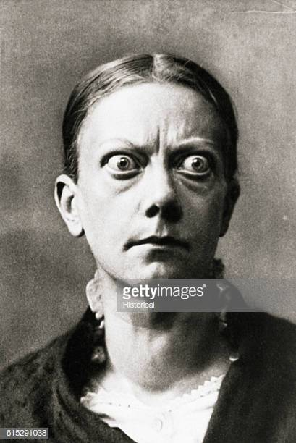

A 45 year old woman with UTI symptoms, diarrhea and abdominal cramping for 2 days. Tremulous, and drenched in sweat. Abnormal observations include an irregular heart rate of 142 and a temperature of 39.5. She has already had full sepsis treatment on arrival. She looks unwell.

1. Explain the difference between thyrotoxicosis and a thyroid storm (aka thyrotoxic crisis) (3)
2. List (5) clinical features of a thyroid storm
3. List (5) known **precipitants** of a thyroid storm for those who already have underlying hyperthyroid disease.
4. Other than resuscitation treatment what (4) specific treatments would you prioritise

**Thyroid Emergencies SAQ**

Answers from EM10, RCEM learning, life in the fast lane, EMcrit

A. **Thyroid storm/ thyrotoxic crisis** is a life threatening exacerbation (1) of hyperthyroid state with 1 or more organ dysfunction (1). A complication of thyrotoxicosis (1).

The exact mechanism of thyroid storm is unclear but it may be due to a change in the amount of unbound thyroid hormone as the overall total thyroid hormone level can be unchanged. May be caused by thyroid hormone or TSH releasing tumours that raise the total hormone levels. The diagnosis of thyroid storm is clinical. Laboratory testing, although helpful, does not distinguish between thyrotoxicosis and thyroid storm. Without treatment, thyroid storm is universally fatal. With treatment, the mortality is still as high as 20-50%. Diagnostic criteria available see ‘Burch and Wartofscy’ score.

**Thyrotoxicosis:** Encompasses hyperthyroidism as well as excessive levels of circulating thyroid hormones caused by gland destruction or extrathyroidal source including iatrogenic causes.

**Hyperthyroidism:** A clinical state induced by excessive production and secretion of thyroid hormones by an overactive thyroid gland.

* + 1. Thyroid carcinoma
    2. DKA
    3. Trauma
    4. Thyroid surgery
    5. 131-I radioactive iodine treatment
    6. Iodine containing compounds, amiodarone
    7. Pregnancy
    8. Stopping anti-thyroid therapy
    9. CVA
    10. PE
    11. Hypoglycameia
    12. No cause
    13. Sepsis
    14. Burns
    15. Epilepsy
    16. Salicylates

B.

* + 1. Hyperthermia
    2. Sweating
    3. HR >140/min, arrhythmia
    4. Coma
    5. Nausea and vomiting
    6. Diarrhea diarrhoea
    7. Signs of heart failure
    8. Confusion
    9. Restlessness
    10. Tremors
    11. May occur 6-24 hours post-surgery

1. **Specific treatment**
   * 1. Start a beta blocker. Propanolol 1 mg IV over 1 minute; if necessary repeat at 5-minute intervals. Maximum total dose 10 mg. Alternatives esmolol, metoprolol.
     2. Hydrocortisone 200mg IV
     3. Thyrostatic agent e.g propylthiouracil 1g PO/NG/PR loading dose or methimazole 20-25 mg PO loading dose.
     4. Iodine
2. Non Specific
   1. IV fluid resuscitation including glucose (‘high output’ heart failure, low glycogen reserves)
   2. Cooling
   3. Paracetamol (no NSAIDs or aspirin as decreases binding to thyroid binding protein)
   4. Manage agitation with benzodiazepine
   5. Treat the precipitation event (Sepsis, DKA, ACS)

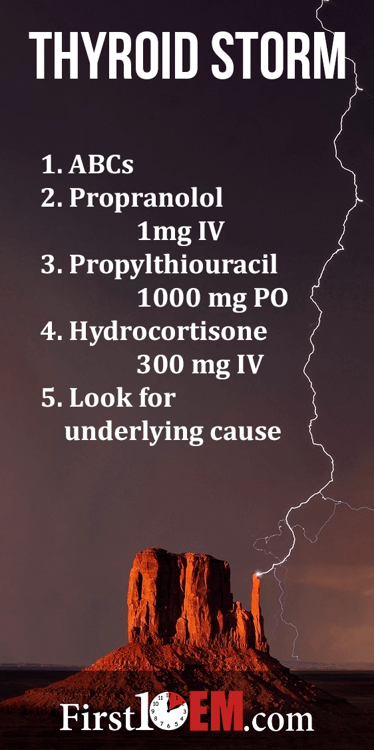

**Beta blockers:** Propranolol is the agent typically used, because it inhibits the peripheral conversion of T4 to T3 and is non-cardioselective so it will also control symptoms such as agitation, fever, and psychosis. EMCrit suggests a target heart rate of 100, because there are some case reports of cardiovascular collapse after propranolol that might be the result of these patients requiring a rapid heart rate as a compensatory mechanism.

**Steroids:** Thyroid storm typically causes depression of the hypothalamic-pituitary axis. Glucocorticoids inhibit the peripheral conversion of T4 to T3.

**Thyrostatic agent (Thionamides):** Decreases the synthesis of new hormone production. Propylthiouracil is hepatotoxic but in addition to decreasing the synthesis of new hormone production, it also blocks the peripheral conversion of thyroxine to triiodothyronine. Propylthiouracil (1g load PO -> 250mg QID to and decrease peripheral conversion from T4-T3). Methoimazole is safer in the second and third trimester.

**Iodine:** Afterblockade give sodium iodide or potassium iodide or Lugol’s iodine. Iodine administration **must be given at least 1 hour after the thyrosta**tic medication. In small doses iodine can lead to increased hormone production, but in high doses (as given here) it inhibits it and prevents release. Propylthiouracil is given first to prevent initial iodine treatment increasing production.

Iodine-containing solutions should not be given to patients with iodine overload or iodine-induced hyperthyroidism or amiodarone-induced thyrotoxicosis. Lithium or potassium perchlorate should be used instead.

Consider **Cholestyramine** to decrease the reabsorption of thyroid hormone from the enterohepatic circulation. In thyrotoxicosis, there is increased enterohepatic circulation of thyroid hormone.

**Definitive Treatment:** Radioactive Iodine or Surgery

# Hypothyroid Emergencies: Myxoedema Coma

* AIRWAY: macroglossia
* CVS: non-pitting oedema of hands and feet, bradycardia, hypotension refractory to vasopressors, reduced contractility, pericardial effusion
* RESP: respiratory depression, impaired respiratory muscle function, hypoxia and hypercapnia
* RENAL: bladder atony, urinary retention, urinary Na+ normal or high
* ELECTROLYTES: hyponatraemia from increased H2O reabsorption from high levels of ADH
* GI:anorexia, abdominal pain, constipation, ileus
* CNS: delayed acidosis
* Bloods:
  + TSH markedly elevated in 95% of cases, 5% are caused by central TSH failure
  + Low free T4, low T3
  + Hyponatraemia, hypoglycaemia, anaemia, hypercholesterolaemia, high CK
* Specific Tx: Hydrocortisone 100mg, T4 loading dose 500mcg IV, underlying Cause