The Blended learning Platform – Standard Operation Procedure Version 1

This document explains the how the Blended Learning Platform should be used by all Specialties within the East of England to create and maintain a large repository of high quality online educational content.
It is universally understood that for The Online Platform to maintain its success and achieve its goals it must be underpinned by a discrete and productive workforce who, collaboratively maintain and sustain a high-quality online educational environment, that is driven by clear, sustainable and contemporary educational methodologies that satisfy trainee and educator needs. This document attempts to describe the strategy and processes that drive that workforce into achieving these goals.

Contents:

Section 1 – Platform Goals and Expectations
  - Goals of the Platform
  - Functions of the Platform
  - Overview of HEE Workforce Structure
1.4 Roles and responsibilities
Sections 2 – Implementation for your Specialty
2.1 Implementation sequence – 5 meetings
2.2 Curriculum mapping and Matrix
2.3 Quality Assurance and Third-Party Applications

Section 3 - Training and Administration

4.1 Administrative Support
4.2 Training requirements

Section 3- Review and Feedback

3.1 Review cycles
3.2 Qualitative and Quantitative datasets
3.3 Return on Investment monitoring

Section 5 – Research and Development

5.1 Academic Research
5.2 Technological Development – Current and Future Requirements for the Platform
5.3 Third Party Integrations

Section 1 – Platform Goals, Workforce Structure and Roles, Quality Processes
  - Goals of the Platform
The fundamental goal of any online teaching platform is to deliver quality educational content to a geographically disparate group of students. This has been achieved to some text within Postgraduate Medical Education through the NHS E-Learning for Health Project. However, there is opportunity to rethink how online teaching is delivered on a regional scale using a Blended Learning Approach. Blended Learning requires an element of learning to be delivered online as a course in combination with either face-to-face or over Webinar (i.e. Zoom/Teams) teaching by a subject matter expert. By combining online learning with online teacher-student interaction, we can increase the quality and equity of Postgraduate medical education on a regional scale whilst reducing the overall time and resources needed to deliver educational events.
To achieve this, we have used a combination of online learning software packages, Bridge/Panopto that enable our educators to record educational events contemporaneously whilst allowing secure, safe and sustainable accessibility to all educational content and adheres to HEE information governance policy. The combination of Bridge and Panopto software packages allows us to achieve the following goals across many specialities with minimal loss of clinical manpower whilst reducing the amount of face-to-face contact that is required at this unprecedented time.

Short Term Goals
- For all trainees to be able to access remote/online educational events and material regardless of rota restrictions or geographical location.
- Enable the creation of rich interactive educational material from a remote site with minimal Audio-Visual hardware i.e. cameras and microphones using just a laptop, and minimal/no knowledge of online learning code/technical ability. This includes the ability to record lectures in real time or ahead of time for trainees to watch at their discretion from their computers or mobile device.
- To create a detailed and curriculum mapped repository of online educational content that is quality assured and maintained to the highest standards in terms of content accuracy, up to date medical evidence and e-learning design.
- For these lectures to be stored on a cloud-based server that is compliant with GDPR and Information Governance HEE Policy whilst having the large memory and processing capacity that is required to sustain the huge amounts of educational content required by the multitude of Schools across the region.
- Enable cross-specialty education and centralisation of educational material, guidelines and experiences across specialities throughout the region to streamline information flow and education.
- The co-ordination of online teaching events across multiple specialities to a large group of trainees without the need for a large number of administrative staff.
- To deliver a supported return to training package for those returning to work post COVID and beyond.

Long Term Goals
- To explore the use of a wide range of educational teaching methods through the Platform to appeal to a wide variety of learning styles i.e. workshops, flipped classroom, blended learning.
- To develop and/or evaluate these methodologies through Quality Improvement Processes and/or Research
- To develop a database of quality assured lectures that can be shared across regions and platforms should a National Blended Learning Platform be released.
- To provide a platform through which Allied Health Professionals can develop Educational material for workforce development and continuing professional development.
- To push the boundaries of immersive medical educational technologies by accurately identifying where new technologies/integrations can be used to improve Medical Education for the short- and long-term view.
- To improve the overall digital literacy of Educators throughout the East of England so that they have the skills necessary to develop, maintain and progress online medical education for future generations.
1.2 Functions of the Platform
There are three main functions of the Platform:
- Regional Interactive Calendar – Each account on the Platform has their own Calendar which acts as an event management system. It allows multiple specialties to publish their regional training events in one digital online calendar. Trainees can access and use this calendar as a booking system for regional training sessions and gives event organisers information about how many trainees will attend an event. It can be used for both Face-to-Face bookings and Webinars. In the case of webinars, when a trainee registers for an event, the webinar link will be sent to them automatically through an automated email. Any webinar event or face-to-face teaching can be recorded and securely stored in the Panopto video library
- Online Courses – Bridge gives educators the ability to build comprehensive online courses through the platform. These courses can be used in multiple ways:
  - To supplement their regional training events as pre- or post-live training material
  - as a part of a Program of Learning where multiple courses can be stacked in an order and assigned to trainees.
  - As part of a truly blended learning experience where a Program of Learning can be mixed with Online Courses and Live training events. This is where online courses and live training events can be organised into a Programme of Learning, coordinated through the platform.
- To help automate attendance records and certification of learning

    - Overview of HEE Online Platform Workforce Structure
Achieving the goals mentioned above requires strong governance processes that convey a consistent message of how the Platform should be used from the quality of the material produced down to user satisfaction and return on investment projections. That strategy must be underpinned by a consistent, skilled, and resilient workforce organised within a structure that supports the implementation, day-to-day operation and development of the platform.
The diagrams below depict the structure of the workforce involved in supporting the platform in achieving its goals. In general, a Working Group forms the “team on the ground”, developing and delivering educational content using the Online Platform. The Individual Project/Speciality Leads develop the overall teaching program together with the Content Lead which should include the following:
- A program of Curriculum Topics that need to be covered over the next 3 years.
- What information needs to be included in those Topics and using what modality – Live lectures, online courses or both? (see figure 3)
- Ensuring there is a shared curriculum breakdown spreadsheet so that they can keep track of what has been delivered. Examples in Appendix B.
These groups are supported by the Operations Group who provide technical and troubleshooting support to both users and educators.

Figure 1. Overview of the Workforce Structure
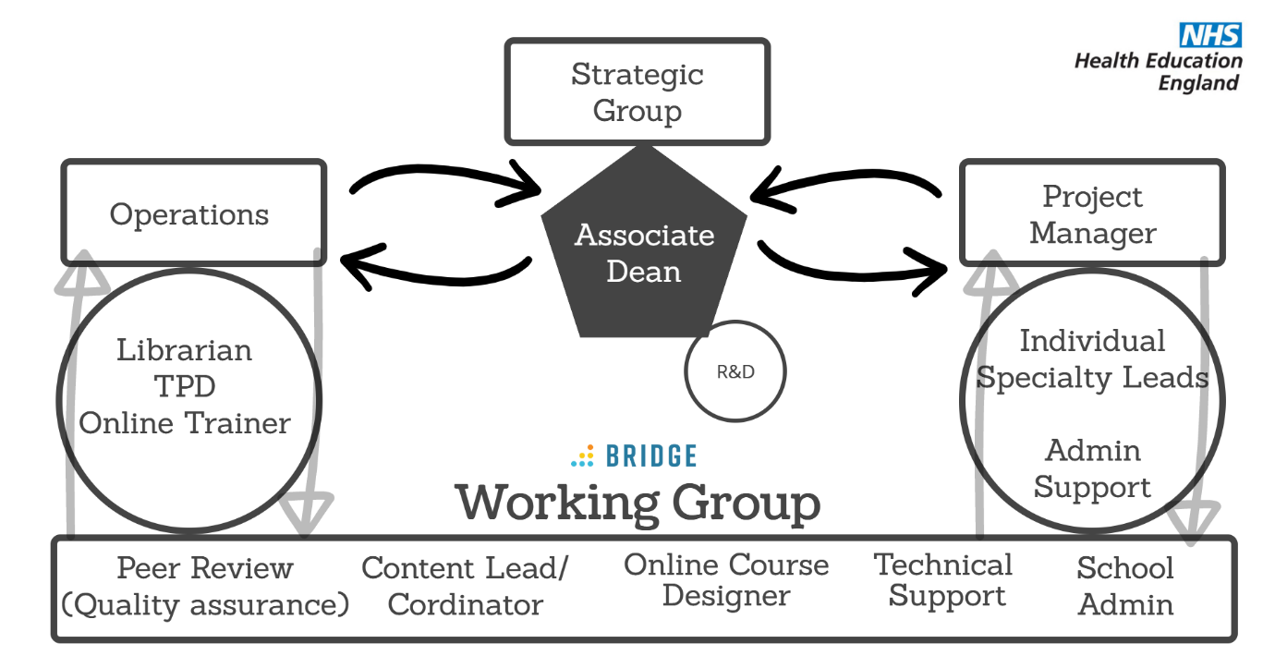

  - Roles and Responsibilities of the Workforce Structure
The Working Group (WG) forms the foundations of the Platform. It consists of a group of Consultants, Trainees and HEE Fellows with specific skills who organise, create and deliver educational events and courses on the platform. It is made up of the following roles listed below with their corresponding desired attributes/skill set:
- Quality Assurance Officer – Coordinates a Peer Review of all online content produced on the platform for their Speciality. Has an Educationalist background with high amounts of subject matter knowledge. Uses the Quality Checklist to ensure all e-learning design best practise principles are followed. Ensures the content is accurate and up to date.
- Content Lead/Coordinator – Contacts subject matter experts, collates all relevant educational content and material from journals/guidelines and writes the main body of content. Think of this role as the “screenplay to the Course”. Requires high subject matter knowledge base, knows when to reach out to sub-speciality subject matter experts. Knows when a to use a live training event i.e. discussion over and above theory. Minimum technological skill required but must understand the principles of Blending learning and the functionality of the platform.
- Online Course designer – Builds and designs online course material on Bridge with the content produced by or with the Content Lead. Confident technologist with high levels of tech initiative. Understand subject topics but does not need high levels of knowledge. Has lots of design flair, willing to incorporate and create interactive pictures/videos that complement but not distract from the main learning objectives. Also willing to experiment with R&D pilots.
- Tech Support – High levels of technological knowledge. A Bridge superuser who can help troubleshoot user problems and/or course design issues. Available to provide additional training for rotating members of the Group.
- School Administrator – Creates a Bridge Live event. Creates Zoom/Teams links and pastes them into Bridge Live event. Attaches Program and schedule to the Bridge Live event. Assigns Groups to the Live events in Bridge. Creates an online feedback form using either the HEE Survey tool or a Google event feedback form. Collates feedback. Audits attendance by exporting live training event data from Bridge.
The Individual Specialty Lead designs an educational program of teaching that is curriculum mapped and consistent with the goals of the Online Platform. The program is usually formed of a combination of Online Courses and Live training events typical of a Blended learning approach, that culminates into a holistic and complete educational experience for trainees. When designing the educational program, they identify curriculum items that form discrete topics which can be made into a Course and/or Live event (Step 1 in Figure 2). They package curriculum items into relevant topics and suggest subject matter experts, within or outside the EOE, that are best placed to teach these programs/courses/events. The Working Group delivers the educational program designed by the Speciality Lead using the Online Platform (Step 2 -4), any webinar and/or Third-Party software packages. This includes training educators/subject matter experts in using webinar packages to deliver lectures using Tech Support.

Individual Specialty Leads Content Sync Meeting:
All Individual Specialty Leads and Online Course Designers should meet every 2 months. During this meeting, Leads should share their learning packages and overviews of what is being delivered. This will help reduce duplicate efforts and help specialties collaborate. If there is duplication across specialities, this may be appropriate (I.e there are specialty specific needs of the course), although should be evaluated by the Specialty Leads.
This is also a chance for Leads to discuss the development of Learning Packages that cross specialities. This facilitates a more joined up approach to education.
There will be a master curriculum matrix that includes all learning packages for each specialty. This allows all Leads to see what has been covered in each specialty schematically.

Figure 2. Working Group and Speciality Lead Workflows – Example 1
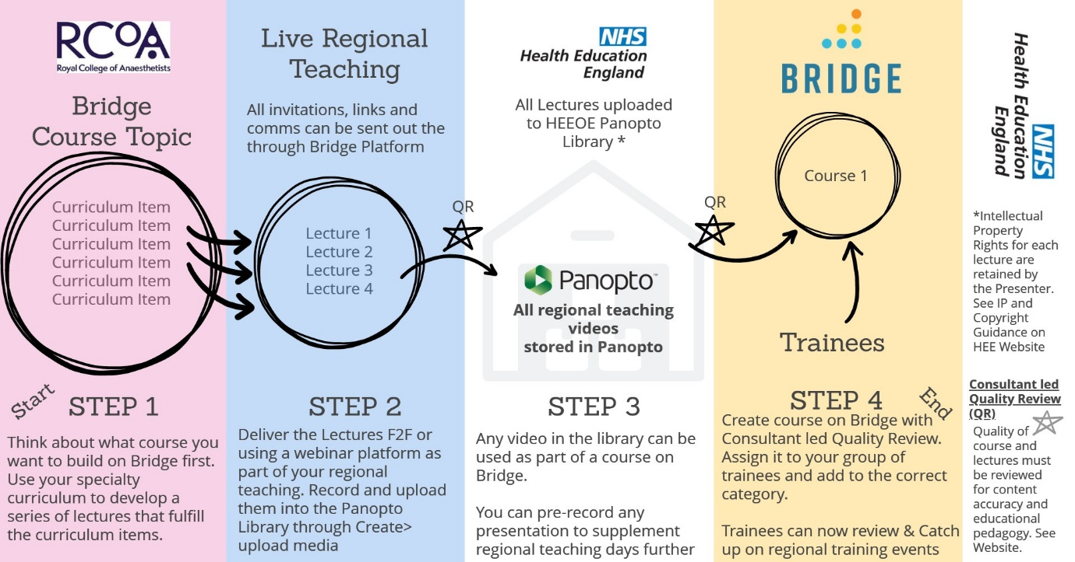
The Operations Group ensures that The Project Leads and Working Group have the tools and resources required to carry out their tasks for the platform. They are also expected to ensure that all users on the platform are updated, in the correct groups and aid smooth transition of data during the “change-over” period. They are expected to facilitate any ongoing training or troubleshooting for users where necessary. This allows The Working Group to focus on delivering high quality education without bureaucratic distraction. It should be noted that any TPD should also be prepared to quality assure educational content over above the quality control lead in The Working Group for their speciality.
Librarian:
- Keeps an index of all video content created on Panopto to help reduce duplication.
- Ensures video content and Bridge Courses are reviewed within time
- Helps promote, organise and source specialty specific webinars that may be held outside the region i.e. if another deanery advertises specialty specific educational events, the Librarian can source the necessary links etc. to promote on Bridge
- Ensures Tagging of content on Bridge is appropriate and consistent.

Online Trainer:
- Trains Online Course Designers on Bridge
- Trains School Admins on how to create events on Bridge and how to upload videos onto Panopto
- Runs regular update events for “How to’s” on Bridge for Authors
- Runs regular update events for how to create video content on Bridge
- Runs courses on how to build basic courses up to Advanced (depending on confidence)
- Trains course creators outside of Course Designers where necessary
- Helps Introduce Specialty Leads and TPDs to Bridge
- Aids in pilots for research and development

Training Programme Director:
- Creates the curriculum matrix and learning packages in conjunction with the Specialty Leads.
- Ensures all curriculum topics have been covered by the Platform over a 3-5-year plan, through a mixture of live events, courses and programs.
- Ensures any new evidence/topic specific evidence or research is updated with the existing modules

The Project Manager
- Metrics
- Review
- Budget
- Procurement
The Associate Dean (AD) overseas and directs the processes above, ensuring that all groups are working towards satisfying the goals of the platform and raises any issues to the Strategic Group, expediently if required. The AD also mediates bilateral, structured, and meaningful communication between the Strategic Group, Project and Operations Managers and The Working Group to keep working relationships effective and dynamic.

Figure 2. The Strategic Group (SG)
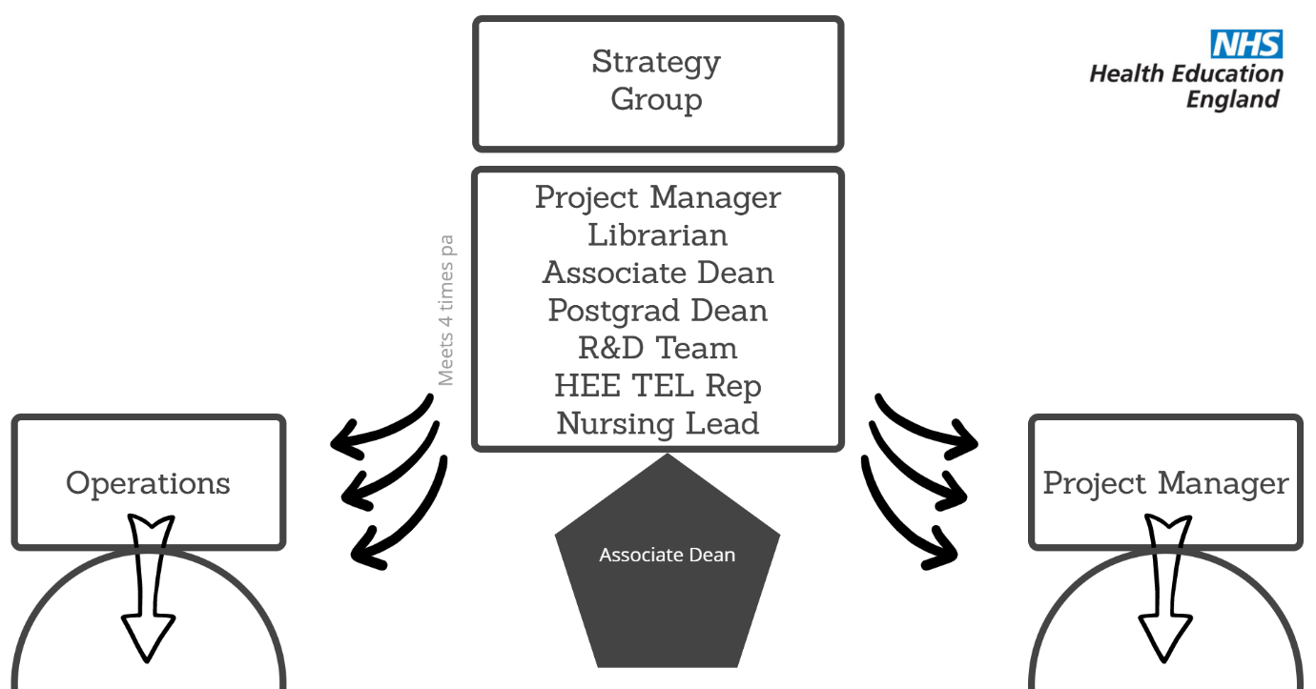

The Strategic Group ensures that the Platform is operating as intended in achieving its short- and long-term goals, specifically
- Ensuring Project and Operations managers have the resources they require to achieve these goals.
- Ensuring the quality of the content is of the highest possible standard.
- Makes decisions surrounding Research and Development potential and direction.
- Keeping the HEE TEL strategy aligned with the regional strategy.
- Resolution of disputes over quality and delivery of educational content.
- Maintaining and reviewing processes that underpin the operational capacity of the platform.
- Identifies areas were workforce recruitment maybe beneficial.
- Its members must be updated on how the platform is performing using the qualitative and quantitative metrics detailed in Section 3.
- Setting up a Strategic Board – four times a year, membership: Deputy Dean, Associate Dean, Education Fellow, HEE TEL, EoE Senior Business Manager, Librarian, Project Manager,
- Updating stakeholders via Annual Reference Group – membership: EoE Dean, Deputy Dean, Education Fellow, Associate Dean, Heads of School, Directors of Medical Education, EoE Senior Business Manager, Librarian, Project Manager, Trainer.

Workforce Meetings Summary:
- Strategic Board – Meets 4 times a year
- Annual Reference Group – Meet once a year
- Specialty Leads Sync – Every other Month

Section 2 – Implementation
2.1 Sequence for each Speciality – 5 Meetings
When a speciality wants to start using the platform, they must go through a 5-step process, made up of 5 meetings with the Speciality Lead, Project Manager and Education Fellow. During these meetings we work through some of the important implementation steps to ensure specialities have the best chance of succeeding in using the platform and creating high quality content.

Meeting 1
Blended Learning Team meets with a speciality lead and discusses the following:
- How the Platform works
- Explains Blended Learning
- Scopes the current resources and Training Program Structure
- Defines the Working Group

Meeting 2
Working Group meeting:
- Explanation of how the platforms work
- Explanation and expectations for each role
- Ensures everyone is happy with their role
- Confirms training session dates and times
- Assigns usernames and logins

Meeting 3
- Training – 1x 90-minute session or 2x 45-minute sessions on ‘How to use Bridge and Panopto’ including:
  - How to create an online course
  - How to create a live training event (webinar/face-to-face)
  - How to use Panopto
  - How to use Zoom/Teams/GoToMeeting/Starleaf
  - How to create a Group
  - How to Assign Learning

Meeting 4
- Curriculum matrix meeting with speciality Leads (Working Group Present)
- How to design a Blended Learning Program from the Curriculum
- Intended first approach discussed with Working Group
- First Attempts of Online content
- Start using the Online Calendar for teaching events

Meeting 5
- Review of First Attempts of Online Content and Curriculum Matrix
- +/- Adjustments – If not Adjustments needed – then assign to group
- Troubleshooting any technical issues

2.2 Curriculum Mapping, the Matrix and Workflows
Developing a Curriculum Matrix is by far the most effective method of coordinating the production of Online Content. This involves Speciality Leads and Content Leads deconstructing the curriculum into a series of learning pathways. Each Learning Pathway is then mapped. It is during this process where speciality and content leads decide whether parts of the learning pathways are delivered through an Online Course or through a live teaching session or a mixture of the two. Subject matter experts can then be consulted to start creating the “script” for each Course and decide on dates where they can give Remote or Face-to-Face lectures. From this point, Live Teaching sessions can be populated on the Platform as far ahead as possible to give trainees the maximum amount of time to make rota adjustments; the 6-week minimum rule still applies. Online Course Designers should be consulted for each Learning Pathway to ensure that the correct media types and programs are being used for the projected purposes.

Learning Packages & Curriculum Mapping Using the Matrix
The Blended Learning Lead for each specialty works with the Training Program Directors (TPDs) to create Curriculum Mapped Learning Packages. These packages are formed of specific topics that contain learning objectives mapped to specialty curricula. One Learning Package includes all the courses, webinars, lectures and articles/guidelines that encompass a range of learning objectives relating to a topic i.e Asthma or Total Intravenous Anaesthesia (below).
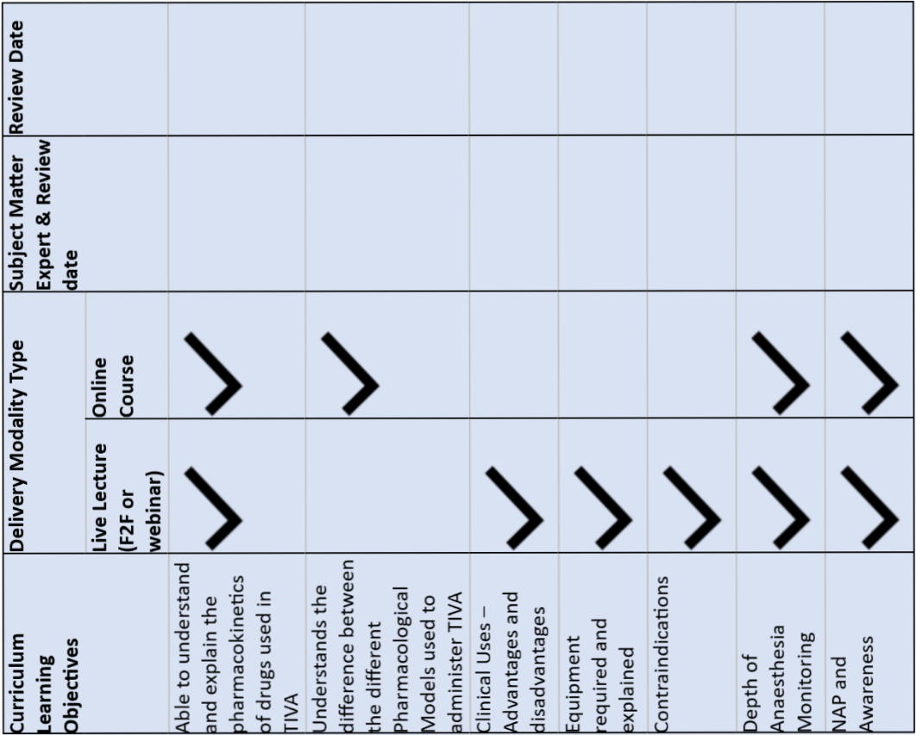
These packages can be created using a Curriculum Matrix that helps map each topic to the teaching modality most suited to that objective. Once the Learning Package is constructed, it is passed down to The Working Group where The Content Lead coordinates the delivery of the educational content using the teaching modalities available through The Platform i.e. Online Courses, Live/Recorded Webinars.
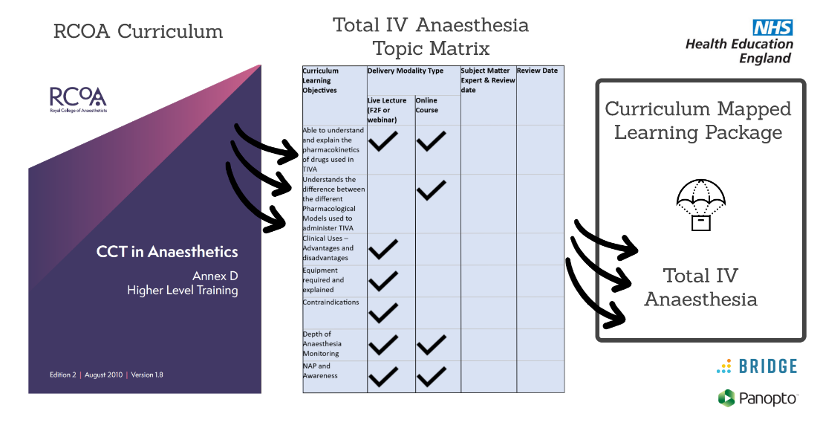
Example Learning Pathway:
Topic: Total Intravenous Anaesthesia (TIVA)

Overall Learning Objectives:
After completing this Learning Pathway Trainee Anaesthetists should be able to:
- Confidently attempt to deliver TIVA to patients using multiple drug combinations and pharmacokinetic models under the supervision of a Consultant Anaesthetist.
- understand when to apply TIVA techniques relevant to the appropriate clinical scenario including its use in Paediatrics

- Understand the different types of equipment required to deliver TIVA (understand TIVA lines, Syringe types, Anti-Syphon Valves and incorrect vs correct set up).
- correctly interpret all types of Depth of Anaesthesia monitoring including its uses and limitations.
- Capable of diagnosing awareness and dealing with patients who may have had an episode of awareness intraoperatively

Blended Learning Matrix - TIVA
Curriculum Learning Objectives | Delivery Modality Type |  | Subject Matter Expert & Review date | Review Date
 | Live Lecture (F2F or webinar) | Online Course
Able to understand and explain the pharmacokinetics of drugs used in TIVA
Understands the difference between the different Pharmacological Models used to administer TIVA
Clinical Uses – Advantages and disadvantages
Equipment required and explained
Contraindications
Depth of Anaesthesia Monitoring
NAP and Awareness

Resulting Learning Pathway - see diagram below
3 x Online Courses covers the following:
- TIVA Pharmacology and Pharmacokinetics – 1 course
- Clinical uses of TIVA – Advantages vs Disadvantages and Contraindications – 1 course
- Equipment overview + Depth of Anaesthesia monitoring – 1 course
3 x Live Training events (Zoom or Face to Face)
- Discussions around the different types of Pharmacokinetic models (Disadvantages and Advantages of each)
- Interpretation of Depth of Anaesthesia monitors
- Dealing with Awareness + NAP take homes

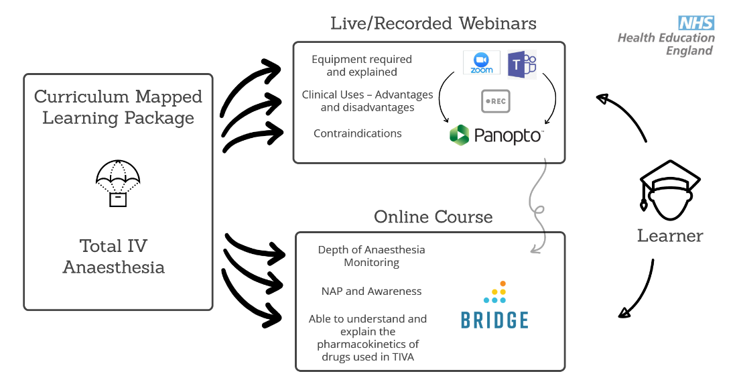

2.3 Standards of Online Content
Assessing the Quality of E-learning Material
Quality of Education is a relative term. The educational experience is unique to each learner. An educational program that is recognised as high quality must fulfil the needs of its learners through curriculum led teaching, effectively satisfying learning objectives whilst supporting an array of learning styles.
A Blended Learning approach gives educators the opportunity to assess the way in which they educate in more detail than ever before. Technology also enables educators to use more varied educational pedagogies to suit the material they are teaching whilst satisfying a variety of learning styles. The checklist below (Interactive version in Appendix A) helps educators and faculty approach the design of their e-learning courses top down by understanding the criteria in which Blended Learning modules are to be assessed against.

Criteria are defined by the four categories below:
- Quality of Content – “Content is King”
- Quality of Educational Delivery/Pedagogy
- Quality of Instructional Design
- Feedback and assessment

Quality of Content – Subspecialty leads – It is important to understand that the success of any platform is determined by the quality of its content. Content is king here.
- Accuracy of content – Content is based on up‐to‐date best practice as advised by experts or opinion leaders in the field and is capable of delivering the programme’s learning objectives.
- Appropriate instructor for the subject matter – evidence provided this is the case.
- Identify and state the target audience.
- Learning objectives based on curriculum and target audience
- Learning objectives satisfied
- Fair and unbiased interpretation of the subject matter

Quality of the Delivery – Educator’s Faculty
  - Appropriate methodology used for the subject matter
  - Expectations of what learners should be do after they have completed the course
  - Varied and engaging resources
  - Relevant articles and hyperlinks included
  - Media types used appropriate and demonstrate the point
  - Course provides activities and questions that allow collaboration
  - Learning objectives stated and not duplicated elsewhere on the Platform

Quality of the Instructional Design – Tech Support Group
  - Course named, assigned TAGS and in Appropriate Category on Bridge
  - Length of the course <1 hr to complete
  - Conflicting interests declared
  - Logical and consistent layout

  - Branding maintained; cover slide included with picture uploaded on cover slide
  - There is evidence that all legal, medico‐legal and ethical considerations are met. These include copyright, patient consent for clinical materials used and data protection
  - All videos embedded with explanation
  - Learning objectives stated at the start of the course
  - Contents page
  - Hyperlinks up to date and Articles embedded appropriately
  - Certificates enabled
  - Learning outcomes summarised at the end of the course
  - Information surrounding how to leave feedback

Feedback and assessment – Educator’s Faculty
Feedback
- Comments enabled on the course
- Survey send out after the course completed
- Any comments or discussions within Bridge and Panopto answered

Assessment
- Quizzes embedded
- Quiz accurately evaluates whether learning outcomes achieved
- If pass mark required for certificate, it is reasonable and achievable based on the content provided

Every course should be part of a narrative. Think of a course as an interactive chapter of a textbook. One small chapter can be a short course, but a large chapter can be split up into multiple courses and then wrapped into a program of learning in Bridge. We have access to numerous Third-Party Applications (see below) that you can use to build break up blocks of text and create interactive pictures, videos and animations that help articulate learning points in a more dynamic and engaging way. Think of them as the pictures and diagrams of your textbook chapter in which learners can interact with to make the online experience more immersive. They form a create way of letting the learner “breathe” after a long block of text or a way of explaining an otherwise overly complicated concept. More information can be found

on Bridge regarding online course design. It is worth thinking about learning point/objective and asking what media type can I use to make this more interactive?
Below are some of the tools available to you - third-party Applications to make more interactive content:
- ThingLink – make any picture, video, 360 video interactive
- Doodly – make a whiteboard animation to explain simple processes or concepts
- Vyond – make any sort of animation (not specific to whiteboard characters)
- Adobe Premiere Pro - Can we make a 360 video?
- Adobe Premiere Pro - Do you need to make a completely new diagram
- Google Images (creative commons filter)
- Articulate 360
The Blended Learning Team can give you access to any of these software packages. We have a limited number of licences for each but more than enough to share.

Section 3 – Training and Admin Support
The Working Group for each Speciality will to be trained on the Bridge and Panopto Platforms. The Working Group will receive training from the HEE Blended Learning Online Trainer through a small series of interactive sessions that are also pre-recorded. These sessions will occur:
- When the Speciality first implements
- If a member of the Group changes
- Quarterly update sessions “drop-in sessions” organised by the HEE Blended Learning Online Trainer
Each Speciality should have a Superuser that is formed of an Educational Fellow and/or Consultant within the working group. This Superuser acts as first line technical support and ongoing training to the group. Should the Superuser need more support they can reach out to the HEE Blended Learning Online Trainer.
The Online Educator is formed of 4 parts, aimed at Course Creators and Content Leads:
- Understanding the platform and how to use Blended Learning (Online Course)
- How to use Panopto and Creating Courses (Live Training Event – Recorded)
- Creating Programs (Live Training Event – Recorded)
- Using Interactive Media in Bridge (how to use ThingLink, Vyond, Doodly) (Live Training Event – Recorded)
- Advanced Instructional Design – How to us Adobe Premiere Pro (requires a personal licence), create 360 videos (Live Training Event – Recorded)

Admin Training and support is formed of two parts and aimed at School Administrators
- How to create Live Training events, feedback forms and collate attendance registers (Live event)
- How to use Panopto (Online Course)
Tech Support – Detailed 1:1 with Online Trainer in Ops Group

Section 4 - Review and Feedback processes
Strategy and Performance
There are two main meetings that evaluate the performance of the Platform:
- Annual Reference Group (EoE Dean, Associate Dean(s) Heads of School, Librarian, Project Manager, Online Trainer, DME’s).
  - Goal is to use the above to ensure Platform is performing to its optimum, user experience is optimised, and content is reviewed. Discusses progress of implementation and expansion plans, progressive ideas, workforce plans.
  - meets 4x pa to discuss the following:
    - Budget
    - Feedback
    - Review of user Feedback and experience, Metrics and Stakeholder opinion
    - Feedback and Metrics (collated twice a year) should be available for two out of the 4 meetings.
- Strategic Board Meeting
  - Goal to determine the overall direction of the platform and R&D.
  - Meets 2xpa
Feedback
User Feedback Surveys should occur twice a year and coordinated through the Project Manager. They should be completed at the end of January and the end of July. This is to ensure that feedback processes do not coincide with clinical change over dates, usually during February and August, to maximise engagement and accurate representation of user experience.
There are three surveys:
- Learners
- Authors/Content Creators
- Administrators

User Metrics
Data is extracted on a twice-yearly basis and coincides with the Feedback surveys ready to be fed back to the Annual Reference Group.

Relevant data required:
- Bridge:
  - Number of User logins
  - Number of enrolled courses
  - Hours of learning achieved by speciality
  - Attendance of Live teaching for each speciality (School Admins to provide)
  - Hours of cross-speciality education
- Panopto:
  - Hours of video storage and usage

Section 5 – Research and Development
R&D opportunities should focus on immersive technologies, new integrations, plug-ins and educational pedagogies that enhance medical education. Horizon scanning is vital to anticipate new technologies and maintain cutting edge applications of technology enhanced education.
The overarching principle is that we should conduct research and development that helps establish the following:
- The most efficacious form of technology enhanced learning and in specific contexts
- Improvements in workforce development in instructional educational design and online learning
- The best user experience in terms of accessibility, clinical relevance, and interactivity

