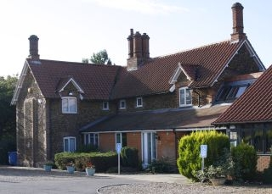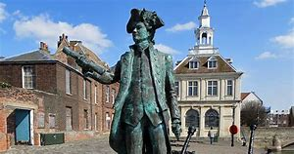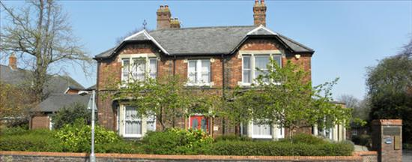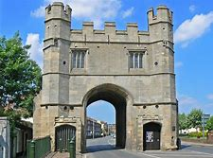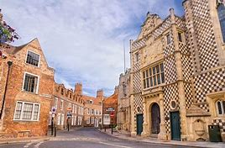

Salaried GP Post Available

**Flexible weekly sessions**

We are looking for an enthusiastic, motivated and dedicated GP to join our well established practices. Southgates & The Woottons Surgeries is split over two sites offering a diverse range of work opportunities. We are a partnership of 11 GPs with 5 salaried GPs working alongside us.

We have a combined list size of over 23,000 patients and provide our services to patients through a team of dedicated Doctors, Nurse Practitioners, Practice Nurses, Health Care Support Workers and a robust and efficient administrative team. The practice also offers minor surgical procedures to the local population and GP led palliative care to a local hospice.

We are a friendly practice and have an established track record in recruiting GP Trainee’s through to partnership. We actively encourage our GPs to pursue their specialisms for the benefit of our patients.

The practice:

Has a dispensing population

Uses SystmOne

Is a training practice for Doctors

Undertakes research

Has a nursing team that supports home visits

Runs PMS and GMS contracts

Has been rated ‘Good’ in all areas from the CQC

Promotes a flexible and supportive working environment

Why not pop in to meet our friendly team, look around our facilities and fantastic surrounding area to see if we are the right surgery for you to practice in. We would love to meet you.

Kings Lynn is a beautiful historical town located in West Norfolk. The town is situated 45 miles from Norwich, 105 miles from London and 36 miles from Peterborough. It has direct rail links to Cambridge and London. There is a wealth of shopping facilities as well as restaurants, public houses and all the usual amenities expected of a market town. There are 3 Secondary Schools and one College all located in the town, plus further Secondary Schools in the surrounding villages. The Royal Estate of Sandringham and the coastal town of Hunstanton are right on the doorstep.

Please feel free to send a copy of your CV to:-

Emma Batchelor – Practice Manager

Southgates and The Woottons Surgeries, 41 Goodwins Road, Kings Lynn, Norfolk, PE30 5QX

The Woottons Surgery, Priory Lane, North Wootton, PE30 3PT

emma.batchelor@nhs.net

Salaried GP Post

Southgates and The Woottons Surgeries

Kings Lynn, Norfolk