HST Regional Training Day 16.08.19 – Endocrine
Norman Pao, EM ST4

Acid Base Disorders (Nikki Yeo, CC CF)
- HAGMA vs NAGMA (high or normal anion gap)
- HAGMA:
  - Renal failure
  - Ketoacidosis
  - Lactic acidosis
  - Toxins
- NAGMA:
  - Saline
  - PN
  - RTA
  - Uretoenterostomy
  - GI loses (diarrhoea/small bowel or pancreatic drainage)
- Lactic acidosos
  - Type A vs B
  - Type A:
    - Reduced supply
    - Increased demand
  - Type B
    - B1: Underlying disease (leukaemia, lymphoma, thiamine def, inf, pancreatitis, renal and liver failure)
    - B2: Drugs ie beta agonists, salicylates,cyanide, ethanol, methanol
    - B3: Inborn errors of metabolism
- Other considerations:
  - Hypoalbuminaemia:
    - Albumin is an anion
    - Low albumin decreases the AG
    - For every 10g/L below normal, add 2.5 to anion gap
  - Delta ratio
    - DR = (increase in anion gap)/(decrease in HCO3)
    - <0.4: associated hyperchloraemia NAGMA
    - 0.4-0.8: consider HAGMA and NAGMA
    - 1-2: uncomplicated HAGMA
    - >2: pre-existing metabolic alkalosis or compensated
  - Causes of low anion gap
    - Increased unmeasured cations
    - Decrease anion
    - Artefactual hyperchloraemia
  - Base excess and tandard base excess
    - Definition: dose of acid or base required to return the pH of the blood sample to 7.4
    - Isolates the metabolic disturbance from the respiratory
  - Causes of metabolic alkalosis
    - Losing or gaining base
    - Ie chronic high co2, gi losses, renal losses, volume contraction, hypochloraemia, hypokalaemia, administration of bases (antacids)
  - Summary of Acid Base assessment
    - Step 1:
      - Acidaemia vs alkalaemia
    - Step 2:
      - Resp vs meta
    - Step 3:
      - HAGMA vs NAGMA
    - Step 4:
      - Bolton formula
      - Winter’s Formula
      - Check degree of compensation
    - Step 5:
      - Determine the delta ratio
      - DR = DG/(24 – bicarb)
      - DG = anion gap -12
      - DR = (anion gap - 12)/(24 - bicarb)
  - Questions 1:
    - 62F, hx multiple bowel sx, severe RA, abdo pain
    - PH 7.22, pO2 98, pCO2 10.0, SpO2 99.6%, Bicarb 4.0, BE -22, Lac 1.4, Na 133, K 5.7, Cl 113, Glu 4.4
    - Anion gap = 21.7 (16 without K, HAGMA)
    - Delta Gap = 9.7
    - Delta Ratio = 0.485 (0.2, associated hyperchloraemia NAGMA)
  - Questions 2:
    - pH 7.04, pO2 60.3, pCO2 5.07, SpO2 95%, Bicarb 10.0, BE -18.0, Lactate 15.0, Na 141, K 2.9, Cl 99, Bicarb 10, Glu 22.4, Urea 4.7, Cr 97, Alb 44
    - AG = 32 HAGMA
    - OsmGap = (2xNa+(BUN/2.8)+Glu/18)+(ethanol/4.6)
    - Purssell equation
  - Question 3
    - 72M abdo pain,n/V, bg T2DM and AF
    - PH 6.98, pO2 12.3, pCO2 4.1, Bicarb 7, BE -22, Lac 14.5, Glu 7.7, Na 146, K 5.3, Cl 103, Cr 711
    - AG = 36
    - DR 1.4, HAGMA
  - Question 4
    - pH 6.92, pO2 10.8, pCO2 9.5, Bicarb 14, Lac 9
  - Question 5
    - 35F, HTN
    - Na 145, K 1.8, Cl 85, Bicarb 40, Ur 3.4, Cr 80, pH 7.56, pO2 11.3, pCO2 6.1, Bicarb 40
    - Primary hyper-aldosteronism
  - Derangedphysiology.com
  - Litfl.com
Paediatric DKA (Nixck Ward, PEM SpR)
- Key to tx is to reduce the risk of cerebral oedema
- BSPED.org.uk dka guideline
- Case 1:
  - 4yo M, 3wk hx of polydypsia and polyuria
  - BM 27, pH 7.2, raised ketones (>3)
  - DKA!
- Case 2:
  - 15yo M, known DM
  - BM 10
  - PH 7.12, Ketone 4
  - DKA! Even if BM no impressive or normal!
- Case 3
  - Ph 7.3, pCO2 2.0
  - High BM, high ketone
  - This is DKA with resp compensation
- Case 4
  - HSS
  - Usually T2DM
  - Marked hyperglycaemia
  - Ketones <3
  - No acidosis
  - Mainstain of treatment is fluids fluids fluids!
  - Assume 15% dehydration
- Initial Mgmt DKA:
  - Severity: dehydration
    - Go by pH
      - pH >7.1 = 5%
        - dry mucous membranes, reduced skin turgor
      - PH <7.1 = 10%
        - Dry mucous + reduced skin turgor + sunken eyes
    - Maintenance fluid:
      - <10kg: 2ml/kg/hr
      - 10-40kg: 1ml/kg/hr
      - But >40kg just do 40ml/hr
      - Neonates may require larger volumes
        - Deficit = % dehydration x weight x 10
      - Rate = (48hr maintenance + deficit – resus fluids given over the first 20ml/kg)/48
    - Initial fluid
      - 0.9% saline with 20mmol K+ in 500ml
- Cerebral oedema:
  - Haedache, agitation, bradycardia, high BP, deteriorating conscious level
  - Hypertonic saline 3% (3-5ml/kg over 10-20min)
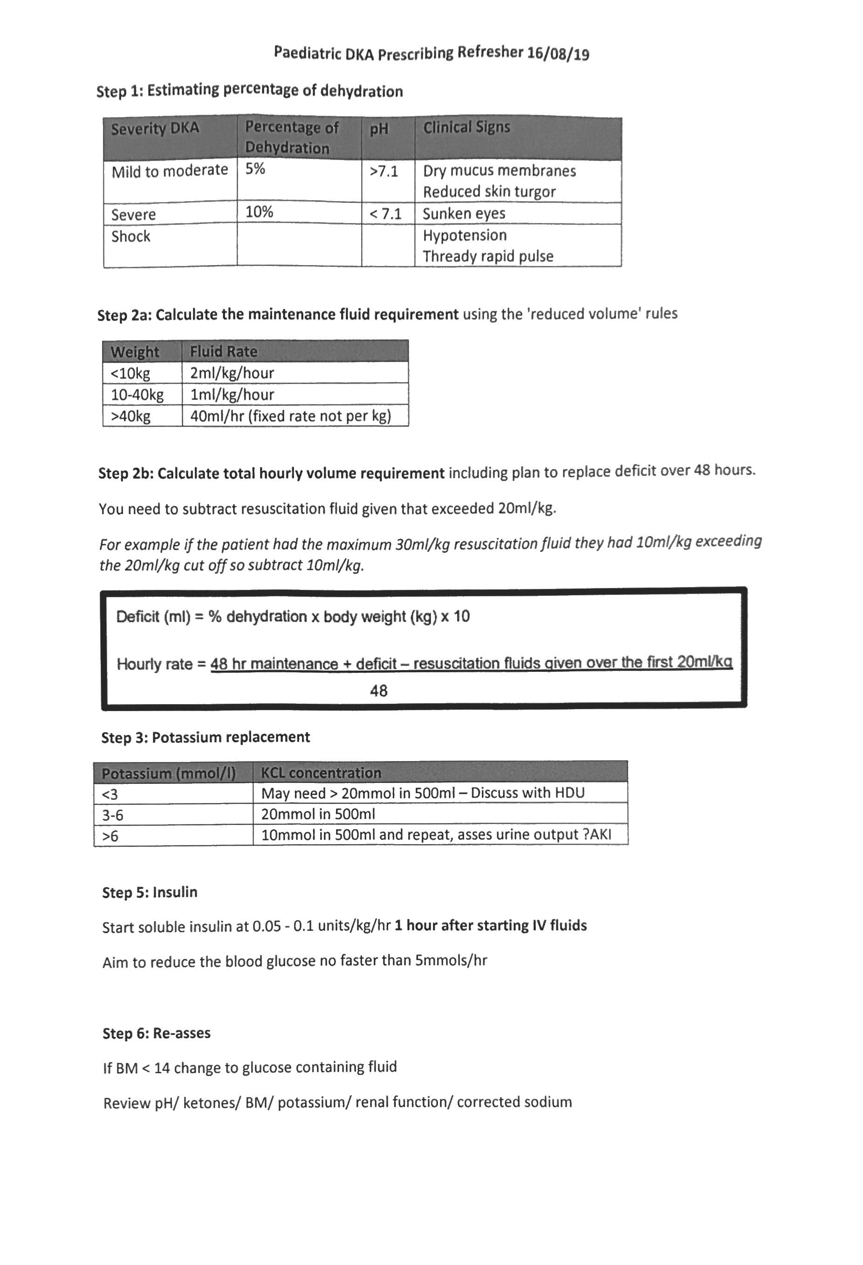
- Call PICU if sick and young (<2)

Prescribing Exercise (Josie Phizacklea)
- Case 1
  - 6yo, 20kg
  - RR35
  - GCS 15
  - PH 7.15
  - Glu 18
  - Ket 4
  - Bicarb 14
  - K 3
  - Deficit 5% (1000ml)
  - Hourly rate = [(20ml/hr x48hr) + 1000ml]/48 = 40.83ml/hr
- Case 2
  - 16yo, 60kg, RR 35, HR 140, BP 60/35, 36 deg
  - Sunken eyes, dry, thready pulse, GCS E3V4M6
  - PH 6.9, Glucose 24, Bicarb 11, Ketone 6, K 4.5
  - Rate = [(40ml/hr x48hr) + 6000ml deficit – 600ml resus]/48hr = 152.5ml/hr
  - Signs of cerebral oedema! 3ml/kg of 2.7% hypertonic saline!

Adrenal and Calcium Emergencies (Dr Ruth Casey, Endocrine Cons)
- Hypercalcaemia – aetiology
  - Primary hyperparathyroidism
  - Malignancy
    - HHM
    - Osteolytic metastases
    - 1,25(OH)2D – dependent ie lymphoma
    - Ectopic PTH
  - Others
    - Sarcoid, Berilyosis, Tb
    - Thyrotoxicosis
    - Etc
- Clinical presentation
  - Bones, stones, psychic moans
  - Commonly asymptomatic
  - Polyuria, polydipsia, constipation, low mood, altered mentition, increased fracture rate, pancreatitis
  - Nausea, vomiting, confusion, coma, arrhythmia, death
- Investigations:
  - Alevated adj Ca
  - Exclude drug cause
  - Measure PTH
    - PTH suppressed: malignancy
    - PTH Normal or elevated
      - Meausre Ca/Cr Cl ratio
      - <0.01 = FHH
      - >0.01 = PHPT
- Case 1:
  - 86F, high Ca. BG: CKD 4, HTN
  - PTH suppressed
  - Diagnosed with Non-Hodkin’s lymphoma and HTLV1-T-Cell leukaemia/lymphoma
- Hypercalcaemia – Mgmt
  - Cases nephrogenic diabetes insipidus
  - Mainstay is IV fluids: 3-6L IV 0.9% NaCl / 24hrs
  - If bisphosphonates are appropriate (after fluid resus)
  - Is definitive therapy indicated? Parathyroidectomy, steroids, chemo/radio/surgery
- Bisphosphonates:
  - Zoledronate, disodium pamidronate, ibandronate
  - Doses will need adjustment accroding to CrCl
- Case 2:
  - 10 days post thyroidectomy and neck dissection for medullary thyroid carcinoma
  - Adj Ca 10.68
  - Parathyroid damaged during surgery
  - Needs IV calcium?
  - Risk stratify: Neck dissection puts into medium risk category for developing significant hypocalcaemia
  - Calcium gluconate:
    - 10-20ml calcium gluconate in 50-100ml 5% dex over 10min
    - Repeat until pt is asymptomatic
    - Then 100ml of 10% CaGlu in 1L or 5% and infuse at 100ml/hr
  - Learning points
    - Aetiology of hypercalcaemia
    - Mgmt of calcium disorders in acute phase
    - Guidelines for hypo and hypercalcaemia
- Case 3
  - 37yo Chinese Female
  - 1 day hx of abdo pain and vomiting
  - Para 2
  - Mild hypertension in recent pregnancy
  - Tachycardic, pale, sweaty,
  - WBC 21.7, Neut 18.6, Hb 143, Na 139, K 3.8, Urea 6.4, Cr 59, CRP 11.1
  - Commenced on metoclopramide, IV fluids, IV augmentin
  - Bilat ground glass changes on CT
  - Left adrenal mass found on left on abdo CT, heterogenous in appearance, ?pheochromocytoma
  - Plasma normetanephrine 10523, Plasma metanephrin 3000
  - Phaeochromocytoma/paraganglioma (PPGL)
  - Phaeo crisis if haemodynamic instability
    - Type A and B depending on severity of instability and number of organ involvement
  - Deteriorates abruptly after returning from CT
    - Lactate 7.1, trop 8744
    - What’s caused it? Metoclopramide? Contrast? Antibiotics?
    - Metoclopramide is a dopamine antagonist and can precipitate crisis!
    - Also beta-agonists, steroids, anaesthetic agents
    - Direct manipulation, trauma, non-adrenal surgery, pregnancy also can cause crisis
    - What should we offer this patient? Cautious alpha blockade and bolus fluid resuscitation. Phenoxybenzamine (24hr half-life), phentolamine has shorter half-life. Beware of shock! This patient also had a cardiomyopathy.
    - Doxazocin and Ca-channel blockers can also be used (no alpha blockers in France)
    - CUHFT PPGL Guidelines available on Merlin
    - Learning points
      - Presentation
      - Precipitants of crisis
      - Acute mgmt
      - Local guidelines
- HPA axis:
  - CRH -> +ACTH -> +Adrogens/aldosterone/Cortisol
  - Cortisol neg feeds back to suppress CRH
- Adrenal insufficiency
  - Primary commonly has hyponatraemia
  - Secondary
    - Steroids either from medical treatment or in anabolic steroid users
    - Don’t tend to get the electrolyte abnormalities that is seen in primary insufficiency
  - Groups at risk:
    - Recent repeated courses, esp if >3weeks
    - Taken a short course within 1yr of stopping long term OCS
    - Received >40mg daily pred or equivalent
    - Received >3 weeks of treatment
  - Synacthen test
    - 250mcg IM or IV at 0900hrs
    - Measure after 30-60 minutes (cortisol)
    - <250 is fail, >400 normal
  - Sick day rules:
    - Temp >37.5, or if need to be off work, then double dose of steroids
    - If vomits within 1hr of taking, then take another dose
    - Diarrhoea, double daily dose
    - General stress – no change
    - Tapering 20/10/10
  - Peri-operative cover
    - Minor sx: double dose on the day, then back to normal
    - Major sx: 100mg hydrocortisone on induction
  - Emergency Pack
    - 100mg hydrocort to be administered IM
    - Have with if travelling
    - Ensure medicine is in date
  - Learning Points
    - Causes of hypoadrenalism
    - Acute management
    - Testing for hypoadrenalism
    - Local policy re sick days, education, etc
HHS and Adult DKA (Dr Vishakha Bansiya, Endocrine Cons)
- Pollev.com/rotacoordina797
- Case 1:
  - 53M, T2DM (dx 35), insulin for past 6 years
  - Chest infections due to fistula between stomach and left hemidiaphragm
  - PH 7.1, bicarb 3.5, pCO2 1.5, BE -23.8, AG 31.5, Glu 9.4 raised ketones 4.9, Na 142, K 4.8, Cl 111.8
  - Is this DKA? Yes!
- Diagnosis
  - Hyperglycaemia: >11mmol/L or known DM
  - Ketosis: > or = to 3
  - Acidosis: < or = to 7.3
- How does DKA develop?
  - Insulin acts as key to the channel to allow glucose to enter cell
  - If no insulin around, the inside of cells does not see the glucose, and goes into starvation mode
  - Protein, fat, and glycogen stores all break down
  - Lypolysis produces the ketosis and ketoacidosis
  - Acidosis without ketones is not DKA
  - Ketosis without acidosis is not DKA
  - But Keto-Acidosis without raised BM, yes this can be DKA!
- SGLT2 inhibitors (eg empagliflozin, canagliflozin)
  - Used in T2DM, soon to be licensed for T1DM
  - SGLT2 channels in the distal segment of proximal tubules
  - Can result in euglycaemic DKA
- DKA monitoring and Tx
  - 0.9% NaCl +/- potassium replacement
  - Fixed rate insulin infusion 0.1unit/kg/hr
- Case 2: HHS
  - 36M, Asian
  - Schizophrenia – on dual antipsychotic
  - 2wk hx of sore throat, generally unwell
  - Found collapsed in room
  - PH 7.07, ketone ‘high,’ haemodynamically unstable, serum osm 411
  - Intubated, inotropes commenced
  - CVVHDF, temp dysregulation, increased acidosis (lactate), increasing inotropic support, decreasing GCS, cardiac arrest and death
  - Mixed picture HHS and DKA
  - HHS – there is enough insulin around to keep lypolysis in check, but eventually if things progress, you can end up with DKA on top of HHS
- HHS Diagnosis
  - Hyperglycaemia > 30mmol/l
  - Hyperosmolarlity > 320mOsm/l
  - AND instability
- HHS Monitoring and Treatment
  - Fluid contraction begins in ICF, then extends to ECF, high concentration of glucose then causes further diuresis, draining ECF.
  - Insulin will drive from already depleted ECF into ICF
  - Fluid resus is important to fill ECF so that above can happen safely, glucose will also fall simply by filling ECF
  - Priority:
    - Primary: safe correction of hyperosmolality
      - Most of the time there is a profound fluid deficit
    - Secondary:
      - Correction of electrolytes
      - Correction of hyperglycaemia
        - Ketones >1.0mmol/l
        - Or glucose plateaus with ongoing adequate fluid replacement
        - Target glucose 10-15mmol/l
        - Fixed rate – 0.05unit/kg/hr
          - You only want to keep lypolysis in check.
  - The point of insulin is to keep a lypolysis in check, and ketones are a good surrogate marker for this

Dealing with a Doctor in Difficulty (Dr Francesca Crawley, Assoc. Dean HEE, Cons Neurologist Guardian of Safe Working)
- There is no straightforward road to success
- Colleagues in difficulty are often hard to recognise
- Trainees can get “pushed through” just because it’s easier
- It’s really important to look out for each other!
- “Tip of the iceberg” –performance on top
  - Things that impact performance
    - Workload
    - Psychological factors
    - Life events
    - Sleep
    - Family pressure
    - Training and education
    - Health issues
    - Cultural factors
- Signs of a struggling colleague:
  - Sick leaves/Tardiness
  - Negativity
  - Temper
  - Withdrawn, or changes to behaviour
  - Concerns about clinical practice and safety
  - Looking unwell
  - Disappearing
  - Being too rigid
  - Slow work rate
  - “Ward rage”
  - “Bypass syndrome”
  - Career problems
  - Insight failure: rejection of constructive criticism, defensiveness, counter-challenge
- Why aren’t these issues tackled earlier?
  - Easy to hide, i.e. choosing who does MSFs
  - Fear of confrontation
  - Fear of retaliation
  - Denial
  - Lack of confidence in skills
  - Cultural issues
  - Lack of “evidence”
  - Desire to rescue or protect
  - Avoidance
  - Frustration
  - Helplessness
- Diagnose, document, and do something!
  - Diagnose:
    - Poor performance is a symptom not a diagnosis
    - Symptoms: knowledge, skills, attitudes
    - Trainee factors: Health, life stresses, sleep, “personality,’ cultural factors, expectations.
    - Environment: Workload, rotas, lack of feedback, wrong level of expertise
    - Trainer: bullying, disorganised, burnt-out, absent
    - Consider symptoms and causes
    - Complicated bits: HR, emplyment law, Discrimination/equality, health and safety, litigation/tribunals, confidentiality, bullying/harassment
  - What is an ideal intervention?
    - Appropriate: address the problem
    - Focused: suits the individual
    - Effective: results in genuine, long lasting change
    - Efficient: requires an acceptable investment of time, money, energy or other resources
    - Measurable: makes a difference that can be quantified
  - Intervention:
    - Involve GP who can sign off if not fit for work
    - Occupational Health
    - Mentoring and coaching
  - Rule 1 of Doing Things Right: Don’t try it on your own
    - Who can help? Clinical supervisor, educational supervisor, college tutor, DME, Medical Director, HR, Deanery (Professional Support and Wellbeing Service), TPD
    - PSW – process
      - Can self refer for exam failure
      - Otherwise, referred by a trainer
      - Referral triaged and assigned a case manager
      - Meeting, generally face to face. Confidential
      - Action points shared with the referrer and TPD
      - Follow-up as required
    - PSW Support Services
      - Exam support
      - Careers support
      - Psychological Support
      - Communication skills support
      - High level occupational health
      - Emotional intelligence testing
      - Signposting to other external services
      - Trainer support
      - Screening, diagnosis and follow on support for neuro-diverse condition (autism)
  - Rule 2 - Record keeping:
    - When writing:
      - Clear, concise, unambiguous
      - Accurate
      - Jargon free
      - Factual and objective
      - Describe sources
      - Separate facts from opinion
      - Focus on behaviour not “personality”
      - Acknowledge good points as well as bade
      - Record in eportfolio
  - Rule 3 – Do something sensible
  - Rule 4 – Recognise your anxieties, but don’t be stopped by them
- Best Practice
  - Document everything, eportfolio
  - Confidentiality
  - Action plan – shared
  - Seek advice and help – you’re not alone
  - Professional/supportive tone

