Report into Progress Form

This form is designed to provide relevant information for a face to face ARCP (Annual Review of Competency Progression) panel when a trainee has been asked to attend that panel for the reasons below.

- The trainee has failed AKT or CSA and is not able to re-take the exam before their CCT date
- The trainee has failed AKT and/or CSA several times – if you feel this is not appropriate, please discuss this with your county Associate Dean or the assessment lead, Janet Rutherford
- Having had an unsatisfactory or refer to panel ESR outcome, the local ARCP panel has reviewed the trainee’s ePortfolio and referred them to a central face to face ARCP panel

Once the ES decides that a face to face ARCP panel is needed, they should inform their local MEC administrator.

Once the local MEC administrator is aware that a trainee needs a face to face ARCP panel, they will ensure that the local Training Programme Directors (TPDs) are aware of this and will also inform the assessment team at HEEofE on heee.assessment@nhs.net, copying in the appropriate associate dean. The local MEC administrator will then complete the pre-panel ePortfolio checks and liaise with the TPDs about who needs to be involved in completing the Report into Progress Form. Meanwhile, the HEEofE assessment team will inform the trainee of the date for the FTP panel and advise them that a Report into Progress is required.

Usually the TPD and the ES +/- Clinical Supervisor (CS) should then complete this form in conjunction with the trainee. Normally the form is completed following a meeting (may be virtual) between the trainee, the ES and the TPD. The TPD should then email the completed form to the Assessment team at heee.assessment@nhs.net copying in the relevant Associate Dean (AD).

We recommend that the TPD makes an Educators Note on the trainee’s ePortfolio summarizing the main contents of this report.

Parts A, B and D should be completed for all trainees whereas Part C is only needed where the trainee might need an extended period of training

Part A – Trainee and Educator Details

Trainee Name: GMC Number:

Clinical Supervisor Name:

Educational Supervisor Name:

TPD name:

Part B – Background and Suggested Plan
,
These boxes will automatically expand when typed into

- Please describe the challenges currently faced by the trainee, including any relevant background information relating to the recruitment process, employment issues, current placements, examination performance, health or social concerns etc.

- Please give a brief overview of what strategies have already been tried and how successful they have been. It would be helpful to hear about any improvement with these strategies so far, the degree of trainee insight, any feedback from recent examination attempts etc

- Please describe the suggested educational plan as well as the likely timescale for implementation

Please indicate if you have any concerns about patient safety Yes/ No

Please indicate if you feel a referral to the PSU would be helpful Yes/No
If so, why?

Please confirm that the potential outcomes of this ARCP have been discussed with the trainee

Yes / No

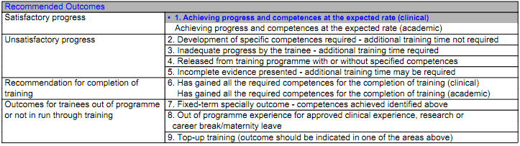

We recommend that the TPD makes an Educators Note on the trainee’s eportfolio summarizing the main contents of this report. However, any sensitive personal information should not be recorded unless the trainee consents to that.

Part C – Application for Extension
This part should be completed where a potential extension to training is being requested. Additional funding is not guaranteed – this would require approval by the GP Dean

Duration of extension requested, please specify if working full time or part-time:

NB Remedial Training Extensions longer than 6 months are rarely granted and only with the express permission of the Postgraduate Dean. This should be considered an exceptional situation and would need to be justified by considerable mitigating evidence.
Proposed dates for this extension:

Where possible, please indicate the name of the GP trainer/practice where this period of extended training will take place:

Do you feel that this placement might require an additional trainer’s grant? If so, why?

NB This would need the express agreement of the GP Dean or Head of GP School and cannot be guaranteed

Part D – Signatures

Trainee:

- I have seen this report:
- I do/do not agree to the content of this report:

(in theory, the trainee doesn’t actually need to agree to the report but they do need to have seen the contents)

I agree to the content of this report (please provide electronic signature where possible)

Educational Supervisor:

TPD:

Associate Dean:

PLEASE RETURN THIS FORM TO heee.assessment@nhs.net, copying in the appropriate Associate Dean

