NHSE WTE&D East of England: Welcoming International Medical Graduates (IMG’s) in their first NHS post, in the East of England (EoE)- A regional guide

CONTENTS | Page
Authors and contributors | 2
Introduction | 3 - 4
Guidance for Trusts  - Prior to IMG arrival  - From arrival- 2 weeks  - 2 weeks- 2 months  - 2 months- 1 year | 5 - 8
Department specific guidance | 9
Audit and guideline revision | 9
Appendices:  Appendix 1-Enhanced gap analysis audit tool  Appendix 2- Exemplars of good Practice  i. West Suffolk Hospital Foundation Trust – IMG Support Group  ii. Charter for new International Medical Graduates at East and North Herts commencing as Locally Employed Doctors (LED’s).  Appendix 3- Link to ‘A new starter guide to East of England handbook for IMG’s’  Appendix 4-Regional Enhanced Induction programme  Appendix 5- Initial and review ES meeting proforma adapted from national guidance. | 10 -16  17-18  19 - 19  20 - 20  21 - 24
References | 25
Authors and Contributors:

Authors:
Lauren Lang | NHSE, East of England, WT&E, Equality, Diversity and Inclusivity (EDI) fellow
Contributors:
Aditi Modi | NHSE, East of England, WT&E, EDI TPD
Malini Prasad | NHSE, East of England, WT&E, EDI Associate Dean
Anshoo Dhelaria | NHSE, East of England, WT&E, EDI TPD
Elizabeth Malaga | NHSE, East of England, WT&E, EDI TPD
Ahmad Khan | NHSE, East of England, WT&E, International recruitment and support fellow

Introduction:

According to the latest GMC workforce report, 30% of all doctors in the UK are International Medical Graduates (IMG’s), who have gained their primary medical qualification overseas and this is projected to continue to rise further in the next decade. 52% of Doctors joining the GMC in 2022 were IMG’s and the GMC have emphasised, in their latest workforce report, how vital it is that the UK continues to attract, integrate and retain these extremely valuable members of the workforce (1). According to the GMC data explorer, there are currently 25,621 doctors on the GMC register in the East of England, 39% (n=10,069) of which are IMG’s. In the East of England, 5,267 complaints were made against doctors, 34% (n=1767) of which were against IMG’s (2). Ethnic Minority staff are likely to experience racism and discrimination and may have poorer experience and progression opportunities (1). NHS Trusts recruit substantial numbers of medical graduates from overseas every year but, unless they are on a national training programme, often expect them to start work without adequate induction. The GMC’s State of Medical Education and Practice report identified as far back as 2011 the need for induction to reduce the higher risk of IMGs being referred for fitness to practice investigation (3).

The GMC has called for a standardised and supportive induction for doctors new to UK practice and in 2022 the joint national guideline ‘Welcoming and valuing International Medical Graduates,’ was published, outlining the minimum standards for induction for IMG’s (3). Using a ‘gap analysis’ tool from the national guideline (appendix 1), the East of England regional global health fellowship team has performed an audit of the induction process in the East of England (EoE) region. Overall, practice across the region was shown to be highly variable. However, overall, the region persistently performed poorly in supporting language and communication skills, providing information about the local area, specialty specific induction and peer support (4).

This guideline aims to provide a framework to ensure that all IMG’s in the EoE have an induction programme designed to support their integration into the NHS and specifically the region. It directs trusts to national and regional services that already exist for IMG induction and how to access them, as well as providing guidance for trusts and trainers to provide a robust induction process for IMG’s. Some region wide resources, including the regional Enhanced Induction programme and ‘a new starter guide to EoE’ are highly recommended for all IMG’s in the region. They help to provide equitable access and uniformity to the induction process, avoid duplication of work across the region, reduce workload for individual trusts and allow several of the minimum requirements for all NHS trusts (appendix 1) to be met, as set out in the national guidance. We recommend that this guideline is used in conjunction with the national guidance and existing local practices to help individual trusts and departments and develop their own practices for onboarding IMG’s. Included in appendix 2 are examples, from 2 trusts in the region, of how implementation of this guideline may look at a trust level.

Who is this guideline for?

IMG refers to all doctors trained overseas, working in the NHS, whether in a training programme or not. Those not in training posts are least likely to receive a robust induction upon starting their new role. Those not in training posts may include but are not limited to Locally Employed Doctors (LED’s) Specialty and Specialist (SAS) doctors, trust doctors, junior and senior clinical fellows and Associate Specialists. This guideline applies to all IMG’s who are new to the UK and the NHS and especially to those not on a recognised training programme. It is written for anyone involved in the recruitment, induction, supervision and support of IMGs, including but not limited to; Trust management, existing IMG/differential attainment/Equality, Diversity and Inclusivity/Ethnic Minorty/BME/culture leads, Medical staffing, recruitment, departmental/SAS/LED leads and Educational Supervisors. Although written to support the onboarding of IMG’s, this guideline would also be highly applicable to International Dental Graduates (IDG’s), particularly those rotating through maxillo-facial posts, who are new to the UK including those locally employed in trusts.

Guidance:

Prior to IMG Arrival- as soon as feasible from the time of conditional offer of appointment:

The trust should:

  - Send all necessary information about the Trust and their department including:

- Job contract- clarity on role, pay, responsibilities
- Human Resources- completion of document checks, references and completion of Disclosure and Barring Service checks. Guidance on arranging accommodation should be given and the IMG should be issued with all the necessary information to arrange accommodation and open a UK bank account.
- Offer and arrange accommodation for at least the first week starting on the day of arrival in the UK.
- Rota-send a work schedule/rota template and rota co-ordinator contact details.

  - Send a copy of the ‘A new Starter Guide to EoE’. (Appendix 3 and available online at https://heeoe.hee.nhs.uk/working-east-england ).

  - Provide a named person within the department whom the doctor can contact if there are any queries. This could be the clinical supervisor, or an administrative assistant.

  - Assign a named buddy and provide the IMG with contact details. (ideally a doctor with at least 1 years’ experience working in the UK, in the same department and with equivalent prior experience)

  - Assign an educational/clinical supervisor and mentor (can be the same person) and provide the IMG with contact details.

The IMG should:

  - Arrange attendance at the regional Enhanced Induction Programme. This can be undertaken remotely via teams and should ideally be done prior to arrival in the UK (Appendix 4).

  - Complete the HEE eLfH :

- ‘NHS national induction programme for International Medical Graduates’ (5) https://www.e-lfh.org.uk/programmes/nhs-induction-programme-for-international-medical-graduates/
- ‘Cultural competence and cultural safety’ modules 01_01 and 01_02 (6) https://www.e-lfh.org.uk/programmes/cultural-competence/

  - Contact their buddy and supervisor/mentor to arrange to meet them when they start their post.

  - Complete the ‘GMC- welcome to the NHS’ workshop online (7). https://www.gmc-uk.org/about/what-we-do-and-why/learning-and-support/workshops-for-doctors/welcome-to-uk-practice This will complement the talks given by the GMC at the regional Enhanced Induction and is especially important for IMG’s who are unable to attend the regional Enhanced Induction prior to arriving in the UK.

  - Arrange indemnity insurance and consider joining a union, to commence at the latest on their first day of employment. Of note, membership to the British Medical Association (BMA) is free for IMG’s for the first year (8). https://www.bma.org.uk/join/join-img-doctors

  - Look through the ‘A new Starter guide to EoE.’ Handbook. https://heeoe.hee.nhs.uk/working-east-england

  - Consider joining the East of England IMG whatsapp group for peer support

  - Complete all pre-employment checks, as requested by the employing trust

The deanery will:
  - Provide ‘A new Starter guide to EoE.’
  - Provide an Enhanced Induction for every IMG that books a place and provide them with a certificate as proof of attendance.
  - Provide a WhatsApp group for IMG’s, offering peer support. This can be joined via the link: https://chat.whatsapp.com/InhoC4xHz819V04BuAoau7

From arrival- 3 weeks:

The trust should:

- Know travel plans for each IMG and ensure that they are met and welcomed upon arrival at the trust.

- Check that the IMG has received a copy of ‘A new Starter guide to EoE,’ and has at least booked, if not attended, the regional enhanced induction programme.

- Provide a general trust induction and IT training of the same standard as that received by doctors in training programmes, as well as a departmental induction appropriate to their grade and specialty. In addition to this:

- Ensure a minimum 2 week supernumerary ‘enhanced shadowing’ period to cover the majority of clinical areas the IMG would be expected to encounter in their role. This should include any out of hours work and ideally should be undertaken with their buddy, prior to starting clinical duties. At the equivalent of registrar level, consider a further 4 weeks of shadowing the on call team prior to joining the on call rota. The nature and time of shadowing should be adjusted to the individual needs of each IMG and discussed at their initial and subsequent supervisor meetings.
- The supervisor should be responsible for assessing the IMG’s competence and confidence to start their clinical duties and help facilitate further support and adjustments to their shadowing as necessary.
- Provide 4 days for IMG’s to shadow other doctors in the use of IT systems. This can be incorporated into the enhanced shadowing period
- Ensure that educational/clinical supervision includes follow-up about their understanding and use of the IT systems, with opportunity to ask questions and improve accuracy
- Provide training on writing discharge summaries and summary care records (particularly on capturing consent conversations)
- Consider providing additional clinical skills induction including but not limited to:

    - Prescribing

      - E-lfh module on Safe Prescribing – (SPB 01) (9) https://portal.e-lfh.org.uk/myElearning/Index?HierarchyId=0_21&programmeId=21
      - Antimicrobial stewardship

    - Managing the deteriorating patient – including sepsis guidelines and clinical scoring systems such as NEWS score
    - Blood transfusion training
    - Venepuncture, IV cannulation, IM injection, arterial puncture and sharps safety.
    - Prescribing, preparation and administration of IV drugs and fluid
    - Urinary catheterisation
    - Performing and interpreting ECG’s
    - Adult and Paediatric BLS and airway management including Bag Valve Mask, airway adjuncts (oropharyngeal and nasopharyngeal) and LMA.

IMG’s should:
- Organise and attend an initial meeting with their educational/clinical supervisor and mentor, using the ES initial meeting form (appendix 5)
- Attend all trust and departmental inductions. Contact educational/clinical supervisor if difficulty accessing these.

3 weeks- 2 months:

The trust should:
- Check that the IMG has attended the regional enhanced induction (evidenced by attendance certificate, met with their educational/clinical supervisor and undergone a minimum period of 2 weeks supernumerary enhanced shadowing in their clinical area (plus an additional 4 weeks of on call shadowing prior to joining an on call rota at ST3+ equivalence).
- Provide ongoing support, tailored to the IMG’s needs, guided by supervision meetings.

IMG’s should:
- Organise and attend a second meeting with their educational/clinical supervisor (1+month after initial meeting) using the review ES meeting proforma (appendix 5)
- Continue working towards completing trust mandatory training in the time frame set out by the individual trust.

2 months- 1 year:
The trust should:
- Provide supervision meetings every month for the first 6 months in post and every 3 months thereafter for the first year.
- Supervisors should continue to assess confidence and competence of the IMG at their current training level equivalence and consider further support or adjustment to work schedules as required. This may also require additional contact with medical staffing/HR.

IMG’s should:
- Liaise with their supervisors to arrange and attend supervision meetings as set out above.
- Continue to work towards relevant specialty specific competencies and PDP goals as discussed with their supervisor and with support from their peer and buddy.
- During the first year, attend communication skills courses and other courses organised by the deanery for IMGs. These are currently under development and more information will follow in updated guidance. The 2 courses likely to be piloted are the STAR (Synergy, Time Management, Art of empathy, Resilience) soft skills course and GMC ‘thriving in the UK’ course, pending approval and funding.

The deanery will:
- Provide updated information on further resources and courses available to IMG’s

Action for Departments:
The national guideline ‘welcoming and valuing International Medical Graduates', has outlined recommendations for specialty specific induction. We would recommend using this guideline, as a guide to help individual departments develop their own enhanced shadowing and supervision for IMG’s in their specialty.

An example from the West Suffolk Foundation Trust of how the trust can ensure individual departments are delivering a specialty appropriate induction, has been provided in appendix 2.

Audit and guideline revision:
Induction for IMG’s across the region will be audited using the national Enhanced Induction gap analysis proforma. Appendix 1 shows the gap analysis proforma, which has been annotated to show which targets can be met using existing regional and national resources and which will remain the responsibility of individual trusts to meet.
There will be a review and update of the guideline 3 months after publication to incorporate feedback and new regional resources. A further gap analysis audit will be conducted by global health fellows in Autumn/winter 2024.
In addition, feedback on induction will be sought from IMG’s following their attendance at the regional enhanced induction programme, with the aim to follow their progress over their first year in the region.
IMG feedback along with results of the gap analysis, will be incorporated into future versions of the guideline, in addition to shaping new and existing regional resources. Guidelines and regional resources should be reviewed annually.

Appendix 1- National guideline- Enhanced induction gap analysis audit tool, completed to show which areas are covered by regional initiatives.

Enhanced Induction - Gap Analysis
Gap-Analysis’ on Trust provisions to implement ‘Welcoming and Valuing IMGs: A guide to induction for IMGs recruited to the NHS’ prepared by Dr Sujesh Bansal, Associate Director of Medical Education, Manchester University NHS Foundation Trust This ‘gap analysis’ document is to support the implementation of ‘Welcoming and Valuing IMGs: A guide to induction for IMGs recruited to the NHS’ in NHS organisations who employ IMGs. The Human Resources, Postgraduate Medical Education Department and Specialties of employing organisation can use this document to do the gap analysis of their ‘current’ provisions for new IMGs vs the guidance document and develop a strategy and action plan on how they will bridge the gap.

Organisation:
Site Lead:
Email Contact:
Welcome and Pastoral Induction | Currently done/not done | Action Plan
Medical Workforce and Human Resources
teams are trained in managing IMG
recruitment and induction with skill and
sensitivity

Considered having a Trust IMG Lead and IMG Office to coordinate the welcome,
induction, supervision, and support of IMGs

Robust recruitment is practised ensuring
right person is recruited to Robust
recruitment is practised ensuring right
person is recruited to Robust recruitment is practiced ensuring right person is recruited to the right post with right skill-mix; with formative development plans identified at the appointment stage for the successful IMGs appointees

Trust has IMG peer buddy network and  Introduces IMGs to peer buddy and a group of other IMG support network | Peer support network provided by regional whatsapp group. Individual trusts to assign a buddy
Provides IMGs with all necessary
information about the Trust and their
department on recruitment

A nominated person meet and greet all new overseas doctors at the place they arrive and take them to their accommodation
Organise accommodation for IMGs for at
least 1st week

Explain the practical support the Trust  has arranged for IMGs, including housing,  banking, salary arrangements, personal IT  and phone contract support, how to obtain  transport, and ensure they are helped to  get utilities. | Covered in ‘a new starter guide to EoE’ handbook
Provide IMGs with all the necessary
documents such as address and salary
details to open UK bank account and
support IMGs in opening bank account
Provide list of local supermarkets, plus  a list of local shops providing a range of  traditional groceries | Covered in ‘a new starter guide to EoE’ handbook
Brief IMGs about the need to register with a GP and provide useful practical information on how to do this, including contact details for local GPs and how to access healthcare in the UK | Covered in ‘a new starter guide to EoE’ handbook
Explain the requirement of registering for  council tax and give practical information to enable IMGs to do this | Covered in ‘a new starter guide to EoE’ handbook
Provide comprehensive and useful  information about IMGs immigration  status (and that for family members where  appropriate) and BRP | Covered in ‘a new starter guide to EoE’ handbook
Provide information to IMGs about how to  facilitate visits by overseas family members | Covered in ‘a new starter guide to EoE’ handbook
Provide information about local religious  resources, education, a guide to the local  area and places of interest, and information about local green spaces | Covered in ‘a new starter guide to EoE’ handbook
Give links to the relevant GMC department  for GMC registration | Covered in ‘a new starter guide to EoE’ handbook
Routinely obtain feedback from IMGs about the induction, within six months, and use that feedback to improve what is provided | Feedback over the first year will be gathered from those attending the regional Enhanced Induction programme
Induction on Professional Medical
Practice in the UK
Ensure that all new IMGs are assigned
supervisor and mentors in the department

ES/IMG meeting checklist is used in
the first meeting to cover all relevant
professional themes new to IMGs
IMGs are informed about online resources  specific for international doctors (hosted on e-Lfh.org.uk) | Covered in ‘a new starter guide to EoE’ handbook
Prioritise LEDs, SAS doctors and those not
on formal training programmes to receive
professional practice induction
Ensure that new overseas doctors attend  a GMC ‘Welcome to UK Practice’ session  at the earliest opportunity, ideally before  starting their clinical duties at the Trust | Covered in regional Enhanced Induction programme
Introduce the GMC’s categories of guidance on ethical medical practice during  induction, to cover core principles and  provide relevant local signposting for each  category Encourage use of GMC resources  tps://www.gmc-uk.org/gmpinaction/ | Covered in regional Enhanced Induction programme
Give all new overseas doctors links to the  GMC material so that they can follow up  their initial induction with further study in  their own time.https://www.gmc-uk.org/ethicalguidance/ethical-guidance-for-doctors | Covered in ‘a new starter guide to EoE’ handbook
There are bespoke sessions for IMGs in  the Trust to train them in using appraisal  platform or e-portfolio | Introduction at Enhanced Induction  Needs reinforcing locally.
Induction on the use of electronic
patient records and other NHS IT
systems
Make IMGs aware of the importance
of using NHS IT systems properly and
accurately, and the rules governing them,
before starting their clinical duties at the
Trust
All new overseas doctors’ training should  include understanding how their effective  use of NHS electronic patient record  systems etc is vital to their meeting the  professional standards of the GMC and  relevant Royal Colleges. Links to those  standards should be provided for them | Covered in ‘a new starter guide to EoE’ handbook
Induction on NHS electronic patient
records and other relevant NHS IT systems
Ensure IMGs are initially trained in how to
use the systems, and given at least four
days to shadow other doctors in their use
Ensure that IMGs’ mentoring and
supervision includes follow-up about their
understanding and use of the systems, with opportunity to ask questions and improve accuracy
Give all new overseas doctors a sound
understanding of
– accurate clinical coding
– how exactly to write an effective
discharge summary
– summary care records; this should
include understanding the expectations
on capturing consent conversations
Speciality Guidance
Shadowing Period with another junior
doctor of same the speciality is provided to
all new IMGs
Exposure in clinical areas which an IMG
might be called to during their clinical work
is provided to all new IMGs
Asking for Help – Lines of responsibilities
are clearly discussed
Speciality specific IT system and specific
software induction provided
Speciality specific medical equipment &
devices training provided
Stress the importance of Multidisciplinary
working
Difference and similarities in the patient
population in UK as compared to overseas
and how it impacts patient care discussed
during supervision
Prescription in the speciality
Regular Educational Supervision
Introduction to Speciality Key personnel
(like Clinical Director, Managers, College
Tutors, Rota-master, Admin Team, MDT)
Informed about Speciality Rota, work
schedule and leave policies of the
department
Introduced to Speciality ePortfolio
Induction on Language and
Communication Skills
Ensure new IMGs have access to online  National Induction programme for  Language and Communication and  recommended resources | Covered in ‘a new starter guide to EoE’ handbook
Provide IMGs with the opportunity to review their language and communication skills, and identify any learning needs with their Supervisors |  | Funding for STAR ((Synergy, Time Management, Art of empathy, Resilience) soft skills course pending approval  Access to further resources under development regionally
Support IMGs’ autonomous, ongoing  language development with follow up  communication skills sessions and to  signpost additional specialist resources as  required | Covered in ‘a new starter guide to EoE’ handbook  Reinforced in supervisor meetings | Access to further resources under development regionally

Appendix 2- Exemplars of good Practice

- West Suffolk Foundation Trust Experience - Establishment of an IMG support group to aid onboarding of IMGs whose first post is within the hospital.
What was done:
      - Enhanced induction
      - IMG group led by IMGs who had been in post for longer. This group provided peer support, educational sessions on negotiating the NHS. It was well received.
      - IMGs were surveyed – 64% said they felt some degree of difficulty in settling into their first post before this intervention.
Benefits:
IMGs found this useful – 93.8% felt that the support group helped improve their overall experience in WSH.
Challenges:
Sustainability as this group is run by IMGs and need to ensure there are motivated doctors to continue the activity.
Top Tips:
Ensure EDI is the golden thread that weaves through all the activities of the trust
Focus on Trainer-Learner relationship
Ensure support is provided to learners and educators

ii. Charter for new IMG’s at East and North Herts NHS trust commencing as Locally Employed Doctors (LED’s)

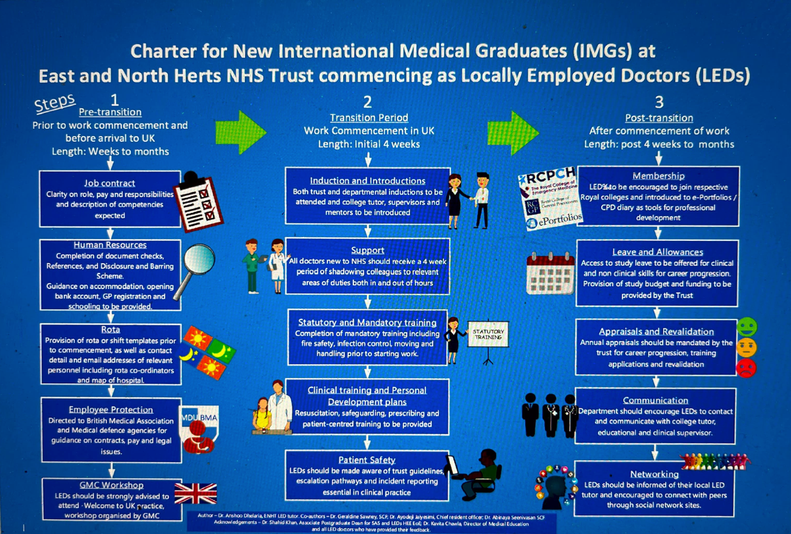

Appendix 3- A new starter guide to East of England handbook for IMG’s

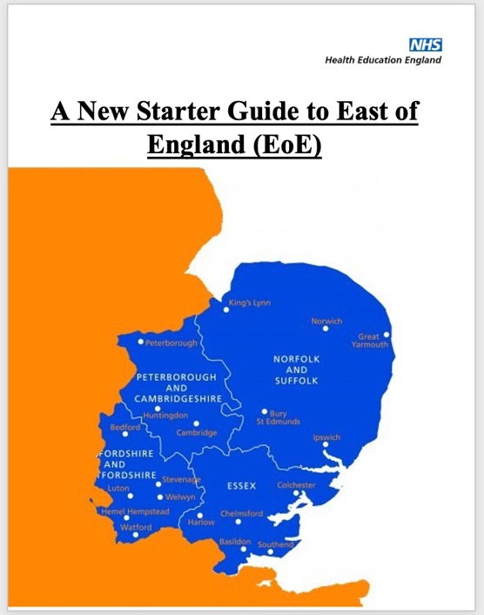

This handbook is also available online at: https://heeoe.hee.nhs.uk/working-east-england

Appendix 4- Regional Enhanced Induction Programme

Enhanced Induction

The EOE region runs a full day of ‘Enhanced Induction’ for all doctors new to the region. This includes both non-trainee and trainee doctors. The aim of the induction was to provide a consistent and effective introduction to the NHS in the region for our international medical graduates no matter which specialty or trust.

Upcoming dates of Enhance Induction in 2024 are below: Email annie.sowinska@esneft.nhs.uk to book your place today.
- 12th March 2024
- 31st July 2024
- 18th September 2024
- 27th November 2024
For more information about the regional Enhanced Induction programme, please contact Annie Sowinska-Global Heallth and International recruitment lead, NHSE annie.sowinska@esneft.nhs.uk

Appendix 5- Initial and review ES meeting proforma from national guidance

Initial ES meeting Checklist for new IMG Doctors
This checklist aims to support IMG doctors who are either newly arrived in the UK or have been working in the UK for less than 12 months. This Checklist should be used by the Educational Supervisor (appointed by the employing Trust) at their first meeting with the IMG trainee/locally employed doctor. This checklist covers areas of specific needs of new IMGs, as per feedback from previous IMGs and experienced educational supervisors. It is expected that this checklist will act as a driver for new international doctors to engage in focussed discussions with their educational supervisors, to build professional development plans and to undertake additional training to address their learning needs.

It is the responsibility of IMG doctor upload this checklist on their ePortfolio/appraisal platform

Name of IMG/International Doctor
UK Address
Name of the base Hospital/Surgery
Date of starting Job
Planned date of finishing post /last date of visa (if applicable)
Name of Educational Supervisor
Name of IMG Lead or contact person in PGMED
Name of Clinical Director
Date of this meeting
Does the trainee need advice re any practical issues (housing, bank etc)?
Welcoming & Valuing IMG NHS Induction programme discussed including language & communication induction
GMC’s Welcome to UK Practice booked
eLearning resources on eLfH.org.uk discussed
Departmental Induction discussed / completed
Trust’s Mandatory Training Discussed / completed & access to learning hub
Peer Buddy offered & allocated (Name)
AoMRC’s MTI Starter Form completed (if applicable)
Membership of medical defence organisation
IMG handbook provided
Previous Experience
Does the trainee have any concerns about their work?
Shadowing & supernumerary period agreed followed by ES meeting
Immediate supernumerary exposure required in which areas?

Review ES Meeting Checklist for new IMG Doctors:

Review Meeting | Review date:
Settling in the UK:
Welcoming & Valuing IMG NHS Induction guidance discussed
Personal & Family settling ok? Social networks
Professional networks Peer Buddy Support
Any further support needed
Wellbeing:
How have you been over the past month/since our last meeting?
Any reasons for how you have been feeling and would you like to discuss them?
Progress:
What has gone well?
What has gone not so well?
Are you staying up to date with your e-portfolio, WPBA, exam preparation?
(Review of ePortfolio done)
Objectives:
How you are progressing against your objectives/PDP? Do they need amending?
Should more support be made available?
(Review of Learning Objectives from the last ES meeting)
Recognition:
Have you had any successes you would like to share?
Have you recognised great work being carried out by a colleague?
Feedback:
Have you received any feedback form your colleagues or supervisors?
Do you have any feedback about your colleagues/ placement/supervisors?
Do you have any issues or concerns about your workload? Are you happy with your current placement?
(Review of 360/MSF – date completed)
Concerns:  Any concerns raised regarding performance as a GMC registered doctor (Needs to be escalated to IMG Lead, CD & Programme Lead)  Any other ongoing concerns (details)  Any remediation action required/undertaken Support offered? | Yes (details)/No

References:

- GMC (2023), The state of medical education and practice in the UK, workforce report. Available at: https://www.gmc-uk.org/-/media/documents/workforce-report-2023-full-report_pdf-103569478.pdf (Accessed: 14 March 2024)

- GMC (2024), Data explorer. Available at: https://gde.gmc-uk.org/the-register/register-by-uk-map/licensed-doctors-by-nhs-region (Accessed 13 March 2024)

- NHS International Medical Graduates Induction Programme Development Group 2018 (2022), Welcoming and valuing Intenrational Medical Graduates, a guide to induction for IMG’s recruited to the NHS. Available at: https://www.e-lfh.org.uk/wp-content/uploads/2022/06/Welcoming-and-Valuing-International-Medical-Graduates-A-guide-to-induction-for-IMGs-WEB.pdf (Accessed 14 March 2024)

- Osuafor, C (2023), Gap analysis across East of England. Available at: Chris Osuafor Gap Analysis across East of England 11.10.2023 copy.pptx (Accessed 14 March 2024)

NHS England, elearning module: Introduction to the National Induction for IMGs. Available at: https://www.e-lfh.org.uk/programmes/nhs-induction-programme-for-international-medical-graduates/ (Accessed 14 March 2024)

- NHS England, Cultural competence and cultural safety. Available at: https://www.e-lfh.org.uk/programmes/cultural-competence/ (Accessed 14 March 2024)

- GMC (2024), Welcome to UK practice. Available at: https://www.gmc-uk.org/about/what-we-do-and-why/learning-and-support/workshops-for-doctors/welcome-to-uk-practice (Accessed 14 March 2024)

- BMA (2024), join IMG doctors. Available at: https://www.bma.org.uk/join/join-img-doctors (Accessed 14 March 2024)

- NHS England e learning for healthcare. Safe prescribing. Available at: https://portal.e-lfh.org.uk/myElearning/Index?HierarchyId=0_21&programmeId=21 (Accessed 14 March 2024)

