Professional Support Unit

2-4 Victoria House
Capital Park
Fulbourn
Cambridge
CB21 5XB

PSU.eoe@hee.nhs.uk

Professional Support for Doctors in Training

Guidance and support for trainees and trainers

Professional Support for Doctors in Training

- Introduction

Almost all medical and dental trainees will complete their training years meeting educational standards and performing their role without any concerns being expressed about their training. However there may be situations where a trainee’s progress gives cause for concern, and this guidance is intended to provide a practical overview of professional support for such trainees.

This guidance is applicable to all Foundation and Specialty trainees appointed to programmes within Health Education England, East of England (HEE, EoE). For Foundation Trainees please also consult Managing Foundation Trainees with Differing Needs.

This guidance:-

- seeks to ensure that there are effective and fair procedures for identifying, managing and supporting trainees giving cause for concern
- highlights the importance of clear, contemporaneous documentation
- provides details on where additional support and help can be sought throughout the process
- clarifies roles and responsibilities
- places patient safety first but also recognises the principles of acting confidentially, fairly and in a supportive manner for both trainees and trainers.

Those involved in supporting trainees should read:

- Section 7 of the Gold Guide particularly paragraphs 7.22, 7.23, 7.35, 7.44 and 7.45.
http://www.gmc-uk.org/education/undergraduate/15_6_provisions_of_the_gold_guide.asp
- The NACT Document: Managing Trainees in Difficulty

Please find the roles and responsibilities of the organisations and individuals concerned in Appendix 1.

- Process for Management of a Trainee giving Cause for Concern

Since the introduction of Personal Development Plans, appraisal, annual assessment, learning agreements and clinical governance there has been an increase in the number of doctors struggling to achieve their goals within the expected timescale. There are also a small number of doctors who have serious and longer term professional concerns.

Identification of concern

It is the responsibility of the Clinical Supervisor (CS) and other colleagues with whom the trainee is working to identify early warning signs of a trainee with professional concerns and report these to the Educational Supervisor (ES) / Training Programme Director (TPD) immediately to reduce risk to patient safety.

The causes for poor performance vary widely but key areas include:

- Clinical performance (knowledge, skills, communication):
- Low standard of work, for example, frequent mistakes, inability to cope with instructions
- Lack of awareness of required standards
- Acting outside limits of competence
- Personality and behavioral issues: (professionalism, attitudes to patients/colleagues)
- Sickness / ill health
- Life events (bereavement, family and personal problems)
- Environmental issues: (organisational, workload, available training, bullying and harassment)
- Lack of engagement with education and training
Seven ‘Early Warning Signs’

The ‘Disappearing Act’ not answering bleeps; disappearing between clinic and ward; lateness; frequent sick leave.

Low work rate slowness in doing procedures, clerking patients, dictating letters, making decisions; arriving early, leaving late and still not achieving a reasonable workload.

‘Ward Rage’ bursts of temper; shouting matches; real or imagined slights.

Rigidity poor tolerance of ambiguity; inability to compromise; difficulty prioritising; inappropriate ‘whistle blowing’.

‘Bypass Syndrome’ junior colleagues or nurses find ways to avoid seeking the doctor’s opinion or help.

Career problems difficulty with exams; uncertainty about career choice; disillusionment with medicine.

Insight failure rejection of constructive criticism; defensiveness; counter-challenge.

Paice E (2006)

Classifying the Scale of Concern

The scale of concern for a trainee will vary. The Educational Supervisor and Clinical Supervisor, usually with the TPD in the case of GP specialty trainees (GPST), will meet with the trainee in the first instance to classify the concern from level 1 (low level) to level 3 (high level).

Level 1  Low Level Concerns | Level 2  Intermediate Level | Level 3  High Level Concerns
Repeated Incidents / Inability to resolve  Non-attendance at educational programme  Educational portfolio not up to date  Some incidents of arriving late  Unavailable on occasions when bleep required | Serious Untoward Incidents  Undue absence from the workplace  Complaints from patients, relatives or healthcare professionals  Poor performance in the workplace clinically, managerially or inter-personally.  Failure to engage in the educational process  Erratic behaviour or issues around bullying or harassment.

Different problems will require differing solutions. For example, ill health will require the involvement of occupational health and / or the trainee’s GP; while unprofessional behaviour may require supportive mentoring, close clinical supervision and feedback to address and change the beliefs behind the undesired behaviour or may involve disciplinary action by the employing authority / referral to the GMC.

In all instances it is also essential that local processes for managing doctors requiring professional support are followed, and advice from Human Resources and Occupational Health is sought early.

It is essential that facts are gathered and communicated to the trainee in a supportive, open way. It is recommended that this occurs in progress review meetings with the trainee’s Educational Supervisor. Meetings must be documented with a copy sent to the trainee.

Overview of Process

The flowchart below gives an overview of processes across the three levels of concern. The trainee may enter the process at any level and may move between levels, particularly needing escalation if there are repeated incidents or the issues remain unresolved. Early recognition of concerns can help to avoid the need for escalation.

The ARCP process is the regulatory framework for assessment of progress in training and may trigger the requirement for additional support, escalate the level of concern, or be informed by processes put in place to provide support for a trainee who is giving cause for concern.

All information concerning sharing of information about progress or conduct of a trainee will be dealt with through the Transfer of Information policy.

(Reproduced with kind permission of Wessex HEE)
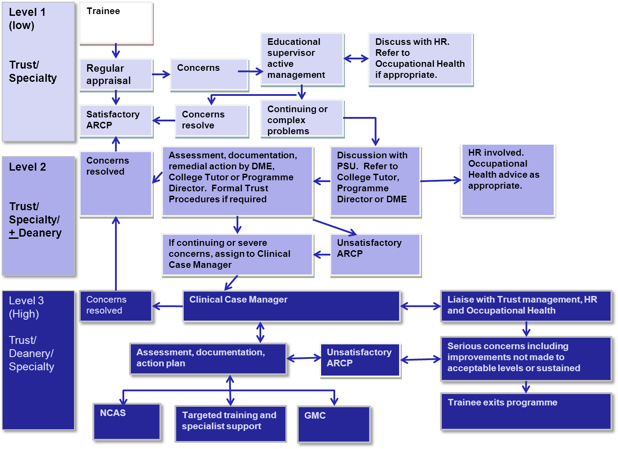

- Principles of Support

Regardless of the level of concern, the following set out the principles for professional support:

- Transparent and understood by all
- Evidence based
- Clear criteria for assessment and decisions
- Consistent application of guidelines and process
- A culture of support and development
- No compromise on patient care
- Responsible use of funding and resources

Level 1 Concerns

Where concerns are of a low level nature, the Educational and Clinical Supervisor, or for GPST in conjunction with the TPD, should discuss these with the trainee and document the discussion by completing the Professional Support Framework (Form 2). Information regarding the concern and resolution must be recorded in the Educational Supervisor’s report.

With early intervention, low level concerns will be resolved without further escalation. Where appropriate, careers support and/or input from Occupational Health may be of benefit However any concerns, even if resolved, should be documented and communicated through the Educational Supervisor’s report and e-portfolio for consideration by the trainee’s next ARCP panel.

If the issue cannot be resolved informally the concern will be escalated to an intermediate or high level concern.

Level 2 / Level 3 Concerns

Where concerns are of an intermediate or serious nature, there should be an escalation of approach within both the Trust and the Postgraduate School (Foundation or Specialty). The Professional Support Framework (Form 2) can be used to guide review and discussion with the trainee, and an action plan with timescales and measurable objectives should be put in place. Further review to assess progress should be planned.

In addition, the Professional Support Unit should be notified using a Professional Support Unit Referral Form (Form 1). This will normally be undertaken by a Training Programme Director or Head of School, but may also be from an educational supervisor. The form may be completed electronically, or during a phone discussion, but the trainee must be notified that the referral is being undertaken.

- Referrals to the Professional Support Unit

The Professional Support Unit (PSU) aims to provide expertise, a consistency of approach, additional support for trainees and trainers, and access to resources. The PSU is led by the Deputy Dean with responsibility for Professional Support, and a Senior HEE, EoE Manager, working with a Case Co-ordinator, who will provide administrative support and co-ordinate the process, and a team of “Clinical Case Managers”. These are drawn from senior educators across HEE, EoE and from different specialty backgrounds with experience of trainee support, and they will have undergone specific training and a programme of on-going support and development.

Referrals to the PSU (see flowchart below) will be triaged and advice may be given, particularly for Level 2 concerns. For all referrals, the PSU will request that a Professional Support Framework (Forms 1 & 2) are completed. If the framework is not filled incorrectly, referrals will not be processed. Following triage and where appropriate, the PSU will undertake a further process of review and development of an action plan. The trainee will be assigned a Clinical Case Manager, and will be invited to a meeting to discuss the concerns raised. An example of items discussed in these review meetings can be seen in Appendix 2.

We currently do not accept self-referrals however; in cases where Exam failure is the only concern, a separate process may be followed (Appendix 3).

Professional Support Unit (PSU) Referral Flowchart

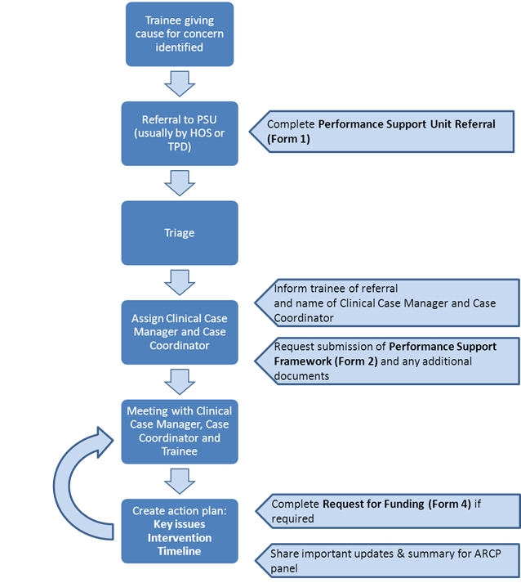

A report and an action plan should be implemented and communicated to the trainee, the Training Programme Director, the relevant College Tutor, Clinical Tutor, GP Associate Dean and HR where relevant. An action plan should be developed against clearly defined measurable outcomes and timescales in consultation with the trainee. Further meetings should be scheduled to review progress.

All documentation will be shared with the trainee, who will be given opportunity to comment before wider distribution. The trainee should be informed of the distribution list for meeting notes, reports and action plans. Some documentation such as OH reports may be highly confidential and should not be distributed without the explicit permission of the trainee.

The CCM, working closely with the supervising educational faculty, should consider if additional support from specialist services should be sought at this stage. If appropriate, the employing organisation’s disciplinary or serious untoward incident policy will be followed alongside HEE, EoE policies such as the ARCP policy. HEE, EoE may also refer the trainee to the GMC and / or NCAS if this has not already been undertaken by the Local Education Provider.

Additional support may include:

- Careers support
- A recommendation for less than full time training or a supernumerary placement
- Occupational health and /or specialist referral. (HEE, EoE will where possible provide additional resource to support recommendations, and this can be accessed through a funding request (Form 4)).
- Psychological support
- Communication Skills
- Dyslexia screening and/or a referral to an Educational Psychologist
- Individual Exam Skills coaching
- Group Exam Support Workshops

- The PSU and the ARCP process

The ARCP process is the regulatory framework to assess progression in training and may inform referral to the PSU or require feedback from the PSU. However, the PSU will follow processes that are undertaken outside of this regulatory framework. Copies of all PSU documentation will be kept in a confidential file and will remain separate from the ARCP process. However, a summary document from the PSU will normally be provided to inform the ARCP panel.

If an unsatisfactory ARCP outcome is thought to be possible, the trainee must be informed and all documentation shared with the trainee prior to the ARCP panel hearing. Please follow HEE, EoE’s ARCP policy. An unsatisfactory ARCP outcome may lead to a period of targeted training or a requirement to undergo a defined further period of training in addition to other supportive measures.

- Quality Assurance

The Professional Support Reference Group (under review) will:

- Shape HEE, EoE framework for Professional Support.
- Ensure that the interests of all parties are met by the framework.
- Validate and quality assure the work of HEE, EoE in this area.
- Undertake an annual review of HEE, EoE policies that may relate to professional support.
- Provide a final report and action plan for HEE, EoE Quality Operational Group.

- EQUALITY ACT 2010

Health Education East of England (HEE, EoE) is committed to equality and diversity within the organisation and this policy is in line with the Equality Act 2010. HEE, EoE will ensure that the application of any part of this policy does not discriminate, either directly or indirectly, against anyone on the grounds of race, disability, sex, gender reassignment, sexual orientation, religion or belief, age, pregnancy or maternity, marriage or civil partnership.

Form 1
Form 2

Form 3

Document History
Version | Date | Remarks
1.0 | July 2010 | First draft JH, AB JW SA
1.1 | July 2010 | Revision and second draft involving HoS representatives
1.2 | Sept 2010 | Second draft discussed with Clinical Tutors
1.3 | October 2010 | Third draft including Eversheds comments (KR and SS)
1.4 | December 2010 | Fourth draft AB, KR
1.5 | January 2011 | Final draft AB, KR
1.6 | March 2011 | Final version
1.7 | November 2012 | Review and amendments AB, KR
1.8 | December 2012 | Amendments AB, KR
1.9 | November 2013 | Amendments AB, KR
1.10 | January 2014 | Amendments (formatting) KP
1.11 | December 2015 | Amendments KP
2.0 | January 2017 | Amendments AB, KB, RW

Appendix 1

Roles and responsibilities

All staff involved with managing TIDs should have undergone Equality & Diversity training within the past 3 years.

Trainee

- As a registered medical practitioner, the trainee has an individual responsibility to practice and abide by the principles enshrined in “Good Medical Practice” and all other GMC Guidance for doctors.

- As an employee of a NHS body (a Trust or General Practice), the trainee has a contractual relationship with his / her employer and is subject to local and national terms and conditions of employment. This will include compliance with clinical accountability and governance frameworks in addition to the employer’s HR policies and procedures.

- As members of a training programme, trainees have a responsibility to fully engage with the educational process at all stages of their training, including taking the initiative to seek help and guidance from their local education provider (LEP) and / or HEE, EoE if they become aware they are experiencing difficulty. The trainee is also required to complete and provide the necessary evidence to demonstrate their progress through the training programme and the acquisition of the required skills and competencies, including Workplace Based Assessments, and to maintain their training portfolio.

- Trainees should inform their training programme director and where relevant, their employer if they are the subject of a formal complaint, involved in a serious untoward incident or if they are referred to the GMC. Similarly, if HEE, EoE or employing body receives information from the GMC concerning a trainee, they should inform the trainee and his / her employer.

The Employer / Local Education Provider (LEP)

- The employing organisation must ensure that employment laws are upheld and employer responsibilities implemented through robust policies and procedures. They are directly responsible for the management of performance and disciplinary matters, and for ensuring that issues identified are addressed in a proportionate, timely and objective way. LEPs should have well developed processes covering clinical governance and the identification, support and management of doctors whose conduct, health or performance is giving rise for concern.

- Employing organisations also have a contractual responsibility to provide Practice / Trust and Departmental induction, appraisal, assessment, counselling and pastoral care for doctors in training as well as Occupational Health services as detailed in Appendix 6a of the Local Development Agreement (LDA) between the LEP and Health Education East of England and the Quality Management Framework for PGMDE.

- Within the employer, Clinical or Educational Supervisors, the Foundation Training Programme Directors, and / or Clinical Tutor/Director of Medical Education may be involved in the identification, support and management of a trainee in difficulty. For this reason it is imperative that employers in partnership with HEE, EoE ensure that these individuals receive adequate training in the management of TIDs.

This training should emphasise that it is one of the duties of a Doctor to act without delay if they have good reason to believe that a colleague may be putting patients at risk. In addition, LEPs should develop a culture where trainers know that if they have serious concerns about a trainee
        - They will be expected to formally document these
        - They will be supported if they do so.

- Educational Supervisors / College Tutors must also inform the TPD immediately of any trainee whose performance they deem to be sufficiently impaired as to lead to the possible award of an adverse ARCP outcome
- When a trainee in difficulty is identified the LEP is required to carry out an immediate risk assessment to ensure patient safety. If it is felt that there is a significant risk to patients, the trainee, the trainee’s colleagues, the LEP or HEE, EoE, the trainee’s duties should be modified in order to reduce that risk; this may involve removing the trainee from the clinical environment

- Additional local support for both the trainee and the trainee’s supervisors should also be provided as appropriate by College Tutors, Clinical, Practice and General Managers, Human Resources Departments, Occupational Health departments and the Medical Director of the Trust or Primary Care Trust (PCT) or equivalent.

- LEPs are required to inform HEE, EoE of any instance involving a trainee that leads to the employer undertaking any investigation into the conduct of a trainee and any disciplinary actions taken including serious untoward incidents and referrals to NCAS or the GMC. In the case of a GP specialty trainee (GPST) they must also inform the PCT.

Health Education East of England
HEE, EoE is responsible for ensuring the quality management of postgraduate medical education to the standards determined by the GMC and to have systems in place to respond quickly to any concerns raised.

HEE, EoE has structures and processes in place for educational governance and operational educational frameworks led by the TPDs overseen by local Postgraduate Schools Boards under the supervision and guidance of Heads of School, the Associate Deans and the Postgraduate Dean / Postgraduate GP Dean.

- Advice from within the Speciality must be available for trainers and will generally be provided through the relevant Training Programme Director (TPD) who is likely to also arrange to interview the trainee. Specialty TPDs will be supported in their role by the Head of School / Lead for Trainees in Difficulty of the appropriate Specialty School and / or the Specialty Associate Dean. The latter should be included in all information transfer regarding such matters.

- Whenever there is a need for HEE, EoE to initiate additional educational support over and above that required in a typical programme an appropriate action plan will be developed, usually in cooperation with the trainee concerned. Records of all meetings must be contemporaneous and accurate; all parties should agree these records.

A plan may involve a multi-professional approach although the Postgraduate Dean/GP Dean will maintain responsibility for the coordination of the educational provision for the trainee. As necessary the delivery of this plan will usually be supervised through the TPD and monitored through the local Postgraduate Specialty School. HEE, EoE will keep the relevant Medical Director and Clinical Tutor informed of any matters of relevance to the employer/PCT/Trust pertaining to a trainee in difficulty.

HEE, EoE is also responsible for trainer development. Training to support the management of TIDs is provided within HEE, EoE Faculty Development programme. Specialty Associate Deans are also available to give advice to all those involved in this process and to help arrange further advice and support for trainees in difficulty and their trainers / supervisors.

National Clinical Assessment Service (NCAS)

The NCAS as part of the National Patient Safety Agency can offer specialist expertise in assessing complex issues of clinician performance. They can also offer management and specialist remediation advice. Employers / LEPs must consider referring any trainee suspended under their internal disciplinary process to NCAS and to inform HEE, EoE of this immediately.

General Medical Council (GMC)

The employer / LEP should involve the GMC in all cases when the doctor’s medical registration is called into question. All doctors are bound by the terms of the GMC’s Good Medical Practice, in particular, the responsibility to raise concerns about the fitness to practice of a trainee in difficulty independently of this guidance.

Appendix 2

Conduct of Review Meetings

Concerns need to be documented and objectively evidenced and ideally shared with the trainee before the meeting. Factors which should be considered include:
- Background information
- Relevant issues identified during selection e.g. assessment of suitability for training?
- Evidence of pre-existing concerns e.g. from previous attachments, and
  - Evidence that these concerns have been recorded
  - Evidence that trainee has been made aware of these concerns
  - Evidence of attempts to address these concerns
  - Evidence of trainee’s response to these attempts
- Evidence of previous satisfactory performance (which has subsequently declined)
- Mitigating circumstances.
- Remedial training time since start of all training
- Details of the issues(s) that have resulted in the event, meeting or concern.
  - Supporting evidence and results of further investigations
  - Learners’ awareness of these concerns and transparency of the process
  - Attempts to address concerns, e.g. educational support
  - Progress to date
  - Evidence of an underlying cause e.g. health issues
  - Unresolved educational issues
  - Proposed attempts to address these – including an estimation of any extra time or resources that might be required.
  - Proposed methods to assess progress

Appendix 3

Referring to the Professional Support Unit for Exam Failure only

The professional Support Unit has access to many different external services offering support to trainees within the east of England.

A large percentage of the referrals received by the PSU are due to exam failure alone. If you supervise any trainees with a number of failed attempts at any of their exams, you may choose to refer them to the PSU in order to gain access to additional Exam support alongside the support offered within the specialty. (Details of which can be found on the PSU webpages)

For exam failure referrals, the process above can seem unnecessary and therefore a Form E may be submitted by a trainee or their supervisor. We ask that the Trainee ensures their Supervisors are aware they have made the self-referral.
Form E should only be used where trainees have experienced exam failure after 2 or more attempts and require access to specialist support available only via the PSU i.e. 1:1 Exam Skills coaching via Skype or the HEE, EoE Exam Support workshop.

As detailed above in the main body of the Professional Support guidance, trainees may also be offered Dyslexia Screening as a standard measure. This measure is not mandatory but is advisable. Should a screening result reflect a moderate or high probability, a referral will be made to an Educational Psychologist. If Dyslexia is proven at this stage, this may grant an additional 25% of extra time during each exam sitting. (With one in 10 [i] of the population estimated to have dyslexia, more than 6.3 million [ii] in the UK potentially have dyslexia.).

* Please note the support detailed above is not limited or restricted to those referred using Form E *

Form E

References

[i] Pennington B F, (1990) The Genetics of Dyslexia, The Journal of Child Psychology and Psychiatry [Online] Volume 31, Issue 2, pages 193–201. Accessed from: http://onlinelibrary.wiley.com/doi/10.1111/j.1469-7610.1990.tb01561.x/abstract
[ii] Census (2011) http://www.scotlandscensus.gov.uk/en/

