**Comms and engagement collateral:**

We have produced several resources to support the distribution of the ‘Defining Worth and Value for the nursing workforce within primary care’ co-design sessions. This includes content to be included in newsletters and a range of social media images and text.

**Newsletter content:**

The following content can be shared with the training hubs and other stakeholders who can promote the co-design sessions. We have included an optional picture that can be used.

In November 2024 Primary Care Careers, in conjunction with NHS SCW launched a survey for primary care nurses and advanced nurse practitioners. The survey aimed to understand the current opportunities for maximising career development opportunities for the primary care nursing workforce and explore the appetite for flexible, short-term role opportunities for nurses to apply skills flexibly beyond traditional definitions of flexible working (e.g. bank or agency).

Following on from the insights gain through this work, we are running a series of co-design sessions. Each session will have a different focus, these include: Role Clarity and Flexi-skills Development, Leadership and Strategy, Skill Perception and Investment in the Profession. The sessions will also cover how worth and value are defined as part of primary care nursing. If you are a nurse or advanced nurse practitioner who is currently working in or has aspirations for developing a career in primary care, we encourage you to sign up to sessions via this link: <https://jointheconversation.scwcsu.nhs.uk/embeds/projects/36881/survey-tools/43804> . Your feedback will help to determine whether PCC could explore further opportunities for supporting the development of a flexi-skilled nursing workforce solutions or resources to support nurses craft their careers beyond the traditional 9-5 as well as developing a framework around worth and value. Thank you for your support!

**Optional picture:**



**Social media posts:**

The following social media posts have been designed to be used on X, Instagram or additional LinkedIn images. These are attached as separate images in the email. These images could also be shared via WhatsApp, along with the following link to the sing up for sessions: <https://jointheconversation.scwcsu.nhs.uk/embeds/projects/36881/survey-tools/43804>

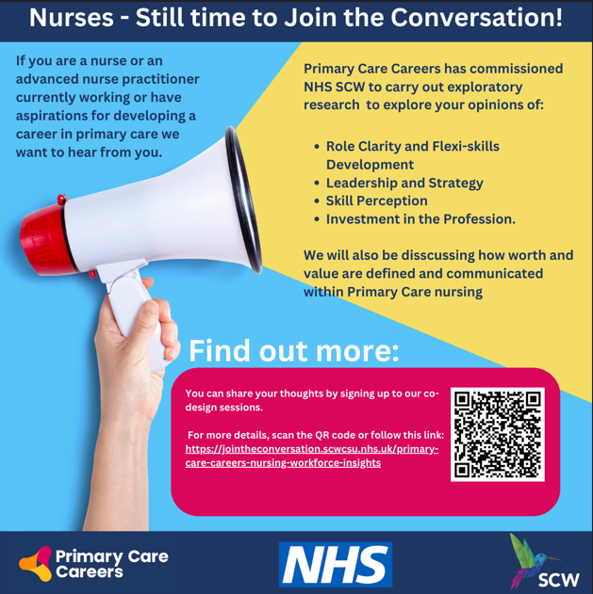

**LinkedIn Posts:**

We have created content for LinkedIn, including an initial post and a reminder post. You can use the image supplied below or the social media posts.

**Initial Post**

**Have your say Primary Care Nurses and Advanced Nurse Practitioners!**

We are launching a series of co-design workshops on the 26th February, 3rd March, 5th March and 11th March and we want to hear from **you**. If you are a nurse or advanced nurse practitioner who is currently working in or has aspirations for developing a career in primary care this is your opportunity to share your insights.

Primary Care Careers has commissioned NHS SCW to carry out an exploratory piece of research using co-design sessions to understand the how **worth and value are understood** within nursing careers in primary care through the themes of **flexi-skill development, leadership and strategy, skill perception and investment in the profession**.

Please follow this link: <https://jointheconversation.scwcsu.nhs.uk/embeds/projects/36881/survey-tools/43804>

**Please share widely with you colleagues and networks** to ensure we gather as many valuable perspectives as possible. Thank you for your support.

**Reminder Post**

**Reminder: Exciting Opportunity for Primary Care Nurses and Advanced Nurse Practitioners!**

Our co-design sessions for primary care nurses and advanced nurse practitioners are still open for sign up and we don’t want you to miss your opportunity to share your insights!

If you are a nurse or advanced nurse practitioner who is currently working in or has aspirations for developing a career in primary care these co-design sessions are designed to understand the how **worth and value are understood** within nursing careers in primary care through the themes of **flexi-skill development, leadership and strategy, skill perception and investment in the profession**.

Please follow this link: <https://jointheconversation.scwcsu.nhs.uk/embeds/projects/36881/survey-tools/43804>

**Don’t forget to share with your colleagues and networks** to ensure we gather as many valuable perspectives as possible. Thank you for your support.

**Email template**

If you want to distribute the sign up for sessions via email directly, we have created a template for you to do so (attached) and also to share with your networks.