Personal development plan:

GDC template

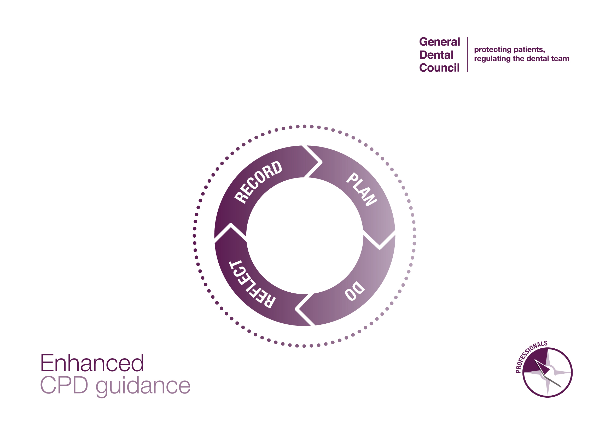

The personal development plan (PDP)
The PDP is designed for you to carefully consider your role as a dental professional, and what CPD will give you maximum benefit for maintaining and developing your practice in your current and future areas of work. The GDC encourages you to regularly review your plan as it relates to your role and daily practice.
For the GDC, your PDP must include:
- The CPD you plan to undertake during your cycle, which must include CPD that is relevant to your current or intended field(s) of practice;
- The anticipated development outcomes that will link to each activity;
- The timeframes within which you expect to complete your CPD over your cycle.
Please note: The PDP is for your personal use.
Having a PDP in place assures the GDC that your CPD activity supports your work as a dental professional. The GDC may ask to see your PDP to check you are keeping records which meet the minimum requirements as set out above. Beyond this, the details within the PDP are not evaluated by the GDC.

The development outcomes:
You must make sure each planned and completed activity has at least one outcome (A, B, C, D) linked. It is possible for some CPD activities to link to multiple outcomes. The GDC encourages you to choose CPD to cover all four development outcomes in your cycle, however this is not a compulsory requirement.

Development Outcome | Example of CPD content
- Effective communication with patients, the dental team, and others across dentistry, including when obtaining consent, dealing with complaints, and raising concerns when patients are at risk; | - Communication skills  - Consent  - Complaints handling  - Raising concerns  - Safeguarding
- Effective management of self, and effective management of others or effective work with others in the dental team, in the interests of patients at all times; providing constructive leadership where appropriate; | - Effective practice management  - Business management  - Team working
- Maintenance and development of knowledge and skill within your field of practice; | - Clinical and technical areas of study  - Radiography  - Cross infection control  - Medical emergencies and CPR  - CPD on quality assurance for MHRA  - CPD specific for your daily role(s)  - Upskilling opportunities
- Maintenance of skills, behaviours and attitudes which maintain patient confidence in you and the dental profession and put patients’ interests first. | - Ethical and legal issues and developments  - Professional behaviours  - Equality and diversity training

The GDC’s PDP template
The GDC has provided a PDP template which we think helps professionals think clearly about their individual learning and development needs, based on their field of practice. However, you are free to choose any other tools or templates instead, to help you get the most out of your CPD. You may create your own, use one created by your employer, colleagues, associations, professional bodies etc., as long as the GDC’s requirements are met.
Remember, you may wish to update and modify your PDP throughout your cycle. For example, if you come across a CPD course that you would find useful but had not planned for in your initial PDP, you can go back to your PDP and update it.

The GDC template consists of two parts:
- Field of practice - to help you analyse all aspects of your professional practice, and to stimulate you to think more widely about your learning and maintenance needs. Please refer to the full guidance for professionals on our website for more information on field of practice.
- Personal development plan - to help you plan your activity in a meaningful and targeted way, reflecting your field of practice and linking to the development outcomes.

To see examples of how the templates may be utilised, please see the PDP examples document on our website. Please note these examples are not intended to demonstrate a full PDP, but just to give examples of how professionals may plan their activity depending on their title, roles and patients.

Name: Registration number:
My field of practice
My registrant title(s) and cycle period: | My work setting(s): | Any additional roles, qualifications or professional interests: | My patient population:
List each title you are registered under, your cycle period and total hours needed. | What is your place(s) of work and its environment? Different settings may require you to undertake certain roles and skills. | Do you have additional roles, qualifications, specialties or areas of focus/interest? Do any of these need continual learning or maintenance? | What are the oral health and management needs of patients in your care? Does this change across your work settings?

My personal development plan
What do I need to learn or maintain for this cycle? | How does this relate to my field of practice? | Which development outcome does it link to? | What benefit will this have to my work? | How will I meet this learning or maintenance need? | When will I complete the activity?
What skills or knowledge have you identified that need developing or maintaining? Are there any gaps that need addressing? | Why have you identified this, how does it relate to your daily job, patients or tasks? | A, B, C or D  (see development outcomes table above) | How will CPD activity in this area help you to maintain or improve your daily work and/or care for patients? | What activities could you do to help meet your learning and maintenance needs? | What are your target dates for review and completion?
Insert more rows by right clicking in a row, click “insert” and “insert rows below”

