Parking:
Free parking is available at Skimpot road 0.6 miles from the hospital (about a 12 minute walk). If there are any issues/concerns please let me know.
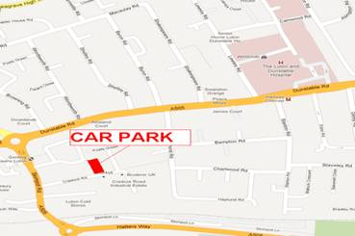
Location:
The training day will take place in the simulation suite behind the COMET centre on the ground floor of the main hospital building. Please access from outside not through the main lecture theatre. See map below:

Main reception
COMET

Sim suite
Cardiac cath lab
EAU
ACC

Main reception
COMET

Sim suite
Cardiac cath lab
EAU
ACC

