Paediatric DKA Prescribing Refresher 16/08/19
Step 1: Estimating percentage of dehydration
Severity DKA | Percentage of Dehydration | pH | Clinical Signs
Mild to moderate | 5% | >7.1 | Dry mucus membranes  Reduced skin turgor
Severe | 10% | < 7.1 | Sunken eyes
Shock |  |  | Hypotension  Thready rapid pulse

Step 2a: Calculate the maintenance fluid requirement using the 'reduced volume' rules
Weight | Fluid Rate
<10kg | 2ml/kg/hour
10-40kg | 1ml/kg/hour
>40kg | 40ml/hr (fixed rate not per kg)

Step 2b: Calculate total hourly volume requirement including plan to replace deficit over 48 hours.
You need to subtract resuscitation fluid given that exceeded 20ml/kg.
For example if the patient had the maximum 30ml/kg resuscitation fluid they had 10ml/kg exceeding the 20ml/kg cut off so subtract 10ml/kg.
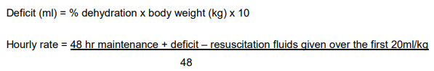
Step 3: Potassium replacement
Potassium (mmol/l) | KCL concentration
<3 | May need > 20mmol in 500ml – Discuss with HDU
3-6 | 20mmol in 500ml
>6 | 10mmol in 500ml and repeat, asses urine output ?AKI

Step 5: Insulin
Start soluble insulin at 0.05 - 0.1 units/kg/hr 1 hour after starting IV fluids
Aim to reduce the blood glucose no faster than 5mmols/hr

Step 6: Re-asses
If BM < 14 change to glucose containing fluid
Review pH/ ketones/ BM/ potassium/ renal function/ corrected sodium

