The North West Anglia Early Pregnancy and Gynaecology Hands- on Ultrasound Course
23-24.11.2019

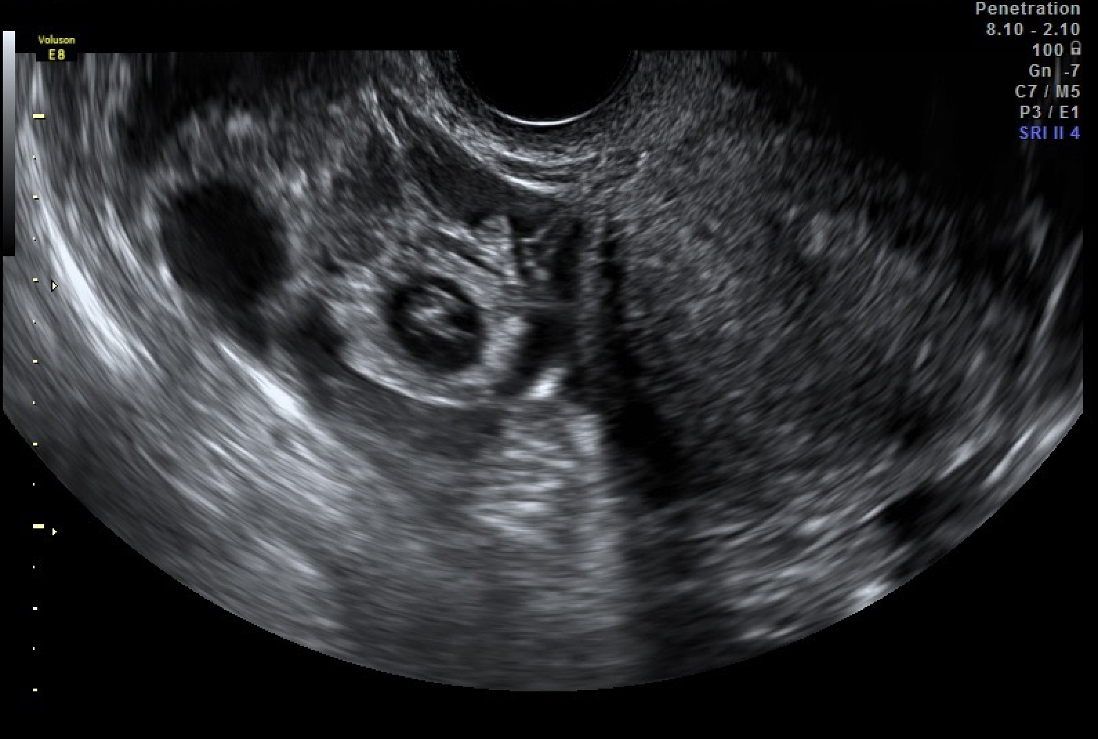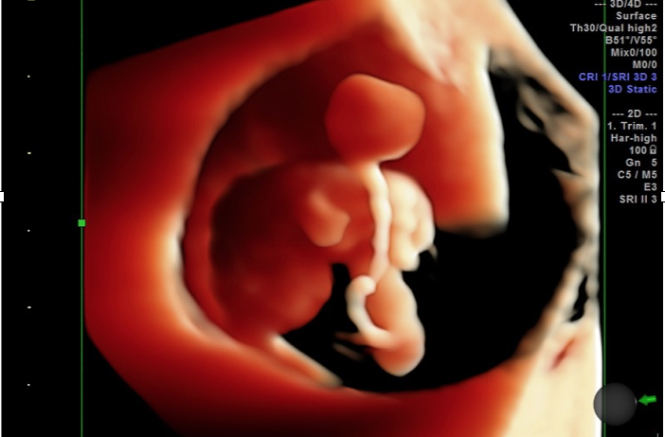
Venue
Seminar Room 1, Delivery Unit, Peterborough City Hospital, Peterborough, PE3 9GZ

Course Organizers and Faculty

Dr Rebecca McKay
Consultant Obstetrician and Gynaecologist, Peterborough City Hospital
Email: rebecca.mckay4@nhs.net

Miss Miriam Baumgarten
Consultant Gynaecologist, Addenbrooke’s Hospital
Email: miriam.baumgarten@addenbrookes.nhs.uk

Miss Hema Nosib
Consultant Obstetrician and Gynaecologist
Hinchingbrooke Hospital
Email: hema.nosib@nhs.net

Miss Ayshini Samarasinghe
Consultant Obstetrician and Gynaecologist, Peterborough City Hospital
ayshini.samarasinghe@nhs.net

Miss Rachel Barratt
Consultant Obstetrician and Gynaecologist, Addenbrooke’s Hospital
Email: rachel.barratt1@nhs.net

Dr Lukasz Polanski
Subspecialty Training Registrar, Guy’s Hospital
Email: lukasz.polanski@gstt.nhs.uk

The aim of the course

This course is designed to provide theoretical and practical knowledge of gynaecological ultrasound. Basic principles and safe practice of scanning will be covered, followed by a wide range of advanced topics on early pregnancy and gynaecological physiology and pathology which will be delivered by expert speakers. A large part of the course will be dedicated to hands on training on real patients with a 2:1 ratio of trainee to trainer. During the course, there will be a possibility to have work place assessments (OSATs) related to ultrasound scanning completed.

Who is this course for?

The course is specifically designed for junior doctors with interest in Early Pregnancy and Gynaecological scanning that wish to either start scanning or improve their skills. The course is designed to cover all aspects of the core curriculum (except obstetric scanning) as well as ATSM curriculum for ultrasound.
Consultants, Nurse Specialists and Sonographers specialising in Early Pregnancy and Emergency Gynaecology Scanning are also welcome to attend and will benefit from the content and practical exercise.
The places are limited to 10 participants only and priority will be given to more senior trainees.

Registration Fee

The fee for East of England trainees is £200 and can be refunded through EoE Deanery Aspirational Study Leave applications.
Fee for nurses and sonographers in £100.

Please attach an Occupational Health clearance letter from your current trust with your application. This will be required due to contact with patients.

Programme

Day 1

08.30-09.00 Registration

09.00-09.10 Introductions and aims of the course (Faculty)

09.10-09.30 Getting to know you equipment and ultrasound safety (Lukasz Polanski, Guy’s Hospital)

09.30-09.45 Principles of TA and TV scanning (Lukasz Polanski, Guy’s Hospital)

09.45-10.15 The normal uterus and ovaries and the menstrual cycle (Ayshini Samarasinghe, Peterborough)

10.15-10.45 Coffee break

11.00-11.30 Endometrial pathologies (polyps, adhesions) (Hema Nosib, Hinchingbrooke)

11.30-12.00 Myometrial pathologies (leiomyomas, adenomyosis) (Rachel Barratt, Addenbrooke’s)

12.00-12.30 Ovarian and adnexal pathologies (Sue Freeman, Addenbrooke’s)

12.30-13.00 Normal first trimester pregnancy development (Charleen Lia, Peterborough and Hinchingbrooke)

13.00-13.30 Early pregnancy pathologies (ectopic pregnancy, miscarriage) (Miriam Baumgarten, Addebrooke’s)

13.30-14.30 Lunch break

14.30-17.30 Live scanning

19.00 Course dinner

Day 2

08.30-09.00 Coffee and day 2 registration

09.00-09.30 Bringing bad news/ communicating with the EPAU patient (Laura Rutherford, Peterborough)

09.30-12.00 Live scanning

12.00-12.40 Lunch

12.40- 13.00 Contrast enhanced sonography (TBC)

13.00-13.30 Ultrasound in fertility assessment and treatment (TBC)

13.30-13.45 Localization of contraceptive devices (Rebecca McKay, Peterborough)

13.45-14.15 Deep infiltrating endometriosis and ultrasound (Miriam Baumgarten)
14.15-14.45 3D ultrasound in gynaecology and early pregnancy (Lukasz Polanski)

14.45-15.00 Principles of ultrasound reporting (Laura Rutherford)

15.00-15.15 O&G trainee perspective on gynaecology scan training (Faculty)

15.15-15.45 Closing remarks and feedback

Application form

(Please complete and return to lukasz.polanski@gstt.nhs.uk, and send printed copy with the cheque to the address provided below)

Last Name ______________________________________________________________

First Name ______________________________________________________________

Title ______________ Work title ________________________________

Place of Work ______________________________________________________________

______________________________________________________________

____________________________ Post Code ____________________

Contact email address __________________________________________________

Mobile ______________________________________________________________

Please send your application form and the cheque addressed to
Dr Rebecca McKay, Department of Obstetrics and Gynaecology, Peterborough City Hospital, Bretton Gate, Peterborough, PE3 9GZ.
Make the cheque payable to ‘EAOGS (US course)’ or arrange for bank transfer to EAOGS meeting, TSB, account number 01943370, sort code 30-96-60, reference as ‘US course fee’.

