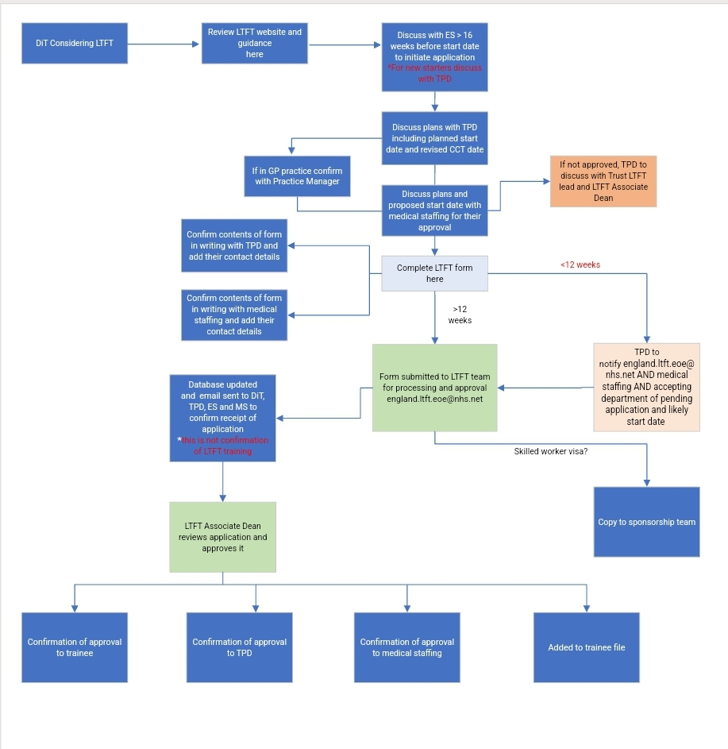

**NOTES**

1. DiT starts application process at least 16 weeks before LTFT start date
2. DiT ticks box on form to confirm:
3. Has discussed LTFT process with ES (For new starters discuss with TPD)
4. ES has signposted DiT to EoE LTFT web page
5. ES has assessed and put in place any extra support needed e.g. PSW
6. Has agreement that receiving trust can safely accommodate DiT
7. DiT ticks box on form to confirm they have approval from TPD/ES/medical staffing that:
8. They can be accommodated to train LTFT
9. Any specific needs of the DiT regarding rotas, out of hours etc has been communicated to the department in which DiT will be placed
10. If application is late (submitted to NHSE <12 weeks before start date), that all appropriate parties are notified
11. For GP trainees: Practice manager confirms DiT is allocated to the practice, including start date and ability to accommodate planned work schedule

*ES/TPD/Medical staffing will receive a copy of the signed application form – if you have ticked that you have received approval from them and tis is not the case, your approval for LTFT training will not be valid and it is likely you will not be able to start on your intended date

DiT: doctor in training

D