HOW TO FIND VICTORIA HOUSE
2-4 VICTORIA HOUSE
CAPITAL PARK
FULBOURN
CAMBRIDGE
CB21 5XB
(OLD SAT NAVS MAY RECOGNISE CB1 5XB)
TEL 01223 597500

FROM EAST (A14) – (From Ipswich and Bury St Edmunds)

Follow A14 west towards Cambridge, exit junction marked Cambridge A1303
- Take left lane into Cambridge
- Turn left at Airport Way, signs to Cherry Hinton and Fulbourn marked A1134
- At roundabout take first left turn, follow across two more roundabouts. At third roundabout turn left onto Cambridge Road.
- Follow along, then take second turning on left into Capital Park, up drive way, following signs for NHS Victoria House.
- Carry along the road until the roundabout, go straight over and then take the next right into the NHS additional car park. At the green post in front of the barrier, key in the code if supplied or press the button on the intercom to announce the meeting you are attending.
PLEASE DO NOT PARK IN THE ARU FACULTY OF CARE (HOMERTON COLLEGE) CAR PARK

FROM WEST (M1)
- Exit M1 at junction 19, following signs to Felixstowe and Huntingdon on A14
- Follow signs to Cambridge A14 (old A604)
- Just prior to City follow the dual carriageway which peels off at A14
- Take turn off marked A1303, Stow Cum Quay and Newmarket
- Take third turn off into Cambridge
- Turn left at Airport Way, signs to Cherry Hinton and Fulbourn, A1134
- At roundabout take first left turn, follow across two more roundabouts. At third roundabout turn left onto Cambridge Road
- Follow along, then take second turning on left into Capital Park, up drive way, following signs for NHS Victoria House.
- Carry along the road until the roundabout, go straight over and then take the next right into the NHS additional car park. At the green post in front of the barrier, key in the code if supplied or press the button on the intercom to announce the meeting you are attending.

PLEASE DO NOT PARK IN THE ARU FACULTY OF CARE (HOMERTON COLLEGE) CAR PARK
FROM NORTH (A1)
- Exit at junction marked A14 Huntingdon/Cambridge
- On approach to Cambridge A14 (old A604) follow the dual carriageway which peels off to A14
- Take turn off marked A1303, Stow Cum Quay and Newmarket
- Take third turn off into Cambridge
- Turn left at Airport Way, signs to Cherry Hinton and Fulbourn, A1134
- At roundabout take first left turn, follow across two more roundabouts. At third roundabout turn left onto Cambridge Road
- Follow along, then take second turning on left into Capital Park, up drive way, following signs for NHS Victoria House.
- Carry along the road until the roundabout, go straight over and then take the next right into the NHS additional car park. At the green post in front of the barrier, key in the code if supplied or press the button on the intercom to announce the meeting you are attending.
PLEASE DO NOT PARK IN THE ARU FACULTY OF CARE (HOMERTON COLLEGE) CAR PARK

FROM SOUTH (A1)
- Exit junction 9, signed Baldock. Follow signs to Cambridge A505. Bypass Royston, follow signs for A10 Cambridge
- Across traffic lights, through Trumpington, at next set of lights take right filter (Long Road) signed Addenbrookes Hospital/Ring Road
- Set of lights at junction Long Road and Hills Road, go straight over the traffic lights and come to a roundabout. Go straight over the roundabout onto Queen Edith’s Way – signs to Cherry Hinton and Fulbourn
- At next lights turn right to Fulbourn onto Fulbourn Road (Robin Hood pub on corner)
- Across next roundabout, onto Cambridge Road
- Follow along, then take second turning on left into Capital Park, up drive way, following signs for NHS Victoria House.
- Carry along the road until the roundabout, go straight over and then take the next right into the NHS additional car park. At the green post in front of the barrier, key in the code if supplied or press the button on the intercom to announce the meeting you are attending.
PLEASE DO NOT PARK IN THE ARU FACULTY OF CARE (HOMERTON COLLEGE) CAR PARK

FROM SOUTH (M11)
- Exit at Junction 9, take A11 to Newmarket/Norwich
- At Stumps Cross roundabout continue across on A11
- After 4 miles come to a roundabout, go across following signs to A11
- After 2 miles turn left off dual carriageway to Balsham, Fulbourn, Teversham. Turn left towards Fulbourn
- Follow road for 3 miles through village of Fulbourn, past windmill on left
- Continue along road, entrance to driveway leading to the Strategic Health Authority (marked Capital Park) is on right.
- Continue up drive following signs for NHS Victoria House.
- Carry along the road until the roundabout, go straight over and then take the next right into the NHS additional car park. At the green post in front of the barrier, key in the code if supplied or press the button on the intercom to announce the meeting you are attending.
PLEASE DO NOT PARK IN THE ARU FACULTY OF CARE (HOMERTON COLLEGE) CAR PARK

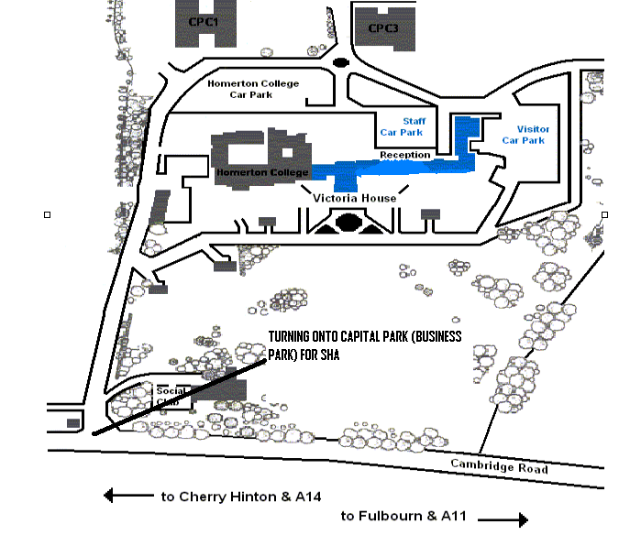

CAR PARK BARRIER CODE: 1379
REPORT TO VICTORIA HOUSE, EAST WING RECEPTION

