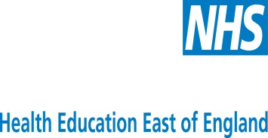
School of Emergency Medicine

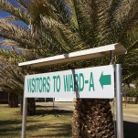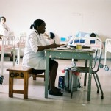

Out of Programme Experience – Exciting! Challenging! Rewarding!

Health Education East of England are pleased to offer, through Africa Health Placements (www.ahp.org.za) a number of one year out of programme clinical posts, based in rural community hospitals in South Africa, starting in August 2017. Africa Health Placements is an organisation with a mission: to support and enhance healthcare systems in Africa, by finding, placing and retaining the right people for the job.

The posts will be offered to those applicants who successfully complete their ST3 year and prior to entering ST4. The successful applicants will return to complete their Higher Specialist Training. The aim of these posts is to enable EM trainees to extend their training and enhance their skills and competencies in resource poor environments.

The jobs will be available within the context of Time Out of Programme as described in the Health Education East of England guidelines.

Full support is given to all trainees prior to departure, during the 12 months away and upon your return back to the UK.

Answers to your questions can be found here . To read stories from doctors who have returned from South Africa, please visit http://ww.ahp.org.za/newsroom/3/doctors-stories

For any questions, no matter how small please e-mail Dr Nam Tong, Head of School, who will contact you and offer further information and advice. Africa Health Placements are also very willing to answer any questions you may have – Esther Dlamini estherd@ahp.org.za

