

Welcome to the East of England Foundation Schools: EAFS and EBHFS

First Class Education for First Class Healthcare

Thank you for choosing to undertake the first stage of your postgraduate medical training with Health Education England (HEE) working across the East of England. We aim to become the best healthcare service in England, and we hope that your skills and motivation will help us to achieve this goal.

As an organisation we support around 4,000 medical and dental trainees in the region, serving a population of 5.6 million. We hope to attract the best doctors and dentists to this region, and to inspire them with the high-quality training needed to ensure that our patients receive the highest standard of safe clinical care. HEE also maintains effective quality management of postgraduate medical and dental education and training and promotes faculty development for our trainers.

We hope that you will thrive here as your career develops, and we look forward to meeting you on one of our many Trust visits.

Here are some key tips for you to get the most out of your placements with us:

- Read our website, HEE EoE Foundation as it has lots of our policies and documents and rationales for how the foundation posts work. It is a good ‘go to’ resource around foundation. We assume you have not only read the website, but also check back with the website as a resource for local and national ARCP, policies and guidance.

  - Our taught programme HEE EoE Foundation Taught Programme

    - You need to be aware of what you need to organise and arrange for mandatory teaching attendance as we have moved from a lecture based approached to a trainee focussed approach. You will need to book your sub regional teaching sessions before the end of August.
  - Our main policy and ‘how to’ HEE EoE Current Trainees

  - Please read the foundation specific study leave guidance on our webpages before application.

- Let our programmes team be aware of your email addresses to use at foundationprogrammes.eoe@hee.nhs.uk. We send out important information, policy updates, and opportunities via the mass email. Don’t let yourself be missed!

  - This is required by July at the latest as we will be sending out information on your regional teaching to book into.


- Get to know your FTPD [Foundation training programme director] and the medical education team.

- If you have ideas for innovation, share them! The foundation schools are always looking to act on trainee feedback and improve and are always keen to support trainees’ enthusiasm for pilots in teaching and simulation.

- We have trainee reps, and we would like you to consider whether you would be keen to try this role.

- Take part in regional and national foundation events, requests for survey completion, feedback [particularly feedback so we can improve your training and hear your opinions]

- If you have concerns or queries or have a complaint around your placement,

  - First talk to the local team, whoever is appropriate from the clinical supervisor, educational supervisor, foundation training programme director or guardian of safe working.

  - Then approach the deputy foundation school director for your region.

- Adjusting to the role of doctor, the pace of work and the stresses within it can be difficult. If you would like to talk this through,

  - We are in the process of placing wellbeing champions in the trust,

  - You have an F2 buddy/mentor,

  - The FTPD is always there to help.

  - If you want a more private discussion,

    - We have our professional support and wellbeing team HEE EoE Foundation Trainee Wellbeing hub

    - The BMA have the following for their members: BMA Support

    - There is a free national wellbeing service at Practitioner Health

- Mostly we hope that you will enjoy your foundation years as they give you a good starting point for your future careers.

The transition from a medical student to a trainee doctor will be exciting and challenging at the same time. You will be regarded as a doctor by all around you. It is important to be professional in your actions and words, work within your competencies, and seek help when you feel necessary. At the end of the day, we are all in this profession to look after patients in a safe and caring way.

Good luck and best wishes!


Professor Bill Irish

Dr Helen Johnson

Postgraduate Dean
Foundation School Director

Additional Information

Surveys:

Part of our making foundation better is from received feedback and survey participation, so I would ask that all of you make time for the number of surveys you will receive. We really do act on the information!

We will provide individual feedback to any Trust (via their Foundation Schools) who have five or more F1s responding to the survey; with regard to preparedness of their F1s and feedback about their induction programme ‘usefulness’.

Please note that no personally identifiable data is collected so GDPR is not an issue.
https://www.surveymonkey.co.uk/r/F1induction2019 or via the QR code:


Before you start your training

Read the key documents available on the Resource Bank

Especially:

The FP Rough Guides
The Foundation Programme Curriculum
The FP Reference Guide

Educational Agreement

When you start your Foundation Programme within the East Anglian Foundation School, you are entering into an educational agreement with the Postgraduate Dean as set out below:
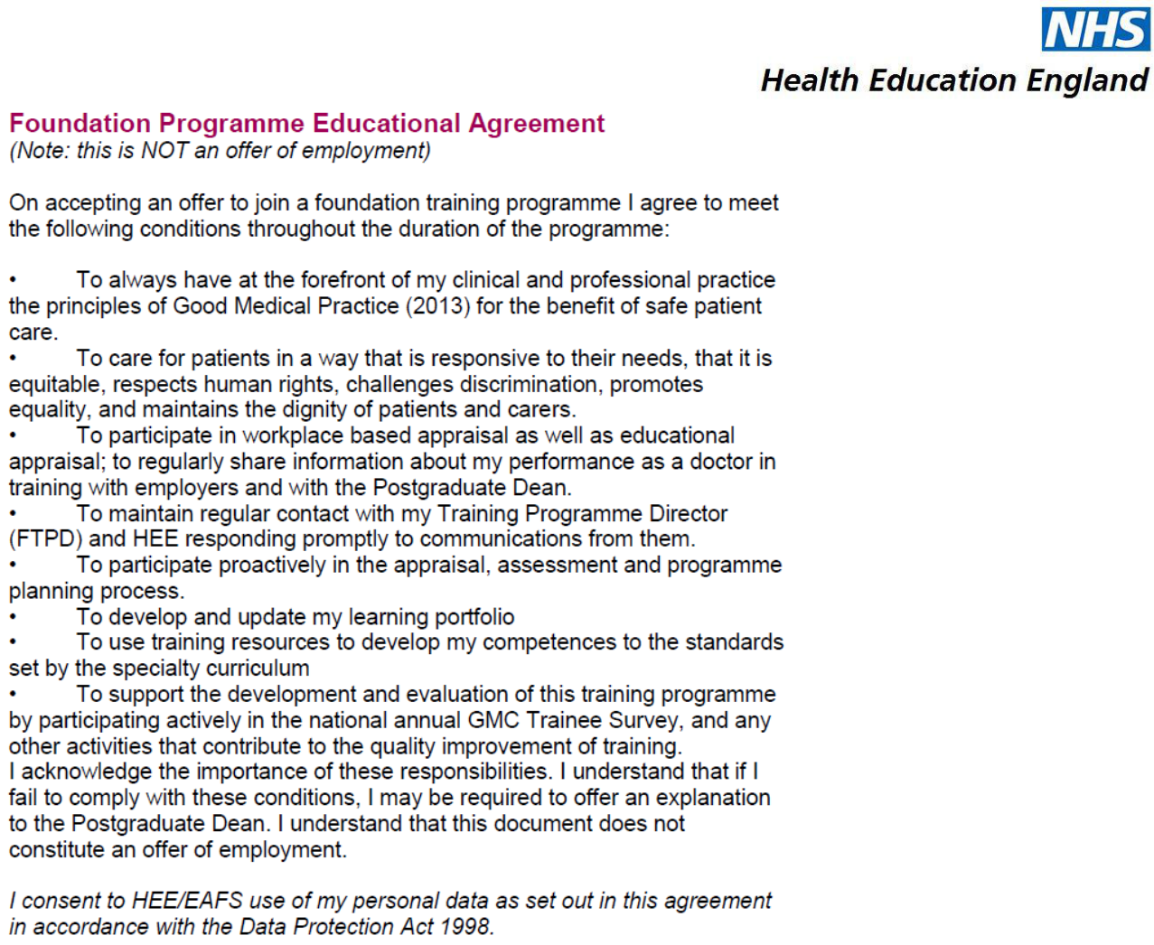

I understand that my personal data is stored by Health Education England on both computer and manual systems. Where appropriate, this information may be shared with those who have responsibility for the organisation, management and delivery of training to help them execute their function, the planning and delivery of specialist training.

Data Protection

In order to perform its statutory functions, the HEE has an obligation to collect and keep data regarding all junior doctors within East of England Foundation Schools.

In accordance with the Data Protection Act 1998, the Foundation School will process personal data and ensure that appropriate measures are in place to ensure the confidentiality and integrity of the data we hold about our trainees.

By submitting your personal data, you consent to use of that data as set out in this agreement. Details of the information we collect and how we protect your data can be found on the privacy notice which is posted on the HEE Website: Privacy Notice
Trainee Contact

Please email foundationprogrammes.eoe@hee.nhs.uk by 15th May to confirm an email address, which you will be able to access throughout your foundation training. Please communicate with us using a secure and professional email account such as doctors.org.uk. Email providers such as Hotmail are insecure, may not be accessible at your place of employment, and often reject group emails or important attachments from the Foundation School.

Who’s Who in Foundation Training

It is important that you know whom you can contact for advice or support. You will meet many of these people in your PfPP week.

All Trusts have an Education Centre, with experienced staff who can provide information, support and advice on your Foundation Training.

There is a Foundation Programme Administrator in each Trust. HR and Occupational Health staff are also an important resource.

- Discuss your training needs with your Educational and Clinical Supervisors.

- Contact your Trust’s Foundation Programme Administrator/Medical Education Manager with queries about policy and procedure relating to your training programme.

- Consult community-based trainers in General Practice, Psychiatry and Public Health (mainly F2)

Foundation Training Programme Directors (FTPDs) are consultants appointed jointly by the Trust and Health Education England, to ensure the delivery of the foundation programme curriculum in accordance with the standards set by the GMC.

Clinical Tutors/Directors of Medical Education are appointed to provide educational leadership in the Trust, and they work closely with the FTPD.

Educational supervisors
Every Foundation trainee has an Educational Supervisor, who is responsible for:
- Overseeing the training and appraisal of a specific group of trainees
- Developing these trainees’ educational development plans
- Trainee appraisal and preparation for F1 and F2 sign off
- Completing key parts of the e-portfolio

Clinical supervisors

Clinical supervisors are responsible for the day to day clinical supervision of trainees during the working week, which includes:

- The provision of training and education opportunities

- Providing constructive feedback, and undertaking workplace-based assessments

- Safe clinical oversight of trainees

Please contact your Trust and also the foundationprogrammes.eoe@hee.nhs.uk inbox if any there are any changes to your situation which may affect your training, such as maternity leave, wishing to train less than full time or planning to leave the programme.

Contacts

If you have a question regarding recruitment policy and procedure which is not answered in this document, or in the Policies and Procedures section of our website HEE EoE Foundation, you can contact HEEoE.

Postgraduate Dean: Professor Bill Irish
Foundation School Director: Helen Johnson
Deputy Foundation School Directors: Helen Barker and Ritwik Banerjee

Recruitment: Recruitment Helpdesk: recruitment.eoe@hee.nhs.uk

Programmes and Information: foundationprogrammes.eoe@hee.nhs.uk
Assessment and sign off: assessment.eoe@hee.nhs.uk
Professional Support: psw.eoe@hee.nhs.uk

Health Education England Foundation School Website:

heeoe.hee.nhs.uk/foundation_main

National Foundation Programme Website:

http://www.foundationprogramme.nhs.uk/pages/home

Less than Full Time Training Email Address: ltft.eoe@hee.nhs.uk

Professional Performance Concerns

The Foundation School has a flexible approach to supporting trainees with professional performance concerns.

If you feel at any point that you need support or advice about any aspect of your foundation training, please do contact your Educational Supervisor or Foundation Training Programme Director, who will work to identify and resolve problems at the earliest stage possible.

Solutions might include targeted training, careers support or supernumerary training. If necessary, the Foundation School Director will also offer advice in consultation with the HR and Occupational Health departments at the Trust.

Preparation for Professional Practice (PFPP)

The EAFS has implemented PFPP for a minimum of 1 week, as a seamless handover to your new post. PFPP helps you prepare for your new role by gaining practical experience of clinical care on the wards. The official start date will be Monday 27th July 2020 – however some trusts may offer an additional (non-mandatory) week starting on Monday 20th July 2020.

Although the structure and duration of PfPP may vary, all Trusts offer ward experience, induction, and some formal teaching and training during this period.

- PfPP is mandatory for all Foundation Trainees in the East Anglian Foundation School.
- Your Trust will be in touch soon to share their PfPP schedule and they can answer any questions you may have.

- You will receive full basic F1 salary for 1 week of PfPP.

It is important that you are provisionally registered at the start of your PfPP. If you do not specify a start date on your application form, the GMC will assume that you will start in early August.

Please note the following:

- Apply for GMC registration in plenty of time
- Record the date you are due to commence your PfPP
- Your start date should not be any later than 27th July 2020

- If you have not heard from the GMC one week before you are due to start PfPP, they advise you to contact them via their contact centre

Indemnity Cover

Trainees who are employed by a Hospital Trust will be covered by Trust indemnity. We have taken advice from both the MDU and the MPS. Both organisations are willing to extend the basic cover for an F1 trainee with no additional charge. Please apply early, stating that you require an extra period to cover your PfPP, and provide a start date.

Undergraduate Shadowing

This is separate to the PfPP week, and you may well be required to complete a period of shadowing in accordance with UK medical school curricula.

The Foundation School will not be involved in organising your undergraduate shadowing placement, as this should be organised with your medical school. There will be the opportunity to organise shadowing in the trust to which you have been allocated, but you would be required to arrange this by direct contact with the employing trust, and where possible with the input of your medical school.

Transfer of Information (TOI/ STEP process)

If you have not heard from your medical school administrator regarding this process, please make enquiries directly with your medical school.

In line with national guidance, the EAFS is participating in the TOI process, which is a means of supporting you as you move from the medical school to the foundation school environment.

In particular, this process highlights students who may require additional support during their foundation training.

The TOI process is one of the mechanisms by which medical schools pass on information relating to students which may affect patient safety.

UK medical students should complete this process through their medical school. UK medical schools then send completed forms to the appropriate foundation school.
For those who have not undertaken their medical training within the UK, please read

the guidance, complete the TOI form and return it to foundationprogrammes.eoe@hee.nhs.uk

This process is designed to be supportive, and any information provided will be treated in absolute confidence.

Guidance for the TOI process and the TOI form are available here .

Trainee Representation

Any Foundation trainee in a two-year programme may apply to be a Trainee Representative for the East Anglian Foundation School.

Trainee Representatives offer local, regional and national representation on issues such as education and training, e-portfolios, careers support and quality management. Please see here for full details of the application process.

e-Portfolio (Horus)

The Foundation Learning e-Portfolio is based on the Foundation Programme Curriculum and sets out the areas of medical practice that you will need to cover, and the standards that will be expected. It will form the basis of a life-long record of your professional development.

You will be issued with an e-portfolio account when you commence Foundation Training. A member of your local postgraduate centre will be able to change or update post and supervisor details for you. More information on the Foundation e-Portfolio can be found on our website. The e-portfolio can be used as a platform to communicate with your colleagues, and we strongly encourage you to use it in this way.
Your eportfolio may be used as part of the selection process for specialty training.

e-Learning

The Foundation e-Learning Programme is a free and innovative resource which supports the Foundation curriculum. Over 50 e-learning sessions are currently available, covering topics from Safe Prescribing to Safeguarding Children and Young People. New sessions are added on a regular basis, using high quality graphics, video, animation and interactive exercises.

Each session takes around 20 minutes to complete, and easily fits in with busy schedules. The programme can be used as a reference or revision tool, to prepare for formal education sessions and to fill in knowledge gaps. When each e-learning course is completed, the self-reporting tool can be used to produce a certificate for your Portfolio.

eLfH will automatically send you login details before you commence training. Please make use of this resource throughout your Foundation training, to support your learning across the Foundation Curriculum.

Less Than Full Time Training (LTFT)

Trainees meeting the eligibility criteria in a substantive Health Education England approved post can apply for LTFT on our website at: Less Than Full Time Training

