SEPTEMBER 2019

FOUNDATION SKILLS
Guidance Document

HEALTH EDUCATION ENGLAND
DENTAL FOUNDATION TRAINING

PROJECT OVERVIEW

All Foundation Dentists are required to complete various project work during their training year, one of these is the foundation skills project.
From the start to the end of this training year you will be providing care and treatment to the patients allocated to you. The project is about writing a brief factual account of what you actually do in delivering the dental services to your patients. You are then encouraged to examine your account in the several areas of primary dental care and provide your detailed personal reflection on the matters concerned.

This project is evidence based, asking you to demonstrate attainment of professional practices and standards in those key areas that are governed by current legislation, and regulated by the services regulator the Care Quality Commission and the professional regulator the General Dental Council. This project requires you to reflect on your working practices, demonstrating that you have been learning and developing as a dentist and so strengthening your professional practice and standards as you journey through your training year. A personalised reflective account supported by good evidence is a requirement for satisfactory completion of foundation training, and a well presented portfolio of work will help you prove attainment in the identified competencies under the domains of professionalism, management and leadership.

This document is intended to provide you with guidance, however you must contact your Training Programme Director (TPD) should you have further questions or require help.

PROJECT PURPOSE

This project demands you to demonstrate that you have acquired the ‘foundation skills’ required to be an effective General Dental Practitioner. You can do this by demonstrating that you are proficient in the stipulated modules, of which there are eight. Furthermore, the foundation skills project will help to:

- demonstrate your developing knowledge
- allow you to critique your work showing you are focussed on improvements
- drive forward your professional development
- demonstrate compliance with legislation and available professional guidance
- evidence progressive learning and identify future learning needs
- evidence your developing skills which are required for achieving the competencies for DFT satisfactory completion

PROJECT FORMAT & TIMELINE

You will be required to produce an electronic portfolio. This will have the following elements
- a brief factual account of your working practice as it related to the topic
- your thoughts and detailed reflection on your factual narrative
- your own suggestions on improvements to your working practices
- inclusion of your own pieces of evidence to support your claims

There are the eight modules for you to complete. Modules are basically broad subject areas. Modules are labelled with a letter as here:

A Infection Control
B Radiography
C Clinical Communication, Consent, Confidentiality and Clinical Record Keeping
D Medical Emergencies
E Prescribing Medicines
F Team work
G GDC Standards, Law and Ethics
H Health & Safety, Quality & Patient Experience

You will find that each of these eight modules is broken down into smaller topic areas pertaining to the broad subject concerned. For identification of any given smaller topic, there is an alphanumeric system to identify these. The letter identifies the module (broad subject area) and the number points to the topic.

Examples of alphanumeric system for identification

A1 Here the letter ‘A’ refers to module A on infection control, and the number ‘1’ is the topic being training in infection control
B4 Here the letter ‘B’ refers to module B on radiography, and the number ‘4’ refers to the topic being radiographic interpretation and reporting

When do I start the project?
You will need to start working on your project work as soon as you have received your induction. Please do not delay as this will impact on your ability to cope with getting the work done in time.

How many topics do I need to complete, and what can you tell me about the timeframe for this project work?

There will be 12 topics to be completed by the end of the first term, and additional 12 topics some months later, a date to be set by your TPD.

By December 2019, you will complete the first set of 12 topics (exact completion date for your scheme will be notified by your TPD). Also please refer to topic selection requirements below.

By March/April 2020, you will complete the second set of 12 topics. These will be different topics than ones completed previously (As each training scheme has its own study day on project work, please ask your TPD for exact completion dates). Once again, please refer to topic selection requirements below when selecting topics.
So how do I select the topics? Are there specific requirements on what I choose?

There are topic selection requirements for the foundation skills project.

For the first set of 12 topics (December 2019 completion)
This is how you are required to select the topics from the modules provided
- Choose one topic from each module, this will give you eight topics in total
- Next choose the remaining four topics, with the proviso that each is chose from different modules.
- The total number will now be 8 + 4 = 12. Note by following this rule you will have at least one topic from each module, and you will see that there are 2 topics from four of the modules. Here is an example of the mix of topics for the first set of submission
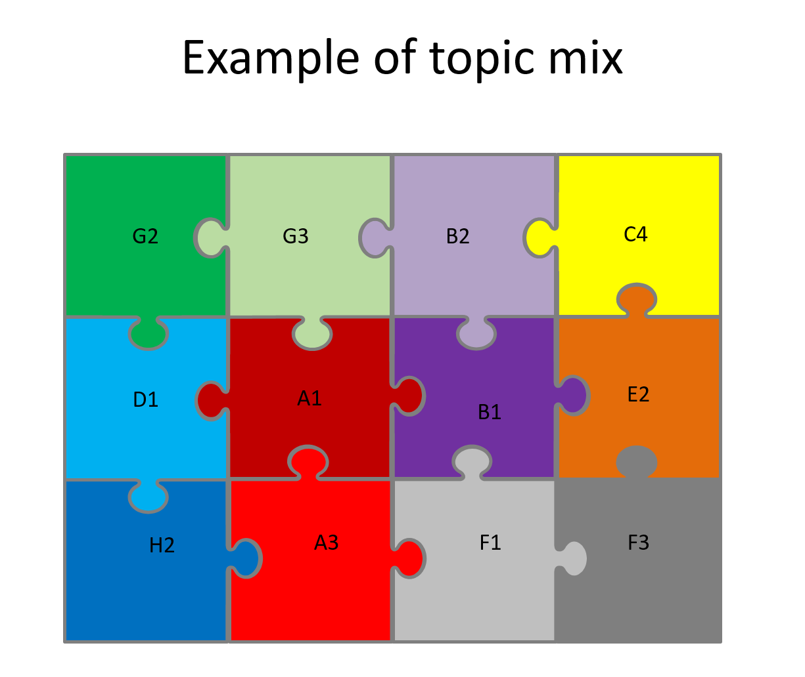
For the second set of 12 topics

You will need to refer to the topic mix taken up for December. None of these topics can be repeated. A new set of topics must now be picked and the process for selection is:

- You will identify the four modules where you have previously only completed 1 topic (December). So your first selection will be to pick 4 topics, one from each of these four identified modules.
- Now choose the next 8 topics, that will be 1 topic from each and every module that has not been picked in the past. Hence you have now selected 8 topics to add on to the first 4 topics, making a total of 12 topics.

Note the second set of topics are all different from the first set. And by the time you have completed the whole project, you will have completed 3 topics from each of the eight modules, bringing the total number of topics completed to 24 topics.

Just remember that the choice of topics is down to you and may be dictated by your learning and development needs at the time. You should careful plan the selection of topics because your work will count towards demonstrating coverage of the foundation curriculum. As this is a practice based project, it is your Education Supervisor who can guide and support you in this project, however the work must be your own. Plagiarism is strictly not allowed.

Your TPD will timetable the two completion dates for your scheme. Your work will be assessed feedback given including a grade for each topic. Any topic not reaching the acceptable grade will need to be revised. Please refer to the information on the assessment sheet.

In summary there are a total of 24 topics for the completed project work for the year. Certificate of satisfactory completion of your foundation skills project need to be uploaded into your e-portfolio as this is required for either IRCP or FRCP processes.

WRITING THE FOUNDATION SKILLS & LINKING THE EVIDENCE

Please refer to each module where you will find the topic areas to select. It is down to you to put together your own brief factual account and include your chosen pieces of evidence that supports your reflective write up. Do make reference to best practice, legislation, professional regulation and guidance.

When writing about a topic, the starting point is a factual account on the topic. This will need to be kept brief and to the point. You are then expected to reflect on your account and this should be more detailed. Reflective writing is about your own thoughts and feeling about the topic at hand and so it is personal to you. The majority of your write up must be in this reflective style. Then finally you may mention some plans to progress or improve. There is information about reflective writing style found in the online DFT portfolio.

It is widely accepted that applying a process of systematic reflection into your decision making, clinical judgements and working practices does contribute to better dental care for your patients. A very good piece of reflective writing often demonstrates attention to detail with intention to provide a high quality of care for all your patients.

Systematic approach to reflective writing can be is represented as follows:

Do I have to follow the exact line of questioning for each topic?
No not at all. If you can think of your own set of questions to answer that is fine, just follow the describe, reflect and action framework to help you structure a piece of reflective writing, and importantly your aim is to demonstrate the foundation training competency topic.

Where do I write my piece of writing?
Each module has included within it a page-long text box, and you are limited to this single text box. This will mean you will need to write concisely and to the point. A large volume of work is discouraged. As a guide for each topic, the word count can range from 250-300 words per topic. Bullet points are encouraged.
Please use Ariel font size 11 with 1.5 line spacing of paragraphs.

Tell me a little bit about supporting evidence

Every topic has a piece of reflective writing formed as covered above. Each of these topics will have references made to the supporting evidence you will need to provide as part of the project work. It is vitally important that evidence you collect is from your own clinical practice.

In your reflective piece of writing, the number of references you can make is limited to a maximum of 5 pieces of evidence per topic.

MORE ABOUT EVIDENCE

How many items of evidence will I need in total?

As the completed project will cover 24 topics when complete, theoretically the maximum number of evidence items could amount 24 x 5 = 120 items. This is far too many items. Instead, it will easier to include pieces of evidence that can be referred to more than once and therefore can be cross referenced by multiple topics from any of the modules. Therefore in reality, the total number of items may actually fall in the range of 45-60 items. The principle of ‘quality above quantity’ is to be promoted when FDs pick their evidence for inclusion. Some evidence items such as a picture or an extract of clinical records usually provide for several references to the evidence base, and therefore selection of the type of evidence may in the end determine the final number of items supplied as evidence.

What can I use as evidence?
You can use a variety of items. Suggestions are made for each module. It is important to remember that the evidence will have arisen from your training practice and you must seek advice or gain permission to use material when it is appropriate to do so.

Be mindful that there may be issues surrounding consent, confidentiality or copyright that may prevent you from using some evidence. You may wish to redact certain pieces of evidence, so you can use them to illustrate your practices without breaching confidentiality.

When thinking about evidence to include, think about:

- quality above quantity – don’t include blank forms or blank templates!
- cross referencing - if a piece of evidence is used more than once, refer to the section it has been used previously instead of reproducing it again.
- photos - are a particularly good way to capture your evidence. You are encouraged to use suitable images within your write up to substantiate your points.
- Anonymous entries – remove sensitive information.
- variety – use a wide range of evidence items to illustrate your practice.

How do I present and provide the evidence?
Firstly label each evidence with an item number ie item 1, item 2 etc
Then complete the ‘item of reference and topic cross reference grid’
Finally, create a single pdf file by scanning all the items in numeric order, and the cross reference grid to be the cover page.
This digital file will serve to hold all the evidence in one document that you can submit for assessment.

PRECAUTIONS

It is vital that you seek Education Supervisor’s advice when you require it, and that they have approved your work. You must take great care to ensure that:
- The process of producing the foundation skills project work (including providing the supporting evidence) does not risk breaking legislation or regulation.
- The selected evidence has no means of direct or indirect potential to cause temporary or permanent harm to a person, a patient or an organisation.
- You devote enough time and effort into this project, and thus produce work that is your own and not plagiarised.

ASSESSMENT FOR SATISFACTORY COMPLETION

A well written and presented foundation skills project that is personalised will serve as a reflective portfolio that you will need to present to meet satisfactory completion requirements.

Please become familiar with the assessment framework provided. Assessor will mark your work. Attainment of average scores of 3 or 4 per topic is expected and essential for satisfactory completion. Scores below are unacceptable and you will then be given an opportunity to redo the work and meet the acceptable mark.

