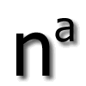 The Department of Anaesthesia,

Norfolk and Norwich Hospital

East of England Novice Course

Thursday 30th August 2018

Room 15 Bob Champion Research and Education Building
Norfolk & Norwich Hospital
09.15 -09.45 Registration and coffee/ Introduction
10:00-10.45 Airway Assessment Dr. Amit Gadre
10.45 –11.30 Pre oxygenation Dr Jon Francis
11.30 - 12.15 DAS guidelines for failed
Intubation Dr Rocio O’Ferraro
12.15 - 13.00 Lunch
13.00 - 15.30 Small group teaching
5 groups, 30 mins session
Equipment – Tubes, SAD and laryngoscopes. Which device Dr Manasi Bhagwat and when
Extubation Dr R Kare
Case Scenarios/Rest session
Rapid Sequence Induction Dr Amit Gadre
Cricothyroidotomy Dr Rocio O’Ferraro
15.30 – 16:00 Feedback and Close Dr Ravi Kare

Directions to Bob Champion Research and Education Building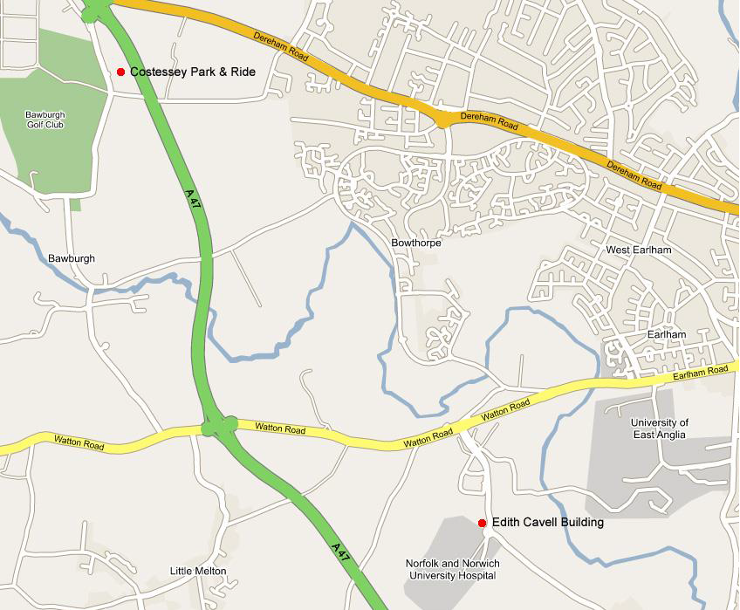
Bob Champion Research and Education Building

Directions from A47: Turn off on to the B1108 towards Norwich. At the set of traffic lights turn right towards the N&N Hospital, through one set of traffic lights and take the third exit at the roundabout. The Bob champion building is the wooden clad building on your left as you drive round the road. The car park is just after the Bob Champion building.

Directions from A11: When you approach the Thickthorn Junction, at the roundabout take the exit signposted A11 (Norwich). At the next roundabout take the first exit signposted to the N&N Hospital. This road takes you through some new housing areas (in the process of being built) and there is only one route through a series of roundabouts. The last roundabout of the series will take you left and then downhill. At the roundabout take the second exit off that roundabout. The Bob champion building is the wooden clad building on your left as you drive round the road. The car park is just after the Bob Champion building.
Park and Ride 510 from Costessey NR9 3LX (advised option)

Car parking cannot be guaranteed at busy times, so please try and use the Costessey Park and Ride or other bus services wherever possible.
Park and Ride Service 510 operates From the Costessey P&R site direct to the Hospital Monday to Friday (no weekend or bank holiday services).
- £1.00 return fare from 07.10 until 18:00
- Parking is FREE at the P&R
- There are 1100 car park spaces (including Disabled and Parent and child parking)
- Journey time to the NNUH 10 minutes
- CCTV (closed circuit television)
For timetable information visit Konect Buses

https://assets.goaheadbus.com/media/timetable_pdf/Norwich_PR_510_timetable_PDF.pdf

The Park and Ride address is Long Lane, Bawburgh, Norwich NR9 3LX

Parking Charges at the hospital
All stays under 30 minutes are free. Within the first 30 minutes the car park ticket will not need to be validated through the pay machine.
- 30 minutes up to 2 hours – £3.00
- Up to 3 hours – £3.50
- Up to 4 hours – £4.50
- Up to 5 hours – £6.50
- Up to 8 hours – £8.00
- 8 to 24 hours – £12.00.

