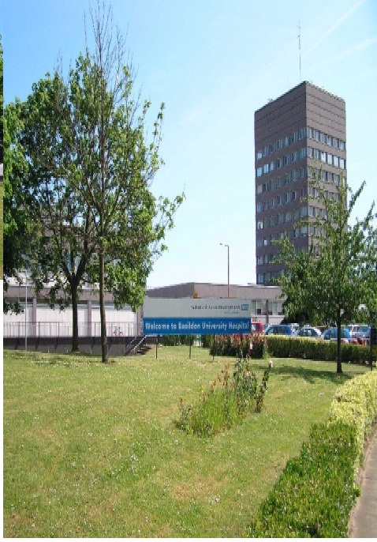
Basildon FRCR 2B ‘A to Zee’ Course

FRCR 2B syllabus in a ‘super-saturated’ format
Whole of FRCR Radiology syllabus covered in 8 days- the only course of its kind in the UK
All subjects presented in modular order with an interactive, viva-style 2B format
25 workstations – a personal monitor for each candidate

SCHEDULE FOR AUTUMN 2016 EXAM
Saturday 4th June 2016 | MSK
Saturday 11th June 2016 | Paediatrics
Saturday 18th June 2016 | GIT
Saturday 25th June 2016 | Cardiothoracic and Breast Radiology
Saturday 9th July 2016 | Rapid Reporting, MSK MRI & MSK Long Case  Workshop (Osirix based)
Saturday 16th July 2016 | Head & Neck/Genito-urinary Radiology/Exam Techniques
Saturday 6th August 2016 | CNS
Saturday 13th August 2016 | Nuclear medicine / Interventional Radiology and Oncology

9.00am Registration for a 9.30am start; 9.00pm approximate finish time

Course Organiser – Dr Sami Khan, Consultant Radiologist

Administrative cost – £50 per course day or £300 for all 8 courses
Venue – The Postgraduate Education Centre, Basildon Hospital
Information & Registration - Jane Lambeth
Tel: 01268 394687 direct or 01268-524900 ext 8644
Email: staffdev@btuh.nhs.uk
Basildon & Thurrock University Hospitals NHS Trust

