Diabetic Foot SAQ
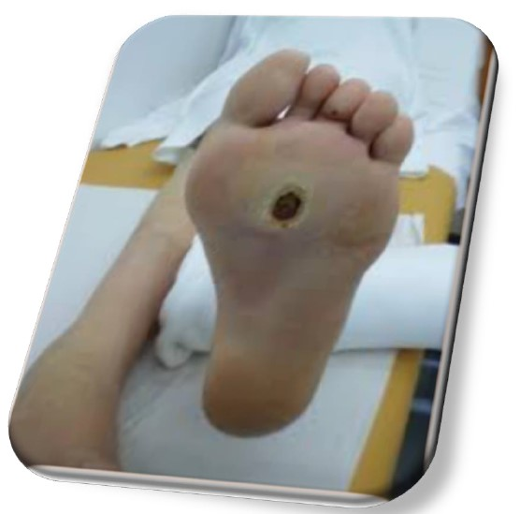
65 year-old-male-patient with chronic diabetes, presented with a diabetic foot ulcer.
- Give (4) ED management priorities?
- Who (4) should be involved in management for this patient?
- Give (4) examples of signs of a ‘limb threatening and life threatening’ ulcer requiring immediate inpatient referral
- Give (3) examples of new diabetic foot problems that can wait for 24 hours for diabetic foot team referral
- Give (4) features of Charcot arthropathy

Answers from online FRCEM questions/ NICE guidance NICE guideline NG19

    - Wound, vascular and peripheral sensory assessment
    - Glycaemic control, review regular medication
    - Non-adherent dressing to wound
    - FBC, U&E, VBG, glucose
    - X-ray to consider osteomyelitis but may be normal
    - Refer for IV antibiotics /debridement
Diabetic foot ulcers presenting to the ED should be debrided as much as is possible as the later that debridement takes place the more likely a patient is to have osteomyelitis.

    - Podiatry
    - Diabetes specialist nursing
    - District nurses
    - Surgery/ vascular input if gangrene or ischaemia

    - ulceration with fever or any signs of sepsis
    - ulceration with limb ischaemia (see the NICE guideline on lower limb peripheral arterial disease)
    - clinical concern that there is a deep-seated soft tissue or bone infection (with or without ulceration)
    - gangrene (with or without ulceration)
If a person has a limb-threatening or life-threatening diabetic foot problem, refer them immediately to acute services and inform the multidisciplinary foot care service (according to local protocols and pathways), so they can be assessed and an individualised treatment plan put in place.

    - New ulceration or wound
    - New swelling
    - New discolouration (whole or part of foot becomes redder, bluer, paler, blacker)
Health care professionals are advised to refer patients to a multidisciplinary foot care team within 24 hours if any of the above occur.

    - Redness
    - Warmth
    - swelling
    - Deformity
Suspect acute Charcot arthropathy if there is redness, warmth, swelling or deformity (in particular, when the skin is intact), especially in the presence of peripheral neuropathy or renal failure. Think about acute Charcot arthropathy even when deformity is not present or pain is not reported.
To confirm the diagnosis of acute Charcot arthropathy, refer the person within 1 working day to the multidisciplinary foot care service for triage within 1 further working day. Offer non-weight-bearing treatment until definitive treatment can be started by the multidisciplinary foot care service. Arrange a weight-bearing X-ray of the affected foot and ankle.
Charcots foot is a neuroarthropathic process with osteoporosis, fracture, acute inflammation and disorganisation of foot architecture. Acutely, it is associated with increased bone blood flow, leading to increased warmth. The diagnosis is based on the appearance of a red, swollen oedematous and possibly painful foot in the absence of infection, though during the acute phase, the two can be difficult to distinguish. A normal x-ray initially does not exclude a Charcots foot or osteomyelitis.

Later, it can become quiescent with increased bone formation, osteosclerosis, spontaneous arthrodesis and ankylosis. SIGN guidelines say that there is insufficient evidence to recommend the routine use of MRI or bone scanning to distinguish acute Charcots foot from osteomyelitis. They therefore recommend that the diagnosis should be made by clinical examination supported, where available, by the use of thermography.

