CAPE (Clinical Attachment Programme for the East of England)
Dr Muzaffer Kaser
NIHR Clinical Lecturer, Department of Psychiatry, University of Cambridge
Honorary Specialty Registrar in General Adult Psychiatry, Cambridgeshire and Peterborough NHS Foundation Trust

The CAPE (Clinical Attachment Programme for East of England) is set to expand recruitment into psychiatry training through offering international psychiatrists an attachment programme and support them through their visit to facilitate their transition to the UK. Psychiatrists from overseas are interested in coming to the UK for various reasons. One of the limiting factors is the lack of knowledge about the conditions and requirements to practise in the UK. A visiting period providing support through mentorship and the opportunity to experience clinical workplace and learn about training paths are key elements of the CAPE. The flexibility in timing is also important for candidates who would consider making a career change. Therefore, we aimed at setting a three months attachment period with an option to extend to six months. In this period, the CAPE attendees will have opportunity to observe clinical setting in the community, specialist, and acute services in the NHS. They will have access to local MRCPsych courses and will get professional support through mentors and peers during their stay. The goal is to recruit international psychiatrists into specialty training programmes in East of England. The programme is detailed in the next section.

The Stakeholders
The CAPE programme will include several stakeholders that have different roles in the process. Dr Muzaffer Kaser is the co-ordinator of the programme. The co-ordinator is responsible for establishing the links between different parties involved. The main stakeholder will be Health Education East of England, School of Psychiatry led by Dr Christopher O’Loughlin, head of school. Other stakeholders will be Directors of Medical Education and the mentors in the trusts involved.
Health Education East of England (HEEoE), School of Psychiatry will be the first point of contact and the integration hub. Dr Christopher O’Loughlin, the head of school of psychiatry will monitor the involvement of the HEEoE. The information regarding the CAPE programme and application forms will be uploaded to the HEEoE website. We have four sites available for observers to choose: Cambridgeshire, Bedfordshire, Hertfordshire and Essex.
Directors of Medical Education in each trust will be responsible for facilitating the access to teaching opportunities in their trust. Ideally, DMEs should arrange to meet the CAPE attendees within the first couple of weeks of their arrival.
The mentors will be in close contact with the CAPE attendees. They will act as sponsor to arrange the visitor’s agreement. The CAPE attendees are not expected to do any clinical work, so they will be observing the clinical setting during their stay. If possible, the mentors should organise the visit to accommodate a wide range of exposure to the mental health services. The key responsibility of the mentors is to be accessible and provide support and guidance to CAPE attendees to make the most of their visiting period. They should encourage peer contact, i.e. participation in activities with local trainees. Brief information about mentors and the facilities in their trust will be available on the CAPE section in HEEoE website.
The CAPE programme attracted 27 applications across the world in the first round. Five observers completed the programme. The CAPE programme was presented as a poster at the RCPsych International Congress 2018. The programme was promoted through social media, email lists, and through Diaspora Psychiatrists Committee at the RCPsych.
Applications
The applications will be open once a year. For administrative purposes, the arrival time of the attendees will be arranged to coincide with regional MRCPsych teaching, and avoid the holiday periods.
The applicants should submit the application form, intention letter, a CV detailing their clinical experience, and the evidence of their English proficiency. An IELTS score sufficient to meet the GMC criteria (i.e. 7.5 in academic IELTS with minimum score of 7 in each sub test: reading, writing, listening, speaking) will be prioritised. It is desirable if the CAPE attendees completed MRCPsych Part A and Part B exams. The applications will be evaluated by the co-ordinator, the head of school, and the panel of mentors. The attendees will be determined according to the capacity and the status of the mentors. The assignment to the mentors should be done as evenly as possible. Once selected, the applicants have to provide a written confirmation from their employers detailing the exact timing of their leave period.
The programme is open to all levels of psychiatric trainees and psychiatrists who aim to pursue psychiatry training in the UK. We expect the candidates to state their future plans in their intention letters. Given the relatively short period of visit, we advise the candidates to apply closer to sitting the MRCPsych CASC examination. Once they obtain the licence to practise, the international psychiatrists can progress to higher training much more quickly than the newly qualified doctors. The entry points to the UK training system are highlighted in Figure 1.
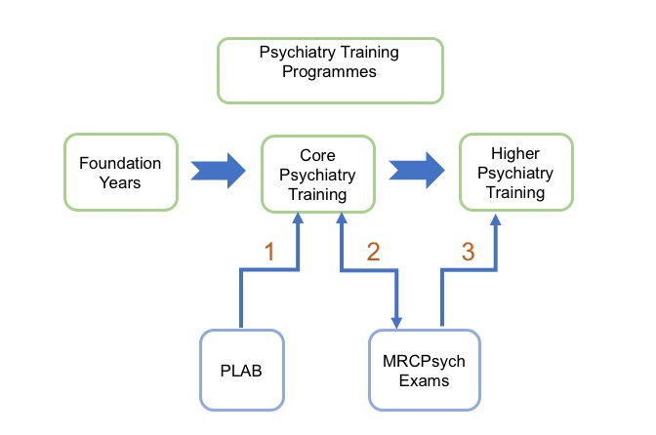
Figure 1. The potential routes for the CAPE attendees to pursue higher psychiatry training in the UK.

Honorary Observer Contract
The mentor(s) and the medical staffing in the relevant trust will set the honorary observer agreement prior to the arrival of the CAPE attendees. An observer contract should define that the CAPE attendees will always be supervised by the mentor or a designated member of staff when they are in the clinical setting. The main principle is that the CAPE attendees should have the opportunity to observe the routine clinical activities, communication style, and familiarise themselves with the NHS. If possible, the mentor should organise visits to a range of clinical services such as acute wards, community mental health teams, crisis teams, and specialist clinics in accordance with the responsible consultant psychiatrists in other clinical settings. In our experience with the first cohort of CAPE observers, they favoured spending the first few weeks with the mentor’s team and visit other clinics in the following months.

MRCPsych Course / Training Opportunities
The CAPE attendees will have the opportunity to attend local MRCPsych course and Deanery led CASC teaching. This is aimed to help with the MRCPsych exams and help attendees to meet local trainees and join the study groups. Depending on the availability, the attendees will also be invited to observe the medical school clinical skills teaching. One of the advantages of UK graduates in CASC examination is that many students have the experience of time-limited structured communication skills teaching in the medical school. CAPE attendees would benefit from the demonstration of those sessions.
The applicants are advised to contact RCPsych Examinations Unit to confirm their eligibility to sit the MRCPsych Exams. The CASC blueprint is available for download at RCPsych website.
The CAPE attendees are advised to keep a record of the clinical activities they observed. If possible, the attendees should observe clinical activities related to the Mental Health Act. Any record of observed activity could be used as portfolio evidence at the stage of job applications and approval processes such as Section 12 approval under the Mental Health Act.

Financial Matters
The CAPE programme will not charge a fee to the applicants. The CAPE attendees should note that they will be responsible for all of their expenses during their stay. The accommodation expenses may differ significantly across the region. The CAPE attendees should consider liaising with the mentors before making their applications regarding the maintenance costs. The banking system in the UK usually does not allow opening a bank account for short-term visitors. The applicants are advised to liaise with their local bank with regards to arrangements while visiting the UK.

Visa
The visitor’s agreement can be organised by medical staffing of the relevant trust while the CAPE attendees are on a tourist visa. It’s the attendees’ responsibility to comply with the regulations set by the Home Office during their stay. Once the attendee obtains their licence to practice they are advised to familiarise themselves with the Home Office updates on the immigration rules.
https://www.gov.uk/government/organisations/uk-visas-and-immigration

Further details:
Dr Muzaffer Kaser, CAPE Coordinator muzaffer.kaser@cpft.nhs.uk
Dr Chris O'Loughlin, Head of School christopher.o'loughlin@cpft.nhs.uk

