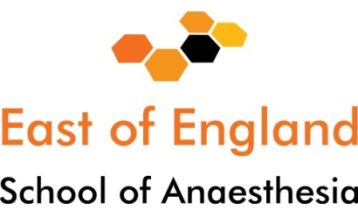

ARCP Checklist for Core Trainees

All trainees within the anaesthetic and ICM training programme are required to undertake a yearly assessment of their progress – the ARCP. In the East of England School of Anaesthesia currently each annual assessment is carried out through a meeting between the trainee and a specialty-based panel.
The process is not an assessment of you but an assessment of the submitted evidence that is presented by you. Trainees are given at least six weeks’ notice to provide the necessary documentation for the review. The evidence is reviewed by the panel prior to the meeting, and therefore must be submitted 3 weeks prior.
You will not be “chased” to provide this documentation by the required date and should be aware that failure to do so can result in an unsatisfactory outcome being awarded.
Before meeting
- Enhanced Form R to be submitted (by email) to HEEoE three weeks before your ARCP.
The following items must be on your e-portfolio and assigned to your ARCP before the deadline date (21 days before the ARCP). Please be aware that your e-portfolio will be locked at this date.
- Educational Supervisor’s Structured Report (ESSR) (must document all sick/compassionate/paternity/maternity leave)
- Multisource feedback (NB takes approximately eight weeks to complete)
- Evidence of Units of training sign-off completed on e-portfolio
- RCOA logbook summary showing breakdown of this year’s cases and total cases (as per RCOA guidance)
- Exam – evidence of success for any parts of the FRCA passed
- Consultant Feedback
- IAC (both pages – CT1 trainees only)
- IACOAC (both pages – CT2 trainees only)
- Attendance certificates for courses/simulation training
Please bring with you to ARCP meeting
- East of England workbook (all trainees)
- The anonymous trainee questionnaire (all trainees)
- Basic Level Training Certificate signed by ES or College Tutor (CT2 trainees only)

