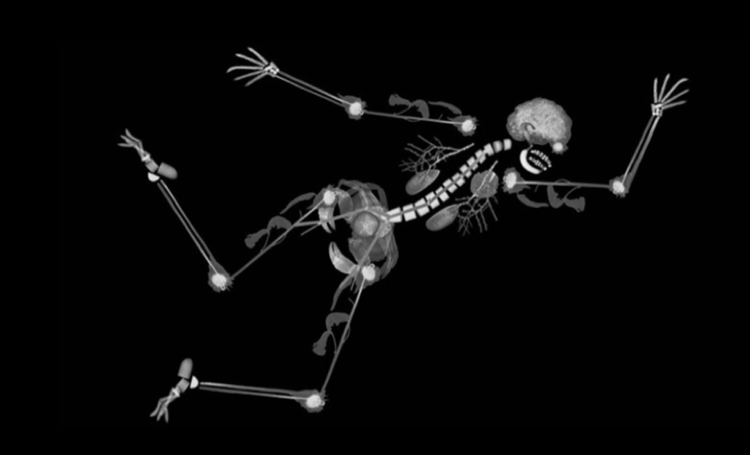  Norwich Radiology Academy  2b Long Case and VIVA Course  This one-day course aims to replicate the VIVA and long case parts of the 2b examination.  Our course is run by a group of experienced Consultant Radiologists.  The day will include 3 Individual VIVAs with a pair of examiners.  3 long cases and the opportunity to discuss the long cases at the end of the day.  Apple Mac and Osirix software.  Refreshments throughout the day and buffet lunch.  Please reply as below:  Norwich Radiology Academy, Cotman Centre, Colney Lane, NR4 7UB  Email: norwichradiologyacademy@nnuh.nhs.uk Telephone: 01603 286143 | Save the date!!!  Tuesday 17th March 2020  The course is limited to 12 spaces.  Venue:  Norwich Radiology Academy  Time: 08:30-17:00  Cost:  £75 for Eastern Deanery Applicants  £200 for other applicants  Course Organisers:  Dr Tariq Ali  Dr Hameed Rafiee  Dr Rayhaan Rahaman

