Pre-hospital Emergency Medicine Sub-specialty Training -
Kent, Surrey and Sussex

Sub-Specialty Training in Pre-Hospital Emergency Medicine is offered by Health Education England working across Kent Surrey and Sussex in conjunction with Air Ambulance Kent Surrey Sussex and other training partners.

Air Ambulance Kent Surrey Sussex (AAKSS) is one of the most well
established and busiest providers of physician lead pre-hospital care in the
UK. The service prides itself on strong governance and a constant desire to innovate in the field of pre-hospital care. AAKSS has a long history of training doctors in the field of Pre-hospital Emergency Medicine and since August 2017 has formally supported sub-specialty training.

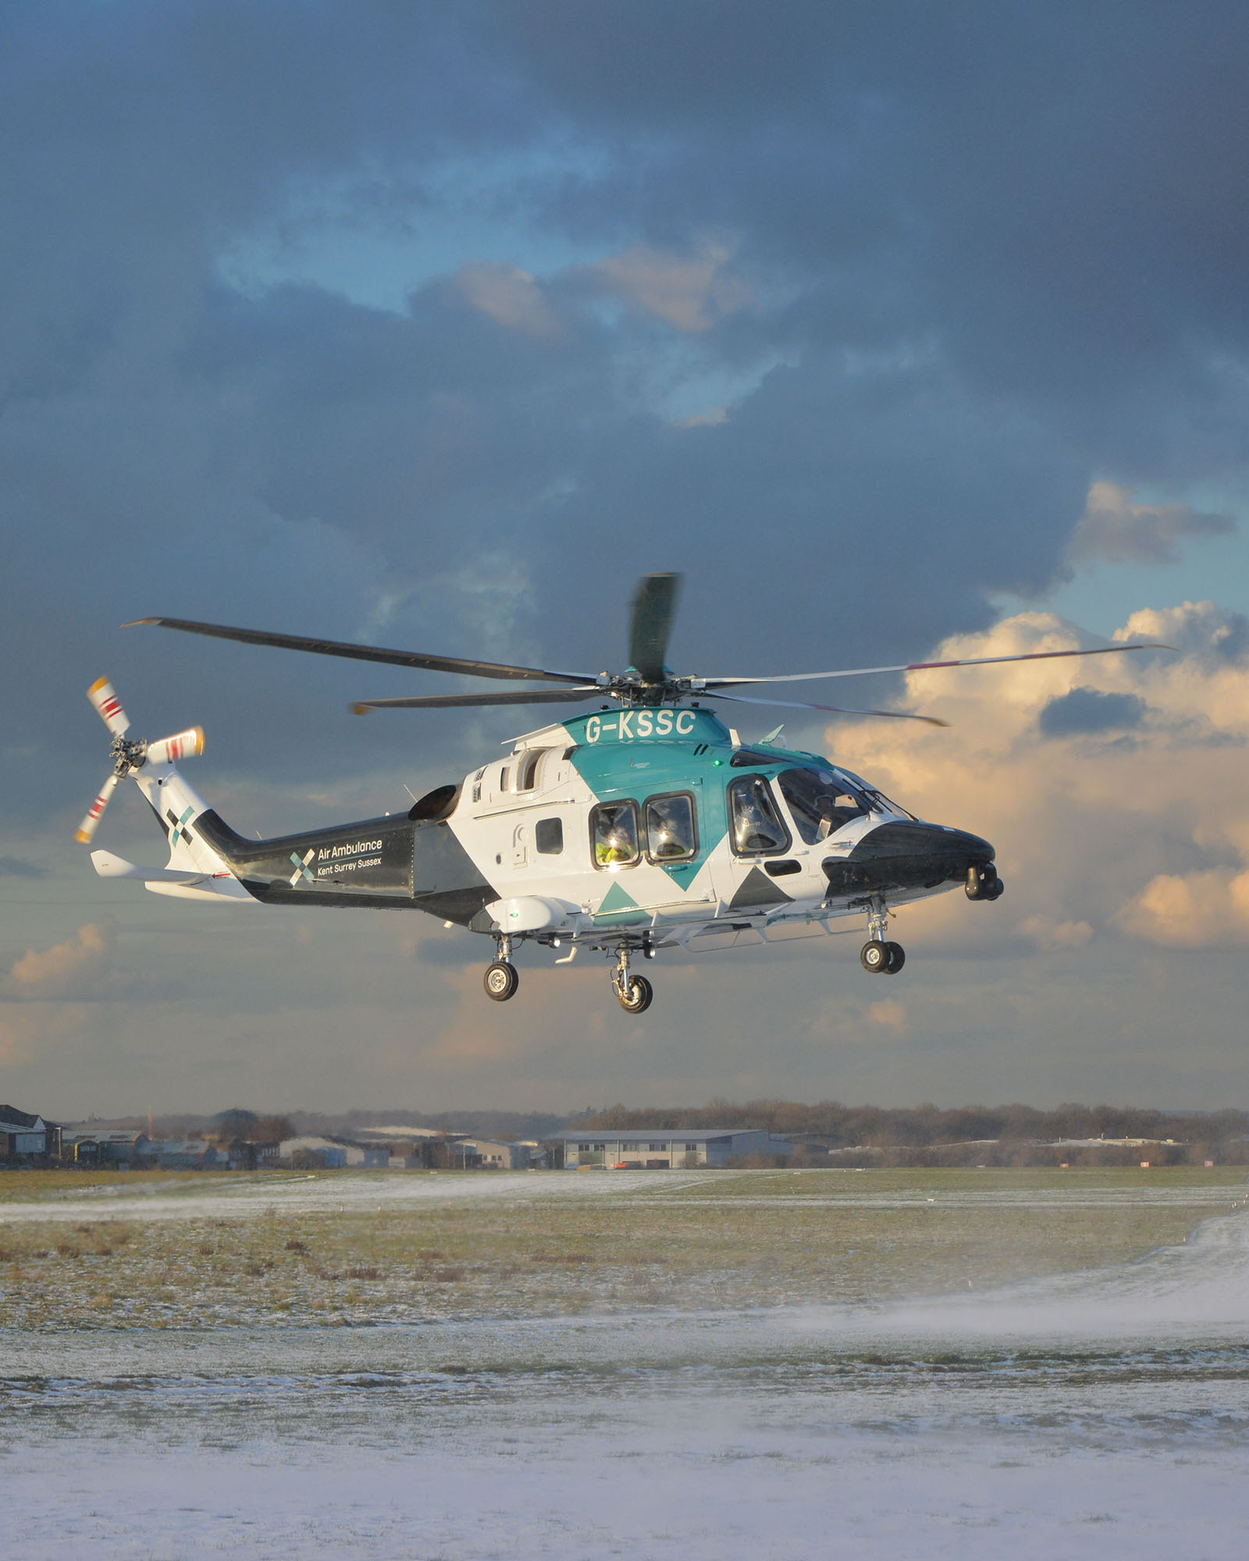

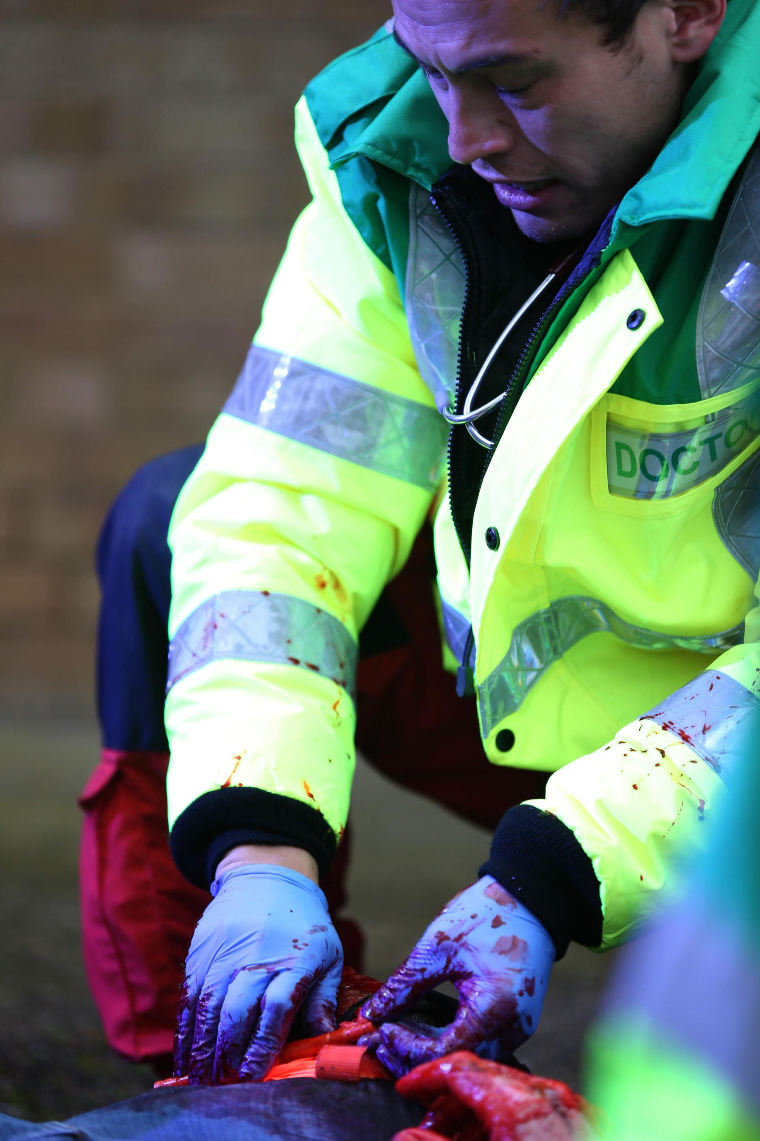

The Region

Trainees in the region will benefit from exposure to cases in a mix of urban, rural and costal environments serving a population of approximately 5 million people. In addition, our region encompasses some of the UK busiest transport networks, airports, ports and rail systems.

Clinical exposure

A PHEM trainee at AAKSS would be exposed to a wide variety of clinical scenarios. Clinical exposure is focused on high acuity trauma though all trainees are trained and expected to attend medical and paediatric cases.

In 2019 AAKSS were activated for a total of 2602 missions and treated a total of 1627 patients. Based on the annual clinical case load we anticipate trainees performing approximately 35 RSIs within the training period.

PHEM trainees in the KSS Region will be trained in the administration of pre-hospital blood and plasma and have the benefit of exposure to working within 3 separate Major Trauma Networks.

Training and supervision is provided by an experienced and enthusiastic group of senior clinicians with strong emphasis on clinical governance, research and innovation.

The training and training partners

Training is provided from our bespoke base in Redhill in Surrey that opened in 2018. Crews operate from both aircraft and response cars. This post also offers the exciting opportunity to develop an understanding of night operations by both a helicopter platform and response car. We also provide a retrieval service across the region.

In addition to AAKSS various external organisations (for example South East
Coast Ambulance Service) will support training across the curriculum. Most notably we expect our trainees to gain excellent exposure to paediatric and neonatal transfer medicine whilst undertaking observer shifts with the Children’s Acute Transfer Service working out of Great Ormond Street Hospital, London.

From August 2021 we will offer 2 training posts following scheme C (full time PHEM for 12 months, though this may be subject to change in the future). The post is currently paid at Band 1A. Candidates who wish to undertake less than full time working will be supported fully.

For further information please contact anthonyh@aakss.org.uk

