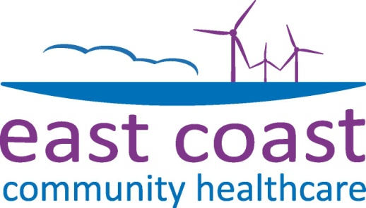
News from

24th October 2014
ECCH staff share learning to promote healthy relationships for local children
The attachments children form with their parents in their early months and years determine the way they form relationships for the rest of their lives. That was the theme of a day of learning and information-sharing by East Coast Community Healthcare’s Children and Families Services this week.
Health visitors, school nurses and other ECCH children’s services providers were among around 150 clinicians who got together to promote best practice and share innovative ideas. Guest speakers at the event, held at the Royal Assembly Rooms in Great Yarmouth on Tuesday, included probation officer Sarah Hipperson who delivers the "Caring Dads” programme helping fathers in Suffolk bond with their children and specialist health visitor Maggie Phillips who spoke about the needs of parents whose children have disabilities.
ECCH’s health visitors, healthy weight practitioners and breastfeeding support teams from across Waveney and Yarmouth also gave presentations about the work they do and the difference it is making for local families.
ECCH Director of Health Improvement and Children’s Services Pamela Agapiou said: “Attachment is a key principle which our teams promote to new mums and dads. A loving and nurturing parental relationship builds a child’s confidence and self-esteem. Research shows that, without a loving role model, children struggle to make successful relationships throughout their lives. We do a lot of work with parents to help them form those bonds.
“Our information day was a chance to learn from each other and from other agencies we work with. It demonstrated that we’ve got a dedicated workforce who are able to support each other. They’re doing difficult work but they are also able to have fun. We celebrated our achievements and were able to thank our staff for their commitment to deliver the Healthy Child Programme.”
The Healthy Child Programme is the government’s early intervention and prevention public health programme for children, young people and families. It offers a programme of developmental reviews, screening tests, immunisations, information and guidance on parenting and healthy choices.
ENDS
East Coast Community Healthcare is a social enterprise which provides NHS community health services, mainly for its local population of 230,000 people from the areas around Great Yarmouth, and Waveney.
These services include district nursing, health visiting, community in-patient services, physiotherapy, occupational therapy, speech and language therapy, specialist nursing care, palliative care, a primary care centre, contraceptive and sexual health services, school nursing and health improvement services.
Prior to 1st October 2011 ECCH was part of NHS Great Yarmouth and Waveney. As a social enterprise it is owned by the staff and uses any surplus money for the benefit of the community in Great Yarmouth and Waveney.
For further information contact:
Clare Weller
Communications
Tel: 07917 183823
Email: clareweller@nhs.net

