Health Visitor Programme - Weekly News

Issue 31
23rd May 2013
……………………………………………………………………………………………………………

Information – Focus on Return to Practice

Children and families in the East of England have benefited from the excellent Health Visitors who have made the decision to return to practice after a break from the profession. Below are the reflections of two of our return to practice Health Visitors.

There are always opportunities for others to do the same, if you know of anyone who may be interested please discuss this with them and suggest that they contact us for more information. Whilst undergoing the return to practice course attendees receive a bursary of £2,000.00

If you have any reflections from your Health Visitors and you would like them to be shared (with their permission) please send them through, these can include New Qualified Health Visitors, Students, and experienced Practitioners.

Returning to Health Visiting Practice
One year on ……

In September 2011 I received a return to practice recruitment letter in the post which had been forwarded from my old address (I am a firm believer in fate!) and the rest is history ……

Later that year I attended a conference in Duxford, Cambridgeshire, about the ‘Changing face of Health Visiting’ and wow was I in for a surprise! To be quite frank I found the conference over-whelming, not only because of the massive changes that had gone on during my absence from the profession, but also I found the whole experience of attending a conference quite daunting. You lose confidence when you are not exposed to events like this on a regular basis and therefore rather than igniting my passion for returning to the profession it made me doubt my confidence and competence. But I took the plunge and here I am, now a fully-fledged Health Visitor working full time having been out of the profession for over 20 years.

In January 2013 I started my RTP course at the University of Hertfordshire alongside 8 other students from across East Anglia - Hertfordshire was the only university in the Eastern region offering the course at this time. It was good being a student again and I enjoyed learning from the knowledge and experience of the other students as well as from the theoretical expertise taught and researched on the course. I also completed 300+ hours on a practice placement near to my home in Letchworth and the other students were able to undertake their placements near to their homes too. However, thrown into the world of full time work created other dilemmas as I had not worked for the past 3 years before RTP and had never really had any intention of returning to part time work, let alone full time!

My practice placement was an interesting experience with highs and lows – days when I enjoyed experiences and days when I seriously questioned what I had let myself in for! The team I worked with were supportive and I learned a lot from them about different styles of individual working and I attended team meetings, safeguarding meetings and had individual supervision. I found the familiarity of clinic work and development checks reassuring; those were the things that I felt I knew best and therefore competent and confident with. I completed my competency passport which I found a useful reflective tool, it enabled me to think about how I needed to update my knowledge base effectively in the limited time I had. The structure of it enabled me to break component parts into “bite sized chunks” which I felt I could cope with at the time.

One of the biggest changes for me was System 1 – the computer system, which I never thought I would be able to navigate round. I can hardly believe it but now I am helping other people with queries and over the past year I have improved my understanding of its intricacies and I continue to learn something new every day. I think it’s a huge asset to the job and I now wouldn’t be without it, despite being a real technophobe just a year ago. The IT support team are incredibly patient and have helped me out of a number of sticky situations! My most embarrassing moment so far – calling IT support only to realise that I have not connected to the internet in the first place – hence no System 1!

Last June I started work as a real life Health Visitor again – I was both excited and anxious at the same time. Yes the course and placement had prepared me well but it was scary! It took a long time to get up and running with simple things like a car park pass and claiming for mileage as my surname had changed from 20 years ago and this seemed to cause a lot of confusion. However I started work doing clinics and development checks and shadowing other members of the team to learn more about child protection and the more complex situations that occur on a day to day basis for a Health Visitor. The team I work with are incredibly supportive and I feel that I can ask anything and someone will always know the answer, which is always very reassuring.

Domestic violence response and CQINN follow ups for Accident and Emergency visits for under 5’s were new to me as well as the complex nature of child protection. This was a vague process 20+ years ago but it is now a very structured process and system which is undoubtedly a benefit to those vulnerable children who are at risk in their everyday lives. I have learned these processes and a year into the job I am developing a wealth of experience and knowledge, enabling me to feel confident and competent to do this part of the job efficiently and effectively. The supervision for this aspect of the job is second to none - without it I would find it difficult to be accountable for this work.

My tough book (laptop) is one of the greatest assets of the job, creating work flexibility for me to input data at home when it suits me. This promotes a healthier work/life balance for me and my family, enabling me to do the job to the best of my ability and enjoy activities outside work that otherwise I might not be able to fit in. An occasional horse ride at the end of a busy and sometimes stressful day is a great bonus!

I would like to take this opportunity to say a massive thank you to the team I have worked with for the past year (you know who you are) and thank you to the team leader who recruited me and enabled me to RTP. I’m back, I’m back, and it’s good to be back!
Heather Gay 18th May 2013

Cath Slater
T: 01707 388004
E: Cath.Slater@hchs.nhs.uk

Return to Practice Reflections

Return to practice health visitor reflection

“When last in practice, health visitors (HV’s) in Ipswich were GP attached. My office in the surgery was fully equipped with a couch, a chair, filing cabinet, telephone, scales and caseload of five hundred families. Scales for weighing babies at home were the hand held spring balance (with baby in a muslin nappy sling) variety, with heavy portable scales and measuring mats coming in to service in the late 1980’s. HV first visits were at 28 days then, with full handover from the GP attached midwife in the preceding days. I recall busy days working largely alone, with four or more visits each morning and afternoon, and baby clinics held in church halls, health authority clinic and GP surgery. Documentation was done immediately after each visit, either in the home or in the car between visits, and if a report needed preparing this would be handwritten (or typed at home) with carbon copies. There were no photocopiers, admin assistance, computers or word processors available for HV’s”
“Returning to practice in 2012, with the impetus of the Health Visitor Implementation Plan, and the return of health visiting and public health to county council management, it seems very much that things have gone full circle. Current geographical working and corporate caseloads, together with the wonders of new technology and paperlite working have been an interesting situation to come into. I had not realised how comforting it is to have a folder full of bits of paper when setting out on a visit, but the Personal Child health record (red book) has the same comfort blanket feel to it, and its use is satisfying to parents and professionals. My impression is that we are doing all the same things as before, but in a much more focused and accountable manner, working with parents very much as partners, with consideration of informed consent, giving evidence based authoritative information and advice, without being authoritarian.”

Clare Slater-Robins
E: clare.slater-robins@suffolk.gov.uk
T: 07940 479016

……………………………………………………………………………………………………………

Reminder & Action – SAVE THE DATE

An official invite will be sent you next week with instructions of how to register – watch this space.
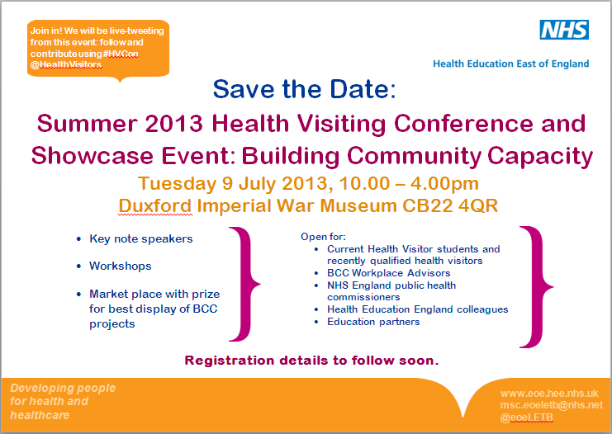

……………………………………………………………………………………………………………

Reminder – Spreading the Word More Widely – Sharing Practice

Please ensure to get your article in to us in plenty of time.
The sharing practice article contents that we have received so far have been excellent, and will all be available on our website from next week. Details of the next 6 scheduled articles listed below:-

30th May - W Essex
6th June – SW Essex
13th June – NE Essex
20th June – SE Essex
27th June – Mid Essex

Articles of up to 200 words in Word format highlighting an innovation or area of good practice (including contact details) are to be sent to Lucy Hall, HealthVisitorPA@eoe.nhs.uk by the Wednesday
…………………………………………………………………………………………………………….

Reminder – Follow us on Twitter East of Eng HV prog@HealthVisitors

We are now up to 49 followers which is excellent. Keep on following for some more updates
……………………………………………………………………………………………………………

Contacts

Julia Whiting, Health Visiting Programme Lead
M: 07535 638236
T: 01223 597512
E: Julia.whiting2@nhs.net

Lucy Hall, Health Visiting Programme Support
T: 01223 596858
E: healthvisitorpa@eoe.nhs.uk

