TOXICOLOGY/ORIGINAL RESEARCH
Accuracy of Noninvasive Multiwave Pulse Oximetry Compared
With Carboxyhemoglobin From Blood Gas Analysis in
Unselected Emergency Department Patients
Dominik Roth, CM, Harald Herkner, MD, MSc, Wolfgang Schreiber, MD, Nina Hubmann, MD, Gunnar Gamper, MD, Anton N. Laggner, MD, Christof Havel, MD
From the Department of Emergency Medicine, Medical University of Vienna, Vienna, Austria.
Study objective: Accurate and timely diagnosis of carbon monoxide (CO) poisoning is difficult because of nonspecific symptoms. Multiwave pulse oximetry might facilitate the screening for occult poisoning by noninvasive measurement of carboxyhemoglobin (COHb), but its reliability is still unknown. We assess bias and precision of COHb oximetry compared with the criterion standard blood gas analysis.
Methods: This was a prospective diagnostic accuracy study according to STARD (Standards for the Reporting of Diagnostic accuracy studies) criteria, performed at a tertiary care hospital emergency department. We included all patients for whom both invasive and noninvasive measurement within 60 minutes was available, regardless of their complaints, during a 1-year period.
Results: One thousand five hundred seventy-eight subjects were studied, of whom 17 (1.1%) received a diagnosis of CO poisoning. In accordance with this limited patient cohort, we found a bias of 2.99% COHb (1.50% for smokers, 4.33% for nonsmokers) and a precision of 3.27% COHb (2.90% for smokers, 2.98% for nonsmokers), limits of agreement from 3.55% to 9.53% COHb (4.30% to 7.30% for smokers, 1.63% to
10.29% for nonsmokers). Upper limit of normal cutoff of 6.6% COHb had the highest sensitivity in screening for CO poisoning. Smoking status and COHb level had the most influence on the deviation between measurements.
Conclusion: Multiwave pulse oximetry was found to measure COHb with an acceptable bias and precision.
These results suggest it can be used to screen large numbers of patients for occult CO poisoning. [Ann Emerg Med. 2011;58:74-79.]
Please see page 75 for the Editor’s Capsule Summary of this article.
Provide feedback on this article at the journal’s Web site, www.annemergmed.com.

A podcast for this article is available at www.annemergmed.com.
0196-0644/$-see front matter
Copyright © 2011 by the American College of Emergency Physicians. doi:10.1016/j.annemergmed.2010.12.024

INTRODUCTION

Background
Carbon monoxide (CO) poisoning is a major cause of morbidity and mortality. Official data from the United States indicate approximately 20,000 exposures¹ and 439 deaths² per year, including only nonfire-related and unintentional cases. Large registry trials, however, show much higher numbers than those officially reported, with approximately 50,000 visits per year to emergency departments (EDs) alone, representing 0.05% of all patients.^{3,4} Data from other countries are limited, but higher rates than in the United States are expected.⁵
Symptoms of CO poisoning are nonspecific, ranging from mild headache, nausea, confusion, and dizziness to end-organ injury such as myocardial infarction,⁶ stroke,⁷ and death.^{8,9} Diagnosis is therefore difficult and relies on clinical suspicion and confirmation by measurement of carboxyhemoglobin (COHb), using either venous or arterial¹⁰ blood gas analysis. However, COHb analyzers are not ubiquitously available.¹¹ As a result, many victims of CO poisoning might be overlooked and misdiagnosed.^{12,13}

Importance
Conventional pulse oximetry uses 2 different wavelengths of light only and is not able to explicitly determine COHb or methemoglobin levels, leading to wrong results.¹⁴ Recent technologic advancements allow for noninvasive measurement of COHb by multiwave pulse oximetry.¹⁵ Multiwave pulse oximeters use 8 different wavelengths to overcome this problem. This technique has been tested on healthy volunteers¹⁵ and small groups of selected patients.¹⁶⁻¹⁹ To date, however, the accuracy of this method has not been studied in daily clinical use with large numbers of unselected patients.
Editor’s Capsule Summary
What is already known on this topic
Multiwave pulse oximetry can noninvasively determine carbon monoxide (CO) levels.
What question this study addressed
This prospective study of 1,578 patients determined the bias and precision of multiwave pulse oximetry, using blood gas analysis as the criterion standard.
What this study adds to our knowledge
Bias and precision seemed acceptable. Negative predictive value at a cutoff of SpCO 6.6% was 100%; however, there were only 17 patients with CO poisoning in the cohort.
How this is relevant to clinical practice
This noninvasive technique could be an effective means for screening at-risk populations for CO poisoning. Further assessment in samples with a higher prevalence of CO poisoning is required to firmly establish the accuracy of this technology.
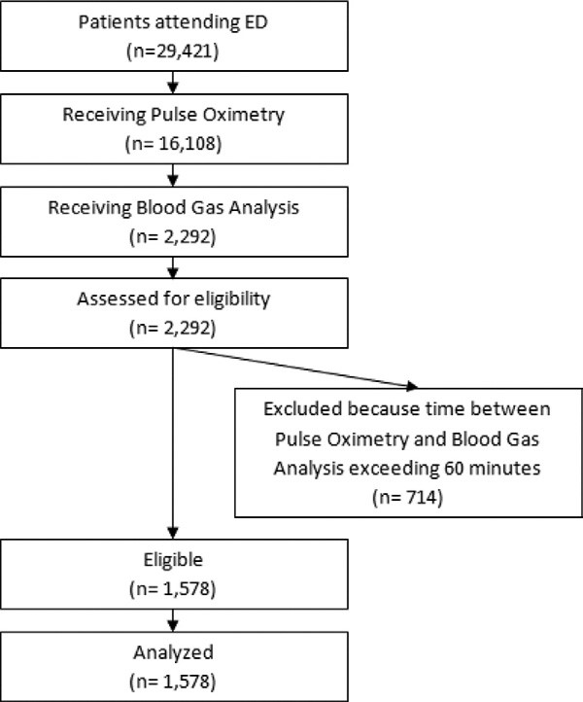
Table 1. Patient characteristics.
n(%) or median (IQR),
Patients Included (n1,578) as appropriate
Women, No. (%) 773 (49)
Age, y, median (IQR) 48 (34)
Body temperature, °C, median (IQR) 36.6 (0.9)
Systolic blood pressure, mm Hg, median (IQR) 130 (30)
Diastolic blood pressure, mm Hg, median 69 (22)
(IQR)
Pulse rate, beats/min, median (IQR) 91 (29)
SpO₂, %, median (IQR) 97.0 (3.0)
SpCO, %, median (IQR) 3.0 (5.0)
SpMe, %, median (IQR) 0.4 (0.5)
COHb, %, median (IQR) 0.9 (1.2)
Venous BGA, No. (%) 1,515 (96) Arterial BGA, No. (%) 63 (4)
Time between CO oximetry and BGA, min, 38 (21) median (IQR)
Smokers, No. (%) 525 (33)
Cigarettes per day (smokers only), No., 20 (10) median (IQR)
Time since last cigarette (smokers only), min, 60 (50) median (IQR)
IQR, Interquartile range; BGA, blood gas analysis.
Goals of This Investigation
The aim of our study was to assess bias and precision of multiwave pulse oximetry compared with blood gas analysis as reference standard in a cohort of unselected patients presenting to a large tertiary care ED. We further aimed to identify the upper limit of normal cutoff values of noninvasively measured COHb to aid in the diagnosis of CO poisoning and identify factors that influence its accuracy. Subgroup analyses were performed for smokers and nonsmokers.
MATERIAL AND METHODS
Study Design and Setting
The study was performed as a prospective cohort-type study according to the STARD (Standards for the Reporting of
Diagnostic accuracy studies) statement for reporting studies of diagnostic accuracy.²⁰ It was conducted at a tertiary care 2,000-bed university hospital ED with a census of 30,000 patient visits per year. The study was approved by our institutional review board for human studies, with a waived written informed consent.
Figure 1. Patient flow chart. Selection of Participants and Interventions
For the purpose of this study, we replaced the standard pulse oximeters with Masimo Radical 7 CO oximeters (Masimo Inc., Irvine, CA). All triage nurses were instructed in the use of the new device both by the study team and company staff. The issue of correct placement of the probe was explicitly addressed, and the potential for different measurement results from correct and incorrect placement was demonstrated. During the study period, the study team supervised the use of the device and continuous feedback was given. Multiwave pulse oximetry was performed by a triage nurse. The primary assessment documentation sheet was modified to include COHb saturation (SpCO), methemoglobin saturation (SpMet) levels, and the patient’s self-reported smoking habits (whether the patient was a smoker, cigarettes smoked per day, and time in minutes since last cigarette). Blood gas analysis (arterial or venous) (Table 1)
Accuracy of CO Oximetry vs Carboxyhemoglobin From Blood Gas Analysis Roth et al
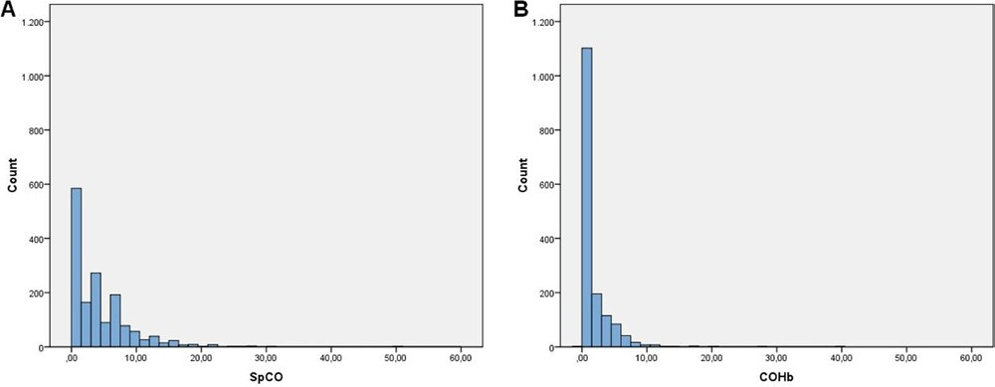
Figure 2. Distribution of values measured by CO oximetry (A, SpCO) and blood gas analysis (B, COHb).
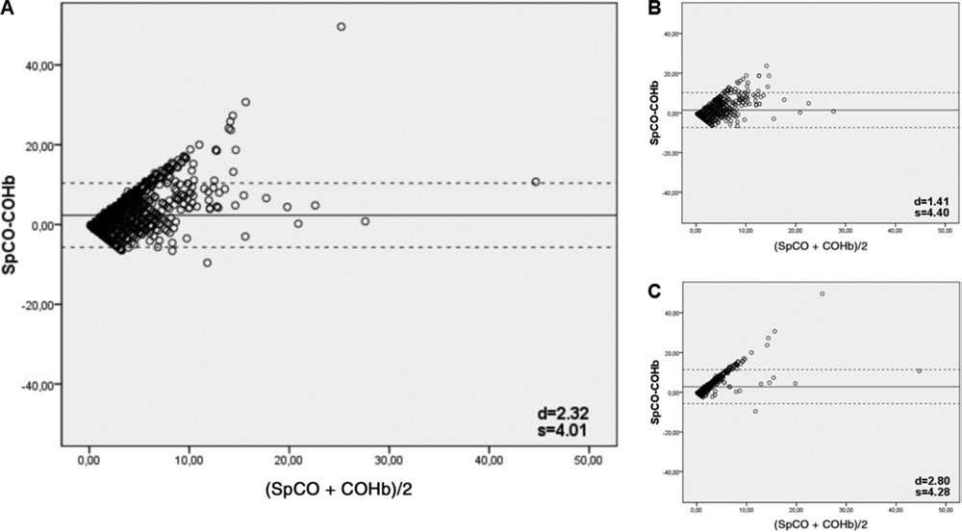
Figure 3. Bland-Altman diagrams comparing CO oximetry (SpCO) with blood gas analysis (COHb). A, All patients; B, smokers only; and C, nonsmokers only. d denotes the bias (mean SpCO to COHb), s denotes the precision (SD of the differences between SpCO and COHb). Dotted lines represent the limits of agreement for SpCO (d2s). Dotted lines
represent the limits of agreement for SpCO (d2s).
was performed later as a standard procedure in our ED on discretion of the treating physician for a variety of clinical reasons.
A Radiometer ABL700 (Radiometer Medical APS, Copenhagen, Capital Region, Denmark) was used for blood gas analysis. We included all patients attending our ED for whom invasive and noninvasive measurement within 60 minutes was available, regardless of their complaints during a 1-year period from July 1, 2008, to June 30, 2009. Patients were excluded if more than 60 minutes had elapsed between multiwave pulse oximetry and blood gas analysis to avoid measurement deviations caused by the half-life of CO (Figure 1). The diagnosis of CO poisoning was based on increased COHb levels and clinical symptoms consistent with poisoning, including headache, vomiting, abdominal pain, and loss of consciousness.

Primary Data Analysis
Data from the primary assessment documentation, including demographics, vital signs, and blood gas analysis printouts, were collected the next day and transferred to a spreadsheet (Microsoft Excel 2007; Microsoft, Redmond, WA). Descriptive statistics were calculated for all available parameters. The method described by Bland and Altman²¹ was used to assess agreement between measurement by CO oximetry (SpCO) and by blood gas analysis (COHb). The mean difference (bias, d) as a metric for the systematic measurement error, the SD of the differences (precision, s), and the limits of agreement (d2s) as metrics for scatter were calculated. Receiver operating characteristic curves were used to find an “optimal” SpCO cutoff value to screen for CO poisoning (ie, focusing primarily on high sensitivity; specificity secondary) compared with conventional criteria (medical history, symptoms, COHb value). The area under the curve was calculated as a measure of discrimination. We used multivariable linear regression models to investigate possible influencing factors on the deviation between SpCO and COHb. According to pathophysiologic and technical considerations, we included sex, age, body
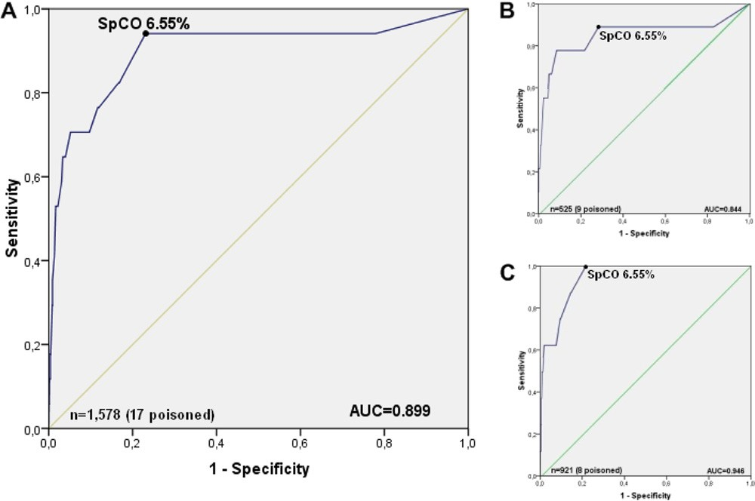
Figure 4. Receiver operating characteristic curves showing sensitivity versus 1–specificity to detect cases considered as having truly increased CO levels for various SpCO cutoff values. Black dot marks “optimal” cutoff value. A, All patients; B,
smokers only; and C, nonsmokers only.
temperature, mean arterial pressure, pulse rate, SpO2, SpCO, SpMet, COHb, time between multiwave pulse oximetry and blood gas analysis, self-reported smoking status, cigarettes smoked per day, and time since last cigarette as covariates. We used SPSS for Windows (version 16; SPSS, Inc., Chicago, IL) for descriptive statistics, Bland-Altman, and receiver operating characteristic curves. Regression models were calculated with Stata (version 10; StataCorp, College Station, TX). For parameters of diagnostic test accuracy, we calculated 95% confidence intervals (CIs) with exact standard errors. A 2-sided P.05 was considered statistically significant.

RESULTS
A total of 2,292 patients receiving both blood gas analysis (arterial or venous) and noninvasive multiwave pulse oximetry were eligible for the study. Seven hundred fourteen patients were excluded because time between CO oximetry and blood gas analysis exceeded 60 minutes, resulting in 1,578 patients finally included (Table 1; Figure 2A and B). SpCO values ranged from 0% to 50% (median 3% SpCO; interquartile range 5% SpCO) and COHb values from 0% to 39.3% (median
0.9% COHb; interquartile range 1.2% COHb). Seventeen (1.1%; 95% CI 0.6% to 1.7%) of the 1,578 patients received a final diagnosis of CO poisoning. Their mean COHb level was 14.1% (SD 9.0%). Among those 17 patients, 9 were smokers and 8 were nonsmokers.
Bland-Altman analysis revealed a bias between SpCO and COHb of 2.32% (95% CI 2.11% to 2.54%) for all patients,
1.41% (95% CI 1.01% to 1.81%) for smokers, and 2.80%
Table 2. Diagnostic test accuracy.*
%(fraction)
95
%CI
Cutoff 6.6% SpCO for all patients (n1,578)
†
Sensitivity | 94 (16/17) | 71–100
‡ Specificity | 77 (1,201/1,561) | 75–79
§  Positive predictive value | 4 (16/376) | 2–7
Negative predictive value  Cutoff 6.6% SpCO for smokers  (n525) | 100 (1,201/1,202) | 100–100
† Sensitivity | 89 (8/9) | 52–100
‡ Specificity | 71 (368/516) | 67–75
§  Positive predictive value | 5 (8/156) | 2–10
Negative predictive value  Cutoff 6.6% SpCO for nonsmokers  (n921) | 100 (368/369) | 98–100
† Sensitivity | 100 (8/8) | 63–100
‡ Specificity | 78 (713/913) | 75–81
§  Positive predictive value | 4 (8/208) | 2–7
Negative predictive value | 100 (713/713) | 99–100
*Information on smoking status was missing for 132 nonpoisoned patients.
Complete information on smoking status was available for all poisoned patients. Parameters of diagnostic test accuracy were derived from multiwave pulse oximetry as the index test and the clinical diagnosis of CO poisoning as reference standard. Continuous SpCO values from multiwave pulse oximetry have been dichotomized at 6.6%.
†Sensitivity: number of true positives/number of true positives number of false negatives.
‡Specificity: number of true negatives/number of true negatives number false positives.
§Positive predictive value: number of true positives/number of true positives number of false positives.
Negative predictive value: number of true negatives/number of true negatives number of false negatives.

Accuracy of CO Oximetry vs Carboxyhemoglobin From Blood Gas Analysis Roth et al
Table 3. Predictors for deviation between SpCO and COHb.
Predictors |  | Regression Coefficient (95% CI)
 | All Patients | Nonsmokers | Smokers
Smoker, yes/no | 2.72 (2.92 to 2.52) | — | —
SpCO, % | 0.89 (0.85 to 0.93) | 0.98 (0.96 to 1.00) | 0.804 (0.73 to 0.88)
Interval between measurements, min | 0.01 (0 to 0.02) | 0.01 (0.00 to 0.01) | 0.01 (0.01 to 0.03)
Age, y | 0.01 (0.01 to 0) | 0.03 (0.01 to 0.00) | 0.03 (0.04 to 0.01)
Number of cigarettes per day —  indicates the according predictor was not part of this particular model. |  | — | 0.05 (0.07 to 0.03)

(95% CI 2.52% to 3.07%) for nonsmokers and a precision of 4.01% (4.40% for smokers, 4.28% for nonsmokers), resulting in limits of agreement from 5.7% to 10.37% (7.39% to 10.21% for smokers, 5.76% to 11.36% for nonsmokers). Deviation between SpCO and COHb, however, was not normally distributed. Accordingly, we also performed BlandAltman analysis, using log-transformed values. This resulted in a bias of 2.99% higher readings in SpCO compared with COHb (1.50% for smokers, 4.33% for nonsmokers) and a precision equivalent to 3.27% (2.90% for smokers, 2.98% for nonsmokers), with limits of agreement from 3.55% to 9.53% (4.30% to 7.30% for smokers, 1.63% to 10.29% for nonsmokers). See Figure 3A and C for Bland-Altman diagrams.
Receiver operating characteristic curves were used to find optimal SpCO cutoff values for the identification of these patients (Figure 4A to C). According to data from the 17 patients who received a diagnosis of CO poisoning, SpCO 6.6% provided the best combination of sensitivity and specificity as a screening test for the total cohort, as well as for both subgroups of smokers and nonsmokers, respectively (Table 2).
We used multiple linear regression to model deviation between SpCO and COHb as the dependent variable. For the total population, for smokers and for nonsmokers we developed separate models. We found that smoking, SpCO, interval between measurements, and age independently influenced the measurement deviation. For smokers, the number of cigarettes smoked per day also was an independent predictor. In smokers, deviation between SpCO and COHb was 2.7% lower compared with that of nonsmokers. Deviation between SpCO and COHb decreased with increasing age (0.01% per year of age) and increased with SpCO levels (0.9% per percentage SpCO) and interval between measurements (0.01% per minute delay). None of the vital parameters, such as pulse rate or blood pressure, had an influence on the deviation (Table 3).

LIMITATIONS
Compared with the large population used for the calculation of bias and precision, the number of patients actually found to be poisoned was small, especially in the group of poisoned smokers. Therefore, the opportunity for false-negative results was limited. Because a false-negative reading could have serious medical consequences, this device should be tested in a much larger number of poisoned patients to confirm the generalizability of our stated cutoff values. Despite intensive staff training, there is potential that the new probe placement affects device accuracy.²² This study was designed to investigate multiwave pulse oximetry as an ED screening tool to detect occult CO poisoning. Independent confirmation of COHb concentration is warranted in patients with positive screening results.

DISCUSSION
In a cohort of consecutive unselected ED patients, we found a bias between SpCO and COHb of 2.99% and a precision of 3.27%. There are currently no standards of acceptable bias and precision of COHb measurements. However, conventional pulse oximetry, which is a widely used and accepted tool, has been shown to measure oxyhemoglobin with a bias of 0.02% and a precision of 2.10% compared with blood gas analysis.²³ As a result, a bias of 2% to 4% seems acceptable to us for the detection of high concentrations of COHb, as found in acute CO poisoning. The international standard on pulse oximeters for medical use requires those devices to measure SpO2 with a root mean square deviation less than or equal to 4.0% SpO2. Bias and precision of noninvasive CO oximetry as found by us was equivalent to a root mean square deviation of 4.43% COHb.
Our study suggests that noninvasive multiwave pulse oximetry constantly overestimates COHb compared with blood gas analysis. This effect is noticeably more pronounced in nonsmokers. We found a number of factors contributing to this uncertainty, but the absolute SpCO value and the number of cigarettes smoked seemed to be of the most clinical importance and should be kept in mind when this technique is used. A COHb value of 6.6% appears to be a reasonable upper limit of normal cutoff value for a screening test in the ED setting. Because of the short half-life of CO, neither method can safely rule out remote CO exposure. Diagnosis must be made according to clinical presentation, history, circumstances, and time elapsed from possible CO exposure.
Previous smaller studies on multiwave pulse oximetry have demonstrated varying outcomes, even differing in the direction of the bias. A study by Barker et al¹⁵ of 10 healthy volunteers resulted in a bias of 1.22% and a precision of 2.19% for the measurement of COHb by multiwave pulse oximetry. In 12 selected patients, Coulange et al¹⁸ found a bias of 1.5% and a precision of 2.5%. Suner et al¹⁷ reported a bias of 4.2% in 64 of the patients in their study, without giving a precision. Piatkowski et al¹⁹ reported a bias of 3.43% and a precision of 2.362% for 20 patients and 5 healthy volunteers. A recently published study by Touger et al²⁴ of 120 patients resulted in a bias of 1.4% and a precision of 6.5%, which did not represent an unselected ED population because only suspected victims of CO poisoning were included. It remains, however, unclear how the decision was actually made because no exact criteria are given, and a median COHb level of 2.3% seems surprisingly low for a population of potentially poisoned patients.
In conclusion, multiwave pulse oximetry was found to measure COHb with an acceptable bias and precision. Keeping influencing factors in mind, it can therefore be used to screen large numbers of patients for latent CO poisoning, using presented cutoff values. Verification of suspicious cases identified noninvasively by blood gas analysis should be undertaken, if possible.
The authors acknowledge the nursing staff of the Department of Emergency Medicine for ongoing support of the CO oximetry project and the Vienna Fire Department for overall excellent cooperation and expertise.

Supervising editors: Matthew D. Sztajnkrycer, MD, PhD; Richard C. Dart, MD, PhD
Author contributions: DR drafted the study protocol and the article. DR and CH conducted the literature search and participated in data acquisition. HH, WS, GG, ANL, and CH critically revised the study protocol. HH, WS, NH, GG, ANL, and CH critically revised the article for important intellectual content. DR, HH, and NH were responsible for statistical analysis. WS and NH participated in data acquisition. ANL supervised clinical implementation. CH supervised the project. All authors gave final approval of the article. CH takes responsibility for the paper as a whole.
Funding and support: By Annals policy, all authors are required to disclose any and all commercial, financial, and other relationships in any way related to the subject of this article as per ICMJE conflict of interest guidelines (see www.icmje.org). Equipment, Masimo Radical-7, was provided by Masimo Inc. Mr. Roth and Dr. Hubmann were paid by a grant from Masimo Inc. Masimo had no influence on the design, conduct, or publication of this study whatsoever.
Publication dates: Received for publication July 13, 2010. Revision received October 12, 2010. Accepted for publication December 15, 2010. Available online April 2, 2011.
Address for correspondence: Harald Herkner, MD, MSc,
Department of Emergency Medicine, Medical University of
Vienna, Waehringer Guertel 18-20/6D, A-1090 Vienna, Austria; 43-1-40-400-1964, fax 43-1-40-400-1965; E-mail harald.herkner@meduniwien.ac.at.

REFERENCES
- Centers for Disease Control and Prevention. Nonfatal, unintentional,non–fire-related carbon monoxide exposures—United States, 20042006. MMWR Morb Mortal Wkly Rep. 2008;57:896-899.
- Centers for Disease Control and Prevention. Carbon monoxide–related deaths—United States, 1999-2004. MMWR Morb Mortal Wkly Rep. 2007;56:1309-1312.
- Hampson NB. Emergency department visits for carbon monoxidepoisoning in the Pacific Northwest. J Emerg Med. 1998;16:695-698.
- Hampson NB, Weaver LK. Carbon monoxide poisoning: a new incidencefor an old disease. Undersea Hyperb Med. 2007;34:163-168.
- Keles A, Demircan A, Kurtoglu G. Carbon monoxide poisoning: howmany patients do we miss? Eur J Emerg Med. 2008;15:154-157.
- Satran D, Henry CR, Adkinson C, et al. Cardiovascularmanifestations of moderate to severe carbon monoxide poisoning. J Am Coll Cardiol. 2005;45:1513-1516.
- Prockop LD, Chichkova RI. Carbon monoxide intoxication: anupdated review. J Neurol Sci. 2007;262:122-130.
- Weaver LK. Clinical practice. Carbon monoxide poisoning. N Engl J Med. 2009;360:1217-1225.
- Ernst A, Zibrak JD. Carbon monoxide poisoning. N Engl J Med. 1998;339:1603-1608.
- Touger M, Gallagher EJ, Tyrell J. Relationship between venousand arterial carboxyhemoglobin levels in patients with suspected carbon monoxide poisoning. Ann Emerg Med. 1995;25:481-483.
- Hampson NB, Scott KL, Zmaeff JL. Carboxyhemoglobinmeasurement by hospitals: implications for the diagnosis of carbon monoxide poisoning. J Emerg Med. 2006;31:13-16.
- Wolf SJ, Lavonas EJ, Sloan EP, et al. Clinical policy: criticalissues in the management of adult patients presenting to the emergency department with acute carbon monoxide poisoning. J Emerg Nurs. 2008;34:e19-32.
- Dolan MC, Haltom TL, Barrows GH, et al. Carboxyhemoglobinlevels in patients with flu-like symptoms. Ann Emerg Med. 1987; 16:782-786.
- Tremper KK, Barker SJ. Pulse oximetry. Anesthesiology. 1989;70: 98-108.
- Barker SJ, Curry J, Redford D, et al. Measurement ofcarboxyhemoglobin and methemoglobin by pulse oximetry: a human volunteer study. Anesthesiology. 2006;105:892-897.
- Mottram C HL, Scanlon PD. Comparison of the Masimo Rad 57 pulse oximeter with SpCO technology against a laboratory COoximeter using arterial blood. Respir Care. 2005;50:1471.
- Suner S, Partridge R, Sucov A, et al. Non-invasive pulse COoximetry screening in the emergency department identifies occult carbon monoxide toxicity. J Emerg Med. 2008;34:441-450.
- Coulange M, Barthelemy A, Hug F, et al. Reliability of new pulseCO-oximeter in victims of carbon monoxide poisoning. Undersea Hyperb Med. 2008;35:107-111.
- Piatkowski A, Ulrich D, Grieb G, et al. A new tool for the earlydiagnosis of carbon monoxide intoxication. Inhal Toxicol. 2009; 21:1144-1147.
- Bossuyt PM, Reitsma JB, Bruns DE, et al. Towards complete andaccurate reporting of studies of diagnostic accuracy: the STARD Initiative. Ann Intern Med. 2003;138:40-44.
- Bland JM, Altman DG. Statistical methods for assessingagreement between two methods of clinical measurement. Lancet. 1986;1:307-310.
- O’Malley GF. Non-invasive carbon monoxide measurement is notaccurate. Ann Emerg Med. 2006;48:477-478.
- Van de Louw A, Cracco C, Cerf C, et al. Accuracy of pulse oximetry inthe intensive care unit. Intensive Care Med. 2001;27:1606-1613.
- Touger M, Birnbaum A, Wang J, et al. Performance of the RAD-57 PulseCO-oximeter compared with standard laboratory carboxyhemoglobin measurement. Ann Emerg Med. 2010;56:382-388.

