- 80 year-old man with known hypertension is brought to the ED by ambulance. He was putting some shopping into a low cupboard when he experienced sudden onset of severe posterior neck pain. He then collapsed. En route in the ambulance, he had a BP of 70/40, and looked pale and mottled.

In the ED, his vitals have normalised and his neck pain has now gone. He now has new onset dysphagia, oxygen saturations on 90% in room air, but the remainder of examination is unremarkable.

List 4 differential diagnosis and which you think is most likely. (2 marks)
Thoracic dissection (with vertebral artery extension)
TIA
PE
SAH
Explain why he might have dysphagia? (2 marks)
Vertebral artery dissection can cause dysarthria, hoarseness, dysphagia secondary to infarction of CN IX/X
What 4 other neurological signs might you find on examination? (2 marks)
Ipsilateral facial pain/numbness
Ipsilateral limb/trunk numbness & limb/trunk ataxia
Ipsilateral loss of taste
Nystagmus
Ipsilateral Horners
2 investigations would you request to confirm the diagnosis. (2 marks)
CT Brain / CTA
MRI Brain / MRA
Vascular Duplex Scanning of vertebral arteries
Transcranial Doppler
Outline the course of the vertebral arteries. (2 marks)
Subclavian origin to transverse foramina of C5/6.
Runs in transverse foramina from C5/6 to C2.
From C2 runs posterolaterally to loop around posterior arch of C1 and passes between the atlas and occiput (Spontaneous dissection usually occurs here).
Pierces dura at foramen magnum and continues to join the pons & medulla where both vertebral arteries join the basilar trunk (intracranial section).

Brief Notes:
The typical presentation of vertebral artery dissection (VAD) is a young person with severe occipital headache and posterior neck pain following a recent, relatively minor, head or neck injury.
A latent period as long as 3 days between the onset of pain and the development of CNS sequelae is not uncommon. Delays of weeks and years also have been reported. Many patients present only at the onset of neurologic symptoms.
Patients most commonly report symptoms attributable to lateral medullary dysfunction (ie, Wallenberg syndrome). Patient history may include the following:
- Ipsilateral facial dysaesthesia (pain and numbness)
- Dysarthria or hoarseness (cranial nerves [CN] IX and X)
- Contralateral loss of pain and temperature sensation in the trunk and limbs
- Ipsilateral loss of taste (nucleus and tractus solitarius)
- Hiccups
- Vertigo
- Dysphagia (CN IX and X)
- Unilateral hearing loss
- Nausea and vomiting
- Diplopia or oscillopsia (image movement experienced with head motion)
Once contraindications to anticoagulation have been ruled out, the accepted management of proven or suspected spontaneous vertebral artery dissection (VAD) consists of anticoagulant therapy in those patients who are not also affected by the complication of subarachnoid haemorrhage.
Complications:
- Brainstem infarction
- Cerebellar infarction
- Subarachnoid haemorrhage
- Vertebral artery pseudoaneurysm causing compressive cranial neuropathy

- A 58 year-old man previously diagnosed with alcoholic liver cirrhosis presents to the ED with fever and generalized abdominal discomfort. He also reports worsening abdominal swelling despite increasing doses of his diuretics. Examination reveals stigmata of chronic liver disease, confusion and significant ascites.
What is the most likely diagnosis? (1 mark)
Spontaneous Bacterial Peritonitis
What is the pathophysiology of this condition? (2 marks)
A combination of bacteraemia and decreased immune function of plasma and ascitic fluid. Previously thought to be due to bacterial translocation through the bowel wall (Remains controversial).
What 3 features in this patient suggest your diagnosis? (1 mark)
Fever
Abdominal discomfort
Worsening or unexplained Encephalopathy
Ascites refractory to diuretics
Give 2 further investigations you would do other than diagnostic paracentesis. (1 mark)
Blood test – FBC/ LFTs/ U&Es/ Clotting
Blood culture
Radiologically – CXR/ AXR/ US
Urine – MC&S
What is the most likely causative organism? (1 mark)
E. coli
Give 2 risk factors for the development of spontaneous bacterial peritonitis? (2 marks)
Cirrhosis of liver
Nephritic syndrome in children
Low complement levels
Chronic renal failure with frequent peritoneal dialysis
What are 2 indications for antibiotic prophylaxis? (2 marks)
Prior episode of Spontaneous Bacterial Peritonitis
Patient with ascites admitted with acute GI bleeding
Patient with ascitic fluid with protein levels of less than 1g/dl

Brief Notes:
Spontaneous bacterial peritonitis (SBP) is an acute bacterial infection of ascitic fluid. 3/4 of spontaneous bacterial peritonitis infections have been caused by aerobic gram-negative organisms (50% of these being Escherichia coli). The remainder has been due to aerobic gram-positive organisms (19% streptococcal species).
Fever and chills occur in as many as 80% of patients. Abdominal pain or discomfort is found in as many as 70% of patients.
Other signs and symptoms may include the following:
- Worsening or unexplained encephalopathy
- Diarrhoea
- Ascites that does not improve following administration of diuretic medication
- Worsening or new-onset renal failure
- Ileus
An ascitic fluid neutrophil count of more than 500 cells/µL is the single best predictor of spontaneous bacterial peritonitis, with a sensitivity of 86% and specificity of 98%. Lowering the ascitic fluid neutrophil count to more than 250 cells/µL results in an increased sensitivity of 93% but a lower specificity of 94%.
An ascites lactate level of more than 25 mg/dL was found to be 100% sensitive and specific in predicting active spontaneous bacterial peritonitis in a retrospective analysis.
Combining the results of the ascitic fluid polymorphonuclear neutrophil (PMN) count and the ascitic fluid culture yields the following subgroups:
- Spontaneous bacterial peritonitis
- Culture-negative neutrocytic ascites (probable spontaneous bacterial peritonitis)
- Monomicrobial nonneutrocytic bacterascites
Spontaneous bacterial peritonitis is noted when the PMN count is 250 cells/µL or higher, in conjunction with a positive bacterial culture result.

- A 30 year-old female, PhD student from Korea, presents to the ED complaining of gradually worsening headache. She also is feeling fatigued and experiencing aches and pains in her joints; when she walks more than 200-metres, she experiences pain in both her calfs that resolves when she stops. She denies and past medical history.

Examination reveals hypertension (BP 152/94), with a systolic blood pressure difference of 20 mmHg between her arms. There audible bruits in her neck, and murmur suggestive of aortic regurgitation. Her ESR is 60 mm/hr.
List 4 differential diagnosis and which you think is most likely. (2 marks)
Takayasu Arteritis
Aortic Disection / Coarctation of aorta
Subarachnoid Haemorrhage
Sarcoidosis
(Anything Sensible)
List 3 further investigations other than blood and urine tests that you would do. (2 marks)
ECG
CXR
CT angiography
What 4 features in the patient fulfil the American College of Rheumatology criteria suggestive of the diagnosis? (2 marks)
Age of 40 years or younger at disease onset
Claudication of the extremities
Difference of at least 10 mm Hg in systolic blood pressure between arms
Bruit over 1 or both subclavian arteries or the abdominal aorta
What is Cogan syndrome? (2 marks)
Cogan syndrome involves interstitial keratitis and a vestibuloauditory syndrome
What other diagnostic criteria available in defining the diagnosis? (1 mark)
Ishikawa criteria
What is the mainstay of therapy? (1 mark)
Corticosteroids

Brief Notes:
Takayasu arteritis is a rare, systemic, inflammatory large-vessel vasculitis of unknown aetiology that most commonly affects women of childbearing age.
Takayasu arteritis can be divided into the following 6 types based on angiographic involvement:
- Type I - Branches of the aortic arch
- Type IIa - Ascending aorta, aortic arch, and its branches
- Type IIb - Type IIa region plus thoracic descending aorta
- Type III - Thoracic descending aorta, abdominal aorta, renal arteries, or a combination
- Type IV - Abdominal aorta, renal arteries, or both
- Type V - Entire aorta and its branches
Complications of the disease include the following:
- Stroke
- Intracranial haemorrhage
- Seizures
- Complications of hypertension
- Valvular heart disease
- Retinopathy
Constitutional symptoms include the following:
- Headache (50%-70%)
- Malaise (35%-65%)
- Arthralgias (28%-75%)
- Fever (9%-35%)
- Weight loss (10%-18%)

Cardiac and vascular features include the following:
- Bruit, with the most common location being the carotid artery (80%)
- Blood pressure difference of extremities (45%-69%)
- Claudication (38%-81%)
- Carotodynia or vessel tenderness (13%-32%)
- Hypertension (28%-53%; 58% with renal artery stenosis in one series)
- Aortic regurgitation (20%-24%)
- Raynaud’s syndrome (15%)
- Pericarditis (< 8%)
- Congestive heart failure (< 7%)
- Myocardial infarction (< 3%)

- A 67 year-old man presents to the ED with left-sided weakness of 2-hours duration. His wife says his speech is incoherent, and that he is ignoring her whenever she stands to his right. Blood pressure is 158/92.
Which vascular territory is affected? (1 mark)
Right MCA
What are the indications for immediate imaging in patients presenting with an acute stroke, as per the NICE CG68 guidance? (2 marks)
Indications for thrombolysis or early anticoagulation treatment
On anticoagulant treatment
A known bleeding tendency
A depressed level of consciousness (Glasgow Coma Score below 13)
Unexplained progressive or fluctuating symptoms
Papilloedema, neck stiffness or fever
Severe headache at onset of stroke symptoms
Which drug is beneficial in the acute treatment of non-haemorrhagic stroke? Give dose, timing and route of administration. (2 marks)
Alteplase 0.9 mg/kg (max 90mg) within 3 hours of symptom onset (up to 4.5 hours in some institution) IV
The patient’s symptoms have resolved completely when you go to assess him.
What are his factors which may increase his risk of having a stroke in the short term? (4 marks)
A (Age): age >60 years (1)
B (Blood pressure): > 140/90 mmHg) (1)
C (Clinical features): unilateral weakness (2)
D (symptom Duration): >60 minutes (2)
D2 (Diabetes): yes/no (1)
What is his ROSIER score? (1 mark)
Unilateral arm weakness (1)
Unilateral leg weakness (1)
Speech disturbance (1)
Visual field defect (1)
ROSIER Score = 4

ROSIER Score
(Nor AM et al. Lancet Neurol 2005; 4(11): 727-34; http://www.ncbi.nlm.nih.gov/pubmed/16239179)
Score NEW Symptoms only:
Unilateral facial weakness | +1
Unilateral arm weakness | +1
Unilateral leg weakness | +1
Speech disturbance | +1
Visual field defect | +1
Loss of consciousness or syncope | -1
Seizure | -1
TOTAL SCORE | ROSIER +1 or more = new stroke/TIA likely  ROSIER -2 to 0 = stroke/TIA unlikely

What artery supplies each marked area of the brain? (2 marks)
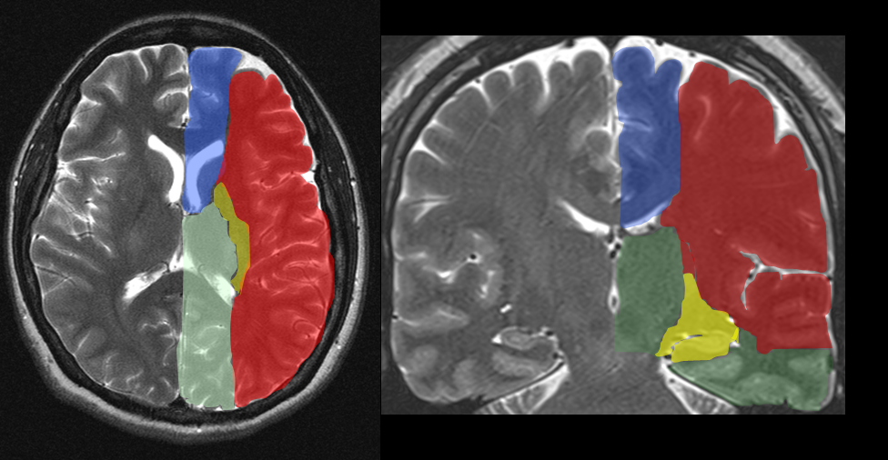
Red – Middle Cerebral Artery
Blue – Anterior Cerebral Artery
Green – Posterior Cerebral Artery
Yellow – Anterior Choroidal Artery
Apart from time of onset, what are other exclusion criteria for thrombolysis in non-haemorrhagic stroke? (3 marks)
Patients older than 80 years
All patients taking oral anticoagulants are excluded regardless of the international normalized ratio (INR)
Patients with baseline NIHSS greater than 25
Patients with a history of stroke and diabetes

- A 34 year-old man has been sent to have a venogram (DSA).
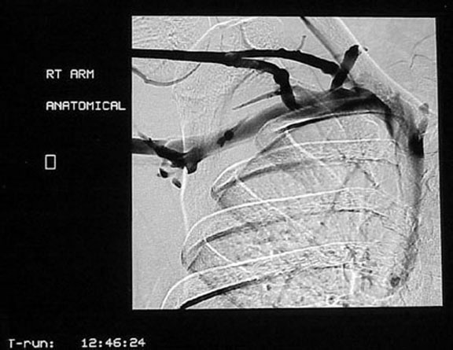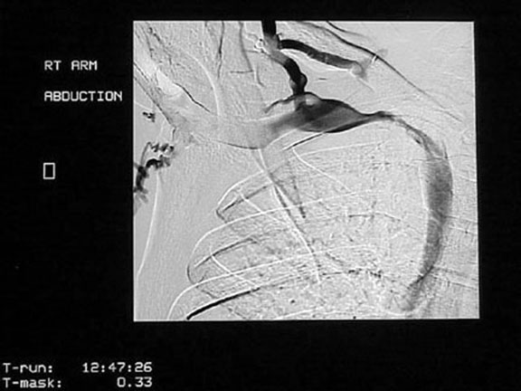
What is the result of the investigation? (1 mark)
Subclavian vein obstruction on abduction
Give 3 causes of thoracic outlet syndrome which will be evident on a chest radiograph. (3 marks)
Cervical rib
Callous from clavicle #/ deformed clavicle
Pancoasts tumour
What is a positive Adson sign? (3 marks)
The Adson manoeuvre is performed by positioning the tested shoulder in slight abduction and extension. Then, the patient extends his or her neck and turns the head toward this shoulder. The patient inhales while the examiner simultaneously palpates the ipsilateral radial pulse. If the pulse diminishes or the patient has paraesthesias, the test result is considered positive as long as this manoeuvre does not cause symptoms on the asymptomatic contralateral side.
What is Pemberton’s sign? (1 mark)
Raising the arms above the head causes visible venous congestion (plethora) of the face and neck.
- 10 month-old girl is brought by her parents to the Emergency Department with a high fever persisting for 8 days. She has been treated by the GP with antibiotics for presumed viral URTI, without any improvement. She was previously well and was breastfed up to 4 months of age. On examination, the child is ill looking, irritable and febrile (T⁰ 39.2 ⁰C).
How would you measure the temperature in children less than 4 weeks old? (NICE Guidance: Feverish Illness in Children CG47) (1 mark)
Electronic thermometer in the axilla
How would you assess for signs of dehydration in this child? (NICE Guidance: Feverish Illness in Children CG47) List 4 (2 marks)
Prolonged CRT
Abnormal skin turgor
Abnormal respiratory pattern
Weak pulse
Cool extremities
List 4 symptoms and signs might you find in a child with Kawasaki disease. (4 marks)
Persistent High fever (>39 C) duration of 7 to 14 days
Conjunctival injection, which is bilateral, non-exudative and painless
Changes in the mucous membranes; dry and cracked lips and a strawberry tongue
Erythematous rash; often diffuse and maculopapular
Changes in the extremities; erythema of the palms and soles with subsequent desquamation
Cervical lymphadenopathy with multiple non tender lymph nodes >1.5 cm in diameter
Give 2 cardiac complications from Kawasaki disease. (1 mark)
Coronary artery aneurysm
Myocardial Infarction
What is the mainstay of treatment for Kawasaki disease? What is the aim of this treatment? (2 marks)
IVIG – to reduce incidence of aneurysmal formation

- 68 year-old man presented to ED with severe back pain. He looks pale and is in very severe pain. His HR is 120/min, irregularly irregular, and BP is 100/60. There is a palpable pulsatile mass in the abdomen.
Define aneurysm. (2 marks)
An abnormal blood-filled dilatation of a blood vessel and especially an artery resulting from disease of the vessel wall
Describe the necessary steps to perform bedside ultrasonography for evaluation of abdominal aortic aneurysm. (4 marks)
Optimise analgesia for patient
Patient in the supine recumbent position
Ultrasonography with an abdominal transducer (the standard probe used for this examination is a 3.5- to 5-MHz transducer)
Scan the upper abdomen in the transverse and longitudinal plane.
Identify the aorta and trace it to its bifurcation with the iliac vessels.
Use the external diameter (outer wall to outer wall) to measure the diameter of the aorta at its widest point.
The patient is on warfarin and his INR is 3.8. How does warfarin work? (1 mark)
Inhibits synthesis of vitamin K dependent clotting factors: II, VII, IX, X
The patient is to be transferred to the operating theatre for urgent laparotomy. The anaesthetist phones down to ask that the patient is administered Beriplex® before leaving the Emergency Department. What is Beriplex®, and what does it contain? (1 + 2 marks)
Beriplex®, a prothrombin complex concentrate derived from pooled human plasma.
Contains the vitamin K-dependent coagulation factors II, VII, IX and X, and the vitamin K-dependent coagulation inhibition proteins C and S.

- A 10 month-old boy presents with episodic abdominal pain. His parents tell you that that the ‘attacks’ are intermittent and occurring every 30 minutes. During these attacks, the infant screams and flexes at the waist, draws the legs up to the abdomen, and appears pale
What is intussusception? (2 marks)
Defined as the telescoping or invagination of a proximal portion of intestine (intussusceptum) into a more distal portion (intussuscipiens).
Name 3 conditions are associated with increased risk for intussusception? (3 marks)
Henoch Schonlein Purpura (complicates 1% of HSP – but an FCEM SAQ favourite)
Adenovirus Type C (and other URTI pathogens)
Cystic Fibrosis
Measles
Seasonal (peak incidence in spring & autumn – Nelson’s Textbook of Pediatrics, 18th ed.)
Gastroenteritis
Meckel’s diverticulum (more likely in those aged > 2 years-old)
Mesenteric adenitis
Abdominal surgery within the previous 5 days – more likely to be ileoileal intussusception
Lymphoma / lymphosarcoma / haemangioma / intestinal duplication / neurofibroma (rare, and more likely if aged > 2 years-old)
Give 3 symptoms or signs you might find? (3 marks)
Palpable abdominal mass
Passage of red currant jelly stool (late sign)
Peritonitis if late presentation
Vomiting
Fever/sepsis
Abdominal distension
What non-operative treatment can avoid the need for surgery in acute intussusception? (1 mark)
Therapeutic enemas can be hydrostatic, with either barium or water-soluble contrast, or pneumatic, with air insufflation.
What are 2 absolute contraindications for this non-operative treatment? (1 mark)
Presence of peritonitis
Evidence of perforation revealed on plain radiographs
Presence of shock
- A 35 year-old man presents to the ED with severe epigastric pain radiating through to the back, with vomiting and inability to keep anything down for the previous 18 hours. Past history includes obesity (BMI 32 kg/m²) and type 2 diabetes mellitus, but no previous episodes of abdominal pain resulting in attendance at hospital. Vital signs are T 35.2 ⁰C, HR 122/min, BP 100/45, RR 32/min, BM 17.2. Examination reveals epigastric tenderness, which is disproportionate to the amount of pain he is experiencing. He appears cool peripherally. Relevant blood results include WCC 14.2 x 10⁹ /L, Creatinine 200 μmol/L, AST 200 IU/L, Alkaline phosphatase 350 IU/L, γGT 450 IU/L, Amylase 1,898 IU/L, and CRP 160 mg/L.
What is the likely diagnosis? (1 mark)
Acute severe pancreatitis.
What markers of severity are present in this patient? (3 marks)
CRP > 150 mg/L
Body mass index > 30 on initial assessment
APACHE II > 8 (score in this patient is 9 based on available data)
Give the two commonest causes of this condition? (1 mark)
Alcohol ingestion & cholelithiasis
Give 8 potential complications that might arise from this condition? (4 marks)
Peripancreatic fluid collections
Pseudocysts
Peripancreatic necrosis +/- infection
Hyperglycaemia
Electrolyte disturbances: hypocalcaemia, hypomagnesaemia, hypophosphataemia
Shock
Acute renal failure
Acute respiratory failure: pleural effusions, ARDS
Multiorgan failure
Disseminated intravascular coagulation

