Question 1
A 45 year old man presents with acute low back pain. He works as a labourer but does not remember any specific event that might have precipitated the pain.

A. Give five indications for radiography of the lumbar spine in patients with non traumatic back pain as described by the Royal College of Radiologists guidelines. 5 marks

B. You obtain a radiograph which is shown in the booklet
Describe the abnormality on the X-ray and its significance in this case (2 marks)

C. Describe the motor, sensory and reflex losses from an S1 nerve compression. (3 marks)

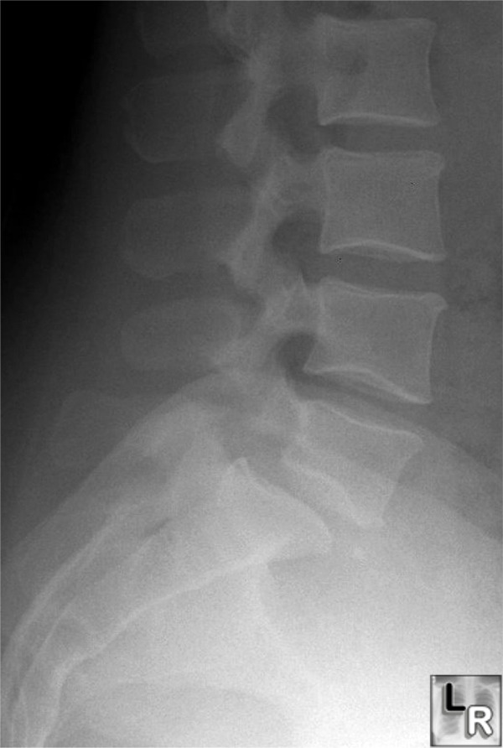
Question 2

A 30 year old female who is 6 months pregnant with her first child presents to the Emergency Department complaining of dysuria. You suspect a UTI.

A: Give 2 physiologic changes that put a pregnant patient at increased risk of a urinary tract infection. (2 marks)

B: Give the 2 most likely organisms in an otherwise healthy pregnant woman . (2 marks)

C: What 3 clinical findings that would make you suspect pyelonephritis (3 marks)

D: Give three complications of pyelonephritis in pregnancy (3 marks)

Question 3
A 45 year old homeless man is found unconscious and smelling of alcohol in a public park. He is brought into your resus room by the paramedics and full monitoring is commenced. He is on high flow oxygen via a face mask with a reservoir bag.
On examination
His Glasgow coma score is 10 (E=3, V = 3, M = 4) , his pulse rate is 110 beats per minute, blood pressure is 100/60mmHg, Temperature 37ºC, respiratory rate 20 per minute.
His bloods show
Na 140, K 3.5, U 10, Cr 110, Cl 92

Arterial blood gases on 15 litres per minute oxygen show
pH 7.29, pO₂ 10 kPa, pCO₂ 3.9 kPa, bicarbonate 16 mmol/l,

A. Comment on both the acid base balance and the ventilation status.
(2 marks)

B. Calculate the anion gap and show your calculation (2 marks)

C. Suggest four causes of the anion gap abnormality calculated in B other than ethylene glycol poisoning (4 marks)

D. Name two clinical manifestations of ethylene glycol when ingested orally and the mechanism of action producing this clinical effect (2)

Question 4:

A 70 year old man attends the ED complaining of headache and double vision. On examination he is unable to open his left eyelid. He has diabetes mellitus and hypertension.

A: Give 2 abnormalities seen here. (2 marks)

B: What is the diagnosis? (2 marks)

C: Name 5 possible causes for this. (5 marks)

D: What is the most likely cause in this patient? (1 mark)

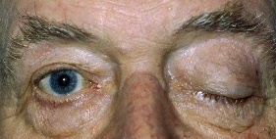

Question 4

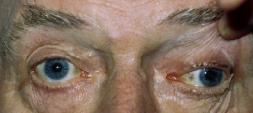

Question 5
A 71 year old lady first presented to the ED 2 months ago with a right Colles fracture after falling. She was placed in a plaster cast for 6 weeks and has been discharged from the fracture clinic.
She returned to the ED complaining of continuing discomfort in the hand and wrist associated with difficulty in using her fingers. Her hands and wrists are shown.

A: Describe 3 abnormalities see and name the most likely diagnosis (4 marks)

B: Name 2 other clinical features you would look for that might support this diagnosis (1mark)

C: Name 1 investigation that might be indicated and give 4 treatments she is likely to require (5 marks)

Question 5

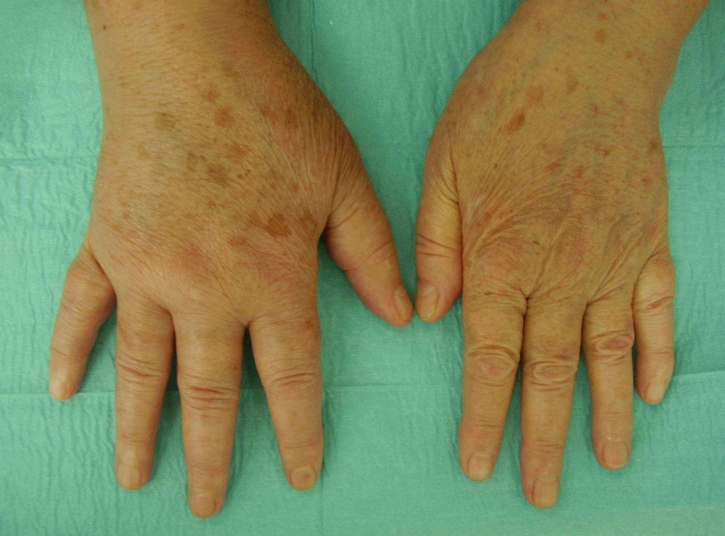
Question 6
A 55 year old man is brought in with fatigue and headache. He had been working in a derelict building’s kitchen and found that the gas oven was leaking. He has no past medical problems. His vital signs are; pulse 120, BP 125/80, respiratory rate 22. Examination of his heart, chest and abdomen are otherwise unremarkable.

The SHO has done arterial blood gases on air which show

pH 7.30
PC02 2.92 kPa
PO2 12.5 kPa
Na 135.2 mmol/l
Ca 1.3 mmol/l
K 4.2 mmol/l
Carboxyhaemoglobin 23%
H⁺ 50 nmol/l
BE -6 mmol/l
HC03 21 mmol/l
Sa02 99.2%
Lactate 2.2 mmol/l

A: What is the diagnosis and give 2 other physical signs would you look for? (3 marks)

B: What 2 further investigations would you request? (2 marks)

C: What single treatment would you initiate (1 mark)

D: Give 4 indications for the more specialised treatment? (4 marks)

Question 7
Your SHO asks to discuss a case.
A 42 year old geologist has presented 14 days after return from a 6 week field trip to Papua New Guinea. He gives a 6day history of fever and rigors. On the day of attendance he had become confused and vague. He took prophylactic anti-malarials.
His temperature is 40ºC, PR 140bpm, RR 28bpm and BP 100/60mmHg. BM 2. He has dry mucus membranes, mild jaundice and pallor. He has splenomegaly and generalised crackles in both lungs. He is drowsy and disorientated but there is no meningism.

Blood resultsHb 6 WBC 2.5 x 109/L Platelets 20 x 109/L
Bilirubin 60μmol/L (3-20)
Cr 612 μmol/L
ABGs pH 7.1 PO₂ 18Ka, PCO₂ 2.5KPa

A. What is the diagnosis that needs to be excluded in this traveler and what single investigation does the SHO need to perform? 2 marks

B. Give 6 clinical and pathophysiological criteria that define this disease as severe. 6 marks

C. Give 2 things you would initiate in the ED to manage this patients.
2 marks

Question 8
A 40 year old man presents to the ED with a history of sudden onset palpitations and shortness of breath which came on while washing his car. He tells you that a routine ECG prior to a hernia operation some years ago showed a left bundle branch block which they said was normal for him.

Vital Signs: HR 152 BP 105/60 RR 25 SpO₂ 94% in room air

A: What is the ECG diagnosis? (2)

B: Give 2 initial things you would do to manage this patient. (2)

C: While you are talking to him, you notice he is becoming pale, sweaty and extremely anxious. You think you may need to electrically cardiovert him. Give 4 indications for this option? (4)

D: You electrically cardiovert him with 3 attempts but he remains tachycardic and hypotensive. Give 2 further treatments you would undertake to manage this situation (2).

ECG Question 7
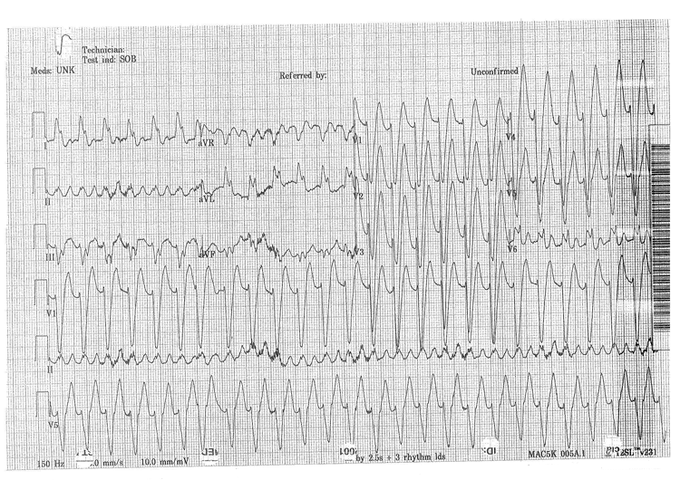

Question 9

A 72 year old previously fit man attends the emergency department with confusion. His vital signs on arrival are
BP 90/62 PR 123 RR27 Temp 38.9ºC BM 8.6
Urinalysis - Protein +++ Blood ++ Nitrates +++

Examination reveals very little other than a strong odour of urine and an enlarged bladder. Oxygen has been started and bloods sent.

A: What is the most likely diagnosis at this stage 2 marks

B: Give 3 things you would initiate to manage this patient 3 marks

A CXR look normal FBC: WCC 27 Plts 120 Hb 11.2
U&E’s : Urea 27 Cr 210 Na 136 K 4
Lactate 7 mmol/l
pO₂ 11 PO₂ 4 pH 7.1 BE -5

C: You decide you are going to apply early goal directed therapy/Rivers protocols to this patient. Give 4 physiological measurements you require and the values considered to be abnormal (4 marks). Give 2 procedures that you need to perform on this patient (1 mark).

A 5 day old baby is brought to A&E in a collapsed state. The pregnancy was uncomplicated and there is no family history of note. The baby was discharged at 12 hours and had been well apart from mild jaundice until this morning.

On examination the baby is obtunded. The airway is patent and the respiratory rate is 60 per minute. There is good air entry bilaterally. Only the apex and the carotid pulses are palpable. Capillary refill is 8 seconds. BM is 1.5 mmols.

This is the baby’s chest radiograph

A: Name 3 diagnosis that should be considered at this stage? (3 marks)

Answer

B: What 2 abnormalities are seen on the chest x-ray? (2 marks)

Answer

C: Name 5 treatments that should be initiated/considered in managing this child. (5 marks)

Answers

Question 10

