SAQs
July 20th Regional Training Day

Question 1:

A 72 yr female patient is BIBA after being pulled off her feet by her large dog. She landed on her left side and complains of severe left hip and thigh pain. Her left leg is shortened and externally rotated. Er past medical history is significant for chronic renal failure and she reports she has a severe allergy to codeine.

What analgesia will you offer this patient?

What two regional anaesthetic blocks could be used?

Describe the landmarks for each.

What is the maximum safe dose of:

Lidocaine?

Bupivocaine?

Is the safe dose altered by renal failure?
Question 2:

A 38 year male was involved in a warehouse fire. He has the following visible injuries:

generalised facial erythema with blistering of the forehead, lips and right ear

erythema of the dorsal forearms and hands, blistering of the volar forearms and black discolouration of both palms

his shirt has not been removed and appears to be melted over his chest

What are your immediate priorities (name 4):

What evidence of inhalation injury will you look for on examination?

What is the estimated area of the burn?

Does this patient require fluid resuscitation and if so describe the appropriate fluid choice and regime.

Question 3:

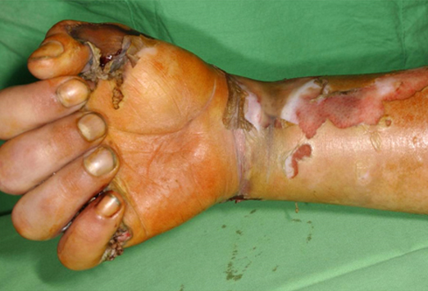

This is an image of an electrical burn sustained by a 16 year old boy who climbed up an electricity pylon.

What are three concerns specifically associated with electrical burns? Why?

What immediate investigations are essential in this young man? Name two.

Is it safe to discharge this patient home following treatment of the wounds to his hand and forearm? Why?

What long-term complications may arise from this injury? Name two.

Question 4:

You have received further information regarding your patient in Question 4. He has left a note stating his intention to end his life and was found by a man walking his dog in a remote field.

What referral is now indicated?

What specific risk factors for suicide can you identify in this patient?

What are the other risk factors for suicide that you should consider in patients presenting with deliberate self-harm?

