*SAQs*

July 20th Regional Training Day

**Question 1:**

**A 72 yr female patient is BIBA after being pulled off her feet by her large dog. She landed on her left side and complains of severe left hip and thigh pain. Her left leg is shortened and externally rotated. Her past medical history is significant for chronic renal failure and she reports she has a severe allergy to codeine.**

**What analgesia will you offer this patient?**

offer paracetamol 1G immediately and q6h

discuss codeine allergy and consider opiates only if appropriate (consider class and give antihistamine)

offer nerve blocks ie. Gain consent and use fascia iliaca or femoral nerve block

avoid NSAIDs

From NICE CG124 Hip Fracture:

* 1. Analgesia
     1. Assess the patient’s pain:
* immediately upon presentation at hospital **and**
* within 30 minutes of administering initial analgesia **and**
* hourly until settled on the ward **and**
* regularly as part of routine nursing observations throughout admission.
  + 1. Offer immediate analgesia to patients presenting at hospital with suspected hip fracture, including people with cognitive impairment.
    2. Ensure analgesia is sufficient to allow movements necessary for investigations (as indicated by the ability to tolerate passive external rotation of the leg), and for nursing care and rehabilitation.
    3. Offer paracetamol every 6 hours preoperatively unless contraindicated.
    4. Offer additional opioids if paracetamol alone does not provide sufficient preoperative pain relief.
    5. Consider adding nerve blocks if paracetamol and opioids do not provide sufficient preoperative pain relief, or to limit opioid dosage. Nerve blocks should be administered by trained personnel. Do not use nerve blocks as a substitute for early surgery.
    6. Offer paracetamol every 6 hours postoperatively unless contraindicated.
    7. Offer additional opioids if paracetamol alone does not provide sufficient postoperative pain relief.
    8. Non-steroidal anti-inflammatory drugs (NSAIDs) are not recommended.

**What two regional anaesthetic blocks could be used?**

Femoral block and fascia iliaca block

**Describe the landmarks for each.**

Fascia iliaca/lumbar plexus block – landmark ASIS to pubic tubercle along inguinal ligament, divide the ligament into thirds and identify the junction between the medial 2/3 and the lateral 1/3. Entry point is 1cm below the junction. Palpate the femoral pulse which should be 1-2cm medial to your entry point and avoid. Use a short blunted or short-bevelled needle to achieve 2-pops through the fascia lata and the fascia iliaca to come into the plane of the femoral nerve. Aspirate prior to injuection and inject approximately 5ml at a time. There should be no resistance to injection.

(This is a volume dependent block and is best achieved with 30ml – 40ml LA, e.g. bupivocaine 0.25% mixed with bupivocaine 0.50% not to exceed 2mg/kg)

Femoral nerve block – ID femoral pulse 1-2cm below inguinal ligament, the femoral nerve lies just lateral and deep to the artery, outside the femoral sheath. Precise placement is ideally achieved by nerve stimulator to see quadriceps muscle concentration at 0.3 – 0.5mA. The nerve can be located by gently probing to create paraesthesia but there are greater risks of injury to the nerve and use of the nerve stimulator is recommended.



1 is injection point for femoral nerve block

2 is injection point for fascia iliaca block

3 is injection point for lateral cutaneous nerve of the thigh

**What is the maximum safe dose of:**

**Lidocaine?** 3mg/kg

**Bupivocaine?** 2mg/kg

**Is the safe dose altered by renal failure?** No

**Question 2:**

**A 38 year male was involved in a warehouse fire. He has the following visible injuries:**

**generalised facial erythema with blistering of the forehead, lips and right ear**

**erythema of the dorsal forearms and hands, blistering of the volar forearms and black discolouration of both palms**

**his shirt has not been removed and appears to be melted over his chest**

**What are your immediate priorities (name 4):**

Airway management, consider intubation early

IV access for fluid resuscitation, avoid burned sites and consider central line

Analgesia, narcotic

ABG for carboxyhaemoglobin in particular

CXR

**What evidence of inhalation injury will you look for on examination?**

Soot in the nares

Singing of facial hair

Carbonaceous sputum

Burns to the face

What is the estimated area of the burn?

Face 3.5%

Forearms 6%

Hands 6%

Chest 13%

**Total 28.5%**

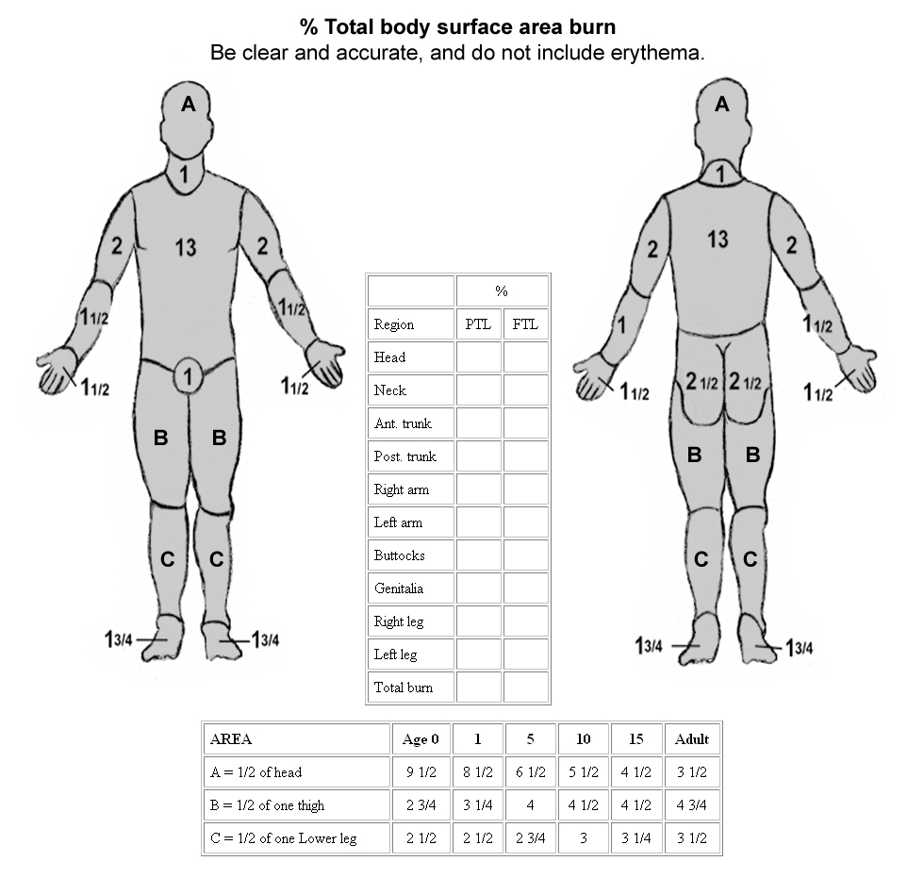

**Does this patient require fluid resuscitation and if so describe the appropriate fluid choice and regime.**

Partial thickness or greater burns should be used for the purpose of initial fluid resuscitation calculation. In this patient, the erythema of the lower face and dorsal forearms and hands is not included.

TBSA = 19-20% depending on the area of the face included

Therefore, this patient does require fluid resuscitation.

Fluid of choice is Hartmanns (Ringer’s Lactate)

Parkland calculation: 4ml/kg x 20% TBSA burned = approx. 4 x 70kg x 20 = 5600ml to be given over the next 24 hours as 2800ml in the first 8 hours and 2800ml over the next 16 hours.

**Question 3:**

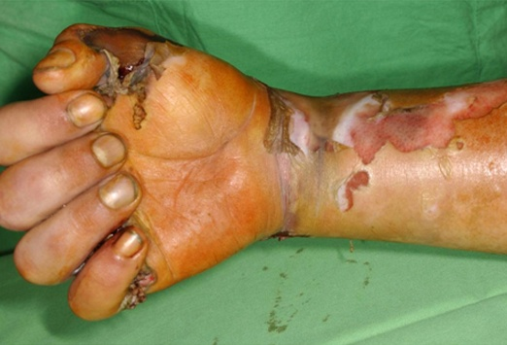

**This is an image of an electrical burn sustained by a 16 year old boy who climbed up an electricity pylon.**

**What are three concerns specifically associated with electrical burns? Why?**

Neurovascular injury

Muscular injury and rhabdomyolysis

Cardiac injury resulting in arrhythmia

Electrical burns can result in transmission of current through the tissues, resulting in thermal burn to deeper structures including muscle, nerves and vessels. The initial appearance of the burn may not reflect these deeper injuries. In addition, the electrical current may directly injure the myocardium or cause electrical disruption to the cardiac rhythm.

**What immediate investigations are essential in this young man? Name two.**

ECG

Electrolytes for K+

CK

**Is it safe to discharge this patient home following treatment of the wounds to his hand and forearm? Why?**

No. He will require admission for cardiac monitoring. He may require escharotomy if the burn to his wrist is circumferential.

**What long-term complications may arise from this injury? Name two.**

Neurologic damage may result in loss of function of the wrist, hand and fingers

Scar formation may cause flexion contractures and decreased function of the hand and fingers

**Question 4:**

**You have received further information regarding your patient in Question 4. He has left a note stating his intention to end his life and was found by a man walking his dog in a remote field.**

**What referral is now indicated?**

Referral to psychiatric services.

**What specific risk factors for suicide can you identify in this patient?**

Male 1

age <19yr 1

organized or serious attempt 2

**Total 4**

There may be other factors uncovered during the psychiatric assessment and this patient must be hospitalized pending that review.

**What are the other risk factors for suicide that you should consider in patients presenting with deliberate self-harm?**

Modified SADPERSONS score:

The score is calculated from ten yes/no questions, with points given for each affirmative answer as follows:

* S: Male sex → 1
* A: Age <19 or >45 years → 1
* D: Depression or hopelessness → 2
* P: Previous suicidal attempts or psychiatric care → 1
* E: Excessive ethanol or drug use → 1
* R: Rational thinking loss (psychotic or organic illness) → 2
* S: Single, widowed or divorced → 1
* O: Organized or serious attempt → 2
* N: No social support → 1
* S: Stated future intent (determined to repeat or ambivalent) → 2

This score is then mapped onto a risk assessment scale as follows:

* 0–5: May be safe to discharge (depending upon circumstances)
* 6-8: Probably requires psychiatric consultation
* >8: Probably requires hospital admission