SAQ QUESTIONS -15TH JUNE 2011 QEHKL RTD

Question One
A 68 year old female is brought to the emergency department with nausea, weakness and general malaise for the last three days. Over the last week she has been taking ibuprofen for her osteoarthritis.
Examination findings: apyrexial
CVS: P 108 bpm, BP 105/89 mm Hg, HS 2/6 ejection systolic murmur, JVP is elevated
Resp: RR 24/min, O2 sats 96%, bibasal crackles
Abdo: soft, nontender
Extremities: pitting oedema to calf
(a) Give 2 differential diagnoses based on the above information (2 marks)
*
*
(b) Which further investigations would you request? (2 marks)
*
*
*
*
*
(c) Other than NSAIDs, list 4 nephrotoxic drugs (2 marks)
*
*
*
*
(d) Give 4 causes of post renal renal failure (2 marks)
*
*
*
*
(e) This patient reports recent haemoptysis. Name 2 multisystem conditions with both renal and respiratory components (2 marks)
*
*

Queen Elizabeth Hospital King's Lynn NHS Trust
Question Two.

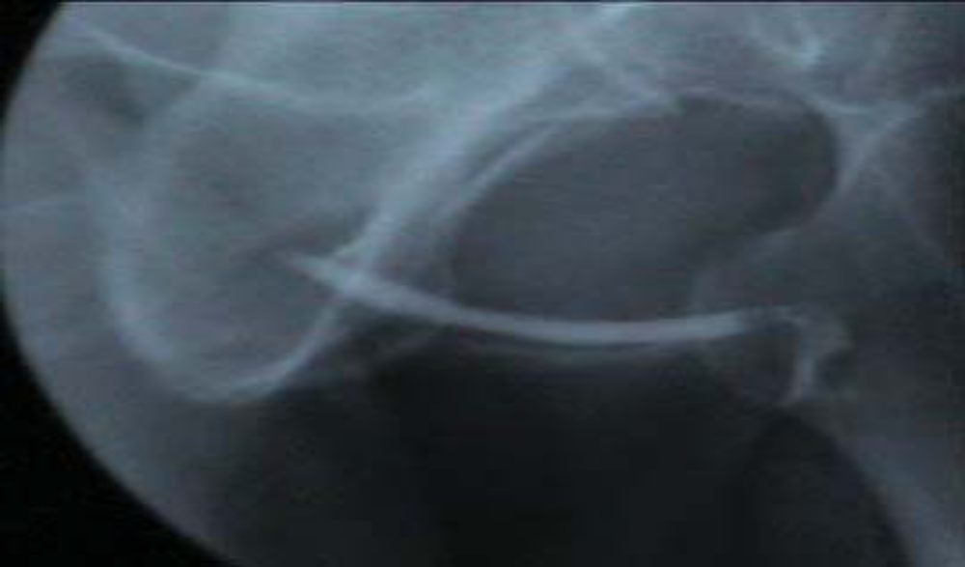

FIGURE 1.

A 12 year old boy is brought to the emergency department after falling twenty feet from a stone fall onto his side. An investigation is performed (See Figure 1 above).

What is this investigation? (1 mark)

*

What does it demonstrate? (1 mark)

*

Which clinical signs may this patient display consistent with this injury?
(4 marks)
*
*
*
*
How would you manage this injury? (3 marks)

*
*
*
Name one long term complication associated with this injury (1 mark)

*
Queen Elizabeth Hospital King's Lynn NHS Trust
Question Three.

A 48 year old male presents to the emergency department with a five day history of generalized swelling. He is a known diabetic.
Examination findings: apyrexial, obvious periorbital oedema, no rash
CVS: P 88 bpm, BP 135/86 mm Hg, HS normal
Resp: RR 16/min, lung fields clear
Abdo: soft, no organomegaly
Extremities: pitting oedema to sacrum

You suspect nephrotic syndrome.

(a) How can you confirm the diagnosis? (3 marks)

*
*
*

(b) What other symptom may the patient complain of? (1 mark)

*

(c) Explain why the patient is oedematous (3 marks)

*

(d) What are the complications of nephrotic syndrome? (3 marks)

*

*

*

Queen Elizabeth Hospital King's Lynn NHS Trust
Question Four.

A 48 year old man with non-Hodgkin’s lymphoma presents with vomiting, weakness and carpo-pedal spasm. He underwent his latest course of chemotherapy last week.
Bloods: K 7.8, urea 34.6, creatinine 390, raised phosphate and urate, hypocalcaemia
ABG: pH 7.21, pCO2 3.2, pO2 13.4, bic 12
An ECG is performed (See figure 2).

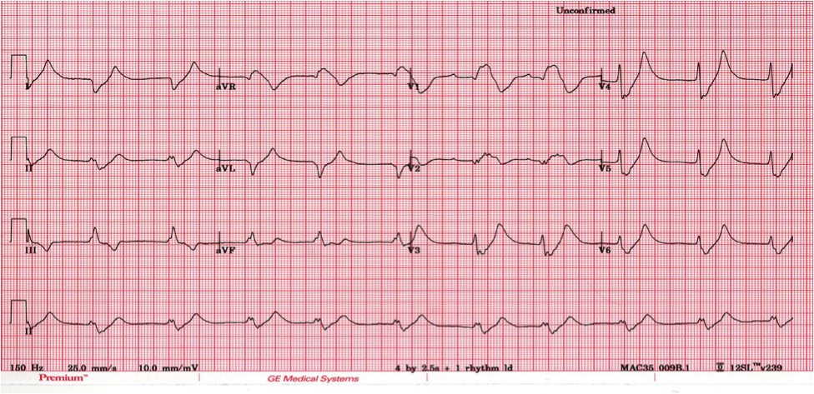
FIGURE 2.

(a) State 3 abnormalities on the ECG, and what does this indicate? (2 marks)

*

(b) Explain the abnormal blood results
(3 marks)
*

*

*

(c) Why has this patient developed acute renal failure?
(1 mark)
*

(d) Give 4 drugs with dose and route (other than oxygen and fluids) you would consider in the immediate management of this patient (4 marks)

*

*

*

*
Queen Elizabeth Hospital King's Lynn NHS Trust
Question Five. (See figure 3 below)

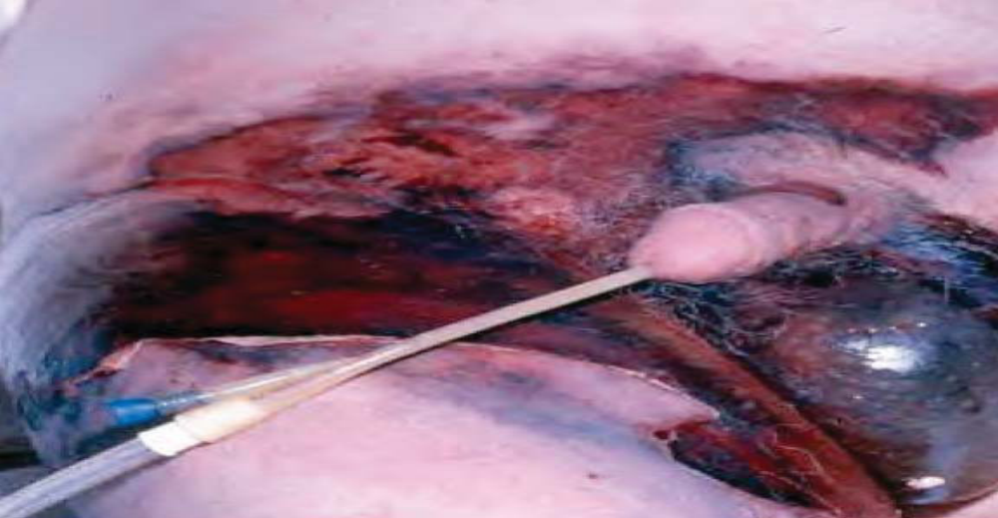FIGURE 3

A 70 year old man presents to the Emergency Department with a five day history of groin and scrotal pain. He has fatigue and anorexia. He has been unable to walk for 3 days due to hip and leg pain.

(a) What is the diagnosis? (1 mark)

*
(b) What are the 3 most likely origins of this infection? (3marks)

*
*
*
(c) State the most common aerobe and anaerobe causing this condition (2 marks)
*
*
(d) Give 4 predisposing factors (2 marks)

*
*
*
*
(e) Give 4 specific treatments for this condition (2 marks)

*
*
*
*
Queen Elizabeth Hospital King's Lynn NHS Trust
Question Six.

A 6 year old girl presents generally unwell with a fever. She has a history of recurrent UTIs. Urine dipstick testing reveals nitrites and leucocytes.

(a) Explain the mechanism by which nitrites are found in the urine in some UTIs
(2 marks)
*

(b) How does the timing of the urine specimen alter the interpretation of nitrite testing results? (1 mark)

*

(c) Other than urinary symptoms, list 4 symptoms or signs of UTI according to NICE guidance “fever in children” (4 marks)

*

*

*

*

(d) Give 3 long term complications of recurrent UTIs (3 marks)

*

*

*

Queen Elizabeth Hospital King's Lynn NHS Trust
Question Seven.

A 32 year old male presents to the emergency department with muscle pains and weakness after running the London marathon yesterday. He has also noted that his urine is dark in colour.

Examination findings:
Apyrexial, HR 110, BP 108/74, RR 20, equal air entry, abdomen soft with no organomegaly, thighs tender to palpation

(a) List 4 blood tests that should be requested (2 marks)

*

*

*

*

(b) What is the diagnosis? (1 mark)

*

(c) What would you expect the urine dipstick and microscopy to show? (2 marks)

*

*

(d) Give 4 non-traumatic causes of this condition (4 marks)

*

*

*

*

(e) Sodium bicarbonate is sometimes used in the management of this condition. By what mechanism does it work in these cases? (1 mark)

*

Queen Elizabeth Hospital King's Lynn NHS Trust
Question Eight.

A 32 year old female gymnast presents to the emergency department with severe left sided abdominal pain and dark urine. She has been diagnosed with a UTI and started on trimethoprim three days ago. The pain is worse and she is now vomiting. She is normally fit and well and takes vitamin supplements.

O/E: apyrexial, CVS: P 98 bpm, BP 112/78, HS normal, Resp: RR 14/min, clear to auscultation
Abdo: soft slight tenderness over the renal angle, no guarding or rebound tenderness

What is the differential diagnosis? (1 mark)

*
*

What percentage of renal calculi are radio-opaque? (1 mark)

*

Which investigations should be performed immediately? (2 marks)

*
*

What are your options for pain control in this patient? (2 marks)

*
*

List 3 signs of ureteric calculi on IVU (3 marks)

*
*
*

What advice can you give this patient to prevent recurrence of calculi? (1 mark)

*

Queen Elizabeth Hospital King's Lynn NHS Trust
Question Nine.

A 59 year old male presents to the emergency department with general confusion. He underwent bronchoscopy last week for investigation of haemoptysis. Cytology is pending. He is a longstanding smoker.

O/E: apyrexial, GEN: cachectic, clubbing, CVS: P 82 bpm, BP 148/86, HS normal, Resp: RR 14/min, clear to auscultation, ABDO: soft, nontender, no organomegaly, NEURO: general weakness, nil focal, planters down

He is seen by a FY2 doctor, and referred to MAU. You are contacted by the lab who tell you the plasma sodium is 124. You suspect SIADH.

List 3 possible causes of confusion in this man (3 marks)

*
*
*

What is the most likely cause of hyponatraemia in this case? (1 mark)

*

Give 4 other causes of hyponatraemia (2 marks)

*
*
*
*

Outline the mechanism of action of antidiuretic hormone (2 marks)

*

How would you manage this gentleman in the ED? (2 marks)

*

Queen Elizabeth Hospital King's Lynn NHS Trust
Question Ten.

A 23 year old female presents to the emergency department with a three day history of lower abdominal pain and that radiates from the flank to the groin. This is associated with high fevers and chills. She is 28 weeks pregnant.
O/E: temperature 39.4oC, other obs normal, ABDO: soft, tender left flank and suprapubically to palpation and percussion, uterus palpable.
You suspect pyelonephritis.

Describe the physiological changes of the urinary tract that occur during pregnancy
(3 marks)
*

*

*

Why are UTIs in pregnancy more likely to progress to pyelonephritis? (2 marks)

*

Give 2 medications (with dose and route) that you would administer to this patient in the ED (2 marks)

*

*

List 4 complications of pyelonephritis in pregnancy (2 marks)

*

*

*

*

Queen Elizabeth Hospital King's Lynn NHS Trust

