1. A 65 yrs old type2 diabetic is brought to the emergency department complaining of increasing breathlessness at rest. His wife says he has been increasingly confused and agitated at home over the last 24 hrs. He is on Gliclazide, Metformin and Perindopril.

His examination findings and observations are as follows:
- Clear, talking
- RR 30, SO2 93% RA, bilateral basal wet crackles
- P76, BP 185/92, well perfused, JVP + 9, HS I-II-0, mild pitting leg oedema
- E-1, V-5, M-6. AMT 5/10. No focal neurology. BM 12 mmol/L.
- Abdomen mildly tender. No guarding. No rebound.

The nurse hands you his ECG:

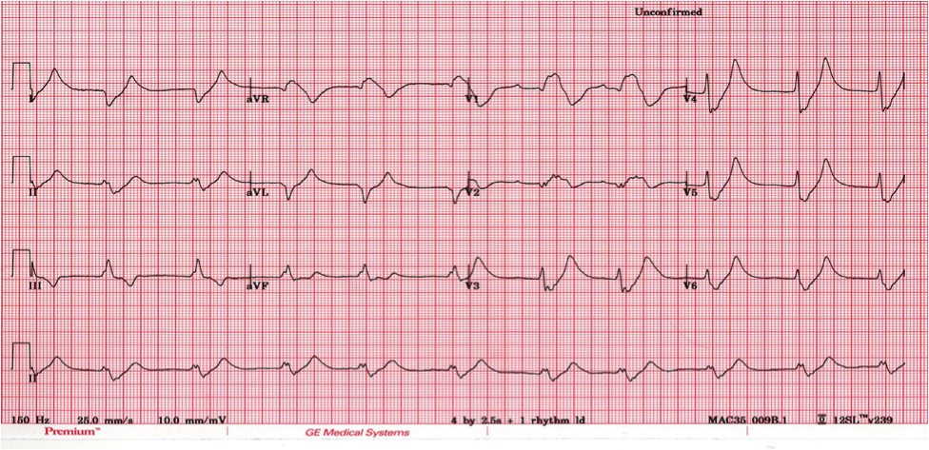

What abnormal features are present on the ECG? (2)

Tented T waves
Small / Absent p waves
Prolonged PR interval
Broad QRS complexes

What is your working diagnosis and what single most pertinent investigation you should do next and why? (1)

Arterial or venous blood gas.

What abnormalities will you expect to find on his arterial blood gases? (2)

Non-lactic metabolic acidosis with respiratory compensation.
High K.

The nurse hands you a subsequent ECG taken because of intermittent rhythm changes. The patient remains alert throughout.

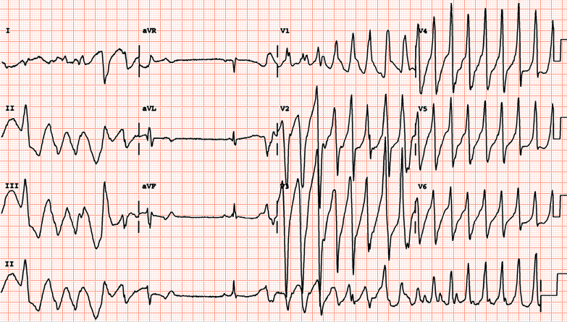

What treatment will you now institute? (2)
IV Calcium Gluconate 10 mls of 10%.
IV Actrapid 10 – 15 U in 50 mls of 50 % glucose over 20-30 minutes.
Nebulised Salbutamol 5mg.
Sodium Bicarbonate 1.4% 500mls over 4 hrs via a large peripheral vein.

What definitive management does the patient require and in general what are the absolute indications for this? (3)

Dialysis, CVVHD, CVVHDF or Haemofiltration.
Absolute Indications:

Acute volume overload with refractory pulmonary oedema
Hyperkalaemia
Acute pericardial effusion
Acidocis with pH <7.2
Urea > 30 with altered mental status.
Question 2
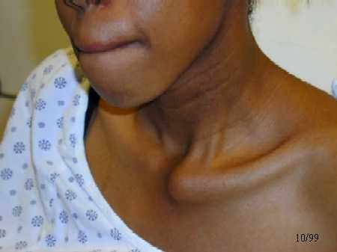

This lady attends the ED after a fall. What is the most likely injury. (2)

Left sided anterior dislocation of sternoclavicular joint

How could you confirm your clinical suspicion without using a CT scan? (1)

Serendipity or Hobb’s view

What management would you initiate in the emergency department? (2)

Analgesia
Broad arm sling
Referral to orthopaedics as an inpatient

Question 3

A 32 year old man attends after an epistaxis. He tells you that he has had three nose bleeds in the last week, but this one has lasted one hour.

- What important features would you elicit in the history (5)
Wafarin use
Asprin use
Symptoms of hypovolaemia (light headed)
Cocaine use
Trauma
Easy bruising or bleeding
Inherited bleeding disorders

- What proportion of nosebleeds arise from the posterior nasopharynx? (1)
5%

- What important features would you look for on physical examination? (3)
Pulse and Blood pressure
Purpura
Hepatosplenomegaly
Bleeding point
Anaemia

- In children with epistaxis, what is the best treatment against further bleeds. (1)
Antibiotic ointment

Question 4

A 39 year old non-English speaking woman is bought to the ED. She is obviously in labour. She is accompanied by a man who states she wanted the baby at home. During the delivery the umbilical cord appears to have fallen out, they did not know what else to do but come to hospital. A quick look confirms an obvious cord prolapse

Question 1

Give 4 initial actions you would take 4 marks total

Answer 1

Place woman in knee to chest position or exaggerated Simms position with 2 pillows
Presenting part should be pushed out of pelvis upwards by fingers in vagina to relieve pressure on the presenting part – keep them here until delivery commenced
If cord protruding, replace inside the vagina - but minimise handling.
Summon help call a obstetrics/ paediatrics/anaesthesia
Provide reassurance and an explanation to woman
Give woman oxygen
1 mark each, must give top 2 to get full marks.

Question 2

Give 4 pre-disposing factors for cord prolapse 4 marks total

Answer 2 1mark each, total of 4

High presenting part
High parity
Prematurity
Multiple pregnancy
Polyhydraminos
Malpresentation

Question 3

What is the definitive management of this complication 2 marks

Answer 3

Immediate LSCS 2 marks
Question 5

A 42 year old women presents with a frontal headache. She is a Nigerian who came to the UK three years ago. The headache began gradually about week ago and has got progressively severe. It is not relieved by simple analgesia. It is worst in the morning and she has vomited once. She has never had this before. She has no other medical problems, and works as a cleaner to support her two teenage children. On examination, she is slender and well. She is afrebrile and has a normal set of observations. She has had a normal sickle cell test.

- What symptoms are regarded as ‘red flags’ for detecting a serious intracranial pathology in patients with headaches. (5)
Onset after forty years of age
Vomit
Waking from sleep
Change in headache pattern
Frontal or occipital pattern
Fever
Seizure
Weight loss
Patient from Africa

- What investigations would you organise? (2)
CT with contrast
MRI
HIV test
Chest x-ray

- What are the most likely differential diagnoses? (3)
Cryptococcus
Cerebral TB
AIDS
Question 6

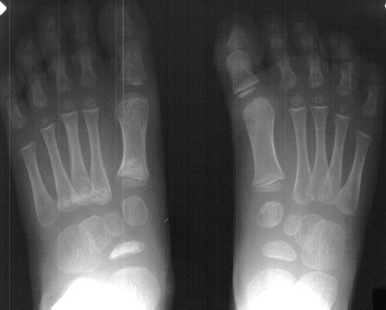

A five year old child presents with an atraumatic limp. She complains of a painful foot. The x-ray is shown above.

- What is the diagnosis? (1)

Kohlers disease / Avascular necrosis of the navicular

- What would advise the parents (2)

Rest / analgesia / outpatient orthopaedic follow up

- What is this disease process called in the lunate? (1)

Keinboks

- What is this disease process called in the metatarsal heads? (1)

Freibergs

Question 7

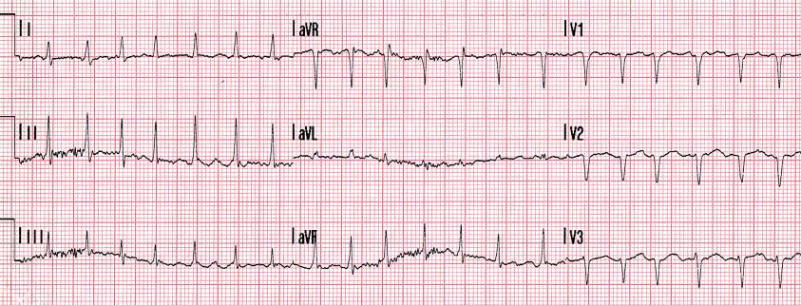

A 48 year old man presents with palpitations and pre-syncope. These started the day before. He denies chest pain. Physical examination excludes a murmur. He has a past medical history of hypertension for which he takes lisinopril. His blood pressure is 135/88.

- What does the ECG show? (1)
Fast atrial fibrillation

- What predisposing causes should you consider in this patient? (3)
Thyrotoxicosis
Alcohol binge
Mitral valve disease
Hypertension
Severe systemic illness

- Outline your management of this patient? (2)
Anticoagulation
Chemical cardioversion

- The man is successfully treated and you send him home. How would decide whether to initiate anticoagulation and what is this man’s score? (4)
CHADS2 Score is 1
Congestive Heart Failure
Hypertension
Age greater than 75
Diabetes Mellitus
TIA or Stroke
Question 8

A 43 year old man attends the ED with vertigo. This started suddenly while he was watching a football match.

- What are the commonest central causes of vertigo (2)

TIA

Stroke
Cerebellar pontine tumor
Multiple sclerosis
- What are the commonest peripheral causes of vertigo (3)
Acute labyrinthitis
Acute vestibular neuronitis
Menieres disease
Benign Positional Paroxysmal Vertigo
- What features in the history make a peripheral cause more likely than a central cause?(3)
Abrupt onset
Head trauma
Severe
Vomiting
Absent cardiovascular risk factors
Hearing loss
- You decide that this man has a peripheral cause for his vertigo and he is keen to go home? What classes of drugs may be helpful in alleviating his symptoms. (2)
Anticholinergics
Antihistamines
Antimuscarinics
Corticosteroids
Question 9

A 28 year old woman presents with seizures. An ambulance was called by her to her house where she was the only person. The paramedics think that she is ‘putting it on’. Her vital signs and a blood glucose are normal. She will not respond to voice, open her eyes or obey commands. When you go to see her, she starts to seize again.

a. What features in the history make a diagnosis of pseudoseizure more likely than an organic seizure? (2)

Female sex

Evidence of planning

Past medical history of chronic fatigue / psychiatric diagnoses

Resistant to anti-epilepsy drugs

b. What physical signs make a diagnosis of pseudoseizure more likely than an organic seizure ? (3)

Intact Bell’s phenomenon

Intact gag reflex

Side to side shaking of the head

Absent tongue biting

Absent incontinence

Absent lip scars (from previous seizures)

Bilateral asynchronous motor movements e.g. cycling

Semi-purposeful movements

Question 10

This 13 month old baby has been unwell for 3 days with irritability and fever. She is miserable and has developed a diffuse rash, a cough and runny eyes.
Her family live on a traveller’s site. She has two older siblings who are currently well. Her mother is 16 weeks pregnant.
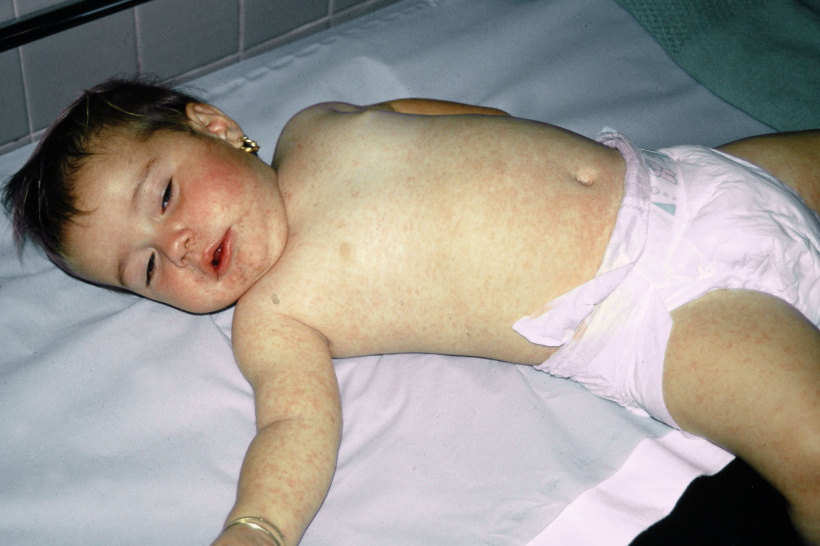

What is the likely diagnosis and how can it be confirmed? (2)
Measles
Measles serology
What is the management of the child?(2)
Antipyretics
Oral fluid intake
What is the management of the siblings? (1)
Vaccination
What is the management for her mother?(2)
Paired serology
Obstetric review

