WEST MIDLANDS FCEM COURSE

CLINICAL SAQS

(CANDIDATES)

FEBRUARY 2011

QUESTION 1

This child presents with a painful right eye, pyrexia and inability to move eye on examination.

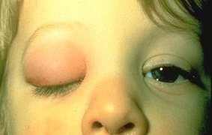

What is the diagnosis? [1]

|  |
| --- |
|  |

Name 2 possible causative organisms. [1]

|  |
| --- |
|  |

What is the likely source of infection? [1]

|  |
| --- |
|  |

List 3 complications. [1.5]

|  |
| --- |
| . |

Name one essential investigation? [1]

|  |
| --- |
|  |

[B] A 50 year old man presents with an acute red eye

List 4 causes of a red eye [2]

|  |
| --- |
|  |

[](http://www.google.co.uk/imgres?imgurl=http://www.cornealdocs.com/images/img-HSV-dendrite.jpg&imgrefurl=http://www.cornealdocs.com/html/other-services.html&usg=__HKhmaZ40RndmYQsSD83RHoRLEyU=&h=136&w=200&sz=15&hl=en&start=7&zoom=1&um=1&itbs=1&tbnid=KVXJtCVpXQiZgM:&tbnh=71&tbnw=104&prev=/images?q=herpetic+keratitis&um=1&hl=en&rlz=1T4ADSA_enGB363GB363&tbs=isch:1&ei=RtRZTfTQEIqLhQfk95TbDA)

On examination you find the above

What is the diagnosis and causative organism? [1 mark]

|  |
| --- |
|  |

Give 3 management steps/treatments for corneal ulceration [1.5 mark]

|  |
| --- |
|  |

QUESTION 2

A 24 year old man is brought in by ambulance c/o severe back pain and a painful erection.

He is of Afro Caribbean decent and is known to suffer from sickle cell disease.

On examination he is in considerable discomfort & SOB, his abdomen is soft and he has obvious priapism.

Describe 4 steps in your management of his priapism [2 marks]

|  |
| --- |
|  |

Name 3 investigations would you perform and reasons why? [3 marks]

|  |
| --- |
|  |

List 3 indications for exchange transfusion in sickle cell anaemia [3 marks]

|  |
| --- |
|  |

List 3 indications for blood transfusion in sickle cell patients [2 marks]

|  |
| --- |
|  |

QUESTION 3

A 60 year old man is brought in following a bout of fresh haematemesis.

He is known to suffer from duodenal ulcers. He looks pale but is conscious and his BP is 140/100.

His pulse is 95, his sats are 98 % on RA and his RR is 18. Apart from his ulcers he has no other medical problems.

You start initial management and gain access and take bloods.

His Hb = 6 so you start a blood transfusion. The patient develops a temperature of 38.8 oC

You suspect an acute transfusion reaction. Other than assessing and resuscitating the patient, name two next management steps? [2 marks]

|  |
| --- |
|  |

List 4 symptoms of acute transfusion reaction, other than pyrexia. [2 marks]

|  |
| --- |
|  |

What is the definition of massive blood transfusion? [1 mark]

|  |
| --- |
|  |

Fill in table for the ROCKALL scoring system. Write ‘BLANK’ in boxes which do not contribute to the score [5 marks]

|  |  |  |  |  |
| --- | --- | --- | --- | --- |
|  | Score = 0 | 1 point | 2 points | 3 points |
| Age |  |  |  |  |
| Shock |  |  |  |  |
| Co morbities |  |  |  |  |
| Endoscopic  diagnosis |  |  |  |  |
| Endoscopic stigmata of recent haemorrhage |  |  |  |  |

QUESTION 4

[A] You receive an ambulance alert that they are bringing in a 25 year old male who has been found collapsed in the street. He is unresponsive and very cold, with no external signs of injury.

What 4 pieces of equipment other than standard resus equipment would you want to have ready in preparation for this patient? [2 marks]

|  |
| --- |
|  |

He arrives and is found to have no pulse, his temperature is reading 28 C.

CPR is commenced. List 3 modifications to the standard algorithm that need to be made in the hypothermic patient? [3 marks]

|  |
| --- |
|  |

What rate should you aim to rewarm the patient? [1 mark]

|  |
| --- |
|  |

What is the complication of rewarming too rapidly? [1 mark]

|  |
| --- |
|  |

[B] A homeless man presents to your ED with a painful left hand.



What is the diagnosis? [1 mark ]

|  |
| --- |
|  |

Give two interventions which are indicated [1 mark]

|  |
| --- |
|  |

Name two interventions which are contraindicated [1 mark]

|  |
| --- |
|  |

QUESTION 5

A 35 year-old male with known asthma presents to the ED with acute asthma exacerbation. In the past 12 months, he had been admitted twice to ITU with life threatening asthma, the last being within the previous month. He is known to have good compliance with his multitude of asthma control medications. His GP has re-commenced him on Prednisolone 40 mg o.d. the previous day. In the preceding 2 hours, he has had 3 home nebulisers (Salbutamol) prior to calling the ambulance.

His respiratory rate is 35/min, pulse rate 130/min, BP 95/60 mmHg. His arterial blood gases on arrival were pH 7.1, PaO2 8.4, PaCO2 11.2, BE minus 4. Despite adequate management, including high flow oxygen, repeated nebulised _-agonist and IV Magnesium, he continues to deteriorate with his RR dropping to 7/min, HR 145/min, unrecordable BP and drowsiness. The intensivist advises immediate intubation/ventilation, but is unable to get down to ED for about an hour (and you are the most competent personnel available).

Give 4 anatomical predictors of a difficult airway [2 marks]

|  |
| --- |
|  |

Following Preoxygenation, what are the three treatment (medication) steps?

[1.5 marks]

|  |
| --- |
|  |

What is the correct head / neck positioning in such patients, how is this position achieved and why? [1.5 marks]

|  |
| --- |
|  |

What are the four steps to ensure / confirm correct tube placement? [2 marks]

|  |
| --- |
|  |

After three failed attempts at intubation, you are unable to adequately oxygenate with BVM (despite correct head & neck positioning). What would be your next step (you are still the most competent personnel available)? [1 mark]

|  |
| --- |
|  |

What would the next step if the above step failed, and you are unable to ventilate or oxygenate the patient? [1 mark]

|  |
| --- |
|  |

What would this patient require if the above step proves inadequate? [1 mark]

|  |
| --- |
|  |

QUESTION 6

A 14-year-old male patient attends your ED following laceration of his foot with a garden fork

Your junior doctor attended to the patient but is unsure about Tetanus immunization in general.

Which wounds are Tetanus prone, name four? [2 marks]

|  |
| --- |
|  |

Describe how C.tetani spores causes muscle spasm and rigidity? [2 marks]

|  |
| --- |
|  |

Using the grid below, explain when the various tetanus vaccine / Immunoglobulin are required depending on the patient’s immunisation status[6 marks]

|  |  |  |  |
| --- | --- | --- | --- |
| Immunisation  Status | Vaccine  (clean wound) | Vaccine  (tetanus prone wound) | Tetanus  Immunoglobulin  (tetanus prone wound) |
| Fully immunised, ie,  has received a total  of 5 doses of tetanus  vaccine at appropriate intervals |  |  |  |
| Primary immunisation  complete. Boosters  up-to-date, but not  completed |  |  |  |
| Primary Immunisation  incomplete or boosters not uptodate. |  |  |  |
| Not immunised or  immunisation status  not known or uncertain |  |  |  |

QUESTION 7

Ambulance phone ahead to say they are bringing a 36/40 who is about to deliver

List 4 pieces of equipment for the foetus other than standard resus equipment that you would get ready [2 marks]

|  |
| --- |
|  |

The baby is delivered in the ED - list 3 factors you would consider/assess before assessing the babys heart rate? [3 marks]

|  |
| --- |
|  |

CPR is commenced, describe the landmarks, technique and ratio for compressions [2 marks]

|  |
| --- |
|  |

Drugs are rarely necessary but if you were to have 3 drugs ready to help the resuscitation what would they be and what doses would you use? [3 marks]

|  |
| --- |
|  |

QUESTION 8

A 22 yr old man presents with a 2/7 history of pain on inspiration and mild SOB. He has no previous significant history, including pulmonary.

On examination he is 6ft, slim with a P100, BP 120/60, a central trachea and reduced AE on the left side of his chest.

You decide to perform an X ray-(shown below).

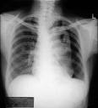

What is the main xray finding? [1 mark]

|  |
| --- |
|  |

You decide to aspirate as per BTS guidelines, where and what volume are you allowed to aspirate. [1 mark]

|  |
| --- |
|  |

Repeat Xray shows no significant difference from the first. You decide to place a chest drain.

What steps do you take next [1 mark]

|  |
| --- |
|  |

What are the anatomical landmarks for chest drain placement ? [1.5 marks]

|  |
| --- |
|  |

What is the maximum of dose of the following [1 mark]

1. Plain Lignocaine (Lidocaine)

|  |
| --- |
|  |

1. Lignocaine, with adrenaline?

|  |
| --- |
|  |

Name 2 techniques are used for placement of chest drains? [1 mark]

|  |
| --- |
|  |

An omental tag has been described as a means of securing a chest drain; describe an “omental tag” [1 mark]

|  |
| --- |
|  |

Name five items described in the NPSA alert relating to the placement of chest drains [2.5 marks]

|  |
| --- |
|  |

QUESTION 9

The new FY2 is confused. He asks you for advice on who needs C spine imaging following an injury.

In adults and children aged above 10, list four indications for requesting immediate three-view plain C-spine x-ray in a patient with suspected neck injury (NICE) [2 marks]

|  |
| --- |
|  |

List six dangerous mechanism of injury in patients with suspected neck injuries [3 marks]

|  |
| --- |
|  |

In adults and children aged above 10, list four indications for immediate CT imaging of the cervical spine [2 marks]

|  |
| --- |
|  |

In patients with suspected head injury, list six indications for immediate CT Head [3 marks]

|  |
| --- |
|  |

QUESTION 10

[A]

A 75 year old woman has been brought into the ED via ambulance. She was found on the floor by her carer at 7am. She complains of pain in her right hip and cannot move it. The triage nurse notes it is shortened and externally rotated.

What is the national guidance for admission time for patients with fracture neck of femur? [3 marks]

|  |
| --- |
|  |

All ED’s must develop fast track protocols for admission of patients with fracture NOF. List 4 parameters of assessment in this protocol? [2 marks]

|  |
| --- |
|  |

List 4 parameters of treatment in the fast track protocol? [2 marks]

|  |
| --- |
|  |

[B] A 75-year-old with left lobar pneumonia has presented to Emergency Department with a temperature of 38.9C, respiratory rate of 32 breaths /min, BP of 130/70mmHg. PR 110/min. His wbc was 15 X109/L, Hb 12.5g/dL, Platelets 250 X 109/L, urea 24mg/dL, Creatinine 140μmol/L, Na 142mmol//l, K 3.8mmol/L.

He was alert on arrival and presented a personally signed “advance directive” stating that he has prostate cancer and he does not want treatment.

**He suddenly deteriorated whilst in the department and went into shock, with reduced level of consciousness. The daughter tells you that he should not be admitted to ITU or ventilated according to his “advance directive”.**

What are the principles of the Mental Capacity Act 2005? [3 marks]

|  |
| --- |
|  |

QUESTION 11

[A]

A 2 year old boy is brought into your Paediatric ED with a fever of 38.5 deg C and vomiting of 2 days duration. He has had no coryzal symptoms or cough. He has no rash.

The nurses have done a urine dipstix which is positive for leucocytes esterase and nitrites.

According to the NICE guidelines for management of UTI in children:

Give two indications for sending the urine sample for culture? [1 mark]

|  |
| --- |
|  |

Give two indications for referring to a Paediatric Specialist? [2 marks]

|  |
| --- |
|  |

What is defined as atypical UTI; give four examples? [2 marks]

|  |
| --- |
|  |

[B]

An eight year old boy presents with a history of painful joints, associated with a rash. He had a sore throat two to three weeks ago. You suspect he has acute rheumatic fever.

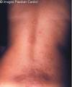

What are the principles of the diagnosis of this condition? [3 marks]

|  |
| --- |
|  |

Outline four principles of treatment of acute rheumatic fever [2 marks]

|  |
| --- |
|  |

QUESTION 12

Who is the Caldicott Guardian? [1 mark]

|  |
| --- |
|  |

Name the 6 Caldicott principles [3 marks]

|  |
| --- |
|  |

When did the Data Protection Act become Law? [1 mark]

|  |
| --- |
|  |

|  |
| --- |
|  |

What does the Act cover? [1 mark]

Name 4 Principles from the Act [4]

|  |
| --- |
|  |

QUESTION 13

You receive a phone call from ambulance control alerting you to a major incident, a tanker with chemical agent has overturned. Initial information is that there is one P1 casualty and 10 P2s.

Define Major Incident [1 mark]

|  |
| --- |
|  |

What are the phases of a major incident? [1.5 marks]

|  |
| --- |
|  |

When the Major Incident is declared, what type of information does Control need to have? List 3 [1.5 marks]

|  |
| --- |
|  |

Define the Triage categories P1, P2, P3 [3 marks]

|  |
| --- |
|  |

You are informed that the tanker contains chlorine.

Give 3 systems affected by chlorine and the likely clinical presentation [3 marks]

|  |
| --- |
|  |

QUESTION 14

A 20 year old lady present with an overdose of 60 ferrous sulphate tablets within the last hour.

What are the features of iron poisoning, list four? [2 marks]

|  |
| --- |
|  |

Name 6 features of severe poisoning [3 marks]

|  |
| --- |
|  |

What investigations may be useful in this patient and why? Name four. [2 marks]

|  |
| --- |
|  |

Name 2 methods of drug elimination in this patient with doses and route where appropriate [1 marks]

|  |
| --- |
|  |

Name the antidote that can be used (route and dose). What clinical sign indicates antidote is working? [2 marks]

|  |
| --- |
|  |

QUESTION 15

[A]

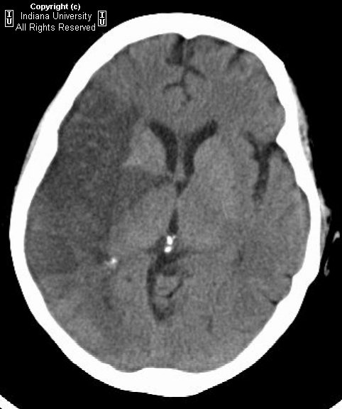

A 58 year old man presents 8 hours after onset of hemiplegia and GCS 10.

An urgent CT is carried out.

What does the CT show and which artery is affected and what is it a branch of?

[2 marks]

|  |
| --- |
|  |

What other 2 other neurological signs are associated with type of infarct?

[1 mark]

|  |
| --- |
|  |

What syndrome should be considered as a complication of this infarct? [1 mark]

|  |
| --- |
|  |

Who would you refer this patient to and for what treatment? [1 mark]

|  |
| --- |
|  |

[B]

A 65 year old man presents with loss of right side of vision lasting 30 minutes.

List 2 essential criteria for diagnosis of TIA [1 mark]

|  |
| --- |
|  |

Name the prognostic scoring system used in TIAs and list the 5 features

[2 marks]

|  |
| --- |
|  |

How long would you advise him not to drive? [1 mark]

|  |
| --- |
|  |

Name 2 symptoms which might suggest an alternative diagnosis [1 mark]

|  |
| --- |
|  |

QUESTION 16

A 70 yr old man with a history of COPD presents to the department by ambulance.

His temperature is 37.6, pulse is 120, RR 28, SpO2 on 2l O2 is 88%

Examination reveals diffuse wheeze and a few scattered crackles.

What 6 initial investigations are recommended by NICE/ BTS? [3 marks]

|  |
| --- |
|  |

List 4 of the recommended standard medical treatments within the first hour? [2 marks]

|  |
| --- |
|  |

What are the indications for NIV? [2 marks]

|  |
| --- |
|  |

Give 8 contraindications to NIV? [2 marks]

|  |
| --- |
|  |

What are the BTS recommended initial settings for NIV [1 mark]

|  |
| --- |
|  |

QUESTION 17

A 35 year old woman presents confused and agitated. Her flat mate tells you she has been unwell for several months and has lost weight and complained of sweating and palpitations. She has been in bed with a severe cold for 24 hours. She has no other significant past medical history. Her brother is a Type 1 insulin diabetic.

On examination she is disorientated, has a temperature of 39C, pulse of 130/min BP 100/60. She has no meningism, photophobia or focal neurology.

List 4 differential diagnoses in this patient? [2 marks]

|  |
| --- |
|  |

You decide she has developed thyrotoxic crises.

Name 4 precipitating factors? [2 marks]

|  |
| --- |
|  |

Name 3 drugs you could give and describe their actions [6 marks]

|  |
| --- |
|  |

Question 18

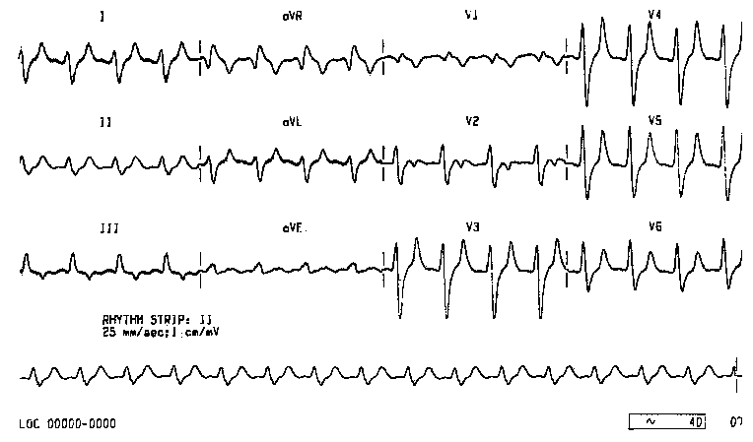

A 65yr old lady presents with a week’s history of vomiting with diarrhoea. She is a type 2 diabetic on insulin and is complaining of weakness and lethargy.

pulse =120 irreg, BP = 100/55, T = 37, RR=20, O2 SATS 96% AIR

Her ABG shows pH 7.21, pO2 =12, pCO2=3.1 BE=-6 HCO=16

Na=129 K=8.1, GLUC=22,

Her ECG is shown above.

Name 6 ECG abnormalities assoc with hyperkalaemia [3 marks]

|  |
| --- |
|  |

After ABCs what cardio protective drug would you give your (name, dose, route)

[1 mark]

|  |
| --- |
|  |

Give 2 ways of rapidly and temporarily reducing the K in this patient (doses and routes for drugs) [2 marks]

|  |
| --- |
|  |

When would you consider haemodialysis in the treatment of hyperkalaemia. List 2 indications [2 marks]

|  |
| --- |
|  |

ALS guidelines state that there are 5 key steps in the treatment of hyperkalaemia. Name 3 [3 marks]

|  |
| --- |
|  |

QUESTION 19

A 14 year old girl comes to the ED with lower abdominal pain dysuria. She is here without her parents and pregnancy test is positive. She is requesting a termination. She is in a relationship with a 19 year old partner.

In the above scenario what are the key issues that you need to consider?

[4 marks]

|  |
| --- |
|  |

What are the 2 commonest causes of STI in this patient [1 marks]

|  |
| --- |
|  |

Name 4 pregnancy related complications of untreated STI [2 marks]

|  |
| --- |
|  |

She asks you for advice on contraception.

What three points must you think about regarding Gillick competence? [3 marks]

|  |
| --- |
|  |

QUESTION 20

[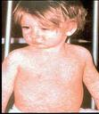](http://www.google.co.uk/imgres?imgurl=http://www.southstaffordshirepct.nhs.uk/images/yourHealth/vacs/measles.jpg&imgrefurl=http://www.southstaffordshirepct.nhs.uk/YourHealth/vacImms/photo/measles.asp&usg=___ZCF69EG5wbTgoH__0fQgA42698=&h=456&w=397&sz=28&hl=en&start=12&zoom=1&um=1&itbs=1&tbnid=u2gmmtCSHCRQRM:&tbnh=128&tbnw=111&prev=/images?q=measles+rash&um=1&hl=en&sa=N&rlz=1T4ADSA_enGB363GB363&tbs=isch:1&ei=pC1bTd2QLYexhAeCxNXhDA)

A 2 year old girl presents with a erythematous maculopapular rash. She is miserable with coryzal symptoms and a pyrexia of 38.5C and conjunctivitis.

She has not been given any immunizations.

Fill in the following table with at least 2 vaccines in each age group ( note combination vaccine such as MMR count as one vaccine)

[6 marks ]

|  |  |  |
| --- | --- | --- |
| Two months old |  |  |
| Three months old |  |  |
| Four months old |  |  |
| Around 12 months old |  |  |
| Around 13 months old |  |  |
| Three years and four months or soon after |  |  |

List 4 complications of measles? [2 marks]

|  |
| --- |
|  |

Name 8 other notifiable diseases [ 2 marks]

|  |
| --- |
|  |