November 18th 2009 Regional Training Day: SAQs

Question 1

A 15 year old boy presents to A&E with 3 hour history of sudden onset severe left lower abdominal pain, radiating to his groin and a tender L testicle. He feels sick but has not vomited, on examination he has exquisitely tender L testicle which feel larger than the right.

- List 3 differential diagnoses and how would you treat this patient? (4 pts)
A 20 year old man presents with 2 week history of gradual swelling to his L testicle (picture). He has a soft but firm swelling to his testicle which is non tender.  - What is the most likely diagnosis? (1 pt)  - How would you confirm it clinically & radiologically? (1pt) | 
A 14 year old boy comes in with his father. His dad had noticed a strange lesion on the patients penis the previous day at a swimming pool (see picture)  The boy says that he’s had it for a week or so but it is painless & he was hoping it would just go away.  - What is the most likely diagnosis? (1 pt)  - How would you treat it? (2 pts)  - What else do you need to ask him in the history? (1 pt)  - What else do you need to consider in his management especially because of his age? (2 pts) | 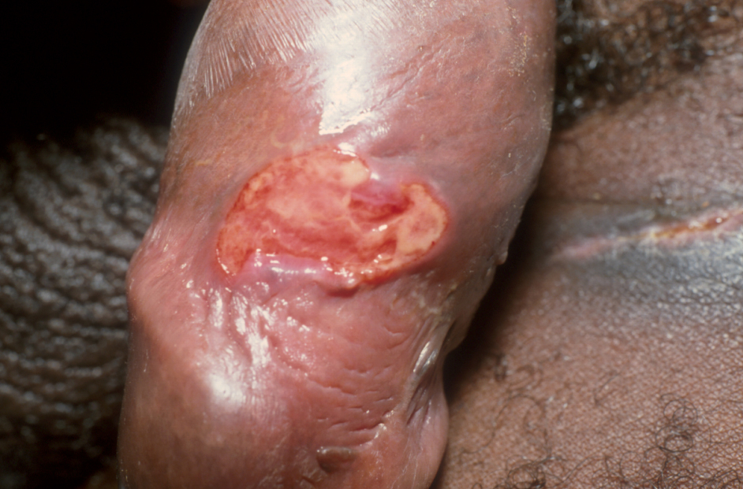

Question 2

According to the BTS guidelines:

- How can the severity of a pneumonia be scored? (5pts)

- Who is admission recommended for? (1pt)
- What antibiotic regime would you use for severe community acquired pneumonia requiring hospitalisation- (3 pts)
- Name 2 other criteria associated with bad outcome – (1 pt)

Question 3

A 25 year old man is brought in by his friend. He had come off his motorcycle the previous night. He slid off at about 50-60mph and hit a kerb with his L shoulder. His shoulder has been very painful since and today, when he sobered up, he noticed that he is having problems holding anything with his hand which also feels numb.

- What is the most likely injury he sustained? (1 point)

- What clinical signs may be visible on inspection? (2 points)

- What would be your initial management of this patient? (2 points)

On examination you find that he has reduced sensation over the area shown.
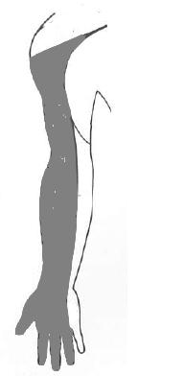

- Which 3 dermatomes are likely to be affected? (1 point)

- Which movements are likely to be affected by this injury? (3 points)

- List 3 other bony injuries that are associated with this injury? (3 points)

Question 4

A 4 year old boy is brought to A&E with a 2 week history of pain in the left foot on weight-bearing. On examination he is tender over the midfoot. His x-ray is shown below.

- What is the abnormality shown on the x-ray? (1 pt)

- What is the likely aetiology of this condition? (1 pt)

- Name 2 similar conditions and the bones that they affect (2 points)

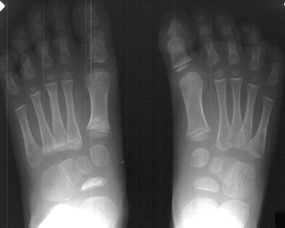

An 8 yr old boy attends your department having fallen out of a tree. His only injury is to his left ankle, which is swollen and painful. The X-ray is shown below.

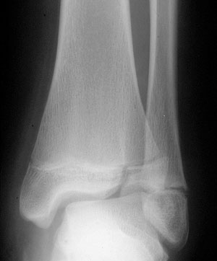

- What type of Salter Harris fracture is this? (1 pt)

- Describe the other types. (2pts)

- What is the management of this injury? (2 Pts)

Question 5

A 65 yr old patient presents to department with sudden onset pain in the left eye. He had been reading a book in bed when it happened. It is a severe pain and he finds it difficult to see out of that eye.

- List 3 features on simple examination which would be suggestive of glaucoma? (3 points)

- Which agents can be used in the initial management (please give doses)? (2 points)
- What features on the examination of the eye would make you suspect bacterial conjunctivitis rather than glaucoma? (4 points)
- What condition is shown below? (1 point)
- How would you treat it? (1 point)

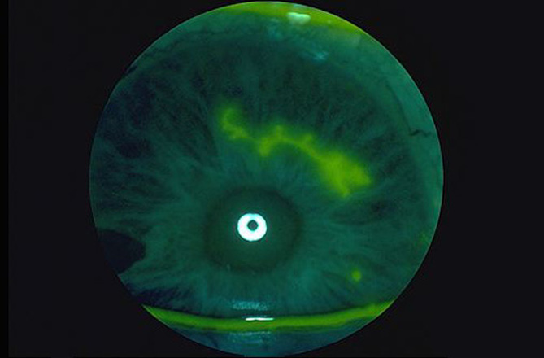

Question 6

A 15 month old girl is brought to your department by ambulance with a history of a 5 minute tonic-clonic seizure at home, which stopped spontaneously. She has seemed hot & been coryzal today. You take a history

- What features of the history (other than pyrexia) would support a diagnosis of febrile convulsion (as opposed to alternative diagnoses)? (3 points)

On examination you can find no focus of infection.

- What investigations would you carry out?

- Which children with febrile seizures require admission?

- What information do you tell the parents prior to discharge?

Question 7

A 2 year old boy is brought to the ED by his mother. He appears to have taken her ferrous sulphate tablets. She has just found the empty container under the sofa. He has vomited twice today and the vomit “looked odd”. He refused lunch but is drinking fluids.

- What are the early features of iron toxicity that could present in the first 12 hours? (2 points)

- What features may develop after 24 hours post-overdose? (2 points)

- What late complications can occur? (2 points)

- What would be the indications for gastric lavage in this patient? (2 points)

Question 8

A 65 year old man comes to the ED complaining of breathlessness and palpitations. His ECG is shown:
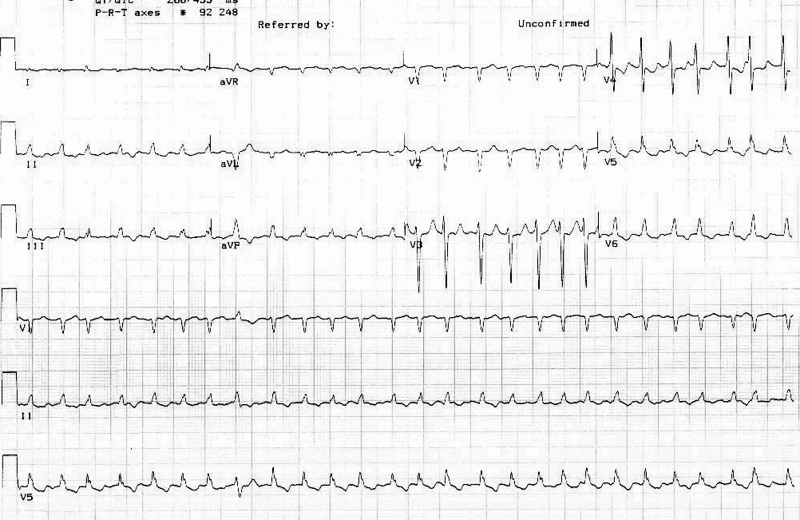

He is discharged the next day on digoxin and anticoagulation with an outpatient appointment to return for DC cardioversion in 6 weeks. He returns 1 week later very unwell. He is agitated and apparently hallucinating.

HR 170bpm, T 41oC, RR 30, Sats 93%, coarse creps throughout both lung fields, and jaundiced.

- What is the diagnosis? (1 pt)

- What conditions could precipitate it? (2pt)

- What investigations do you do? (3pt, ½ pt each)

- What is your initial management? (4pt)

Question 9

A 60 year old man presents to your department having tripped over the cat. His right femur x-ray is shown.

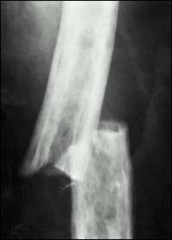

- Describe the x-ray (1 point)

- What alterations in biochemistry would you expect? (3 points)

- What is the underlying diagnosis? (1 point)

Question 10

This 8 year old boy presented with a weeks history of erythematous rash on his flank( see pic). He has been treated by the GP with an antifungal and steroid ointment but it is not improving. The child does not seem to be bothered by the rash except when the cream is being put on he seems to be in a lot of pain.
He is otherwise well and healthy, immunisation UTD.

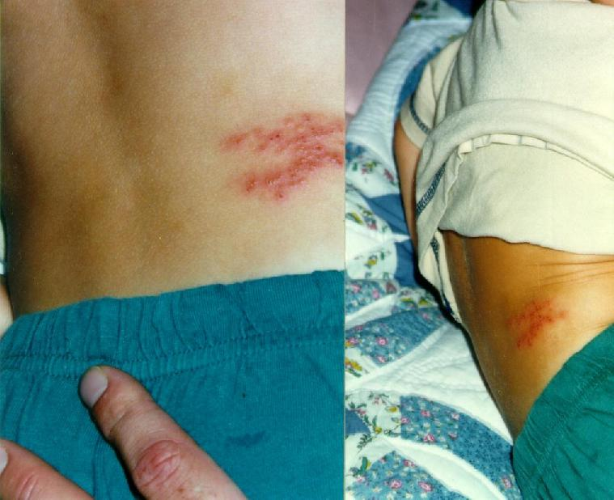

- What is the diagnosis? (1 point)
- What is the key question in the past medical history? (1 point)
- What is the most common complication of this condition and which patient subgroup is most likely to suffer from it? (2 points)

Bell’s palsy is defined as an abrupt, isolated, unilateral, peripheral facial paralysis without detectable causes.
- What is the treatment of choice currently? (1 point)
- Name 4 factors which would give a worse prognosis (ie make recovery less likely). (4 points)

Question 11

- What does the SAD PERSONS score stand for? (10 points)

