FCEM SAQ
September 2008

20 questions
10 marks per question
200 marks
2.5 hours

Question 1
An elderly man presents with fever and foul-smelling urine. He has a palpable bladder. Observations are as follows:
T>38
P110
SBP 110

- Give three initial treatments [3 marks]

- Give 4 physiological parameters and their limits as per early goal directed therapy / River’s protocol [4 marks]

- Give 3 procedures you would perform. [3 marks]

Question 2
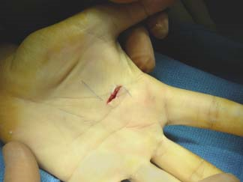
This man presents with a wound to his hand.

- What are the anatomical relationships of median nerve at the wrist?

- Name two landmarks for a median nerve block

- Which drug would you use for local anaesthesia? What dose?

- How do you know if you’ve hit the nerve? What do you do?

Question 3
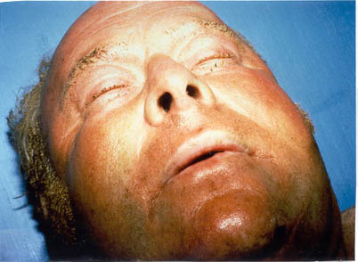
This patient was rescued from a house fire.

- What clinical findings suggest airway burns?

- Details of burns of other parts of body are given. What % body surface area is affected?

- Calculate his fluid requirements in the first 8 hours

Question 4
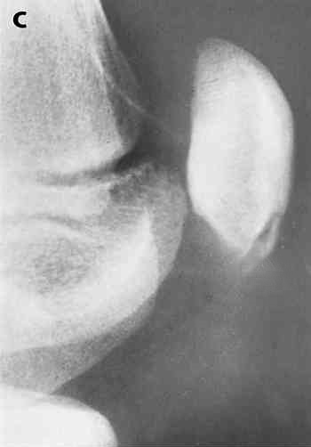
A 14 year old boy attends your emergency department having fallen at school
a couple of hours ago on his left knee. He complains of pain in his knee
and he cannot extend and cannot straight leg raise.
A
1 a What are the 2 abnormalities on the knee X ray? [2 points]
1 b What is the diagnosis? [2 points]
1 c What investigation would you consider if you were convinced of your
clinical findings but cannot find it on the X ray? [1 point]
B1
A 50 year old man sustains a trauma to his knee and cannot extend his knee
and cannot straight leg raise. Give 3 causes. [3 point]
B2 At what age does the distal femoral epiphyseal plate fuse? [2 points]

Question 5
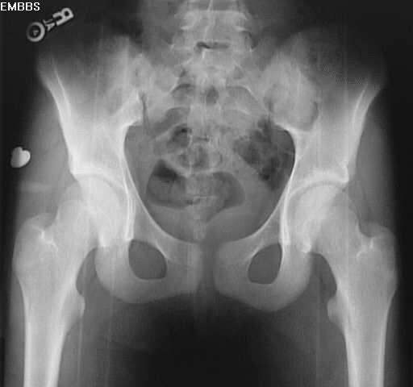

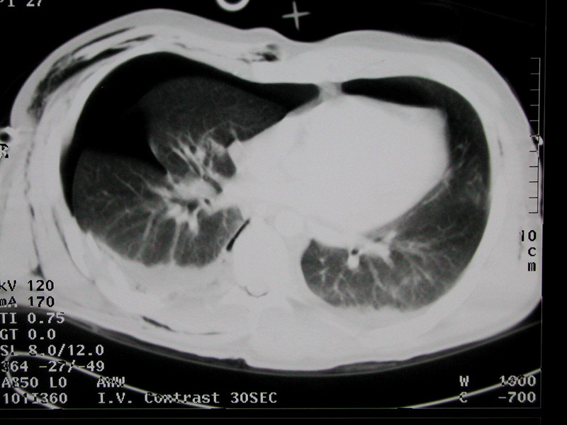

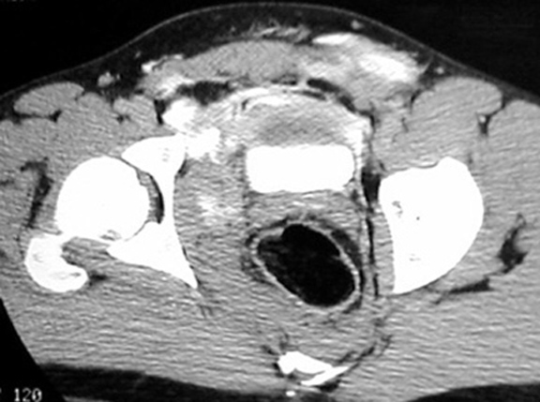
This 30 year old man fell 10m from scapholding. Observations are as follows:
HR 130
BP 80/40

- What does the X-ray show?

- Name 2 immediate steps in the management while awaiting specialist treatment

- Give 2 abnormalities show on the CT scan.
Question 6
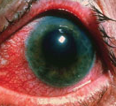
This patient has closed angle glaucoma.

- Name 2 systemic symptoms of this condition

- Name the abnormalities shown in the photo

- What is the drug type and mechanism of action of (i) mannitol and (ii) acetazolamide?

- How would you differentiate between central retinal vein obstruction and retinal detachment?

Question 8
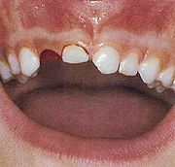
A 4 year old girl who had fallen on her chin and has a missing tooth.

What 2 questions would you ask her mother and state your reasons why? (2)

What would you do now and why? (2)

You decide to discharge her, what advice would you give her mother? (4)

If an adult presented to the emergency department with a history of a recent dental extraction and bleeding from the socket, state what treatments you could do for this patient? (2)

Question 9
A 32 year old lady presents to the emergency department with headache.
She is 34 weeks pregnant with no previous history of problems during her pregnancy.
Her blood pressure is 160/120
Her GCS is E4V4M5

Blood results :
Hb 8
Plt 30
Poikilocytes
ALT raised

Urine dipstix:
Proteinuria ++++
Blood +
What is the diagnosis (2)

Comment on the full blood count result and give an explanation for your findings. (4)

Explain your management of her hypertension and include route and drug. (2)

You’ve contacted the appropriate specialties and SCBU, what 4 management steps would you take whilst in the Emergency Department? (2)

Question 10
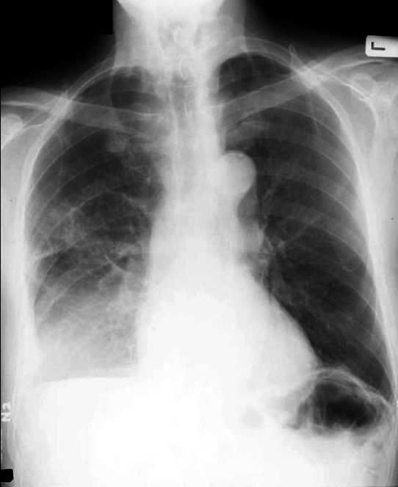

A 77 year old woman is brought to ED from her own home with a 3-day history of cough, yellow sputum and fever. Her temperature is 37.9ºC, heart rate 90/min, BP130/90.

a) What is the abnormality on the CXR? Where is it localised and justify your answer? What is the diagnosis? [2 marks]

b) What are the likely causative organisms in this patient? [1 mark]
(i) (ii)

c) What are the 6 features of severe illness? [3 marks]
(i) (iv)
(ii) (v)
(iii) (vi)

d) What measures can be taken to prevent the spread of clostridium difficile infection? [2 marks]
(i) (iii)
(ii) (iv)

e) Which antibiotics predispose to clostridium difficile infection? [2 marks]
(i) (ii)

Question 11
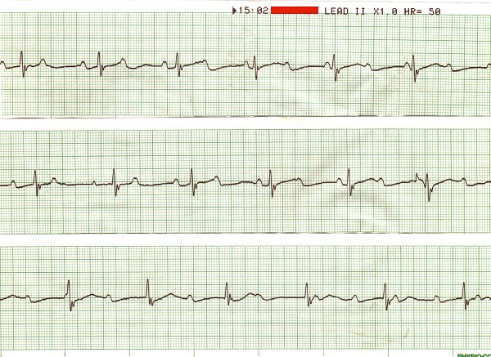
A 50 year old Venezuelan woman is brought into resus. Her heart rate is 46/min, the blood pressure is unrecordable. She has a raised JVP and bibasal crepitations. She is unrousable and has a poor respiratory effort. This is her rhythm strip. She is fully monitored.

a) Give 2 abnormalities on the rhythm strip [1 mark]
(i) (ii)

b) Give the principles of management of this patient [6 marks]
(i) (iv)
(ii) (v)
(iii) (vi)

You obtain a collateral history that she has recently been commenced on digoxin and amiodarone by a private GP.
c) What are the effects of digoxin and amiodarone in overdose? [2 marks]
Digoxin:
Amiodarone:

d) In the light of this information, what further tests would you do, and which treatment would you give? [1 mark]

Question 12
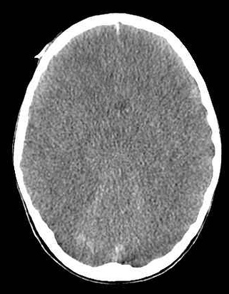
An 11-month old child is brought in to ED after having fallen out of a carrying chair while being taken upstairs by his mother. His mother states that he did not cry but fell asleep immediately afterwards. Then he made some jerking movements of his limbs. When the ambulance crew attended to him, his GCS was 10/15 but is now 14/15.

a) What are the differences in GCS measurement between adults and children? [2 marks
b) What are the possible indications for immediate CT head in this patient? [2 marks]
c) What abnormalities are shown on his CT scan? [2 marks]
d) What other issues need to be addressed? [4 marks]

Question 13
A 24 year old woman is brought to the ED following a cardiac arrest for 15 minutes. 3mg atropine and 3mg adrenaline were administered intravenously by the paramedics. She had returned from Norway after fracturing her tibial spine skiing 2 days ago.
a)What is the likely diagnosis(1)
b) Highlight each abnormality in the arterial blood gas results and give the physiological reasons for each result (4)
Ph 6.88
pCO₂ 9.0 KPa
pO₂ 64 KPa
HCO3⁻ 5 mmol/l
Lactate 17mmol/l
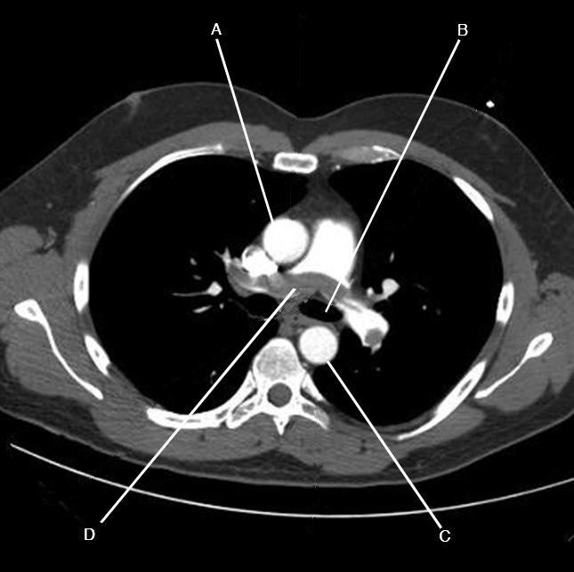
c) Name the 4 structures labelled A-D on the CT scan (4)
d) Calculate the alveolar-arterial O2 gradient. Show your calculations. (1)

Question 14
A 56 year old woman attends the Emergency Department complaining of anxiety and a sensation of tingling in her face and hands. On checking her blood pressure she develops cramp in her hand.
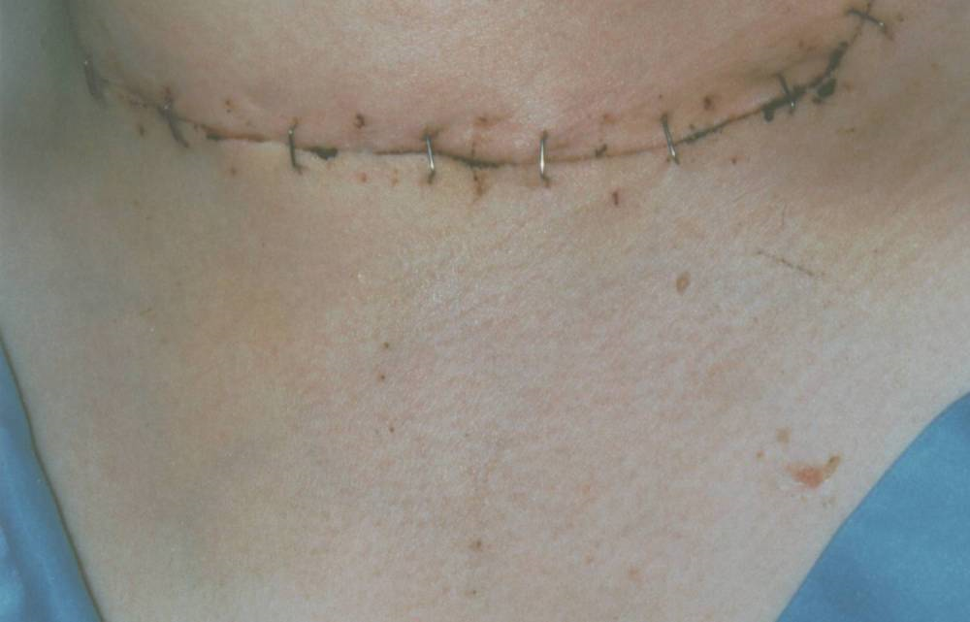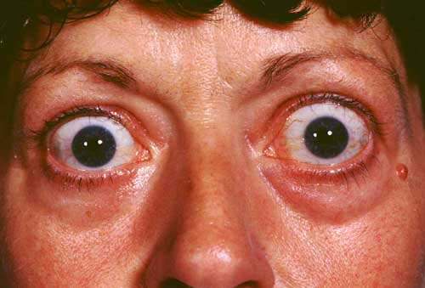
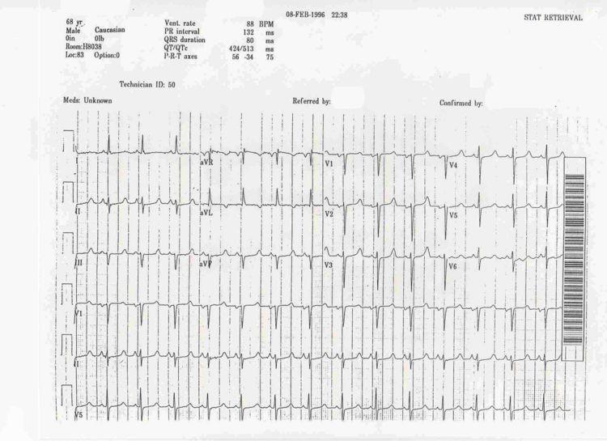
a) Name 4 blood tests you would do in the emergency department and your reasons for doing them(4)

b) What 2 relevant ECG abnormalities are present (2)

c)What treatment would you give and what 2 precautions would you take (?4)

Question 15
A 24 year old man attends the ED after 4 weeks foreign travel in Europe with a dry cough, sore throat , fever and muscle pains he is convinced that he has bird flu.
Temp 38.9 Pulse 110 RR 22 BP 110/70

- Give 3 features that may suggest that he does have bird flu(3)

He says that he stayed on a farm where there were some sick birds.
You decide to admit him as his O2 sats are 85% (air).

- What appropriate actions do you take before further evaluation(3)

- Name 4 appropriate on call personnel or agencies would you notify(4)

Question 16
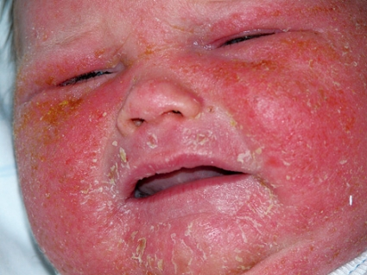

The Baby brought by mum, and they have just returned from a 2 week holiday in Florida.

a) Describe the appearance of this rash [3 marks]

b) Give two potential diagnoses [2 marks]

c) Where else might this rash typically occur [1 mark]

d) How might their holiday be implicated in their presentation? [2 marks]

e) What advice do you give to mum before discharge regarding treatment of the rash? [2 marks]
Question 17
A 39 year old man who is previously healthy presents to the ED with 5 day hx of fever and 2 day hx of RUQ pain. He is jaundiced and been passing dark urine. He is normally fit & well. There is no previous medical history of note. Drinks 18u/week.
o/e: 2 cm palpable liver edge. No stigmata of chronic liver disease.
Bilirubin 135
AST 150
ALT 1000
Alkaline phosphatase 34
Gamma GT 25
INR 1.1

a) What type of jaundice is this? (1)

b) Give reason why (1)

c) Name 4 causes of the above (4)

d) List 4 investigations you would do to help confirm your diagnosis (4)

Question 18
A 6 year old boy is brought in to ED by his mother. His GP has diagnosed him with asthma 3 weeks ago after a history of cough and wheeze.

According to May 2008 BTS guidelines, list 4 immediate assessments necessary for this child [2 marks]
(i) (iii)
(ii) (iv)

List 3 features of an acute severe attack in this age group. [3 marks]
(i)
(ii)
(iii)

List 3 immediate treatments necessary in the first 5-10 minutes, including routes and doses [3 marks]
(i)
(ii)
(iii)

If the above treatment fails, list other therapies that you might consider (2 marks)
(i)
(ii)

Question 19
Your hospital is conducting an audit of data protection procedures.

a) List 4 key principles of the data protection act [4 marks]
(i) (iii)
(ii) (iv)

b) List 3 situations where clinical information can be released by the ED without the patient’s consent [3 marks]
(i)
(ii)
(iii)

c) List 3 situations in an ED where confidentially can inadvertently be breached, and explain how you could prevent it from occurring. [3 marks]
(i)
(ii)
(iii)

Question 20
A 72 yr old man fell forwards and injured his mouth and chin. He was brought to the ED immobilised on a spinal board. He is fully alert and orientated.

a) Excluding the person performing the examination, how many people are required to do a log-roll? [1 mark]

b) Give 2 reasons for early removal off the spinal board [2 marks]

c) He is noted to be vasodilated in his arms and legs. Give 4 signs suggestive of neurogenic shock. [4 marks]
(i) (iii)
(ii) (iv)

d) Your F2 doctor thinks this is a case of central cord syndrome. Give 2 features of central cord syndrome. [1 marks]

e) List the indications for a c-spine x-ray in an alert patient. [2 marks]

