March 2006 SAQ Paper

1. A 26 year old man attends the ED at 6pm on a Friday evening. He is complaining of lower abdominal pain and dysuria. The GU clinic is closed for the next 3 days as it is a long weekend.

His urinalysis shows

Blood ++
Protein +
Glucose –ve
Nitirites (nitrates were negative) ve
Leucocytes negative

i) What features in the history would suggest an STD rather than a UTI (2)

i)

ii)

You decide it is an STD.

ii) What 3 things would you like to do before commencing empirical therapy? (3)

i)

ii)

iii)

iii) What antibiotic regime would you commence and for how long? (3)

i)

What 4 things would you tell him before he leaves the department? (2)

i)

ii)

iii)

iv)

2. An 18 month old child is brought into the ED by his mother. He has been playing with a few 10p coins and she thinks she saw one in his mouth.

i) What 3 questions would you ask in the history? (3)

i)

ii)

iii)

ii) What (two things would you include in your) examination would you make? (2)

i)

ii)

iii) What two methods of investigation could be carried out in the ED? (2)

i)

ii)

iv) describe 3 sites and the vertebral level at which foreign bodies are most likely to get stuck (3)

site: level:

site: level:

site: level:

3. A 34 year old women returns to the ED. She was seen the day before with a history of malaise, arthralgia, fever and dry cough. She was seen by one of the SHOs and sent home as a viral illness. She returns to the ED SOB with sats of 94% on high flow oxygen.
This is her xray. (I am sure xray showed RML as well as bibasal shadowing)

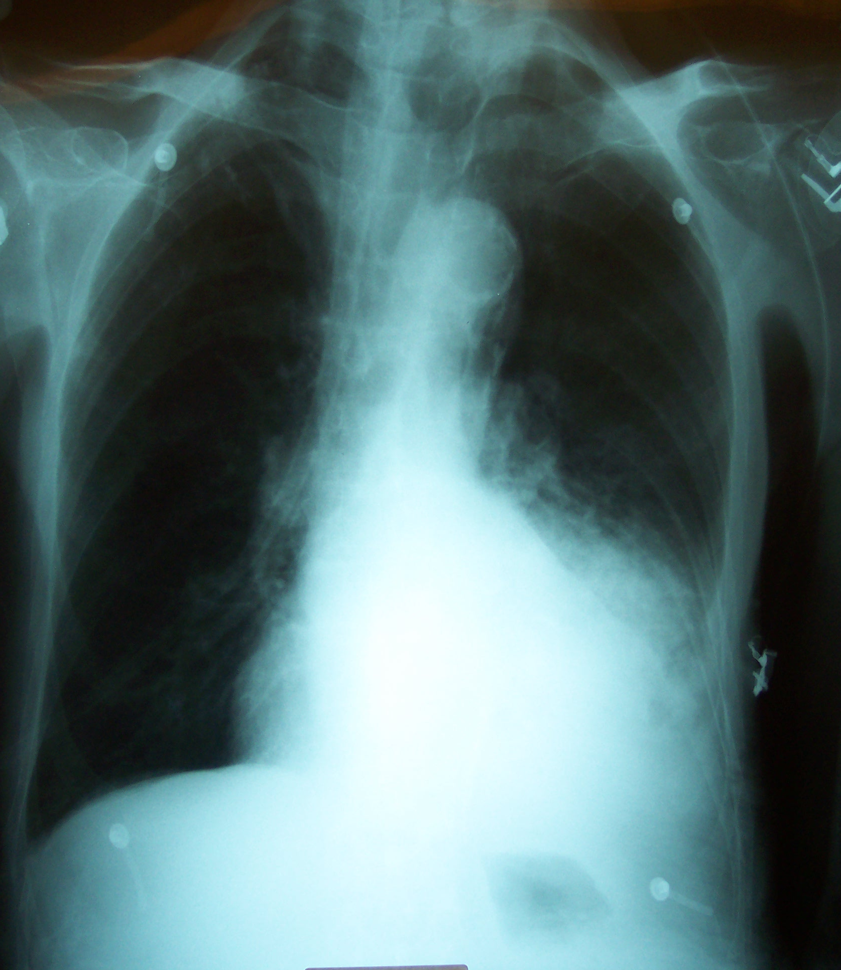

Comment on her x-ray (2)

What tests in the ED could you perform to confirm your diagnosis? (2)

i)

ii)

What type of NIV would you use if indicated? (1)

i)

How could you improve compliance with NIV? (3)

i)

ii)

iii)

There was an ECG question for 2 marks but no ECG in the data for this question.

Q4. A 35 year old man comes to the ED with bloody diarrhoea and abdominal pain. He has a 5 year history of Crohn’s disease. He has severe pain, looks unwell (he has guarding) and has a temperature of 37.8°C. He is tachycardia at2 120/min

Comment on his X ray. (2)

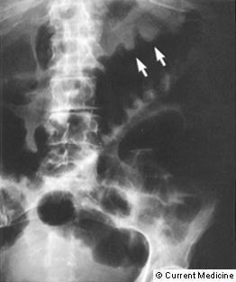

i)

ii)

iii)

iv)

What antibiotics and by what route would you give? (2)

i)

ii)

Give 2 other drug treatments and routes (2)

i)

ii)
Give 4 skin and musculoskeletal manifestations of inflammatory bowel disease (4)

i)

ii)

iii)

iv)

Q5. A 46 year old woman attends the ED with pins and needles in her toes, she feels clumsy and has (blurred) double vision. She had an “upset stomach” last week. She is usually fit and well.

Examination reveals power 4/5 in her lower limbs with absent deep tendon reflexes and diplopia on right lateral gaze.

What is the likely diagnosis? (1)

i)

What are 2 other possible differential diagnoses? (2)

i)

ii)

What (three) investigations would you do in the ED and why (3)

Give nerve root innervation of the following reflexes. (5)

Jaw

Supinator

Triceps

Biceps

Knee

Ankle

Q6. A mother brings her 10 year old Caucasian child to the ED with lethargy and malaise for a few weeks. She is limping and complaining of hip pain. There is gross limitation of movements of the left hip.

Bloods are: Hb 8.4
Plts 20
WBC 28
Retics 0.5%

Give 4 possible diagnoses (4)

i)

ii)

iii)

iv)

What investigations would you like to perform? (3)

i)

ii)

iii)

iv)

v)

vi)

Comment on the blood results (3)

i)

ii)

iii)

Q7. A 51 year old man comes to ED by ambulance. He has been up all night vomiting. This morning he has suddenly got worse. He is SOB, his RR is 40. He has a pulse of 130 and he is pyrexia at 38.5° C
Hb 12.7 WBC 9.8 MCV 106 ALT 50
Plts 150 ALP 75 Bili 9 GGT 252
Comment on his Xray (2)

i)

ii)

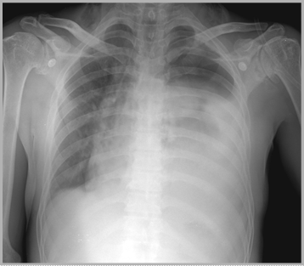

What is this condition called? (2)

i)

What investigations/ therapeutic measures could confirm the diagnosis? (2)

i)

ii)
8
Comment on his blood results (2)

i)

ii)

In view of history and blood results, what is the likely underlying aetiology/precipitant (1)

i)
Q8. A 25 year old man comes to hospital complaining of a sore (red) left eye for 2 hours. He was hammering metal yesterday and wears permanent contact lenses. His vision is slightly reduced in the effected eye.

What questions might you want to ask in the history? (4)

i)

ii)

iii)

iv)

v)

vi)

What features might suggests penetrating eye injury on inspection of the anterior aspect of the globe? (3)

i)

ii)

iii)

You decide this is a penetrating eye injury. What 3 drugs would you give? (3)

i)

ii)

iii)

Q9. A 9 year old boy (25kg weight) is brought into the Ed by his mother. He is dehydrated and lethargic. He looks unwell.

Give 5 specific features to suggest 5% dehydration. (4)

i)

ii)

iii)

iv)

He has received resuscitation fluids and his deficit has been calculated.
Calculate his maintainance fluid requirements for the next 8 hours. (3)
Show your calculations

Give 3 other tests you would like to do in the ED. (3)

i)

ii)

iii)

Q10. A 37 year old male comes to the ED with a 3 month history of malaise, night sweats and weight loss. His partner is HIV positive.

Comment on his chest x ray (1)

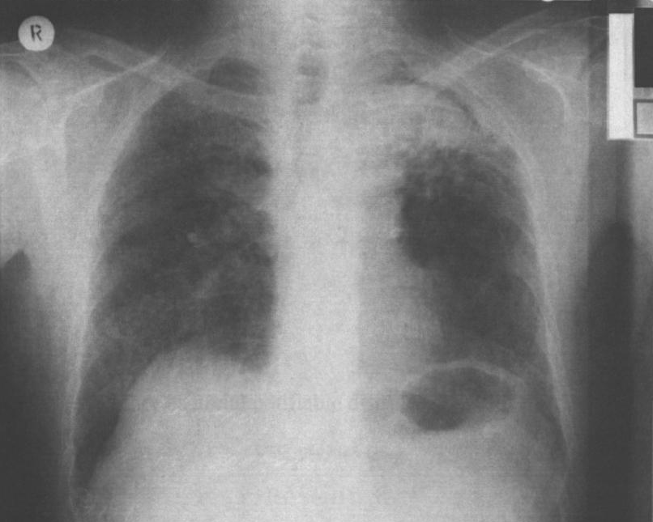

Give 3 possible diagnoses of the x ray findings. (4)

i)

ii)

iii)

iv)

List 3 common respiratory pathogens in HIV (2)

i)

ii)

iii)

Give three items in the BTS guidelines that can help assess this patient? (3)

i)

ii)

iii)
Q11. A 14 year old girl comes to the ED with lower abdominal pain. She is here without her parents and pregnancy test is positive. She is requesting a termination. She is in a relationship with a 19year old partner. (She does not want her parents notified)

How do you assess someone has capacity? (3)

i)

ii)

iii)

What things must you ensure regarding Gillick competence (3)

i)

ii)

iii)

On closer questioning she tells you she has had multiple sexual partners who are all adult and provider by her 19 year old boyfriend.

What do you do now? (4)

i)

ii)

iii)

iv)

Q12. A 37 year old woman comes to ED. She has recently been diagnosed with SLE and has been taking regular Ibuprofen for joint pains. She has come in because her ankles, hands and eyelids are swollen and she feels very breathless. Her exercise tolerance in greatly reduced. She was fit and well prior to this. Her bloods show
Na 145 K 6.7 Urea 16.7 Creat 135 FBC normal
Metabolic acidosis on ABG Total Protein 24 LFT normal

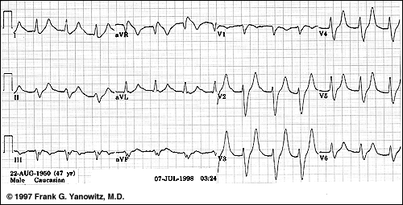
Comment on her ECG (2)

i)

ii)

She has runs of VT. Other than antiarrythmic medication what drug treatment would you begin? (2)

i)

ii)

What other investigations (three things in the urinalysis) would you do? (4)

i)

ii)

iii)

Give 2 processes to explain her blood results (2)

i)

ii)

Q13. A 95 year old with advanced alzheimers is brought in from a nursing home. He has a 3 day history of the rash seen below. He has a low grade fever, has a pulse of 100 and a BP of 102/65

Give 4 causes of the picture below (4)

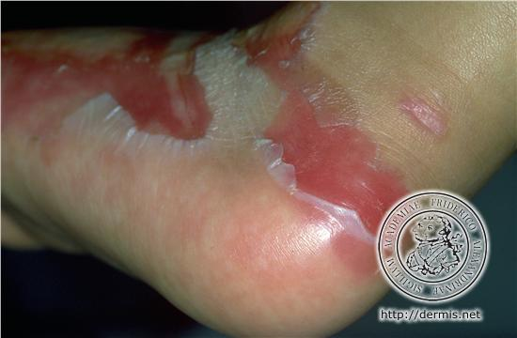

i)

ii)

iii)

iv)

What one question (in the standard medical history) would (help you) out?(1)

i)

What is Nikolsky’s sign? (1)

i)

What treatment would you give? (4)

i)

ii)

iii)

iv)

Q14. A 72 year old man has fallen from a horse. He is immobilised and brought into the ED on a spinal board. His pulse is 80 per minute and his BP is 102/64. He is complaining of abdominal pain and back pain. He has a past medical history of atrial fibrillation and hypertension.

Name two medications other than warfarin that he may be taking which may effect his physiological status. (2)

i)

ii)

You decide to do a FAST scan. Give 4 limitations to FAST scan. (4)

i)

ii)

iii)

iv)

The surgeons decide to take him to theatre – what two things would you do now with doses (2)

i)

ii)

What are the complications of the medications in iii) (2)

i)

ii)
Q15. A 45 year old lady attends 1 week post abdominal hysterectomy for fibroids. She is known to have hyperthyroidism, on treatment. She attends with a tachycardia of 140 bpm. She is pyrexial with a temp of 39.1°C and is agitated. Her abdominal wound is well healed and her abdomen is soft. She may have had a seizure too.
You decide the diagnosis is thyroid storm.

Give 4 other possible differential diagnoses that could account for her symptoms. (2)

i)

ii)

iii)

iv)

Give 4 non-drug interventions (management) in her management. (4)

i)

ii)

iii)

iv)

Give 4 drug treatments in this specific case and their purpose (4)

i)

ii)

iii)

iv)
Q16. A 27 (69kg) year old female attends the Ed with the butterfly from her ear ring stuck in her lobe.

Draw the ear, its sensory innervation and the landmarks for nerve blocks that would enable you to remove the butterfly. (5)

Calculate the dose (mls) of 1% plain lidocaine you could use for this procedure. Show your calculations. (2)

Give 3 systems affected by local anaesthetic toxicity and how they are affected. (3)

i)

ii)

iii)

