OCTOBER 2005 FFAEM SAQ’s

Wherever possible give dosages and route of drugs you mention

Question 1
A 28 yr old man presents presents to the A&E department complaining of shortness of breath and pleuritic chest pain. His arterial blood gases are as follows

On Air

pH 7.37
pO2 8.0
pCO2 2.3
BE -2.0

Give three investigations, other than D-Dimer, you would perform in the ED (3 marks)
F.B.C., CXr, ECG, CRP,

At this stage give 4 risk factors as described by the BTS to exclude Pulmonary Embolism. (4 marks)

Surgical- major abdo/pelvic surgery, hip/knee replacement, Post op ICU
Obstetric- puerpurium, late pregnancy, Caesarain Section
Lower limb problems- Fracture, Varicose veins
Malignancy- pelvic or abdominal, disseminated
Reduced mobility- hospitalisation, Institutional care
Others- proven previous VTE

His D-Dimer result returns at 0.2 (normal range <0.14)
What 2 management steps would you now make? (2 marks)

Start anticoagulants initially LMH- enoxiparin 1.5 mg/kg OD or 1 mg/kg BD
Arrange definitive investigation- spiral CT chest or CT angio or VQ scan if clear CXr, or pulmonary angio

The patient now becomes acutely short of breath and hypotensive. What one management step would you now take? (1 mark)

Thrombolyse with 50 mg bolus of alteplase

Question 2.

7 yr old child presents to A&E with a 12 hour history of headache and photophobia, but with no rash

Urea and Electrolytes as follows

Na+ 125
K+ 3.7
U 3.2
Cr 51

Give 2 possible neurological diagnoses for the symptoms described. (2 marks)

Meningitis, intracranial haemorrhage, Migraine, Encephalitis

What is the neurological cause for the Hyponatraemia (1 mark)

Meningitis

2 complications of Hyponatraemia (2 marks)

Seizure, anorexia, headache, drowsiness, nausea and vomiting, tachycardia and about 10 million others

Give 5 investigations you would perform in the ED for a patient with Hyponatraemia (5 marks)

Urinalasis, FBC, U&Es, LFTs, BM/glucose, urine osmolality, ECG, CXr, consider CT head, LP if no signs of raised ICP

Question 3.

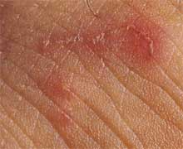

A 45 year old man presents to the ED with a rash on his palm which is intensely itchy. The SHO thinks it is Scabies

Describe 2 features of the rash (2 marks)

Erythematous linear popular rash suggestive of burrows

Give the Diagnosis and one differential (2 marks)

Diagnosis: Scabies
Differential: Insect bites, dermatitis or psoriasis

What causes the itching? (1 mark)

Itch caused by reaction to the faeces, eggs and the mites themselves later during disease

Give 2 other features of this condition (2 marks)

Tends to be worse at night and during winter months, tends to affect multiple household members, if undiagnosed lasts for years (7 year itch), can become superinfected,

Give 2 treatments (2 marks)

Scabicide – e.g permethrin
Antihistamines- tablets or creams
Steroid cream/ointment- 1% hydrocortisone
Crotamiton- anti pruritic topical

What further advice would you give to the patient? (1mark)

Advise thorough hygiene and treatment of all household members
advise to boil wash all clothing and bedding
See GP if not effective or returns
Question 4.
A 65 yr old man is in your ED with a known overdose of Digoxin. An ECG has been performed. His U+E’s are Na+ 142, K+ 6.7, U50.1, Cr 502

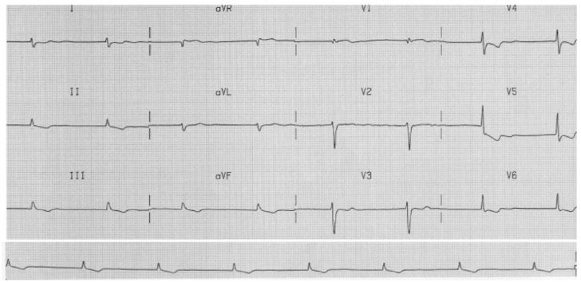
Describe 4 features of the ECG (4 marks)

Supraventricular bradycardia ? slow AF as no visible p waves, T wave inversion and ST depression inferolaterally, reverse tick sign laterally, prominent u wave laterally,

Give 3 indications for digibind (3 marks)

K+ > 5, digoxin level >15, ingested >10mg, ventricular tachyarrhythmia, haemodynamically unstable bradyarrhythmia, altered mantal status attributable to dig toxicity

Give 3 other treatments for this patient and give reasons for them (3 marks)

Calcium gluconate- 10ml of 10% over 2 min to counteract the hyperkalaemia
Calcium chloride- 5 ml of 10% over 2 min
Salbutamol nebuliser 5ml- increases intracellular K+ reabsorption
Fast acting Insuline 10-15 iu in 500ml of 10% dextrose- increase K+ reabsorbtion
Atropine 0.5 mg up to 3mg to reverse bradycardia
Magnesium in case of torsades de pointes

5. A 30 yr old female who works as an accountant and who is known to have been depressed for some time is brought to the ED having been found unresponsive. An ECG has been taken on arrival.
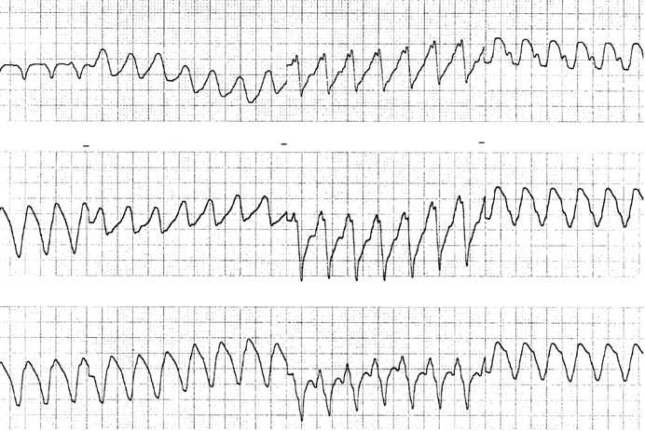

Describe ECG and give the cardiac diagnosis (2 marks)

Broad complex Tachycardia, regular, most likely Ventricular tachycardia

As you are looking at the ECG the patient has a fit.
Given this event what is the most likely diagnosis for the patient? (1 mark)

Tricyclic overdose

What drug would you give and what is it’s mode of action? (2 marks)

Drug: Sodium bicarbonate 1mEQ/kg bolus
Mode of action: Unblocks the sodium channels and might reduce the bioavailability of TCAs by increasing their binding to protein

What aspects of the patients condition would you monitor after giving this drug (2 marks)

Monitor pulse, BP, rhythm, mental status, oxygenation

Give 4 other actions you would take to manage this patients fitting (4 marks)

Protect airway- recovery position +/- nasopharyngeal airway, give O2 if not already on, IV lorazepam 0.1 mg/kg, call anaesthetist/ICU, follow the seizure pathway

6. A 65 yr old male attends complaining of loss of vision in his left eye

Give six features you would enquire about in the history (3 marks)

Visual acuity
Flashers/floaters/ amaurosis fugax
trauma
headache/temporal pain/ systemic upset
neurological signs or symptoms
eye pain
previous medical history e.g. AF, TIA

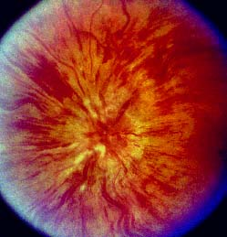

2 abnormalities of the fundus (2 marks)

Venous engorgement and widespread haemorrhage. Sunset appearance

What is the diagnosis? (2 marks)

Central retinal vein occlusion

Give 6 associations of this condition (3 marks)

Trauma- closed head
Vasculitis
Hypercoaguability states
Hypertension
DM
Alcohol
Glaucoma
7. A 10 yr old girl has fallen off a wall and presents with a “sore arm”.

Give three features which are required to “clear the neck” (3 marks)

Pt fully conscious
No evidence of intoxication
No neck pain/ midline tenderness
No neurological deficit
No distracting injury
ROM >45º in all directions
Age < 65

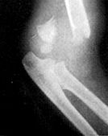

Describe the X-ray (1 mark)

Fracture distal shaft of humerus with posterior displacement

Give the diagnosis (1 mark)

Supracondyla fracture humerus

Give 2 potential neurological complications of this injury and how you would test for them. (4 marks)

Median nerve palsy- reduced sensation over the palm, reduced thumb opposition and wrist palmar flexion
Radial nerve – reduced sensation thumb, reduced wrist dorsiflexion

Other joint injuries can also give rise to nerve injuries, give an example. (1 mark)

Shoulder dislocation- axillary nerve
Neck of fibula fracture- peroneal nerve
Knee dislocation- superficial peroaneal nerve
Hip dislocation- anterior- femoral nerve
Posterior- sciatic nerve
Medial(acetabular)- gluteal nerves
Wrist- median nerve
8. 38 yr old pregnant woman 35 weeks pregnant comes with visual disturbance and headache. Her Blood pressure is 165/100

FBC WTU LFT
Hb 8.1 Blood ++ Bil 12
Plt 50 Protein+++ AST 1000
WCC 5.1 Nitrates - GGT 817
poikilocytes seen

Describe 2 abnormalities of the FBC and explain them (2 marks)

Anaemia due to haemolysis
Low platelets due to microangiopathy as part of HELLP syndrome (Haemolysis, elevated liver enzymes and low platelets)

What is the likely diagnosis? (2 marks)

Pre eclampsia and HELLP syndrome

To control BP what drug , including dose and route, would you use? (3 marks)

Labetalol 10mg IV or 100mg PO
Can use hydralazine 10mg IV

Give 3 other steps in the management of this patient (3 marks)

Call anaesthetist and senior obstetrician.
Magnesium 4-6mg IV
Arrange to deliver baby.
Treat in darkened, quiet room

Question 9

A 28 year old man has been out kite surfing and was thrown into the water at high speed. He is brought in on a spinal board with C-spine protection. He is intubated and ventilated and put on a propofol infusion.
His observations are, pulse 65, BP 90/60 and he is warm and well perfused.
The C-spine film and tomogram are shown below.
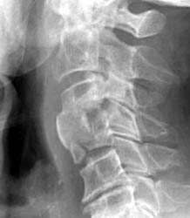

Describe 3 abnormalities on the XR (3).

# body C4, loss of space C3-4, probably soft tissue swelling
Burst fracture

Describe 2 aspects of his cardiovascular status (2).

Hypotensive and bradycardic/normocardic

What is the likely diagnosis? (2)

Spinal shock

What 3 signs would support this? (3)

priapism
Pink, well perfused peripheries,
flaccid paralysis below level C4,
increased tendon jerk reflexes below that level (might be absent initially)
loss of sensation,
very weak respiratory effort,

Question 10

A 42 year old man has been found outside A&E fitting. He is dishevelled and smells strongly of alcohol. BM =2.4

What is the definition of status epilepticus? (1)

Status epilepticus is seizure lasting > 30mins or more than one seizure wiith failure to recover between fits.

Name 3 steps in managing his fitting. (2)

Treatments:support airway and giove high flow oxygen. And check BM
Give 4mg IV lorazepam or 10mg iv diazemuls .
Pabrinex IV replacement and then give 50mls 50% dextrose or 500mls 10% dextrose IV.
May need phenytoin 18mg/kg IV or thiopentone 4-3-5mg/kg.

List 3 reasons for organising an urgent CT head on this man.(3)

Reasons for CT. May have intracranial bleed requiring surgery.
May have meningitis.encephalitis and need LP and look for SOL.
Possibility of closed head trauma

Give 4 reasons as to why alcoholics are more likely to fit. (4)

more likely to have head injury with complications. Alcohol withdrawal.
coagulopathy making bleeds worse,
impaired gluconeogenesis causeing low BM

Question 11

A 15 month child comes to A&E following a 3 day history of a viral illness with a maculopapular rash. On the day prior to presentation he had had bouts of colic but had been eating and drinking and had been otherwise settled.
He comes to the department unwell, with bloody diarrhoea and a capillary refill time of 3 secs.
This is his abdominal XR.
What is the likely diagnosis? (2)

Intussusception

List 3 predisposing factors. (3)

Vviral illness, cystic fibrosis, benign or malignant bowel tumours- e.g. putz Jeager, Meckel’s, coagulopathies e.g HSP- causing haematomas, sutures and staples, inverted appendiceal stump, Male gender

What would be the child’s fluid requirements be over the next 12 hours? (3)

Fluids- 1yearold= 10kg, 500 ml over 12 hours, keep UO 2ml/h

Name 2 treatment options. (2)

Air contrast/hydrostatic enema if large bowel involved,
Surgical
Question 12

A 60 year old man comes to A&E with his sister. She says he has been withdrawn and quiet lately, and has been saying he wants to die.

Give 6 features in assessing his risk of suicide. (6)

Sex
Age
Depression- H/O
Previous attempt at suicide
Excessive alcohol/drugs
Rational thinking loss
Separated/divorced/widowed
Organised/serious attempt
No social support
Suicide intent for the futu

What are 4 important aspects of the mental health act where you work? (2)

How would you ensure the patient could make a decision regarding his treatment? (2)

13. A man staggers into your department and says that he and many other people have been on the Tube and were sprayed with a liquid. He then collapses.

Other than calling your ED consultant, give 4 actions you would take to manage the situation.

1. Isolate the pt- undress and destroy clothes, thoroughly wash- all done in protective gear

2. inform unit/hospital manager

3. declare major incident standby,

4. contact police to corroborate story

inform ambulance control,
[3 Marks]

Give four of the muscarinic effects of organophosphate poisoning

Diarrhoea
Urination
Miosis
Bronchospasm
Emesis
Lacrimation
Salivation
Piloerection

[4 Marks]

Give three drugs to treat organophosphate poisoning.

Diazepam- 10mg IV, or another benzodiazepine
Atropine- large doses may require 20mg or more infusion
Pralidoxime- specific antidote to organophosphate poisoning

14. A 3 year old child attends your department late one night . She has stridor but is alert, and has previously been well.

Apart from croup give four differential diagnoses.
1. inhaled foreign body

2. epiglotitis

3. angiooedema

4. tracheitis. [2 Marks]

List 3 drugs with dose and route of administration used to treat croup.
1. dexamethasone 0.15-0.6mg/kg,

2. prednisolone 1-2mg/kg,

3. budesonide 1-2mg nebulised,
adrenailne 5mls 1:1000 neb. [3 Marks]

Give 4 aspects of the scoring system to evaluate croup.

1. recession, ,.

2. stridor,

3. air entry

4. cyanosis, [4 Marks]

mental state

Give 2 reasons to admit a child with croup.

1. croup score > 2

2. no response to treatment
[1 Mark]
parental anxiety. late at night as croup tendss to get worse overnight..

15. A 35 year old male attends your department. His partner is HIV positive and being treated for TB. Blood gases on 60% oxygen show
pH 7.44
pCO2 4.0Kpa (30mmHg)
pO2 16.5Kpa (124mmHg)
Bicarb 22 mmol/L
B.E. -1
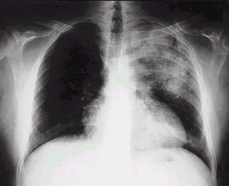

CXR as shown
Describe the CXR [2 Marks]

PA erect CXr- Patchy consolidation in the L upper zone

Excluding TB give 2 differentials diagnoses. [2 Marks]

Left upper lobe pneumonia
Aspergilosis
Pneumocystis
Psitticosis
Pneumonitis- viral

List 3 organisms that may infect the pulmonary system in HIV. [3 Marks]

Staphylococcus Aureus, a, Pneumocystis Cariniae, Aspergillous, Streptococcus pneumoniae, Legionell, Haemophylus- you name it it’ll do it

Give 6 tests in the ED which would help in the management of the patient. [3 Marks]

FBC, U&Es, CRP, Glucose, CD4 count, pulse oximetry, ABGs (sigh), BP
16. A 24 year old male had been assaulted. He has swelling around his LEFT eye and a cut on his RIGHT cheek. Your SHO has requested facial views 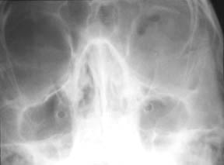

Give 3 abnormalities on the Xray [3 Marks]

left, ? orbital floor fracture. ? fluid level in left antrum.

List six aspects of assessment of the orbit and its contents. [4 Marks]
Visual acuity. pupil response, anterior chamber/lens and fundus. eye movements, infraorbital nerve function. proptosis and enophthalmos, subcut emphysema.

List 3 further steps in this patients management. [3 Marks]

discus with max fax,
advice re nose blowing.
return immeiately if decreased vision or pain on eye movements
Analgesia- eg 800 mg ibuprofen TDS
advice to avoid flying/pressurined areas
commence on ABX

