

  - “Quick Start” Guide for Mentors

  - How to get started with MentorNet

  - version 1.0

Contents

1. Introduction 3
2. Getting an Account and Logging In 3
2.1. Getting an Account and Registration 3
2.2. Logging In 3
2.3. Smartphone Users 5
3. Updating Your Profile 5
3.1. Changing Your Password 5
3.2. Adding a Profile Photo 5
3.3. Editing your User Profile 5
3.4. Matching Keywords 6
4. Matching 6
4.1. Administrator Matching 6
4.2. Mentee-led Matching 7
4.3. Defining Maximum Number of Mentees 7
5. Developing your Mentoring Relationship 7
5.1. Home Page 7
5.2. Messaging 8
5.3. Activity Logs 8
5.4. Sharing Documents 9
5.5. Resources 10
5.6. Calendar 10
6. Concluding a Mentoring Relationship 10
6.1. How to close a mentoring relationship 10
6.2. Evaluation 10
7. Common Problems 11
7.1. General 11
7.2. Unable to Log In 11
7.3. Forgotten Password 11
7.4. Not Receiving Automated Emails 11

Introduction
Welcome to the mentoring programme at NHS England East of England. This guide is intended to give you the basic information you need to get started using the MentorNet mentoring system.

There are four main phases which are described in this document:
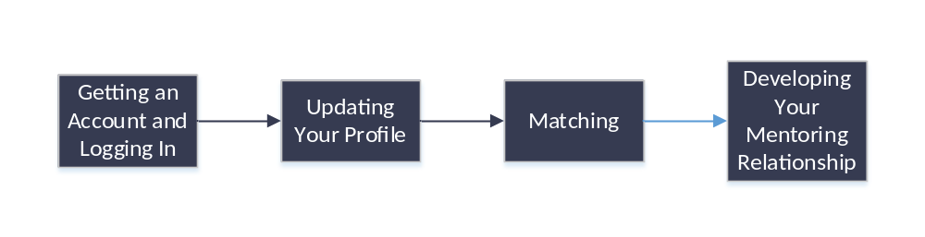

Getting an Account and Logging In

Getting an Account and Registration
There are two possible ways by which you get a MentorNet account, described below:

- Your administrator may have created the account for you
If this is the case then you will have received an automated email with your login details.
- You may be asked to ‘self-register’ on MentorNet
If you have been asked to self-register then you should go to the following url and follow the self-registration process: https://nhseoe.sfgmentornet.com/spa/?program=1&role=Mentor

You will receive an email to confirm your registered email address and a link to continue your registration.

Once you have submitted your self-registration, you will be sent a confirmation email with your account details and you then need to wait for an administrator to authorise your account. This can take up to 5 working days and you will be sent another automated email once your account has been authorised. You can then login and access your account. Note you will not be able to access your account until the administrator has authorised your account and you have received the email to confirm.

Logging In
Once you have your login details (see above), you can log in to MentorNet as follows:

- Open your web browser using any of the common browsers (e.g. Microsoft Internet Explorer, Google Chrome, Firefox).
- Go to https://nhseoe.sfgmentornet.com. You will see the following login page:
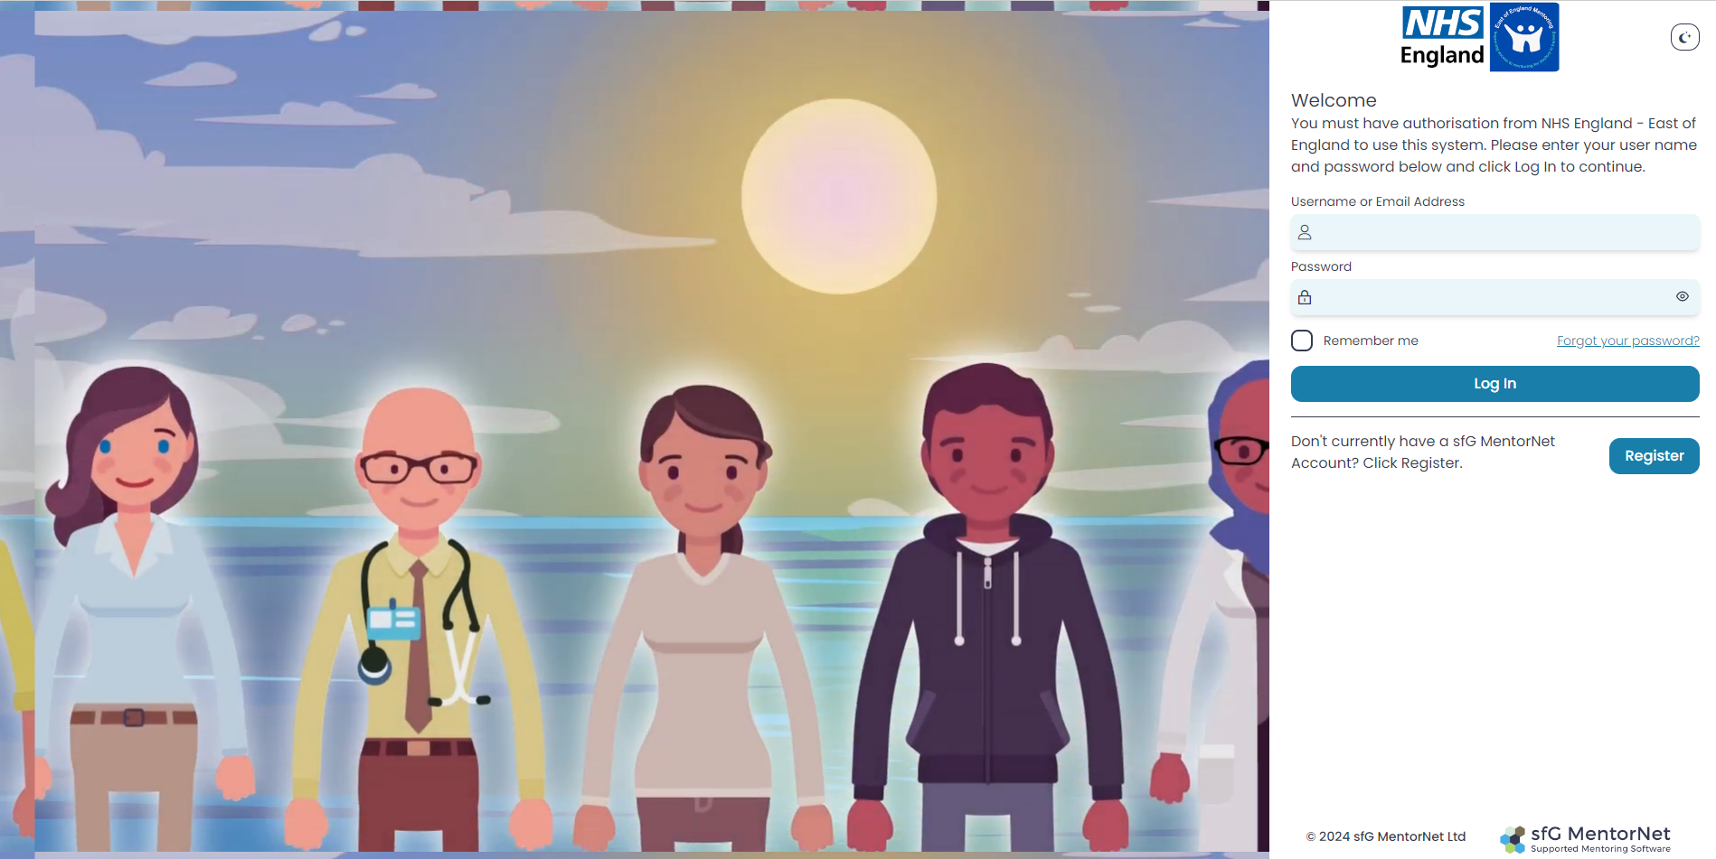
- Enter the username and password that you chose during the self-registration process, or which you were sent in the automated email.
- The first time you log in, you will be asked to read and sign the Privacy Notice and Consent Agreement before you can access the system. These notices tell you what your rights are under data protection legislation; they explain how your personal data will be used and who you can contact if you want to correct any mistakes or withdraw your consent. Nobody can access any of your personal data, and you cannot access MentorNet, until you have accepted the Privacy Notice and given your consent.
- Once you have logged in, you will see a screen similar to the one below:
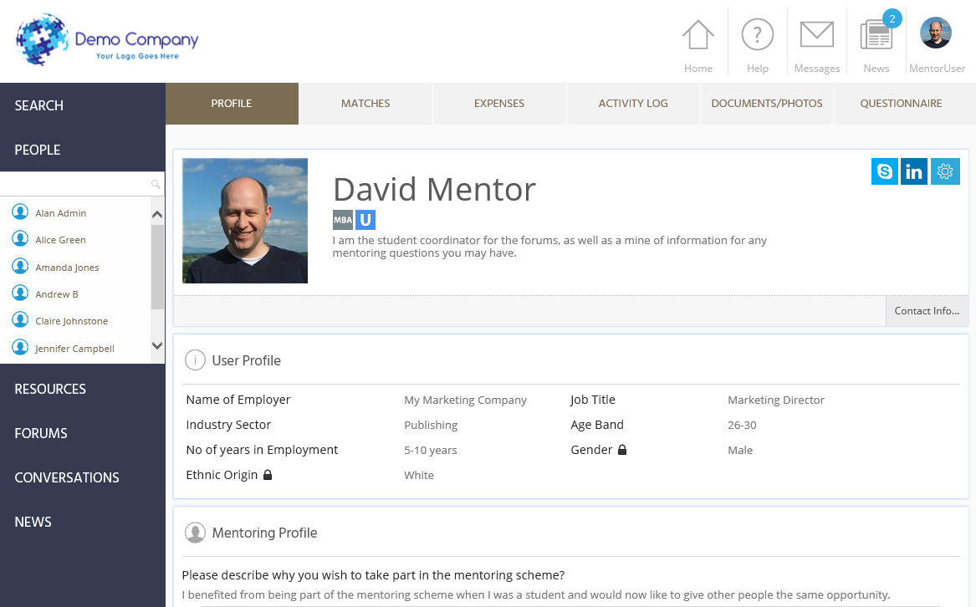

Any fields which have the padlock symbol () against them are ‘private’ fields – this data can be seen only by you and by administrators. Your mentee and other users cannot see this information.

Smartphone Users
You can also access the MentorNet site through a smartphone. Just go to your standard smartphone browser and use the same url and user details as above (ie https://nhseoe.sfgmentornet.com.) You may find it helpful to add a shortcut to MentorNet on your home page; if you’re unsure how to do this then you’ll find instructions for various types of smartphone under the Resources Section of MentorNet (‘Training Documents’) on the left-hand side of the screen. Look for the document titled: “Setting up MentorNet on a Smartphone”.

Updating Your Profile
Once you have logged in you will be able to update your profile. Most functions to edit your profile are available by clicking on the  icon on the top-right of your user profile screen – clicking on this icon will bring up the following drop-down list of options.

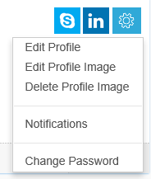

Changing Your Password
In order to keep your personal data secure, you should change your password to a secure password that only you know. Do this by selecting the “Change Password” option above. Passwords are required to be a minimum of 8 characters in length containing at least 1 uppercase character and 1 number.

Adding a Profile Photo
You should add a profile photo to make your profile more personal and to help others to identify you. Click on the “Edit Profile Image” and choose an image file to use. You can preview the image and crop/zoom the image to fit. Click “Upload Image” when you are happy with the image.

Editing your User Profile
If the administrator has created your account for you then you will probably need to add more information to fill out your profile. Or you may just want to edit information you have already added.

Choose the “Edit Profile” option from the drop-down list above. This gives you the following headings:
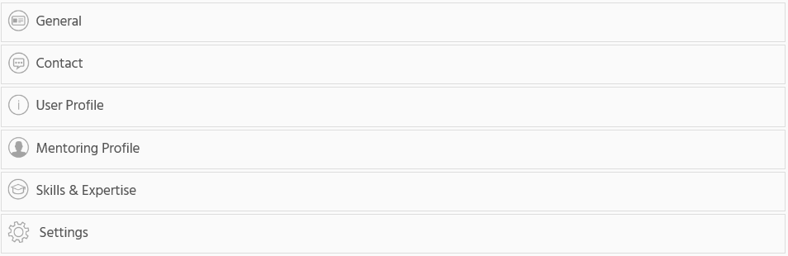

You can expand each heading and edit the detail within.

Matching Keywords
The Matching Keywords section is used to help describe what skills you’re able to offer your mentee during your mentoring relationship, and they will be used to help with the matching process.

This section has a drop-down list containing words that describe the skills you’re able to offer. Select words from this list that capture skills that you think you can offer a mentee during your mentoring relationship. You can select up to 10 keywords.

There are two ways in which you can add skills/expertise:

- Click on the icon and a drop-down list of words will appear.
- Start typing in the input box and the list will start filtering depending on the text you have entered.

With every keyword you select please click the  icon. Once you have finished adding your skills, click the  icon at the bottom right of the screen.

Don’t forget to click when you have finished all the above edits!

Matching
There are two main ways in which you may be matched to a mentee:

Administrator Matching
You, as the mentor, will be assigned a mentee by the administrator. When the administrator assigns you a mentee, you will receive an automated email giving you the name of your mentee. You will then be able to see the mentee’s profile details the next time you log in to MentorNet. You can see the name of your mentee by clicking on the Matches tab – see below. Clicking on your mentee’s name will take you to his/her user profile.

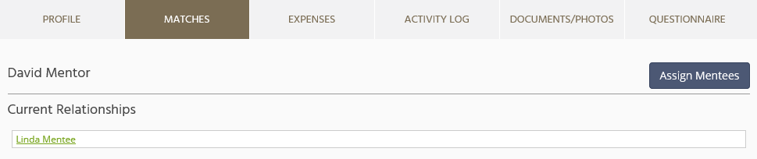

Mentee-led Matching
A mentee is able to search for and request a mentor. This request is then approved (or rejected) by the administrator.

The mentee and you will both receive automated emails confirming the match and inviting you to make contact with each other. You can see the mentee’s profile details the next time you log in to MentorNet by clicking on the Matches tab. Clicking on your mentee’s name will take you to his/her user profile.

Defining Maximum Number of Mentees
MentorNet allows you to define a maximum number of mentees you are able to accept at any time, so that you can ensure you are not overloaded. To change this setting, edit your profile as described above, and open the “Setting” group:

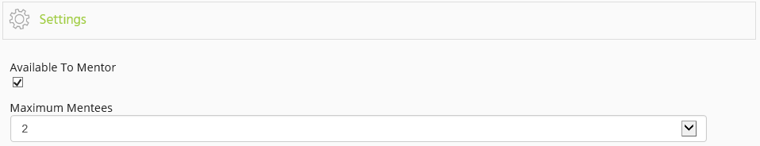

You can choose your maximum number of mentees and you can also make yourself unavailable for mentoring. If your limit has been reached, or if you are ‘unavailable’ to mentor, then you will not appear in any search results during the matching process.

Developing your Mentoring Relationship
Once you have been matched, you will want to use MentorNet to develop your relationship with your mentee. Most of MentorNet should be fairly intuitive to use, but you may find the following features useful as you build and develop your mentoring relationship:

Home Page

If you ever get ‘lost’ in the system, clicking the Home Page icon, at the top right of the screen, will take you back to your user profile page.

Messaging
Messaging in MentorNet works in much the same way as messaging in most social media apps. The key difference is that you are assured of confidentiality and security within the MentorNet system.

To access your messages:

- Click on the 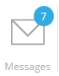 icon at the top right of the screen. The number highlighted in a blue background indicates if you have unread messages.
- You will see a list of all the conversations you are having with other users. A ‘conversation’ is a list of all the messages with that user – you have one conversation per user.
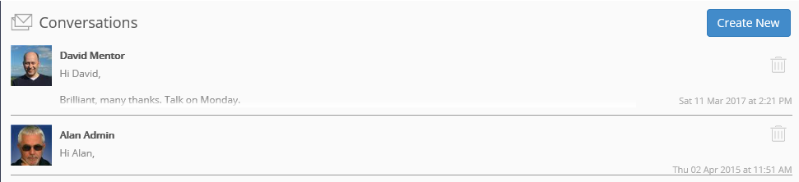
- If you click on the conversation, you will see a list of all the messages with that user, and you are able to reply:
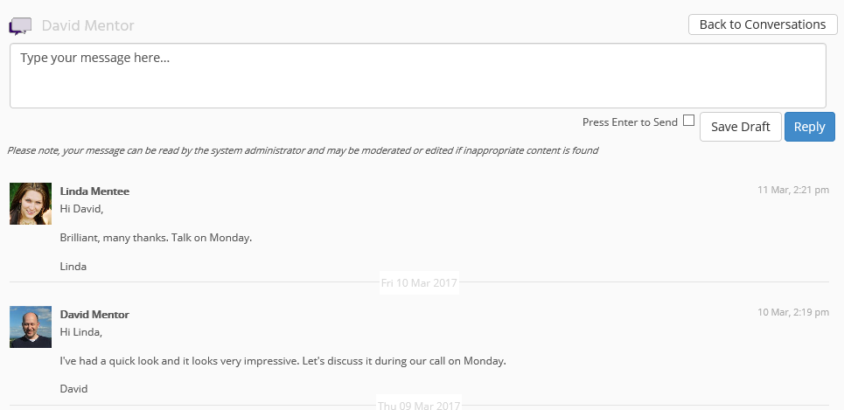
Notes:
- You are able to type a draft message, save the draft, and return to it at a later date without sending it
- Remember you can send/receive messages on your mobile device (see above for instructions on how to setup MentorNet on your phone)
- You will receive email notifications when you receive a new message. Email notifications can be configured so that you can change the frequency of the notifications.
- If you use inappropriate language in your messages, your message may be moderated and edited by the administrator.
- You must always maintain strict confidentiality of patient information.

Activity Logs

There are activity logs set up on the system including “Mentoring Agreement” which should be completed at the start of a mentoring relationship. These activity logs should be completed by the mentee.

To view an existing Activity Log:

- Firstly, make sure you are looking at your mentee’s profile (not your own). If you are on your own profile then any activity logs created will be about you, not about your mentee. To create an activity log about a specific mentee, you must start from that mentee’s profile.
- Go to your mentee’s profile and click on the Activity Log tab:
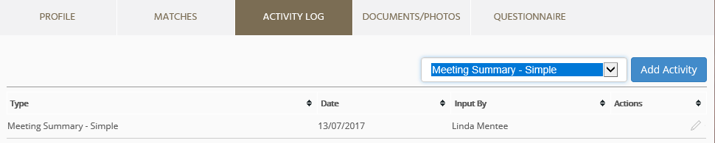
- You will see a list of any activity logs that have already been created and you have the option to add a new activity.
- You can view/edit an existing activity log by clicking on the pencil () icon at the far right of the activity log entry.
To create a new Activity Log:

- To create an activity log, select the appropriate template from the drop-down list and click “Add Activity”.
- An example of a simple Activity Log template is as follows:
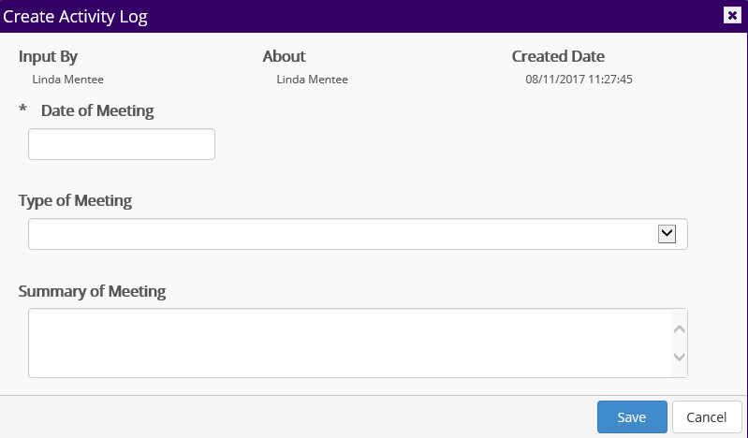

Sharing Documents
You may want to share documents with your mentor, perhaps so that he/she can review the document and you can discuss it at your next meeting.

To upload and share documents:

- Firstly, make sure you are looking at your mentee’s profile (not your own). If you are on your own profile then any documents uploaded will be for you, not for your mentee, and your mentee will not be able to see them. To upload a document to be shared with a specific mentee, you must start from that mentee’s profile.
- Go to your mentee’s profile and click on the Documents/Photos tab:
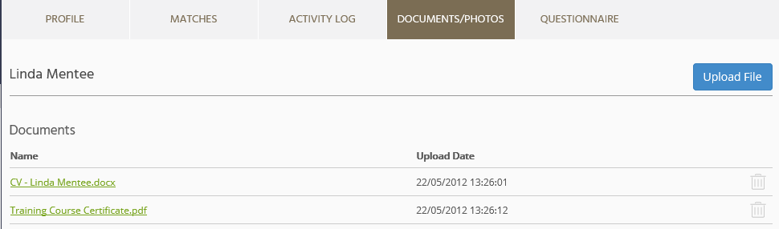
- You will see a list of any documents (and photos) that you have already uploaded and you can add new documents by clicking “Upload File”.

Note: Documents uploaded here can be viewed only by you, your mentee, and administrators.

Resources
MentorNet has a ‘Resources’ section where you can find documents that your administrator has made available to you. These might be training materials, templates, best practice documents, policies, etc.

You can access these by clicking on the “Resources” heading on the left-hand side.

Calendar
Click on “Calendar” on the top bar to schedule any meetings with your mentee.

Concluding a Mentoring Relationship

How to close a mentoring relationship
Once you have discussed and agreed to conclude your mentoring relationship with your mentee, you can click on the tab “Matches” and next to the mentee’s name there will be a button to close the relationship. Admin will be notified of this.

Evaluation
Once your mentoring relationship has ended, you and your mentee will receive an email with a link to complete the Mentor evaluation form. You can also do this by clicking on “Evaluation” and then “Create”. Once this is complete, you will receive a certificate of participation.

Common Problems

General
If you have any problems or questions about the mentoring programme or about use of the MentorNet system, you should contact your administrator on england.mentoring.eoe@nhs.net.

Unable to Log In
If you cannot login to your account, the most likely reason is that your username or password is incorrect, or your account has been locked. For example, if you enter your password incorrectly 5 times then your account will be locked and you will need to ask the Administrator to unlock your account.

If you cannot log in then check you are using the right username and double-check your password is correct (check caps lock is off and check any upper/lower case characters – sometimes a lower case “L” can look like the number “1” or the letter “I”). If you still cannot get logged in then contact your administrator.

Forgotten Password
If you forget your password, click on the "Forgotten Password?" link on the Login page. You will be asked to enter your username and to confirm the email address held within the system. A new password will then be sent to the email address registered within MentorNet. If this is the incorrect email address then you will need to ask an administrator to reset your password.

Not Receiving Automated Emails
If you aren’t receiving any of the automated emails, the most likely reason is that they are going into your spam/junk folder. Check the following:
- Check the email address on your user profile is correct
- Check your spam/junk folders
- Check your Notification settings

You should also add the MentorNet email address (noreply@sfgmentornet.com) to your ‘safe senders’ list in your email system to ensure future messages aren’t put into your junk/spam folders.

