

  - “Quick Start” Guide for Mentees

  - How to get started with MentorNet

  - version 1.0

Contents

1. Introduction 3
2. Getting an Account and Logging In 3
2.1. Getting an Account 3
2.2. Logging In 3
2.3. Smartphone Users 5
3. Updating Your Profile 5
3.1. Changing Your Password 6
3.2. Adding a Profile Photo 6
3.3. Editing your User Profile 6
3.4. Matching Keywords 6
4. Matching 7
4.1. Administrator Matching 7
4.2. Mentee-led Matching 8
5. Developing your Mentoring Relationship 9
5.1. Home Page 10
5.2. Messaging 10
5.3. Activity Logs 11
5.4. Sharing Documents 11
5.5. Resources 12
5.6. Calendar 12
5.7. Evaluation 12
6. Common Problems 12
6.1. General 12
6.2. Unable to Log In 12
6.3. Forgotten Password 13
6.4. Not Receiving Automated Emails 13

Introduction
Welcome to the mentoring programme at NHS England East of England. This guide is intended to give you the basic information you need to get started using the MentorNet mentoring system.

There are four main phases which are described in this document:
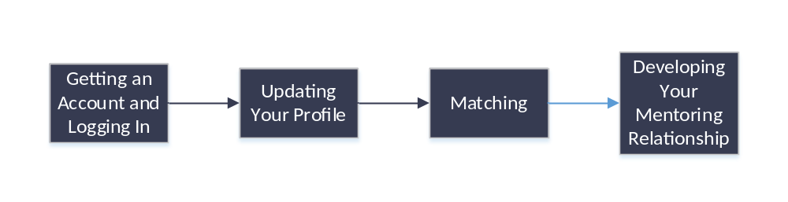

Getting an Account and Logging In

Getting an Account
There are two possible ways by which you get a MentorNet account, described below:

- Your administrator may have created the account for you
If this is the case then you will have received an automated email with your login details.
- You may be asked to ‘self-register’ on MentorNet
If you have been asked to self-register then you should go to the following url and follow the self-registration process:
https://nhseoe.sfgmentornet.com/spa/?program=1&role=Mentee

You will receive an email to confirm your registered email address and a link to continue your registration.

Once you have submitted your self-registration, you will be sent a confirmation email with your account details and you then need to wait for an administrator to authorise your account. This can take up to 5 working days and you will be sent another automated email once your account has been authorised. You can then login and access your account. Note you will not be able to access your account until the administrator has authorised your account and you have received the email to confirm.

Logging In
Once you have your login details (see above), you can log in to MentorNet as follows:

- Open your web browser using any of the common browsers (e.g. Microsoft Internet Explorer, Google Chrome, Firefox).
- Go to https://nhseoe.sfgmentornet.com. You will see the following login page:
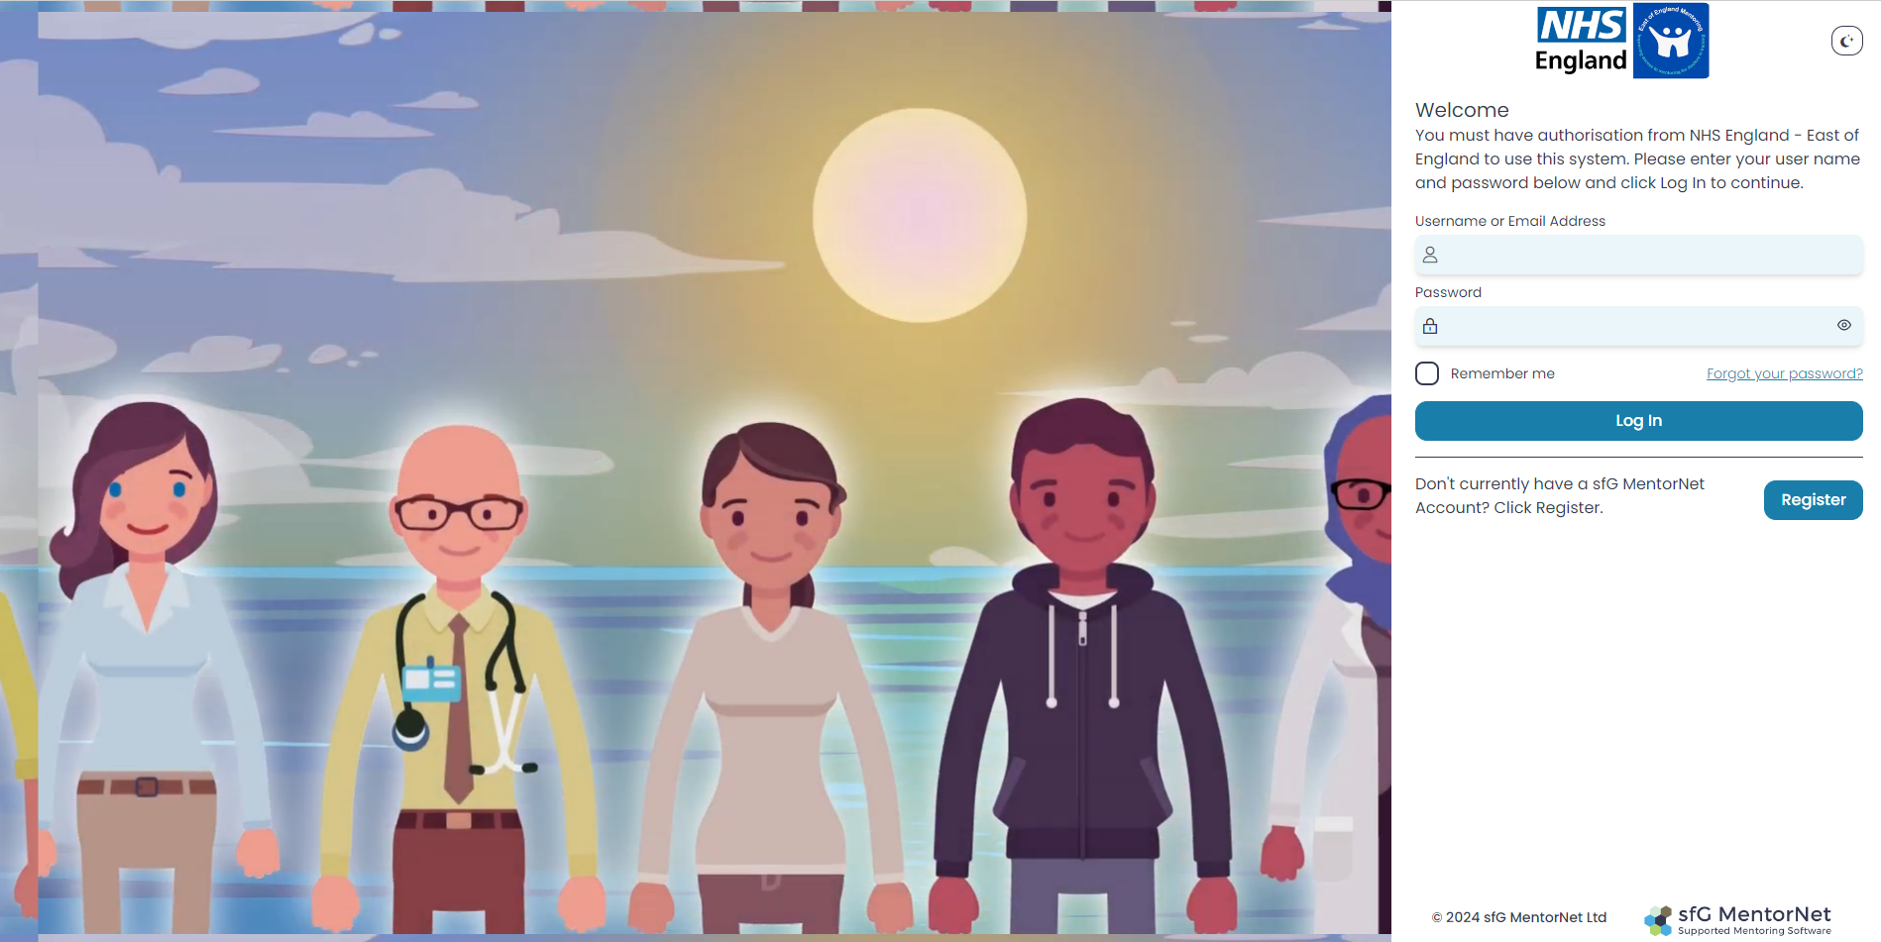
- Enter the username and password that you chose during the self-registration process, or which you were sent in the automated email.
- The first time you log in, you will be asked to read and sign the Privacy Notice and Consent Agreement before you can access the system. These notices tell you what your rights are under data protection legislation; they explain how your personal data will be used and who you can contact if you want to correct any mistakes or withdraw your consent. Nobody can access any of your personal data, and you cannot access MentorNet, until you have accepted the Privacy Notice and given your consent.
- Once you have logged in, you will see a screen similar to the one below:
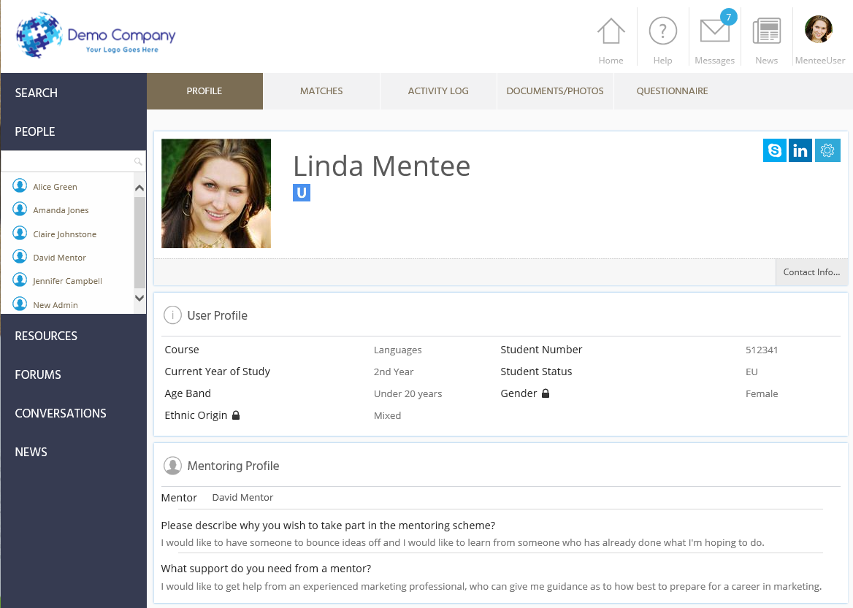

Any fields which have the padlock symbol () against them are ‘private’ fields – this data can be seen only by you and by administrators. Your mentor and other users cannot see this information.
- Once you have logged in you should update your profile, as per the following section.

Smartphone Users
You can also access the MentorNet site through a smartphone. Just go to your standard smartphone browser and use the same url and user details as above (ie https://nhseoe.sfgmentornet.com.) You may find it helpful to add a shortcut to MentorNet on your home page; if you’re unsure how to do this then you’ll find instructions for various types of smartphone under the Resources Section of MentorNet (‘Training Documents’) on the left-hand side of the screen. Look for the document titled: “Setting up MentorNet on a Smartphone”.

Updating Your Profile
Once you have logged in you should update your profile. Most functions to edit your profile are available by clicking on the  icon on the top-right of your user profile screen – clicking on this icon will bring up the following drop-down list of options.

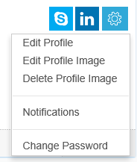

Changing Your Password
In order to keep your personal data secure, you should change your password to a secure password that only you know. Do this by selecting the “Change Password” option above. Passwords are required to be a minimum of 8 characters in length containing at least 1 uppercase character and 1 number.

Adding a Profile Photo
You should add a profile photo to make your profile more personal and to help others to identify you. Click on the “Edit Profile Image” and choose an image file to use. You can preview the image and crop/zoom the image to fit. Click “Upload Image” when you are happy with the image.

Editing your User Profile
If the administrator has created your account for you then you will probably need to add more information to fill out your profile. Or you may just want to edit information you have already added.

Choose the “Edit Profile” option from the drop-down list above. This gives you the following headings:
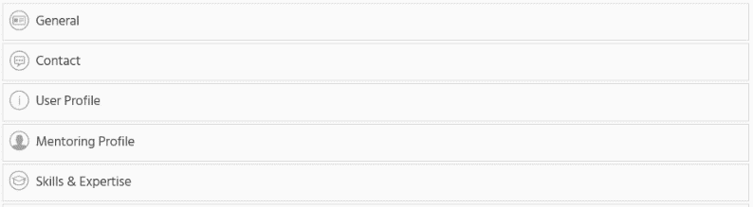

You can expand each heading and edit the detail within.

Matching Keywords
The Matching Keywords section is used to help describe what skills you’re looking to gain during your mentoring relationship, and they will be used to help with the matching process.

This section has a drop-down list containing words that describe the skills you’re looking for. Select words from this list that capture skills that you wish to gain during your mentoring relationship. You can choose up to 10 keywords from the list.

There are two ways in which you can add skills/expertise:

- Click on the icon and a drop-down list of words will appear.
- Start typing in the input box and the list will start filtering depending on the text you have entered.

With every keyword you select please click the  icon. Once you have finished adding your skills, click the  icon at the bottom right of the screen.

Don’t forget to click when you have finished all the above edits!

Matching
There are two main ways in which you may be matched to a mentor:

Administrator Matching
You, as the mentee, will be assigned a mentor by the administrator. When the administrator assigns you a mentor, you will receive an automated email giving you the name of your mentor. You will then be able to see the mentor’s profile details the next time you log in to MentorNet. You can see the name of your mentor in your user profile – see below. Clicking on your mentor’s name will take you to his/her user profile.

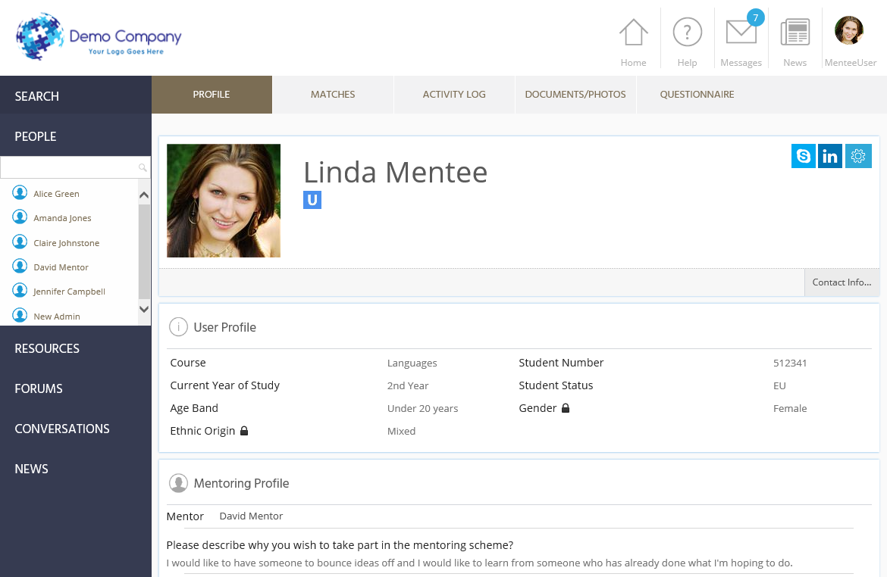

Mentee-led Matching
You are able to search for and request a mentor. Your mentor choice is then approved (or rejected) by the administrator.

- Click on “search” on the left hand side of the page. When searching for mentors, please use the Advanced Search section and use “AND” “Speciality” and choose your specialty filter to match with mentors in the same speciality.

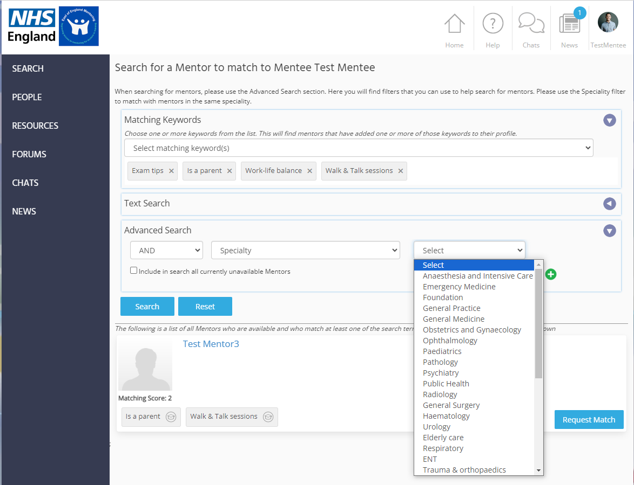
- You will then have a choice of mentors. They will be ordered in preference of the matching score (ie. How many of their keywords match your keywords). You will be able to look at their profile.

- Once you have chosen your preferred mentor, click the “Request Match” button. A new screen will pop up, allowing you to enter additional information:
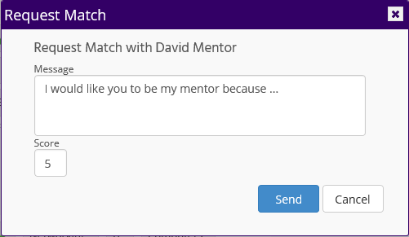
- You may type in some information about your requested match, perhaps to explain why you have chosen that particular mentor. You may also type a number in the ‘Score’ box to indicate a preference if you are selecting multiple mentors.

Your request will be sent to the administrator who will then either accept or reject the match request. This process can take a few days.
Once your match request has been accepted, you will receive an automated email confirming your match has been accepted. If your match is rejected then you will also receive an email informing you of this.

Alternative Way of Requesting a Match
If you are viewing the profile of a mentor with whom you’d like to request a match (e.g because you have found the mentor under the “People” heading), you can request a match directly from the mentor’s user profile screen. Simply click the “Send mentoring request” icon at the top-right of the mentor’s user profile – see below.

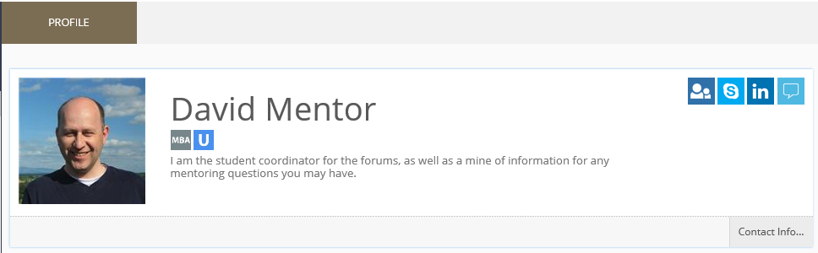

Developing your Mentoring Relationship
Once you have been matched, you will want to use MentorNet to develop your relationship with your mentor. Most of MentorNet should be fairly intuitive to use, but you may find the following features useful as you build and develop your mentoring relationship:

Home Page

If you ever get ‘lost’ in the system, clicking the Home Page icon, at the top right of the screen, will take you back to your user profile page.

Messaging
Messaging in MentorNet works in much the same way as messaging in most social media apps. The key difference is that you are assured of confidentiality and security within the MentorNet system.

To access your messages:

- Click on the 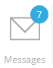 icon at the top right of the screen. The number highlighted in a blue background indicates if you have unread messages.
- You will see a list of all the conversations you are having with other users. A ‘conversation’ is a list of all the messages with that user – you have one conversation per user.
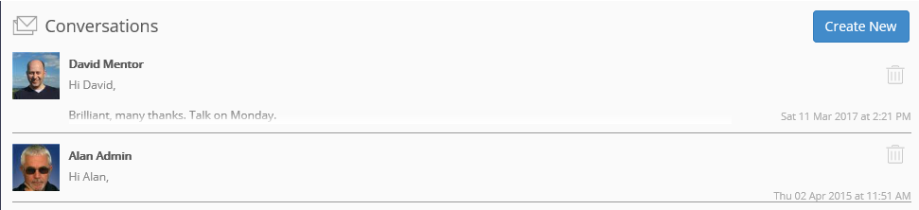
- If you click on the conversation, you will see a list of all the messages with that user, and you are able to reply:
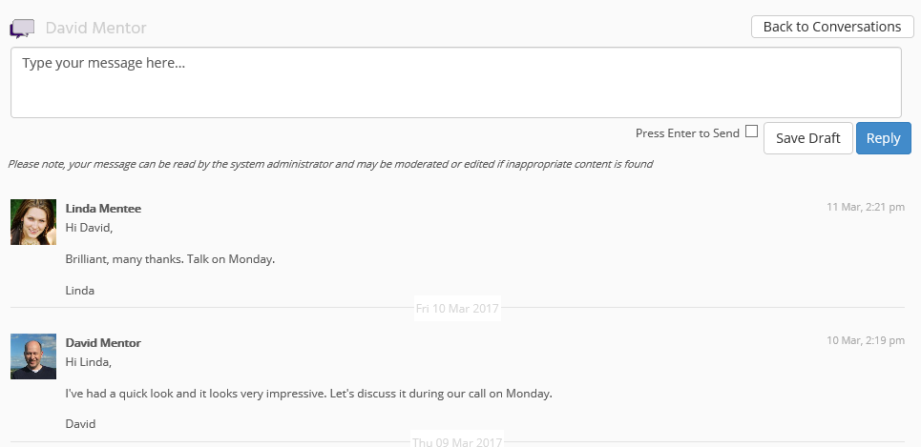
Notes:
- You are able to type a draft message, save the draft, and return to it at a later date without sending it
- Remember you can send/receive messages on your mobile device (see above for instructions on how to setup MentorNet on your phone)
- You will receive email notifications when you receive a new message. Email notifications can be configured so that you can change the frequency of the notifications.
- If you use inappropriate language in your messages, your message may be moderated and edited by the administrator.
- You must always maintain strict confidentiality of patient information.

Activity Logs
There are activity logs set up on the system including “Mentoring Agreement” which should be completed at the start of a mentoring relationship. You can record pre-session and post-session reflections and feedback for your mentor. These activity logs should be completed by the mentee.

To view an existing Activity Log:

- Go to your profile and click on the Activity Log tab:
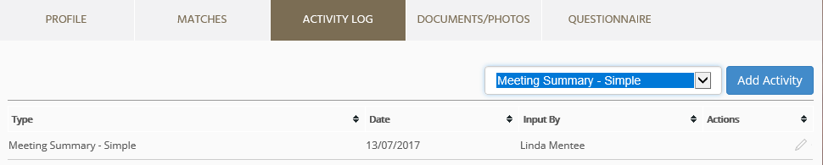
- You will see a list of any activity logs that have already been created and you have the option to add a new activity.
- You can view/edit an existing activity log by clicking on the pencil () icon at the far right of the activity log entry.
To create a new Activity Log:

- Select the appropriate template from the drop-down list and click “Add Activity”.
- An example of a simple Activity Log template is as follows:
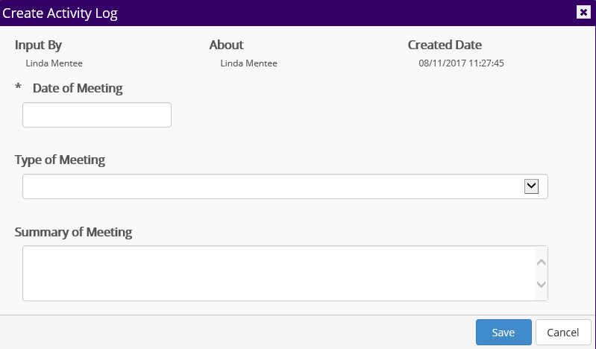

Sharing Documents
You may want to share documents with your mentor, perhaps so that he/she can review the document and you can discuss it at your next meeting.

To upload and share documents:

- Go to your profile and click on the Documents/Photos tab:
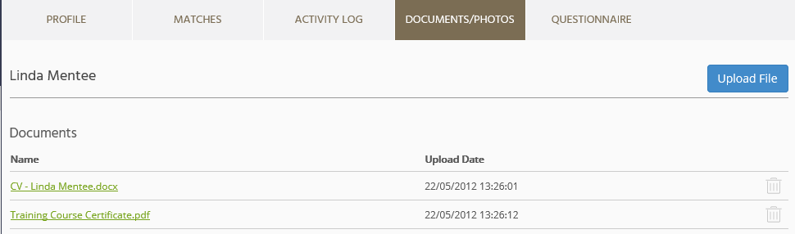
- You will see a list of any documents (and photos) that you have already uploaded and you can add new documents by clicking “Upload File”.

Note: Documents uploaded here can be viewed only by you, your mentor, and administrators.

Resources
MentorNet has a ‘Resources’ section where you can find documents that your administrator has made available to you. These might be training materials, templates, best practice documents, policies, etc.

You can access these by clicking on the “Resources” heading on the left-hand side.

Calendar
Click on “Calendar” on the top bar to schedule any meetings with your mentor.

Concluding a Mentoring Relationship

How to close a mentoring relationship
Once you have discussed and agreed to conclude your mentoring relationship with your mentor, your mentor can close the relationship on MentorNet and admin will be notified of this.

Evaluation
Once your mentoring relationship has ended, you and your mentor will receive an email with a link to complete the Mentor evaluation form. You can also do this by clicking on “Evaluation” and then “Create”. Once this is complete, you will receive a certificate of participation.

Common Problems

General
If you have any problems or questions about the mentoring programme or about use of the MentorNet system, you should contact your administrator on england.mentoring.eoe@nhs.net.

Unable to Log In
If you cannot login to your account, the most likely reason is that your username or password is incorrect, or your account has been locked. For example, if you enter your password incorrectly 5 times then your account will be locked and you will need to ask the Administrator to unlock your account.

If you cannot log in then check you are using the right username and double-check your password is correct (check caps lock is off and check any upper/lower case characters – sometimes a lower case “L” can look like the number “1” or the letter “I”). If you still cannot get logged in then contact your administrator.

Forgotten Password
If you forget your password, click on the "Forgotten Password?" link on the Login page. You will be asked to enter your username and to confirm the email address held within the system. A new password will then be sent to the email address registered within MentorNet. If this is the incorrect email address then you will need to ask an administrator to reset your password.

Not Receiving Automated Emails
If you aren’t receiving any of the automated emails, the most likely reason is that they are going into your spam/junk folder. Check the following:
- Check the email address on your user profile is correct
- Check your spam/junk folders
- Check your Notification settings

You should also add the MentorNet email address (noreply@sfgmentornet.com) to your ‘safe senders’ list in your email system to ensure future messages aren’t put into your junk/spam folders.

