WPBA ePortfolio PDP guidance document 2016

What is the purpose of the PDP within the portfolio?
The PDP (Personal Development Plans) area in the portfolio is designed to ensure that trainees are able to demonstrate that they can
- assess their learning needs
- plan actions to meet these needs
- review their achievement of these, with supporting evidence and, as a result, demonstrate the completion of learning loops.

On-going assessment of learning needs and planning to address these is an essential part of preparing for the annual appraisal process, which leads to revalidation. As such it is an essential part of GP training and should be demonstrated and assessed within WPBA and the ePortfolio.

How does the PDP appear in the portfolio?
Within the portfolio there are initially four strands to the PDP
- Learning objective
- Target Date
- Action plan
- How will I know when it’s achieved?

A date is added when the PDP is created and subsequently every time it is updated or amended a ‘last updated’ date changes.

An ‘Is achieved’ box and an ‘Outcome (after PDP achieved)’ box also appear.

How should a PDP be written?
PDPs should aim to be
- Specific - this means clear and possible to demonstrate; for example, ‘learning all about women’s health’ is not specific, but ‘improving knowledge of contraception options’ is. It should be about you and your needs as a GP and the practice where you work
- Measurable - this means you can demonstrate that you have evidence that your objective has been achieved; for example, by a reflection in your learning log or CbD on that area
- Achievable - for example, doing an e-learning module on joint injections, attending a minor surgery course or clinic and documenting your learning from these in the log is realistically achievable
- Realistic / Relevant - this means with respect to time and ability, and appropriate for your role as GP trainee and GP in the future and should relate to personal goals
- Time-bound - setting a ‘Target Date’ that is realistic, reviewed and changed as needed is key to setting a time-frame for achievement

Learning objective
- The more specific the learning objective, the easier it is to construct an action plan, agree a focused date by which to achieve this and to evaluate how it has been achieved
- Confidence on its own is very hard to measure and, therefore, we would recommend avoiding this term in your learning objectives
- Suggested words for learning objectives include - provide, learn, develop, deliver, manage, summarise, demonstrate, document and evaluate
- Appropriate examples
  - learn about acute eye conditions and demonstrate in log entries use of this knowledge and skills in assessing and managing them
  - demonstrate the ability to recognise the acutely unwell child and how to safely manage them
  - summarise my learning about management options for menorrhagia, and demonstrate applying these in clinical cases
  - learn about and identify resources for supporting patients and their relatives suffering from dementia
- Several short specific PDPs are better than an extensive one
- Inappropriate examples
  - Pass the AKT
  - Pass the CSA
  - Add more log entries
Passing the AKT and the CSA are national requirements for all trainees and so there is no benefit in adding these to the PDP.
Adding more log entries is not specific enough to show learning.

Target Date
This can be
- in the near future, short term, next few weeks, for example, for learning objectives for entries that involve e-learning or looking up information
- medium term, in the next six months, for attending courses and gaining experience of others managing conditions
- longer term, by end of ST3 year, for becoming confident and efficient with dealing with specific conditions

Action plans
- need to be specific and relevant to the objective and the time-frame set
- can have a variety of elements to them, for example
  - e-learning modules
  - sitting in, attending clinics
  - attending courses
  - looking up on the intranet / in a book
  - visiting social services
  - writing a practice protocol
  - writing patient information leaflets

How will I know when it’s achieved?
- This is easier the more specific the learning objective
- Reflecting on the actions detailed above (action plans) in the learning log and recording the learning from these
- Reflections on clinical encounters and how your learning was applied

Examples of PDPs:

These are real examples taken with permission

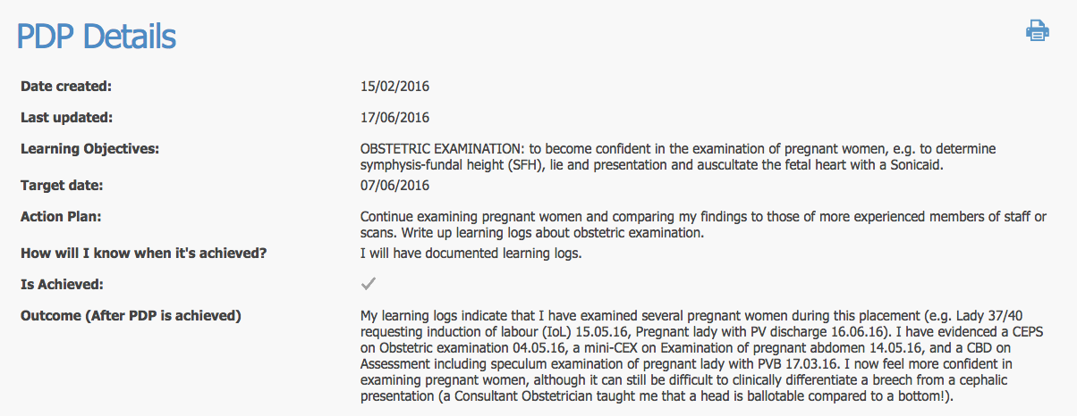

This PDP might be improved by instead of stating ‘more confident’ it summarised the learning. A PDP needs to be SMART and it is difficult to measure confidence.

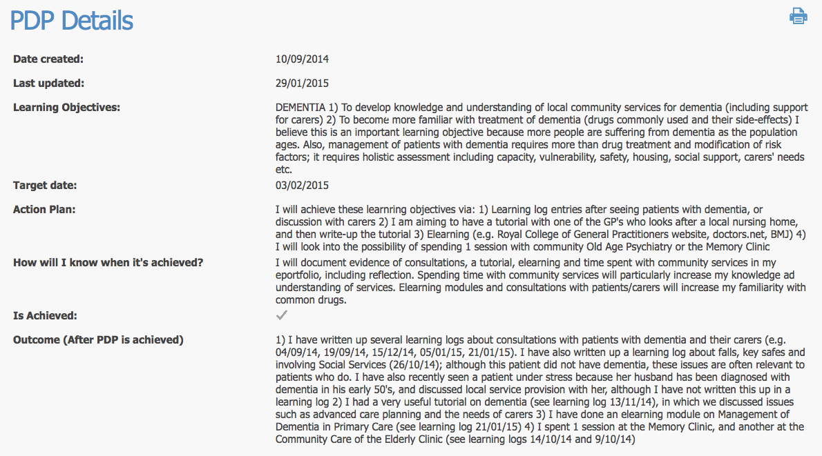

This is long and complicated and may be better separated as two learning objectives.

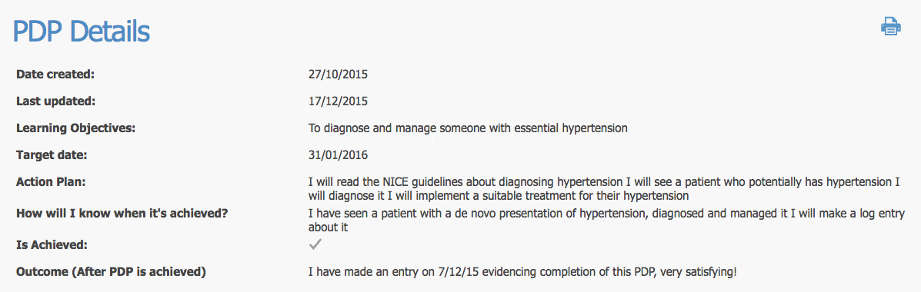

Although this is simple, it is an effective PDP entry.

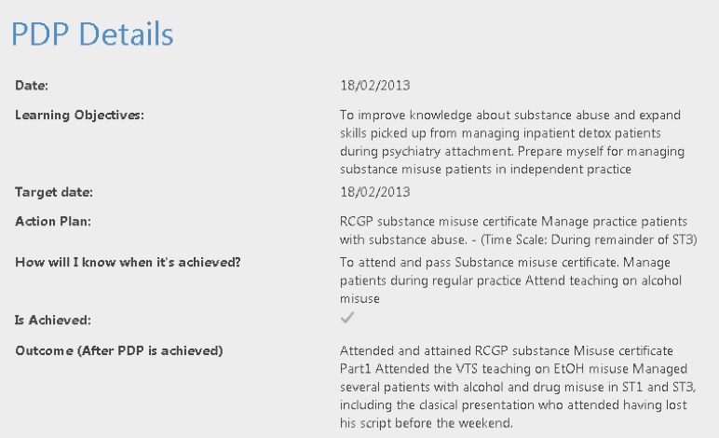

This is another good example of an identified learning need, which was addressed using a variety of sources. However, it seems to have been written retrospectively.

ESR-generated PDPs:
- As part of the ESR process, in addition to completing the self- assessment section, trainees will be required to create at least one PDP to cover their next review period or post
- If they already have created current PDPs, additional ones will not be required, but the ES will review all PDPs created in the last review period and may help edit to make them SMART or advise trainees to add further entries to cover missed or future learning needs, if appropriate
- Personal PDPs should continue to be created throughout the training post, and progress on those created in the last review assessed and recorded

