Learning how to teach– Nima Ghadiri
In November 2017, I graduated with a Masters of Clinical Education from the University of East Anglia. Embarking on this course was a rather daunting, though ultimately fruitful, endeavour which was borne out of the remarkable opportunities to be involved in teaching and training in this region.
I had always been interested in learning more about teaching, with a particular interest in how we can harness new technologies to enrich the learning experience. Training in Cambridge and Norwich has allowed me to practice by teaching medical students in small groups. Becoming a clinical supervisor affiliated with a Cambridge college also cultivated experience in other key skills for a teacher, such as mentorship and support in times of difficulty.
By this point, I became aware of the value in formalising my learning and developing a framework for growth. Herein lies the strength of the region in having institutions and individuals who can accord formal training in these areas. These include the Chief Residents’ Programme for Healthcare Leadership and Management, which is a highly-regarded joint programme run by Cambridge University Health Partners and the Judge Business School.
Another example is the Integrated Foundations of Medical Education course (IFME) run by the University of Cambridge Institute of Continuing Education and the School of Clinical Medicine’s Clinical Deanery. This course (comprised of two full-day sessions, four evening sessions, a dissertation and some distance learning) provides a foundation for teaching in medical settings, giving feedback, appraisal and assessment, with the opportunity to put this into practice whilst working as a clinical supervisor. It also provides the valuable opportunity to meet and learn from peers in other specialties. It is accredited for Associate Fellowship of the Higher Education Academy, a British professional institution committed to promoting excellence in higher education. As such, it acts as a precursor for further professional development, of which there are a number of local possibilities. These include the PGCert in Medical Education at the University of Cambridge, the MSc, PG Dip and PG Cert at Anglia Ruskin University and the MClinEd, PG Dip and PG Cert at the University of East Anglia. Other courses outside the region are available, however financial support for them is not guaranteed.
I embarked on the the MClinEd at the University of East Anglia for two reasons: The first being convenience as I was primarily based in Norwich. Secondly, the course has strong feedback for both its theoretical grounding in teaching and research, and opportunities for candidates to explore their own particular area of interest. I was very fortunate to be supported by the School of Ophthalmology and the HEEoE Trainee Bursaries Team.
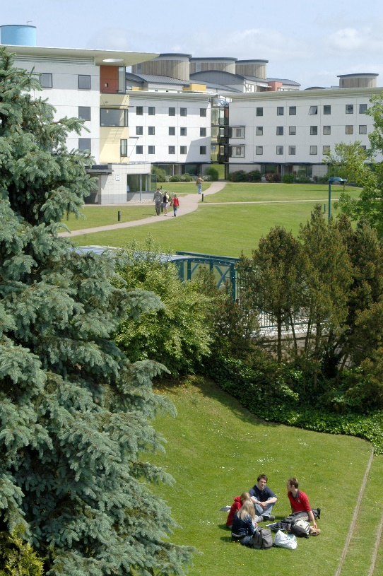
The course allows both full and part-time study, and takes place at the spacious UEA Campus, which is very close to the Norfolk and Norwich University Hospital. The candidates ranged from intercalating medical students to hospital consultants and nurse specialists. It was fascinating to compare and contrast how the problem-solving focus of the UEA medical curriculum differs from the University of Cambridge, and learn from the best bits of both approaches. The inter-professional learning opportunities within the small teaching groups were also invaluable, allowing for an exchange of knowledge, practice and ideas throughout the course. It was very well managed, with the organiser submitting evidence following the Masters for a further qualification – FHEA (Fellowship of the Higher Education Academy).
The course was split into four compulsory modules, one student-elected module, and a research dissertation. The compulsory modules provided a strong theoretical grounding in not only teaching, but also principles of qualitative and quantitative research. The elective module allowed for further exploration of research methods or principles of research synthesis and systematic reviews. This strong early focus on principles of research underpinned the academic nature of the course. Assessment was through a mixture of examinations, dissertations and presentations. Throughout the course, there was always an opportunity to explore one’s own interests through projects. For example, I experimented and learnt from areas as diverse as webinar and podcast-creation as a way of promoting constructivist active learning and collaboration amongst students, to exploring patient experiences of living with chronic uveitis in the context of a systemic diagnosis.
My main project throughout the course was to discover whether immersive technologies such as room-scale virtual reality have a role in education, given that this technology has rapidly advanced and become more cost effective recently. I explored the benefits of the newest technologies for patients and students alike, and also carried out a systematic review of the available literature.
Overall, I found the course valuable from a number of perspectives. Principally, it enabled me to learn more about what kind of teacher I want to be, and modify my general method from a didactic one to a more heuristic approach. I found the supportive learning culture useful for obtaining insights into which areas I can improve upon and identify goals for future development. I would recommend the course to other East Anglia trainees looking to apply, and would be more than happy to discuss the course and qualification in more detail.

