**Welcome to our Heads of School in Health Education England, East of England.**

We have asked all our Heads of School to submit a photo and a short biography so that you can see who you might wish to contact around training in our region. We are hoping to attach trainee reviews to this as well.

It is a work in progress! Should you wish to submit a review, please do so to

educatorsfaculty.eoe@hee.nhs.uk

**Maria Ross-Russell**

Role: Regional Postgraduate Deputy Dental Dean (Dental Workforce), Midlands and East

Maria is the Regional Postgraduate Deputy Dental Dean across Midlands and East. She is also a GDC registered Specialist in Special Care dentistry and a Tutor for the University of Cambridge Postgraduate Certificate in Medical Education. Maria’s portfolio includes HEE’s Dental Workforce Development, Performer List Validation by Experience and Restoring the Efficiency of Registrants workstreams. She is a member of the national Dental Workforce Development Advisory Group. Maria also represents the Midlands and East Postgraduate Dental School on the East of England Heads of School committee.

**Trainee Review: to be added**

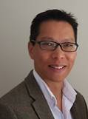**Nam Tong**

Associate dean and Head of School of Emergency Medicine

Undergraduate training in London Hospital Medical School. Junior posts in East London/Essex and Northern Ireland.

Helped set up first Medical Assessment Unit in Northern Ireland (Ulster Hospital Dundonald).

Research fellow with Trauma Audit and Research Network (TARN), Manchester.

Completed specialty training in Emergency Medicine In East of England.

Consultant in Emergency Medicine Queen Elizabeth Hospital King’s Lynn since 2005, clinical lead since 2014.

Head of School of Emergency Medicine since April 2016.

Associate Dean since March 2018 with responsibility for introduction of Annual Development Planning and Workforce Transformation. Current project is Emergency Medicine International Training (EMIT) programme – a joint initiative between HEE, RCEM and SEMI (Society for Emergency Medicine India) for region-based recruitment of EM doctors with training focus.

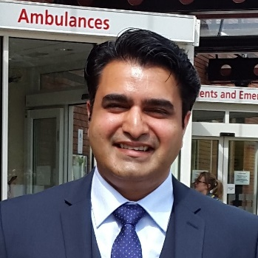**Trainee Review:**

Hi, my name is Kashif and I am delighted to welcome you to the EOE School of Emergency Medicine page. I started my training as an ST1 in East of England in 2017 and I am so glad that I chose this deanery as a run through Emergency Medicine trainee.

East of England has a good mixture of Hospitals offering an opportunity to learn Emergency Medicine with all its varied dimensions – I have enjoyed learning the different challenges of Emergency Medicine at both Addenbrookes Hospital (a leading major trauma centre) and at West Suffolk Hospital (an excellent DGH). EOE Prehospital and Paediatric Emergency programs are very sought after and during my rotations I have had the opportunity of working and learning with the dual training emergency trainees and consultants which has helped me better plan for my own personal training path as I move towards my HST years. Our ACCS program treats all the ACCS streams equally, so I had the same opportunities in all rotations as the trainee from their own base stream. This equipped me with the right skills and understanding of Acute Medicine, Anaesthetics and Intensive Care Medicine and boosted my confidence before my return back to Emergency Medicine as an ST3.

We all know that Emergency Medicine training can be tough and demanding so it is crucial that one trains in a supportive deanery. The EOE school of Emergency Medicine is committed to both training and emergency medicine trainees - I can testify to this as I am one of the trainee representatives since my ST1 year. As a trainee representative I have found Dr Nam Tong (head of school of EM) and Dr Pawan Gupta (TPD ST£/DREAM) to be supportive of trainees and have helped in facilitating rotation requests, LTFT requests and out of program requests. In the first two years of my training I have worked closely with Dr Diane Williamson (TPD ACCS) in addressing trainee concerns and requests in the deanery – and have found her to have trainee welfare as a core principle in her heart. I mention all of this, to let you know that should you chose to join our deanery – you will find yourself in a supportive and caring deanery willing to engage and listen to your needs. Come join us!

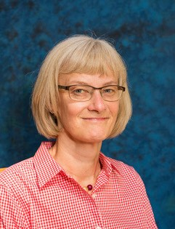

**Janet Rutherford**

I am a GP from Bury St Edmunds, West Suffolk. Having been a GP tutor, GP Trainer, Training Programme Director and Associate Dean, I am now the Head of School for general practice. This means that I have responsibility for the operational delivery of GP training within our region. This task is made much easier by working closely with both the fantastic teams at HEE as well as all our GP educators. I am really keen to keep our trainees at the centre of everything we do – how can we best help our trainees to achieve their potential and succeed as the GPs of the future?

I am also the Associate Dean leading on the ARCP process for GP trainees and am keen to make this process as straight forward as possible for all concerned. My other interest is in supporting educators, especially those who are trying to help trainees with complex needs.

**Trainee Reviews:**

I’m Nish, a GP registrar on the Cambridge scheme. I took year out of her GP training to be a Clinical Fellow to the National Medical Director in London, and then moved deaneries to the East of England in September 2017.

I’ve absolutely loved being here since I moved. I felt hugely welcomed when I arrived, and I found the training programme directors to be very supportive and positive about the future of general practice. The other trainees on my scheme have also been equally helpful and friendly, and lots of them are pursuing interesting opportunities in academia, leadership and roles outside of medicine too, which makes for interesting perspectives when we meet for teaching. My practice has been a fantastic learning experience for me too, and it feels like the registrars in the area are generally well supported wherever they end up.

I’ve also become the RCGP trainee representative for Central and East of England and sit on the East Anglia RCGP Faculty board- mostly because I found senior GPs in the area to be encouraging and supportive of taking up additional roles like this.

I have decided to pursue a local ST4 leadership and commissioning fellowship in the coming months too. This feels like an invaluable opportunity to hone my clinical skills, whilst also being given the privilege to undertake some postgraduate education and get involved in local leadership endeavours. The healthcare system here is evolving rapidly, and I’m deeply excited about the future of general practice here and the career opportunities it will provide.

Overall, I have found my time here to be a rewarding experience, and would recommend it wholeheartedly to anyone considering applying to the deanery.

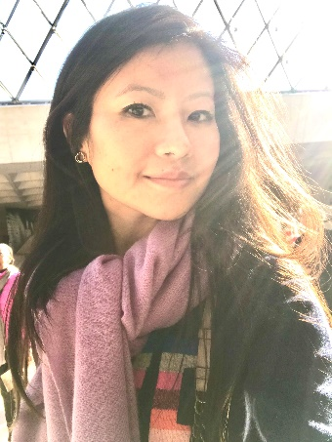

**Nisha** (GPST2 currently rotated in Medicine in Norfolk and Norwich University Hospital)

I met the most outstanding, inspirational and dedicated mentors while doing the tasks of preparing myself to become of professional GP. They are my "true idols" who keeps me going.

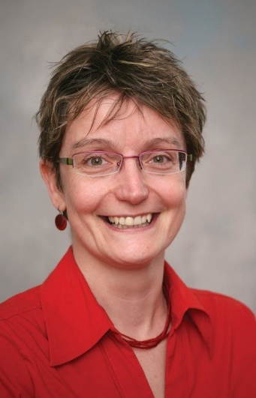**Jan** **Yates**

Role: Head of School for Public Health

Jan is a senior Consultant in Public Health with experience at Director level. Highly motivated and action oriented. A sound, politically astute leader and effective team player. Able to deliver high quality, efficient health and care outcomes and provide professional support for effective decisions. Exceptional teaching skills with experience in coaching, mentoring and supporting staff through personal and organisational development. Jan's career history includes several years teaching followed by Public Health training and time as a Director of Public Health and in various regional and national level positions.

Projects: Public Health workforce development and oversight of speciality and practitioner training in public health

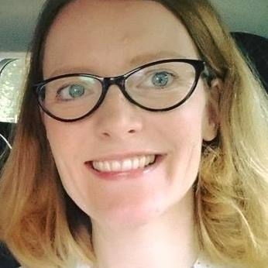**Trainee Reviews:**

Hi I’m Nicola and I’ve been lucky enough to work on the East of England South Public Health training programme since 2016.  I’m from a non-medical background - before training I worked as an analyst at NICE on interventional procedures and public health guidelines. The region is very friendly and all trainees are well looked after.

The Deanery is very accommodating and allows trainees to work LTFT and I found it a very easy process to switch from full to part time working.  I completed the MPhil in Public Health at the University of Cambridge as part of the training and found this hugely enjoyable and a good preparation for many elements of the Part A professional exam (The Faculty of Public Health Diplomate Examination).   The work within Local Authority Placements is varied and interesting. In my time at Hertfordshire County council I’ve worked on a joint strategic needs assessment for looked after children, evaluated health services, written a business case for a physical activity campaign and much more.  There is a wide variety of placement opportunities available within the region and in London.

Trainees really support each other in this region and there are regular training events.  Support for exam preparation is exceptionally well co-ordinated.  I’m thoroughly enjoying my time here and I’m sure you will too.

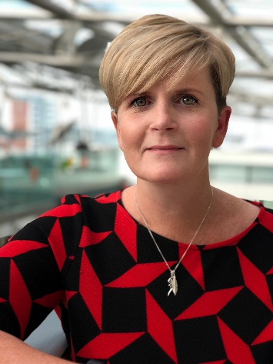

My name is Bev and I am currently an ST3 on the public health programme. I joined the training programme in 2017 after spending 22 years in nursing and I relocated to Suffolk to take up my post. My first 2 years were spent undertaking a Master’s in Public Health at the University of Cambridge and on placement with the  Suffolk County Council Public health team. During that time, I also undertook a four-month placement with the local health protection team and have recently started on-call health protection work, which I am really enjoying. I have had some fantastic opportunities and there is really good support from supervisors and training programme directors. We are a small speciality and have a very active Registrar group, which runs regional training events six times a year. I have been the group secretary for the last 12 months and I am now also a Health Protection rep for the group as this is a particular area of interest for me. With the support of a HEE bursary I am just about to start a Postgraduate Certificate in Medical Education, which I’m really excited about. I have also had lots of training and study opportunities on the programme and there is excellent Faculty exam preparation on offer. My experience as a more mature trainee has been really positive and I’m so glad I made the move to the East of England.

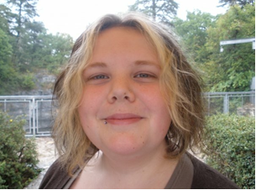

**Fiona**

I am a ST2 Public Health registrar in my second year of five years of specialty training to become a Public Health Consultant. I am based in the East of England (based in Essex), and have a non-medical background. I started training as a specialty registrar in public health in August 2018 and have recently returned to working in the local authority, having completed a MPhil in Public Health in Cambridge as part of my first year of training. I’m really enjoying the wide range of work I can get involved in at my local authority, and I’m currently part of several projects looking at a range of areas of public health including: research on families living below the minimum income standard, referral pathways for financially disadvantaged children, workplace health and strength and balance services. I’m also working with my supervisor and research team from the MPhil to develop my thesis for publication, which is a great opportunity arising from training in the East of England. Along with the other trainees in my year I will be sitting the first of my professional exams, the Diplomate exam in Public Health, in January, so am making the most of the peer support and guidance from the training scheme in order to prepare for this milestone in my training.

Before the training programme my undergraduate studies were in Anatomy and Physiology. I joined the NHS in 2013 and have held a number of roles in the East of England, including training on the NHS Graduate management scheme as an Informatics trainee in the East of England (2013 intake), with placements at Hertfordshire Partnership Foundation Trust (HPFT), Specsavers and Mid Essex Hospital Trust (MEHT). Most recently I have spent the last 3 years working as a CCG planned care commissioner.

**Charlotte Patient**

Head of Postgraduate School of Obstetrics and Gynaecology

I am a Consultant Obstetrician at Addenbrookes with a special interest in maternal medicine. In the past I have been the Clinical Lead for Obstetrics, College tutor at Addenbrookes and Associate TPD. I have an interest in Global Health and work in a collaborative partnership with the University of Makerere and Mulago Hospital in Uganda and am on the MTI and Volunteering Committee at the RCOG.

**Need picture**

**Trainee Review:** We already have trainee reviews on or website [https://heeoe.hee.nhs.uk/obstetrics_gynaecology/meet-trainees](https://protect-eu.mimecast.com/s/CdsiC00PqFGQWG0swQNmH?domain=heeoe.hee.nhs.uk)

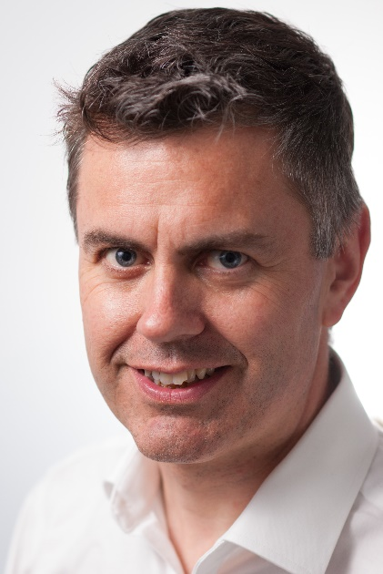**Chris O’Loughlin**

Main Role:  Head of School for Psychiatry

Dr Chris O’Loughlin took up his role as Head of School in the East of England in 2017, bringing his enthusiasm for psychiatry training, fostered whilst Training Programme Director and Director of Medical Education for Cambridgeshire and Peterborough Foundation Trust, to the regional level. He is a strong believer in the trainee experience in training and the workplace, combining this with social media (twitter @chrisol1) to promote recruitment to psychiatry and raise standards.   In 2018 he was the Royal College of Psychiatrists’ Trainer of the Year.  He is also a case-manager with the Professional Support and Wellbeing Service.  Clinically , Dr O’Loughlin works as a general adult community psychiatrist in Cambridge.

Projects:

Foundation Psychiatry Fellowship posts and Longitudinal Posts

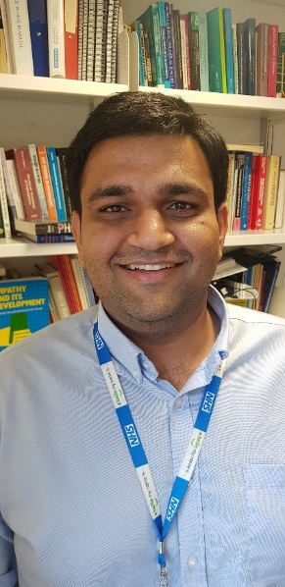Psychiatry recruitment

Professional Support and Wellbeing Service

**Trainee Review:**

**Satnam**

I started my higher training in General Adult Psychiatry with the East of England (EoE) deanery just over 2 years ago. I now live in the beautiful city of Cambridge. The best thing about training in Psychiatry in Eastern Region is that you can pick between different locations or hubs to potentially choose to train in. Within my current trust, I have worked in team across Cambridgeshire and Peterborough.

It has been massively rewarding 2 years so far. As a higher trainee in Psychiatry, the Deanery offers many exciting opportunities for trainees to tailor their training experience to suit their personal and professional interests while achieving one's core competencies. A major reason why I chose EoE when applying for ST4 posts was the availability of substance misuse training locally. Such specialist training posts are far and few across the nation. I secured a spot for endorsement in substance misuse psychiatry through a competitive process and have since completed my year long sub-speciality endorsement in Substance Misuse Psychiatry.

There are plenty of opportunities to pursue ones interest and hone skills in research, leadership & management, medical education and psychotherapy as well. I have successfully completed the Chief Resident Management and Leadership programme which is run by Cambridge University Hospitals NHS Foundation Trust in association with Judge Business School, Cambridge. Subsequently, I am now a part of the national RCPsych Leadership and Management Leadership scheme and feel proud to be able to have the opportunity to represent my Trust and the deanery at a national level.

As an International Medical Graduate (IMG), the deanery has helped me feel supported and valued, allowing me to maintain my enthusiasm and zeal for learning. Our TPDs Dr. Albert Michael & Dr. Rebecca Jacob and our Head of School Dr. Chris O’Loughlin are extremely approachable and I have always been able to count on their wise counsel whenever I have needed it. I highly recommend training in East of England.

**Stuart Williams**

Head of School – Radiology

Medical school in Oxford followed by medical jobs in Oxford, Birmingham and London. Returned to Oxford for specialty training in radiology. Consultant at the Norfolk & Norwich University Hospital (NNUH) since 2001 with subspecialty interest in GI and oncological imaging. Various subsequent roles including being TPD for the Norwich Radiology Academy and clinical director for the NNUH 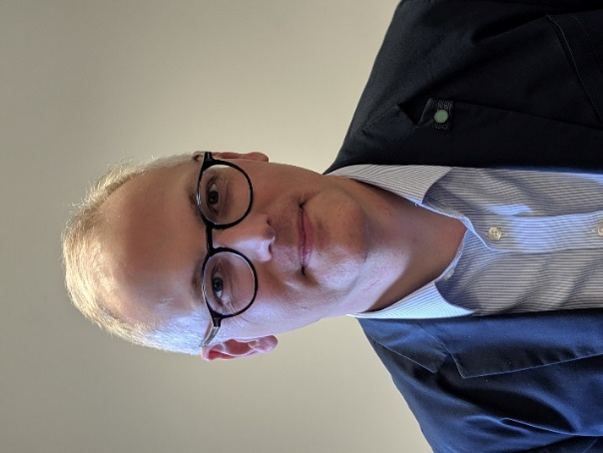radiology department. Fellowship at NICE. Honorary senior lecturer at Norwich Medical School. Examiner for the final part of the Fellowship exam at the RCR.

Projects

Current aim of expanding training numbers for radiology in the East of England as demand still outstrips supply at consultant appointment level. Increasing training capacity in cardiac imaging and in interventional radiology to cope with anticipated service developments. Working with ST HEE fellows to enhance trainee experience across the varied high quality training sites we have across the region.

**Trainee Review:**

Hi, I'm Jennie and I am a Radiology Registrar in the East of England based at the Norwich Radiology Academy.

The Academy is a unique and fantastic place to undergo radiology training and I have thoroughly enjoyed my time here so far. The first year is carefully structured to allow trainees to learn the basics of radiology in a supported environment, which I feel is essential as this specialty is so vastly different to others that trainees may have worked in before. Also, in being an academy, we have a large registrar body which creates a wonderful collegiate atmosphere and helps to foster great friendships.

At Norwich, we are actively encouraged to take part in both teaching and research, with plenty of opportunities for teaching within the hospital and at the university. There are also various leadership and management courses which are offered both within Norwich and the East of England deanery, which are widely enjoyed. The in-house teaching is second-to-none in this training scheme with consultants going out of their way to help you learn and guide you through the FRCR exams, from physics and anatomy in your first year to the final viva-style exam.

Having recently returned to work from parental leave, I have been supported by the deanery, the academy staff, my registrar colleagues and consultants, who have been invaluable in helping me get settled back in again, using the Supported Return to Training plan.

I can highly recommend radiology training at the Norwich Radiology Academy in the East of England deanery. It enables people to become competent and confident radiologists by providing a hugely friendly, structured and supported training environment.

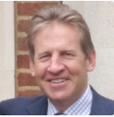**Mr Anthony J Vivian FRCS FCOphth**

Head of School of Ophthalmology

Tony Vivian is a paediatric ophthalmologist and adult strabismus surgeon at Addenbrookes Hospital, Cambridge and West Suffolk Hospital, Bury St Edmunds. He has been Head of the School of Ophthalmology for 4 years. He is also on the Training Committee and Evaluation of Training sub-committee of the Royal College of Ophthalmologists. He is the past president of the British and Irish Paediatric Ophthalmology and Strabismus Association (BIPOSA). He has a long-held interest in medical education and training, especially surgical training and simulation, mentorship and reflective practice.

Current projects include developing the Ophthalmology Mentorship program and creating a Global Health Fellowship.

**Trainee Review: already on website**

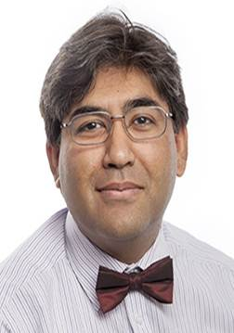**Fraz Mir** is a Consultant Physician at Cambridge University Hospitals NHS Foundation Trust, United Kingdom and an Associate Lecturer in the Department of Medicine, University of Cambridge. In November 2017, he was appointment as Head of School of Postgraduate Medicine and Associate Postgraduate Dean, Health Education East of England. In this role, he is responsible for overseeing the clinical training and welfare of over 500 doctors across the region and has a special interest in the Medical Training Initiative scheme. He became a bye-fellow of King’s College, Cambridge in May 2018 and Director of Clinical Studies from September 2018. From June 2013-2017, he was Associate International Director for the Royal College of Physicians (RCP) London.

His clinical and research interests are in the fields of therapeutics and hypertension.

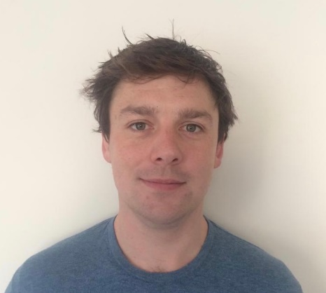**Trainee Reviews:**

Hi I am Ieuan, a CMT year 2, and Academic Clinical Fellow.  I am also the chair of the East of England CMT/ IMT training committee.

Training in the East of England has been great fun. I have been fortunate enough to be placed at Addenbrooke's Hospital (Cambridge University Hospitals Trust) for the past 2 years. The deanery has been extremely supportive of my training and are always looking to actively improve it. Addenbrooke's has been an excellent place to train, and has a strong teaching programme to help us obtain MRCP- boasting a very successful pass rate! The academic opportunities have been large and I have been well supported in pursing these.

The region offers a good mix of district hospitals, tertiary hospitals and national centres, I have found the experience very supportive and friendly. I would highly recommend training in the region and have found a lot more support and training opportunities here than friends in other regions.

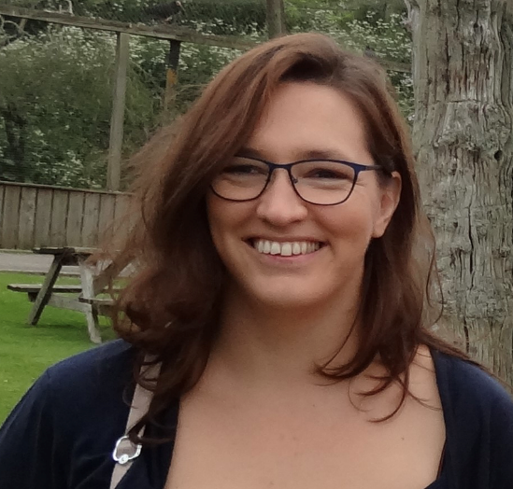My name is Martha. I am a CT1 trainee in ACCS-Acute Medicine in Ipswich and one of the educational reps for ACCS East of England. I chose to train in the east of England as it offers access to academic centres but also allows for training in smaller hospital settings where more practical experience may be gained. I have found the deanery to be very open to let trainees attend further education and training courses. I have also made new friends in the training programme that are all in different streams of ACCS and will have a different take on the same problem - which is helpful in a clinical setting. The deanery is very organised and out RCP tutor takes good care of us as ACCS-AM trainees. I would encourage anyone considering training to look into training here - as you might find yourself pleasantly surprised.

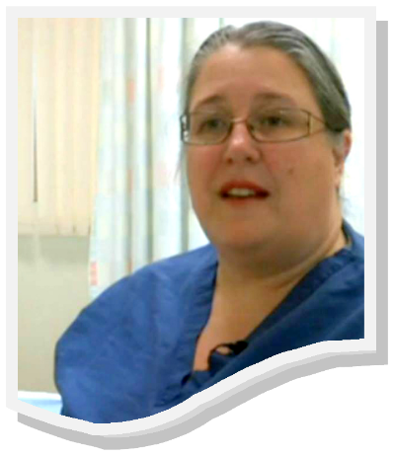

**Dr Helen Johnson**

**Foundation School Director**

I was a consultant in obstetrics and Gynaecology, with subspecialist interest in urogynaecology. I went to St Mary’s Medical School, and did my specialty training, of which some was LTFT, in the Yorkshire deanery before settling in Cambridgeshire. I was heavily involved in education in the school of Obstetrics and Gynaecology, the national education urogynaecology subcommittee and in foundation. From February 2019 I have been working full time at HEE EoE.

We focus on training our doctors for their future within the NHS, providing rotations that are balanced and mapped against the curriculum. Our busy hospitals provide you with a broad experience as well as making sure that you have the opportunity to look at sub-specialities. We pay special attention to our teaching and training, with communication and personal skills training as well as a high class simulation training programme and the first area to run a full Virtual Reality programme. We are also very keen to provide personal pastoral support, whether this be the opportunity for less than full time training, our mentoring and support programmes our just an ear when things seem difficult.

We aim to improve our foundation experience year on year, listening to your voices and being responsive to them.

One of my passions in foundation is around making foundation inclusive. We are strong supporters of those requiring to be LTFT or have a need for more considered rotations. In this I have been proud to sit on the GMC working part for the welcomed and valued guidance.

For more information on our educational programme please see [e](https://heeoe.hee.nhs.uk/node/1189)[ducation opportinities](https://heeoe.hee.nhs.uk/foundation/teachingopportunities)

**Trainee Reviews**: can they be taken from the foundation page: <https://heeoe.hee.nhs.uk/foundation/foundation-recruitment>

**Rowan Burnstein**

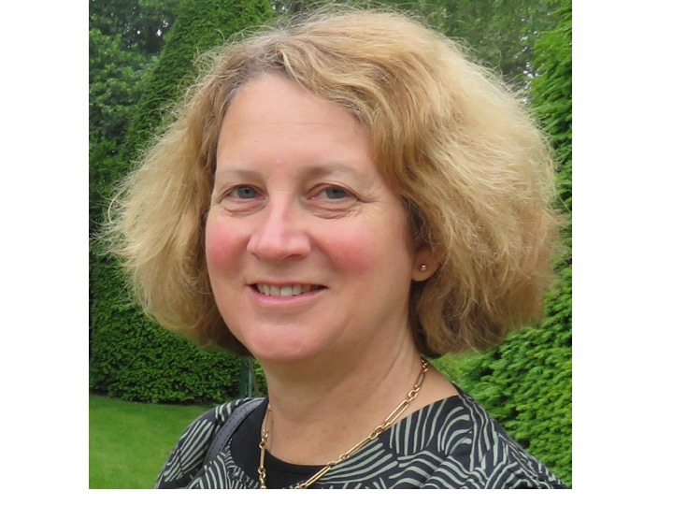Head of School of Anaesthesia 2017 to present

I am a consultant in Anaesthesia and Intensive care at Addenbrookes Hospital, Cambridge, with a subspecialist interest in Neurocritical Care and Major Trauma. I was educated in Sydney, graduating from the University of Sydney in 1985. I subsequently undertook the majority of my postgraduate training in anaesthetics and intensive care in the East of England, including completing a PhD within the University of Cambridge. I am a fellow of both the Royal College of Anaesthetists and Faculty of Intensive Care Medicine. I am also a Fellow, College Lecturer and Director of Studies at Magdalene College, Cambridge. Since becoming a consultant I have undertaken a variety of leadership roles prior to becoming Head of School. These have included Chair of the Cambridge Research Ethics Committee (2007-11), Clinical Director of Neurocritical Care (2006-13), Clinical Director Perioperative Services and Adult Critical Care (2013-17), Clinical Lead for Organ Donation (2012-19). I have been Regional Advisor for Intensive care (2007-13) and have completed an NHS Clinical Leadership Fellowship (2011-2). I am currently the Clinical Lead and Intensive Care Lead for the Cambridge Yangon Trauma Intervention project, and a partner researcher in the NIHR Global Health Research Group in Neurotrauma, based in Cambridge.   My research interests currently focus on applications of principles of health systems engineering and service improvement, particularly in the context of global health (traumatic brain injury), medical education and high risk surgical patients.

**Trainee Review:**

**Waiting for:**

* Dental Trainee Review
* Charlotte Patient’s picture
* Anaesthetics Trainee Review
* Adrian Park bio and picture (Pathology)
* Pathology Trainee Review
* Vasanta Nanduri bio and picture (Paediatrics)
* Paediatrics Trainee Review
* Mark Bowditch bio and picture (Surgery)
* Surgery Trainee Review