Welcome to Wales! Croeso I Gymru! PHEM posts in Wales provide an opportunity for senior training grade doctors (ST 5-7) in Emergency Medicine, Anaesthesia, Intensive Care Medicine or Acute Internal Medicine to undertake sub-specialty training in Pre-hospital Emergency Medicine within appropriately supported and governed clinical services. It is aimed at those individuals whose long-term career aspirations involve a significant component of Pre-hospital Emergency Care work. Successful completion of the training programme will allow for sub-specialty accreditation in Pre-hospital Emergency Medicine.
This should be read in conjunction with the Intercollegiate Board for Training in Pre-hospital Emergency Medicine (IBTPHEM) Guidance available on their website www.ibtphem.org.uk

Posts are available for Scheme A, B or C training which can combines training in core specialty and sub-specialty over a one or two year period. This may be delivered as a full time 12 months training period outside core specialty or as two 6 month training periods over the two years. Less than full time trainees can also be accommodated.

The training scheme is split into 3 phases. Phase 1a is an induction phase where you will be fully immersed into the Welsh Emergency Services – becoming familiar with EMS, Police and Fire and Rescue services, the specialist health responders such as EMRTS, Hazardous Area Teams and Physician Response Team. You will also spend 10 days on the national PHEM induction course and 4 days on a specialist simulation course in North Wales.

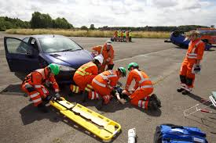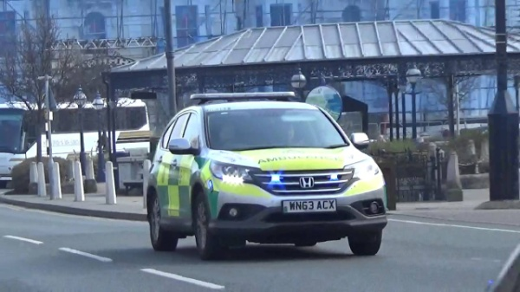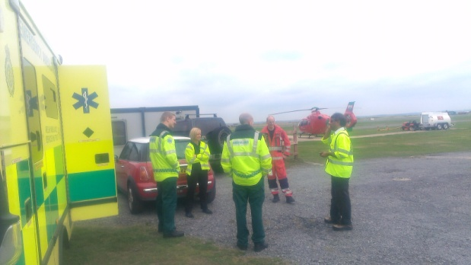

Pictures from top left clockwise:
IBTPHEM induction course
WAST Response vehicles used for Physician Response Unit
North Wales simulation course
EMRTS team

In phases 1b and 2, you will be trained by the full range of pre-hospital medical staff including Doctors, Paramedics, Critical Care Practitioners and Nurses, all with appropriate qualifications and expertise. You will also have a Wales Deanery Educational Supervisor allocated to you to guide you safely through the curriculum. You will always work under the supervision or mentorship of an experienced provider in the pre-hospital environment.

Most of the Wales PHEM training is completed as an attachment to the Emergency Medical Transfer and Retrieval Service – EMRTS Cymru. This service runs in conjunction with Wales Air Ambulance from its bases in Llanelli and Welshpool, therefore most shifts will be based around these sites. Accommodation or travelling expenses are provided between the sites.

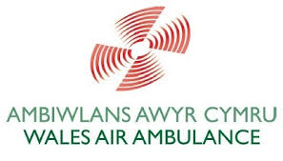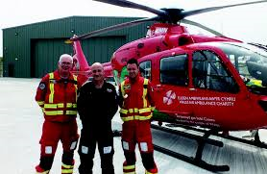
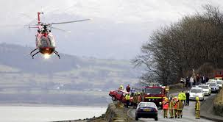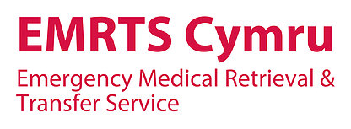

Pictures:
Top right – Helimed 57 crew at Llanelli base
Bottom left – Helimed 59 attending incident in North Wales

Please note that due to the nature of the post applicants appointed to Wales will be required to pass a further fitness test for EMRTS. Details from mark.winter@wales.nhs.uk

EMRTS have a brand new airbase opened in 2016 with dedicated training rooms and conferencing facilities. There are also IT and study facilities there.

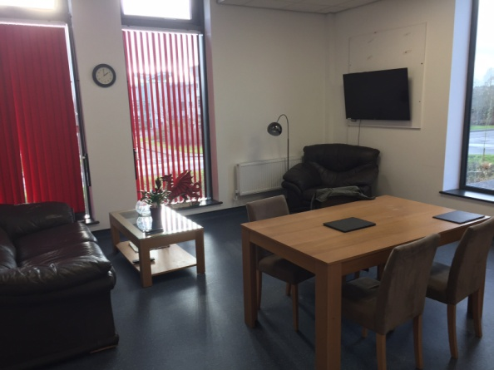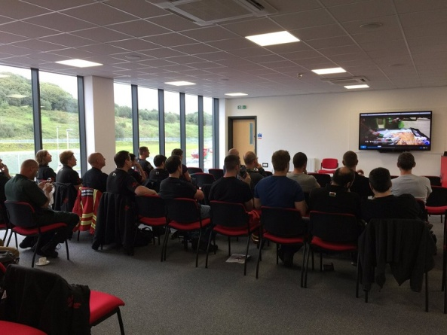

Some aspects of the PHEM curriculum cannot be covered by Critical Care and therefore PHEM trainees in Wales will also spend some time on the Physician Response Unit – a joint venture between Welsh Ambulance and the Health Board in Gwent. These shifts will enable you to see lower acuity patients. More specialist training will be delivered by study days at a regional and national level in conjunction with IBTPHEM. We also have several NSA 1 and 2 examiners in the region who are great for advice regarding examinations.

Supervision is provided on several levels. Once Phase 1a is completed, the trainee will be working directly with doctors and paramedics who have been trained in the use of the IBTPHEM Workplace Assessment tools. A Consultant Clinical Supervisor will also directly supervise the trainee at least one shift in five, and your Educational Supervisor will meet with you regularly to assess your progress. During phase 2 more independent practice is encouraged and supervision can be maintained at a more distant level.

Another good reason for training in Wales is the amazing people you will meet and places you will see – what other reasons can you need for training here?

For any further information please contact Dr Ian Bowler, PHEM TPD – ian.bowler2@wales.nhs.uk

