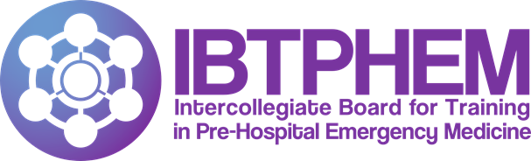
Pre-hospital Emergency Medicine
Sub-specialty Training
This is an exciting opportunity to train in an area of GMC approved sub-specialist practice. National recruitment into sub-specialty training posts in Pre-hospital Emergency Medicine (PHEM) for posts commencing August 2024 or February 2025 opens to applications on 13 September 2023. These posts are in approved Training Programmes around the UK.

Further information on what you can expect during training, the national person specification and approved Training Programmes is available at www.ibtphem.org.uk

Online applications are submitted via https://heeoe.hee.nhs.uk/recruitment_phem .
Closing date: 27 September 2023 (1200 noon). Applicants must have permission from their local Training Programme for the duration of their sub-specialty training.

